Mockito –Exercise #2 BiggestBazarRetail

Retail shops publicise different promotional offers such as “buy one get two free” or “buy 2.5kg sugar and get 30 percent off”. Given the following (all the code is provided.)

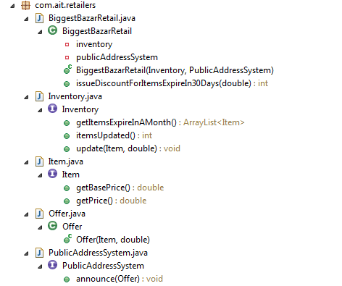

1. We want to test the *issueDiscountForItemsExpireIn30Days* method in *BiggestBazarRetail.java*

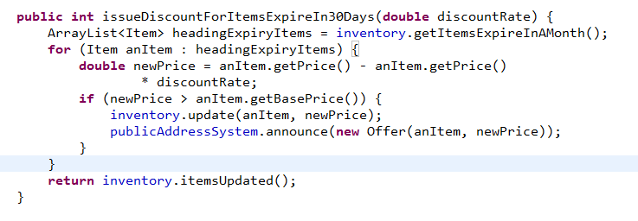

In order to execute the above method, instances of *Inventory* and *PublicAddressSystem* (PAS) are required. They are resource-intensive objects – Inventory accesses databases and PAS requires driver software. Use Mockito to mock these two objects.

Your test class should provide the following tests:

A. Test that a discount is issued on one item.

Stub the database call (*getItemsExpireInAMonth*) so that an ArrayList with one Item object is returned. Use test data values to ensure that the discounted price will not be less than the base price. Stub the *itemsUpdated* method to return 1. Assert that 1 is returned from issueDiscountForItemsExpireIn30Days.

Verify that the *update* method is called on the *inventory object* and the *announce* method is called on the PAS object.

B. Test that no Item qualifies for a discount if the discounted price is less than the base price.

Stub the database call (*getItemsExpireInAMonth* method) so that an ArrayList with one Item object is returned. Use test data values to ensure that the discounted price will **be** **less** than the base price. Stub the *itemsUpdated* method to return 0. Assert that 0 is returned from issueDiscountForItemsExpireIn30Days.

Verify that the *update* method is **not** called on inventory and the *announce* method is **not** called on PAS.

C .Test that two Items qualifies for a discount.

Three items are returned in the *getItemsExpireInAMonth* method, but for one of the items the discounted price is less than the base price. Stub the database call (*getItemsExpireInAMonth* method) so that an ArrayList with three Item objects is returned. Use test data values to ensure that the discounted price will **be** less than the base price for **one** of the Items. Stub the *itemsUpdated* method to return 2. Assert that 0 is returned from issueDiscountForItemsExpireIn30Days.

Verify that the *update* method is called on inventory twice and the *announce* method is called on PAS twice.

**Note** : Using Generic values

