Master Thesis Plan Master Artificial Intelligence

Date : 25th October, 2016

Name and student number : Stefanie Deckers, i6099223

Name of the thesis examiner : Kurt Driessens

Name of the daily supervisor :
(if different from the thesis examiner)

Title of the master thesis : Development of a Recommender System for multiple online shops

Expected final date : 25th January, 2016

Signature thesis examiner Signature master student

………………………………………….. ………………………………………..

Assessment
The assessment will be based on the contents and form of the thesis, the presentation of this thesis and any product and/or software that accompanies the thesis.

Research plan

Description of the assignment:

The master thesis will be performed at the e-business company Braintags GmbH in Willich, Germany. They are hosting various online shops for different customers and want a universal recommender system for all shops. This recommender system will be developed in the scope of the master thesis.

The recommender system is supposed to work as an independent software component, such that every online shop Braintags is hosting can request recommendations from it. It will be implemented in Java using the tool-kit vert.x (http://vertx.io/).

In general there are different kinds of recommendation systems: collaborative, content-based, knowledge-based, demographic, community-based or hybrid recommendation systems as described in [1]:
- Content-based techniques make recommendations based on similarities between items, i.e. by finding items that are similar to the items that the user liked in the past.
- Collaborative approaches rely on preferences of similar users, where user similarities are calculated by similar purchases/clicks/ratings in the past. There are two different types of collaborative filtering approaches. Memory-based, also called neighbour-based, approaches find neighbours of a user or an item at runtime and use them to make recommendations. Model-based techniques learn an alternative model in advance by transforming users and items into the latent factor space, e.g. by singular value decomposition.
- Knowledge-based approaches require domain knowledge which is used to make recommendations. Such domain knowledge needs to be built and maintained by a knowledge-engineer and contains information about which items or item features match a user's needs or preferences.
- Demographic recommenders make use of any demographic information of the users like their age or language.
- Community-based recommenders require information from any social network and use the preferences of the user's friends to make recommendations.

The only techniques that come into question are collaborative filtering, content-based and demographic techniques. A knowledge-based approach cannot be implemented, because there are no domain experts that could build a knowledge-base for every online shop. Community-based recommenders require any kind of social network, that is not available within online shops. Collaborative filtering approaches only need feedback for different items of any users in the system. Moreover there is content-based information for items as well as demographic information for users available, which allows the use of content-based and demographic recommenders, respectively.

Which algorithm to choose depends on the requirements to the recommendation ([2]) as well as on the available data. Collaborative filtering for example requires a sufficient amount of user feedback, while content-based techniques only need information about the preferences of the current user and information about items in general. Hybrid recommender systems aim to benefit from different techniques and overcome their drawbacks. [3] shows different possibilities of how to combine different recommenders to improve prediction accuracy.

Still performance of the different algorithms depend on the datasets they are applied on. So in this thesis it is aimed to find an approach to develop a hybrid recommendation systems that can serve different datasets from different domains and different sizes. This will be realized by developing an adaptive recommender system that can be tuned for different datasets.
For this purpose two different approaches will be investigated. For the first approach a weighted hybrid recommendation system is developed in which an unknown item rating is predicted by a linear combination of two or more predictions of single recommender systems. The weights for the different recommender systems can be trained by minimizing an objective function like:

Here w_{k} denotes the weight for the k^{th} involved recommender, r(u,i) is the feedback of user u for item i and r_{k}(u,i) is the predicted value of user u for item i of the k^{th} involved recommender. The training is performed separately for each dataset. In this approach every single recommendation algorithm is involved in the final recommendation. Another and less runtime intensive possibility is a switching hybrid approach, i.e. only one recommendation system is chosen based on some criteria. This is a classification problem where meta-information about the shops and the current user like number of users, number of items, average number of purchases per user, number of purchases of current user etc. can be used to predict the most promising recommendation algorithm. This model can be trained by building a decision tree.

Besides the choice of recommendation algorithms and hybridization the problem of implicit user feedback will be addressed. Research mostly refers to recommender systems using explicit user feedback in the form of continuous or discrete ratings. In the context of online shops feedback has to be derived implicitly from user behaviour like purchases, shop cart entries or page views. Different approaches to model this kind of feedback will be compared. The simplest approach is to use binary data indicating whether a user purchases an item or not, or the number of times a user purchased an item. Another possibility is to apply a function incorporating the number of purchases, shop cart entries and page views for every user and item pairs to estimate a users interest in a specific item. It will be tested whether different feedback models influence the performance of the single recommendation algorithms.

All in all the research questions that are addressed in this thesis are:
Does the modelling of implicit user feedback of online shops influence recommendation performance?
Can a weighted hybrid recommendation system be automatically optimized for different datasets by learning different weights for different datasets?
Can a switching hybrid recommendation system be automatically optimized for different datasets by training a decision tree using information about the dataset and the current user?

References:

[1] Ricci et al.: Introduction to Recommender Systems Handbook. In: Recommender Systems Handbook, pp. 1–35. Springer, New York/Dordrecht/Heidelberg/London (2011)
[2] Ramezani et al.: Selecting and Applying Recommendation Technology
[3] Burke, R.: Hybrid web recommender systems. In: The Adaptive Web, pp. 377–408. Springer, Berlin / Heidelberg (2007)

Planning:

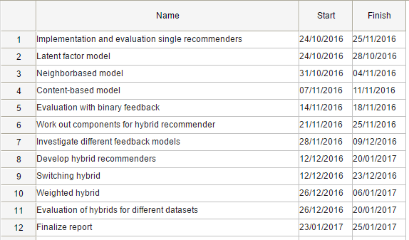
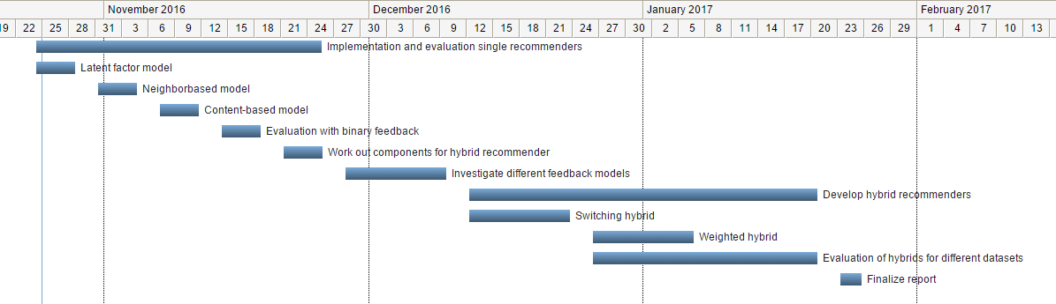

In case of an external training period

Name of the company : Braintags GmbH

External supervisor : Martin Plücker

Size of the project :

Working hours : 40h / week

Frequency of contact : Daily

Agreement about payment : 400€ gross / month
(if applicable)

Confidentiality : Confidentiality agreement regarding used data

Special agreements :

Signature external supervisor

……………………………………………………..

