Master Thesis Plan Master Artificial Intelligence

Date : 12th December, 2016

Name and student number : Stefanie Deckers, i6099223

Name of the thesis examiner : Kurt Driessens

Name of the daily supervisor :
(if different from the thesis examiner)

Title of the master thesis : Development of a Recommender System for multiple online shops

Expected final date : 25th January, 2016

Signature thesis examiner Signature master student

………………………………………….. ………………………………………..

Assessment
The assessment will be based on the contents and form of the thesis, the presentation of this thesis and any product and/or software that accompanies the thesis.

Research plan

Background
The master thesis will be performed at the e-business company Braintags GmbH in Willich, Germany. They are hosting various online shops for different customers and want a universal recommender system for all shops. This recommender system will be developed in the scope of the master thesis.

The recommender system is supposed to work as an independent software component, such that every online shop Braintags is hosting can request recommendations from it. It will be implemented in Java using the tool-kit vert.x (http://vertx.io/).

Description of the assignment
The goal of the research is to develop a recommendation system that is able to provide recommendations for different online shops.
The two most common kinds of algorithms described in [2] will be investigated:
Content-based techniques make recommendations based on similarities between items, i.e. by finding items that are similar to the items that the user liked in the past.
Collaborative approaches rely on preferences of similar users, where user similarities are calculated by similar purchases/clicks/ratings in the past. There are two different types of collaborative filtering approaches. Memory-based, also called neighbour-based, approaches find neighbours of a user or an item at runtime and use them to make recommendations. Model-based techniques learn an alternative model in advance by transforming users and items into the latent factor space, e.g. by singular value decomposition.

Implicit feedback
Most research activity is based on datasets with explicit feedback data, where users intentionally give some kind of rating to express their preferences as in the Netflix price [1]. For this thesis only implicit feedback data is available that consists of purchase histories, page views and shop cart entries. This kind of data is more noisy, because those implicit user interaction might not correlate with the user's real preferences. Moreover it lacks negative feedback. A user who did not buy or view an item may either not know or not be interested in that item. Due to those difficulties most common recommendation techniques are not applicable. So the task of this thesis is to find a recommendation technique that can manage the e-commerce data in real-time.

Generally a model-based approach is preferable, because after a model is trained recommendations can be made faster and less memory intensive than using a memory-based approach. This is especially important for large datasets.
The most common model-based approach aims to learn user and item features similar to singular value decomposition (SVD), such that a rating of a user for an item can be calculated by
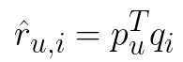
.
This approach is problematic for e-commerce data, because there are no ratings, but only one-class positive feedback. Sampling or weighting schemes as in [3] will be examined to adapt the model to e-commerce data.

The performance of different recommendation techniques depends on the data it is applied on. Since the developed recommender system should be able to serve different shops, hybrid approaches like in [4] are investigated to allow to tune the system for different datasets.

Evaluation
Evaluation will be performed in terms of the mean average precision (MAP)
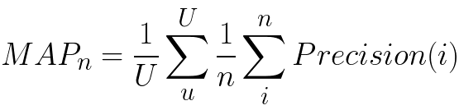

where U indicates the number of users, n the number of recommended items. Precision(i) measures the precision at the list of recommendations cut off at position i.

Research questions:
What kind of algorithms perform well on implicit feedback e-commerce datasets?
How can model-based recommendation approaches be applied to implicit feedback data?
Are hybrid approaches able to improve performance?

References:
[1] Bennett, James, and Stan Lanning. "The netflix prize." Proceedings of KDD cup and workshop. Vol. 2007. 2007.
[2] Ricci, Francesco, Lior Rokach, and Bracha Shapira. Introduction to recommender systems handbook. Springer US, 2011.
[3] Pan, Rong, et al. "One-class collaborative filtering." 2008 Eighth IEEE International Conference on Data Mining. IEEE, 2008.
[4] Burke, Robin. "Hybrid web recommender systems." The adaptive web. Springer Berlin Heidelberg, 2007. 377-408.

Planning:

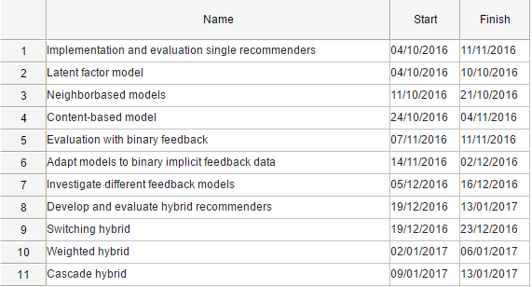
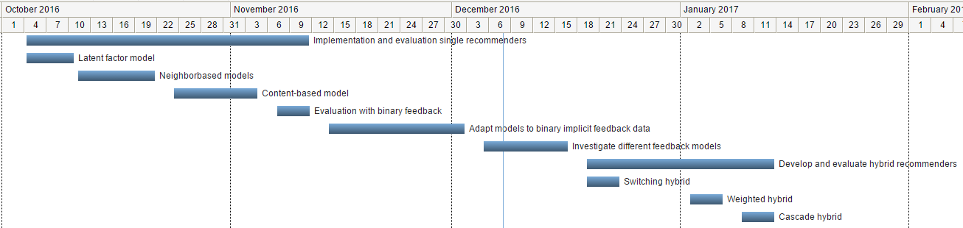
In case of an external training period

Name of the company : Braintags GmbH

External supervisor : Martin Plücker

Size of the project :

Working hours : 40h / week

Frequency of contact : Daily

Agreement about payment : 400€ gross / month
(if applicable)

Confidentiality : Confidentiality agreement regarding personal data only

Special agreements :

Signature external supervisor

……………………………………………………..

