Front End Test

Please use vue.js to build the pages.

We use symfony and WordPress in our environment. Vue.js is used to create components to give the user better experience interacting with the website.

The goal of this test is to build a responsive website and apply Vue.js. The test mainly focuses on building mobile views. The main components get their data from api end points, in this test
, I attached the json files for every component, so you are tasked with utilising/consuming the JSON response.

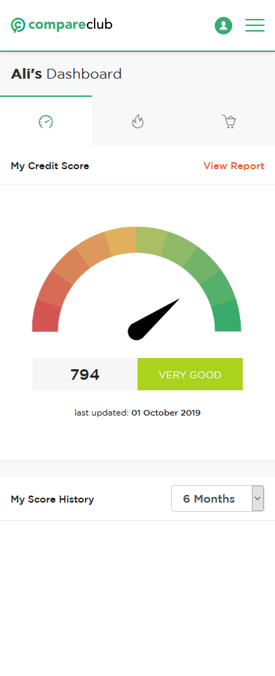

The Dashboard, which is what the candidate is responsible to build, consists of many components

1. My Credit score

1.1 The gauge is scaled from 0 to 1000.
1.2 the values (black oval) should be taken from the JSON response below

{"response":[{"id":1579,"userId":"127","categoryId":4,"optionName":"creditscore_value","optionValue":"{"creditscore":"794","fetch_date":"2019-10-01"}"}],"total_history":1}

2. Fuel

2.1. use the json file attached to get the list of petrol stations and the prices
2.2 The e10 and LPG refer to fuel type, only extract these two types and show them.
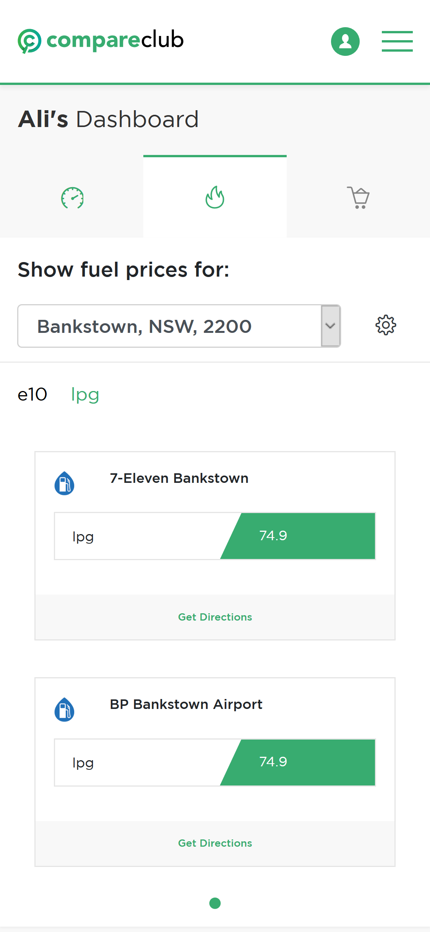
2.3 In mobile view only show two petrol stations per page.

3. Groceries
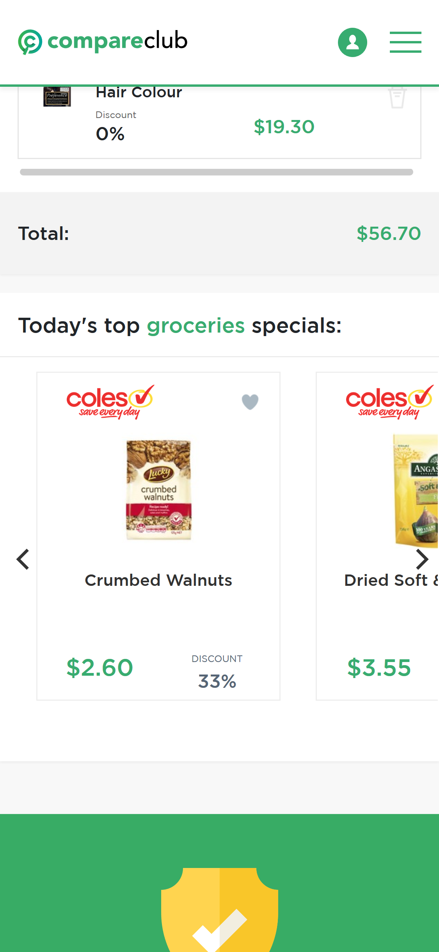
This page shows the list of product selected by the user (shopping_list.json), also it recommends products to users
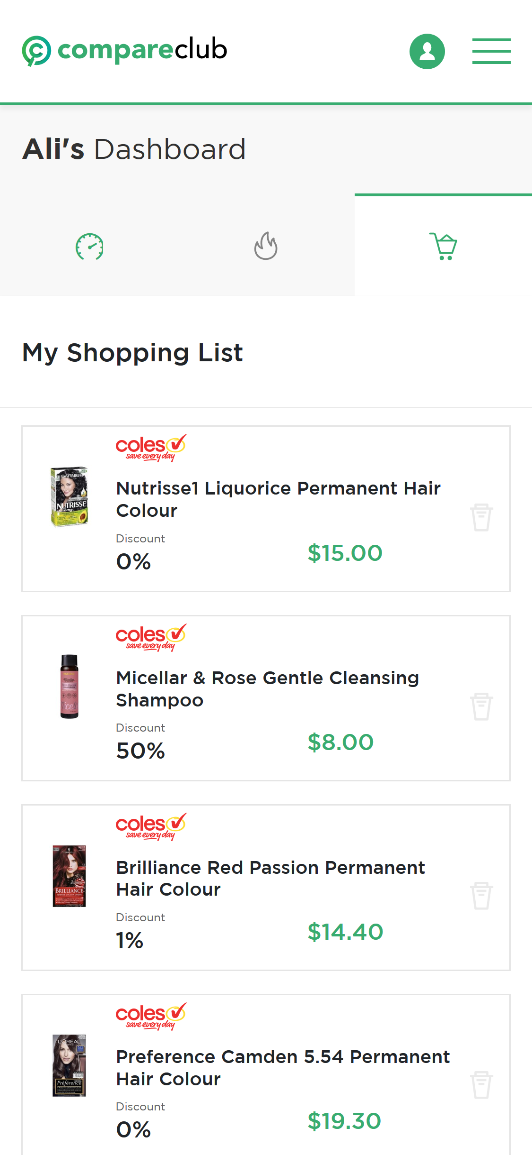

3.1 My Shopping List: Use shopping_list.json to list all the products.
3.2 oday’s top groceries specials: use specials.json

