**Task 1: Create table**

/*Name 22/01/2023 */

CREATE TABLE DB1 (

EmployeeID INTEGER(10) NOT NULL,

SSN TEXT(11) NOT NULL,

FName TEXT(12) NOT NULL,

LName TEXT(12) NOT NULL,

Position TEXT(12) NOT NULL,

Salary NUMERIC(10,2) NOT NULL,

PhoneNum TEXT(12) NOT NULL

);

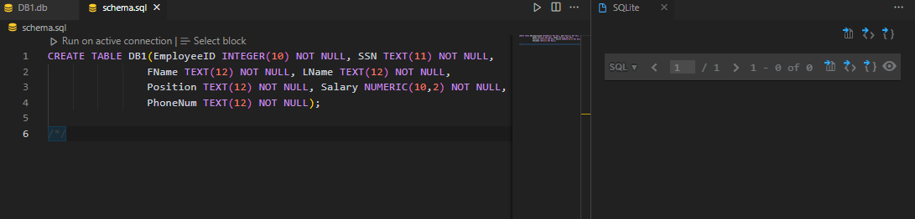

**Task 2: Insert data**

/*Name 22/01/2023 */

INSERT INTO DB1 (EmployeeID, SSN, FName, LName, Position, Salary, PhoneNum)

VALUES (100, '111-11-0607', 'John', 'Smith', 'Manager', 35000.75, '800-350-0000');

/*Name 22/01/2023 */

INSERT INTO DB1 (EmployeeID, SSN, FName, LName, Position, Salary, PhoneNum)

VALUES (200, '333-22-0607', 'John', 'Jones', 'Associate', 25000.00, '202-999-0000');

/*Name 22/01/2023 */

INSERT INTO DB1 (EmployeeID, SSN, FName, LName, Position, Salary, PhoneNum)

VALUES (300, '444-44-0607', 'Sally', 'Smith', 'Manager', 46500.00, '303-999-0000');

/*Name 22/01/2023 */

INSERT INTO DB1 (EmployeeID, SSN, FName, LName, Position, Salary, PhoneNum)

VALUES (301, '555-55-5555', '*firstname*', '*lastname*', 'Manager', 36900.00, '555-555-5555');

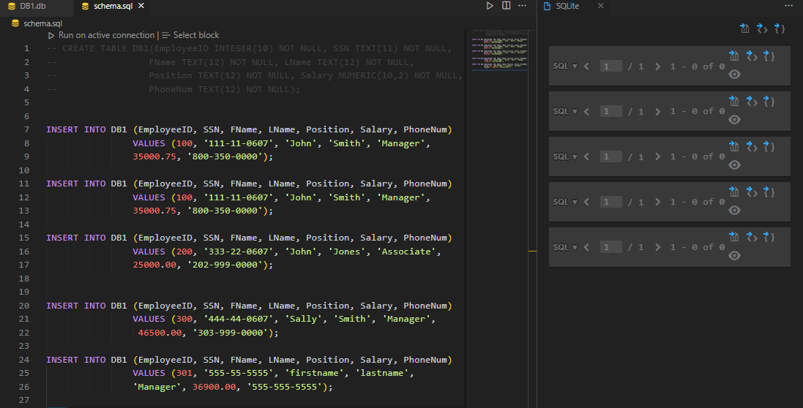

**Task 3: Select * command**

/*Name 22/01/2023 */

SELECT * FROM DB1;

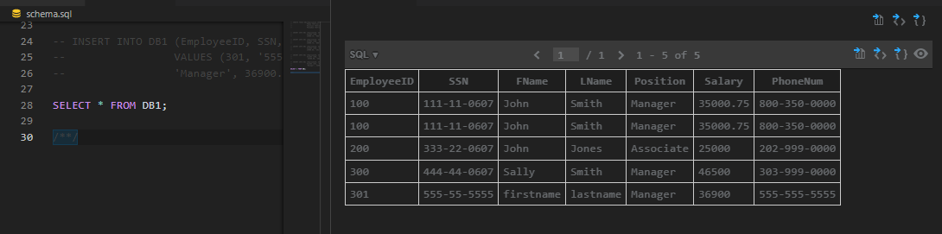

**Task 4: Select command to list**

/*Name 22/01/2023 */

SELECT EmployeeID, FName, LName, Position, Salary FROM DB1 WHERE LName = 'Smith';

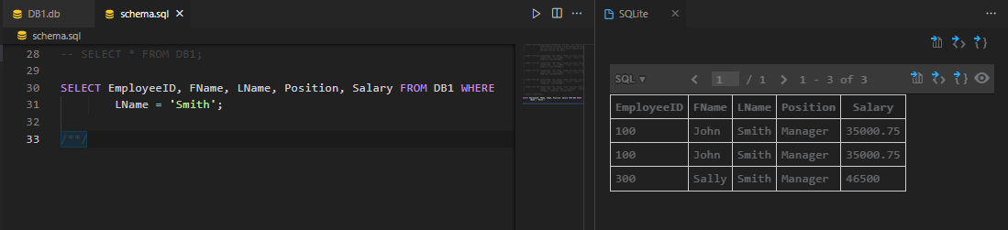

**Task 5: Select command to list**

/*Name 22/01/2023 */

SELECT EmployeeID, FName, LName, Position, Salary, PhoneNum FROM DB1 WHERE Salary > 20000;

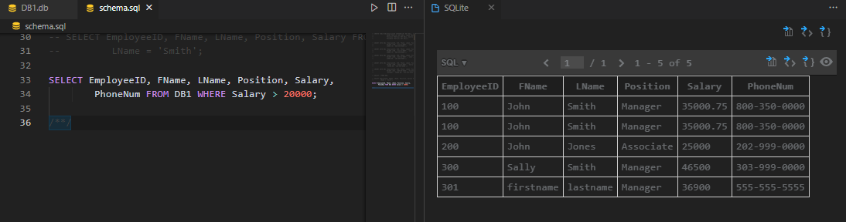

**Task 6: Select command to list**

/*Name 22/01/2023 */

SELECT EmployeeID, FName, LName, Position, Salary FROM DB1 WHERE Salary > 30000 AND Salary < 45000;

