What is Entity Framework?

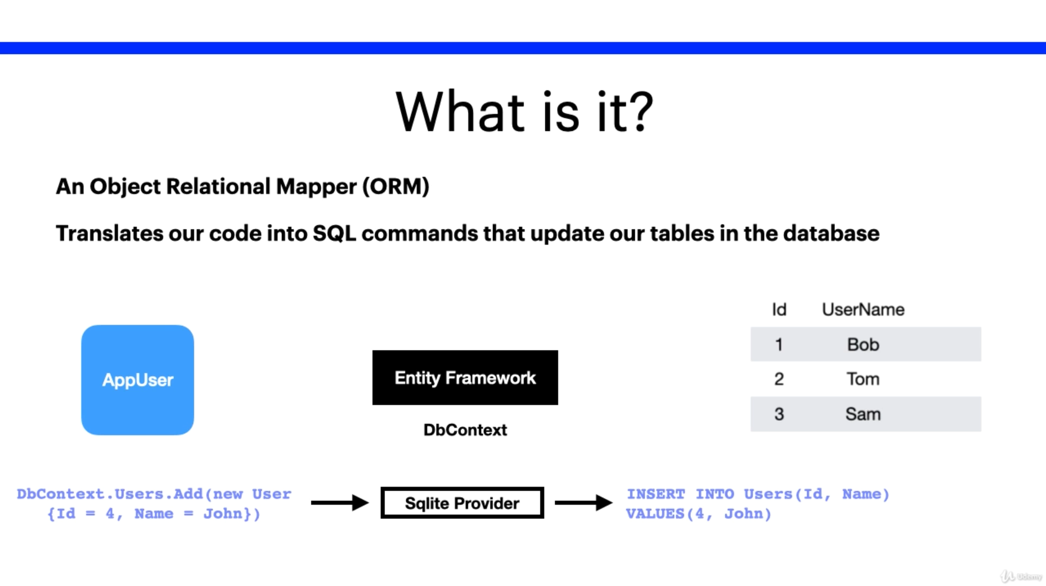

Features

* Entity Framework allows us to **query** our database
* Entity Framework allows us to use **change tracking**. This allows us to keep track of the changes made to the database.
* Entity Framework allows us to **save** to the database. Insert, Insert Into, etc commands for example
* Entity Framework gives us **concurrency**. This will protect overwriting changes from another user.
* Entity Framework deals with **transactions.** This will provide automatic transaction management while querying and retrieving information from the database.
* Entity Framework also provides **caching**.
* Entity Framework provides **built-in conventions.** The framework needs to follow certain conventions (such as naming conventions) and default rules for the entities to work properly
* Entity Framework allows you to **configure** your entities.
* Entity Framework allows for **migrations**. This gives us the ability to create a database schema.

