DOORTRONIX USA
Automatic Sliding Door
INSTALLATION MANUAL
Working draft · Structure taken from Tucker Auto-Mation SL10.4L Installation Guide (UG 920.1019.04) · Replace yellow EDIT notes and Tucker figures with Doortronix parts.
Doortronix USA · 5783 County Road 1219, Malakoff, TX 75148 · (888) 453-5196 · info@doortronixusa.com
EDIT — This file is for you to edit in Word/Pages. Yellow notes mark Tucker-specific hardware or settings (travel rod, SL10.4L controller, motor lock, belt tensioner, telescopic, FS=07 vs your FS=03 rocker). Delete this cover note before publishing. Do not post until drawings are yours.

How to use this draft
- Keep the step order. It matches how the door actually goes in.
- Each step has a Tucker source figure underneath. Delete that picture and insert your photo or CAD.
- Search this document for “EDIT —” to jump to every place that needs a Doortronix change.
- When done, File → Save As PDF and put it on resources.html.

Table of contents
- Important — read before install
- Step 1 — Check the rough opening
- Step 2 — Assemble the door frame to the header
- Step 3 — Install the frame into the wall opening
- Step 4 — Install threshold and tracks
- Step 5 — Install door panels
- Step 6 — Electrical connections
- Step 7 — Power on and programming
- Step 8 — Troubleshooting
- Job documentation and closeout
- Appendix A — Motor / electric lock
- Appendix B — Decal and label placement
- Appendix C — Factory / field wiring
- Appendix D — Belt tensioning
- Appendix E — Telescopic packages (if offered)

Important — read before install
Doortronix USA recommends that this automatic pedestrian door be installed by a trained automatic door technician, and that the finished installation comply with the current ANSI A156.10 or A156.38 (whichever applies) and any applicable building code.
A full inspection of the operating system should be performed per AAADM guidelines by a certified AAADM inspector at completion of installation and after every service call. If service is not performed within one year, a routine AAADM inspection should be performed and documented. The product should not operate more than one year without an AAADM inspection.
If after install or service the door is unsafe or does not meet national performance standards, repair immediately. If it cannot be repaired at once, disable the operator and secure the opening so it can be used safely by hand. Notify the owner (or person responsible) and advise what must be done to return the door to safe operation.
Glass / glazing is by others unless otherwise specified. Frames are prepped for the specified glass thickness. Electrical: 120 VAC, 15 A dedicated circuit at the header — by others.

Step 1 — Check the rough opening
- Check the size of the rough opening. Take measurements at several points (width and height).
- Compare to the approved shop drawing / order confirmation for this opening.
- Do not proceed if the opening is out of square, out of plumb, or undersized.
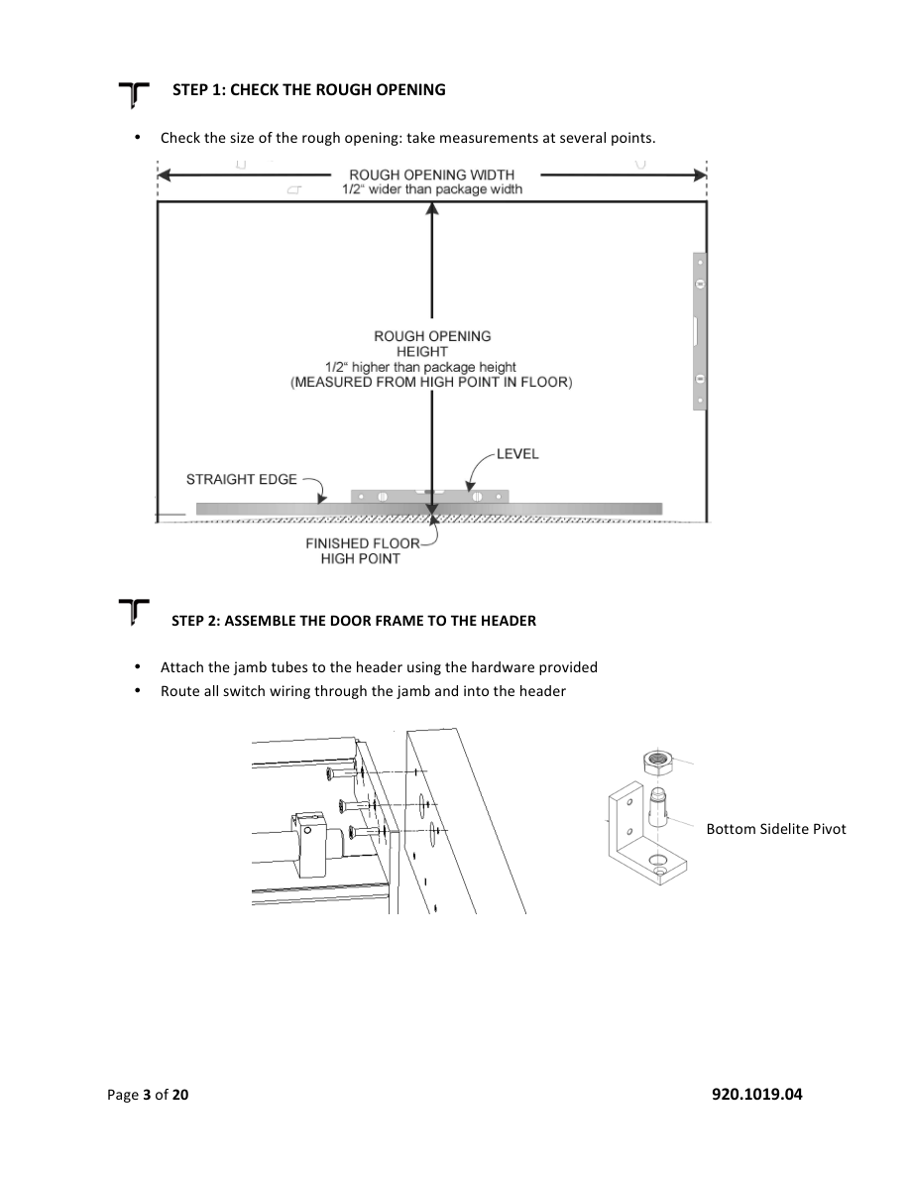
Source figure (Tucker p.3) — replace with Doortronix RO / header drawing.

Step 2 — Assemble the door frame to the header
- Attach the jamb tubes to the header using the hardware provided.
- Route all switch wiring through the jamb and into the header.
- Pre-fit bottom sidelite pivot (if used) so it is ready before the frame is stood up.
EDIT — Replace “bottom sidelite pivot” drawing with your pivot / clip hardware.
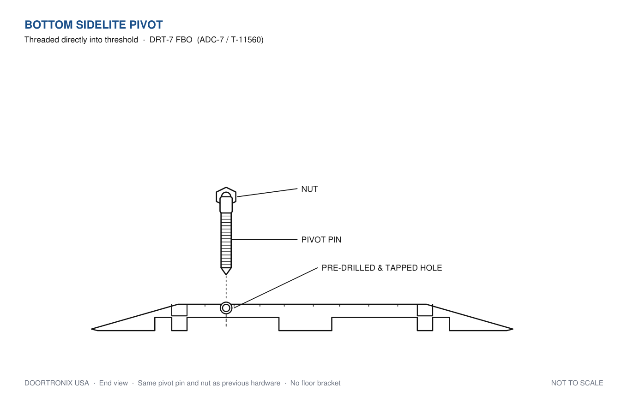
Doortronix — Bottom sidelite pivot (DRT-7). Pivot pin threads into threshold. Delete the Tucker L-bracket figure above.

Source figure (Tucker p.3, lower) — jamb to header and bottom sidelite pivot. Replace.

Step 3 — Install the frame into the wall opening
- Attach any sidelite bottom pivot blocks (floor portion) to the bottom of the jamb tube before standing the frame into place.
- Stand the frame up and walk it into the rough opening.
- CAUTION — two or more people. The assembled frame is top heavy.
How to face the package in the opening:
- FBO (full breakout): linear travel rod / drive to the interior side.
- FSL (fixed sidelite): linear travel rod / drive to the exterior side.
EDIT — Confirm Doortronix drive/header orientation vs Tucker “linear travel rod.” Rewrite these two bullets if yours is opposite or uses a different carrier.
- Whether recessed track or surface (floor) mount, jambs rest on the finished floor.
- Level and plumb the jambs. Shim as necessary.
- Install mounting screws through the pre-drilled holes. If more than 4 screws are required, typically one every 16" to 20".
- Recheck the entire package plumb and level. Correct with plastic shims.
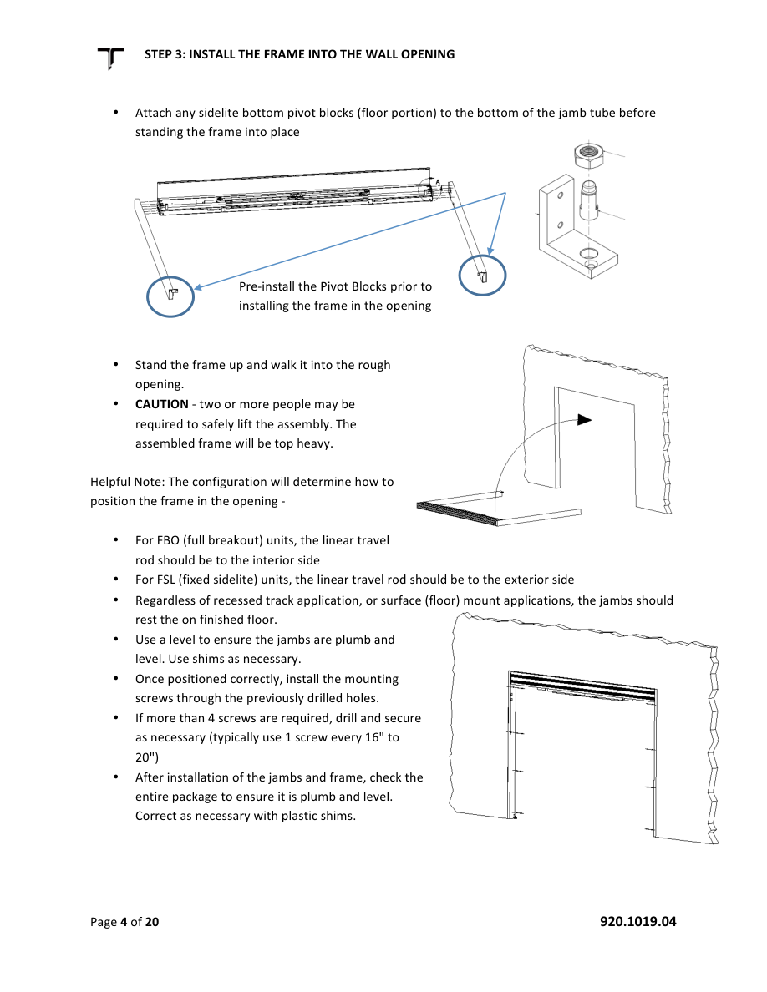
Source figure (Tucker p.4) — frame in opening and pre-install pivot blocks. Replace.

Step 4 — Install threshold and tracks
Three mounting configurations:
FSL — surface track
- FSL is surface-mounted bottom track only. The sliding-panel bottom guide rides in the track under the fixed sidelite, so nothing is recessed.
FBO — surface track
- Entire package sits on finished floor. Use a ramped threshold on each side of the track.
FBO — recessed track
- Bottom tracks set in a 1/2" deep recess, level end to end. Jambs recess as well.
EDIT — Confirm Doortronix offers all three. Delete any config you do not sell. Swap the three track photos.
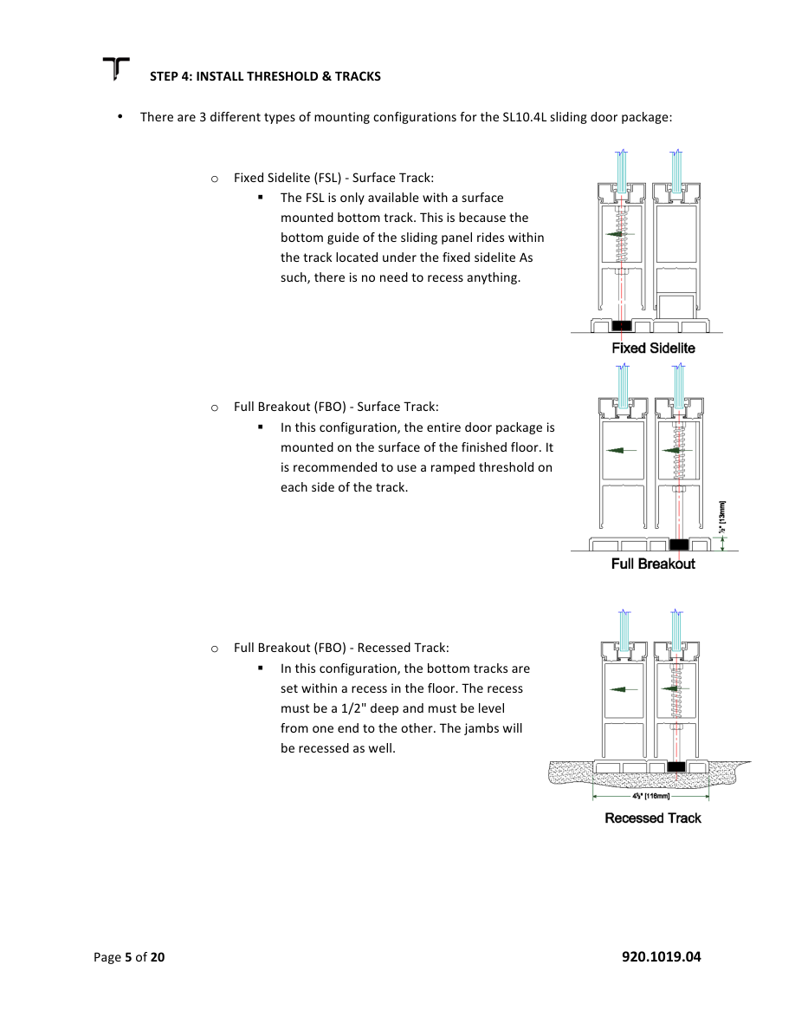
Source figure (Tucker p.5) — FSL surface / FBO surface / FBO recessed. Replace.
Install the tracks
- Position bottom tracks per door configuration.
- Snap a chalk line jamb to jamb.
- Secure tracks with countersunk screws only. No screw heads proud of the track.
- Recessed tracks: 1/2" deep recess.
- IMPORTANT — align the edge of the guide track with the 1-3/4" face of the jamb tube. Misalignment causes problems on full breakout packages.
EDIT — Confirm jamb face is 1-3/4" on Doortronix extrusion. Change the dimension if yours differs.
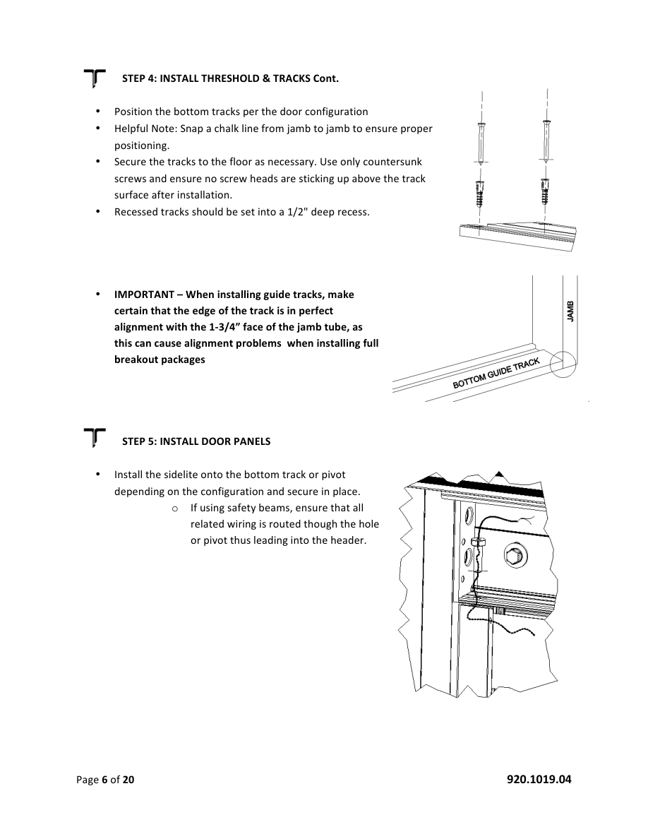
Source figure (Tucker p.6) — track alignment. Replace.

Step 5 — Install door panels
- Install the sidelite onto the bottom track or pivot, depending on configuration, and secure.
- If using safety beams, route all related wiring through the hole or pivot into the header.

Source figure (Tucker p.6, lower) — sidelite on track. Replace.
Sliding panel
- Place the sliding panel in a breakout position.
- Insert the breakout bar into the carrier already in the header — always from the trailing end of the carrier.
- Slide the door in the carrier so the leading edge lines up with the edge of the carrier.
- Two screws attach it; one larger screw adjusts the leading edge up so the panel does not drag when broken out. Backing that screw out lifts the nose of the door.
- Sidelite height: loosen the lock nut and adjust.
EDIT — This is Tucker carrier / breakout bar hardware. Swap for Doortronix carrier photos and rename parts if you use clips instead of a travel rod.
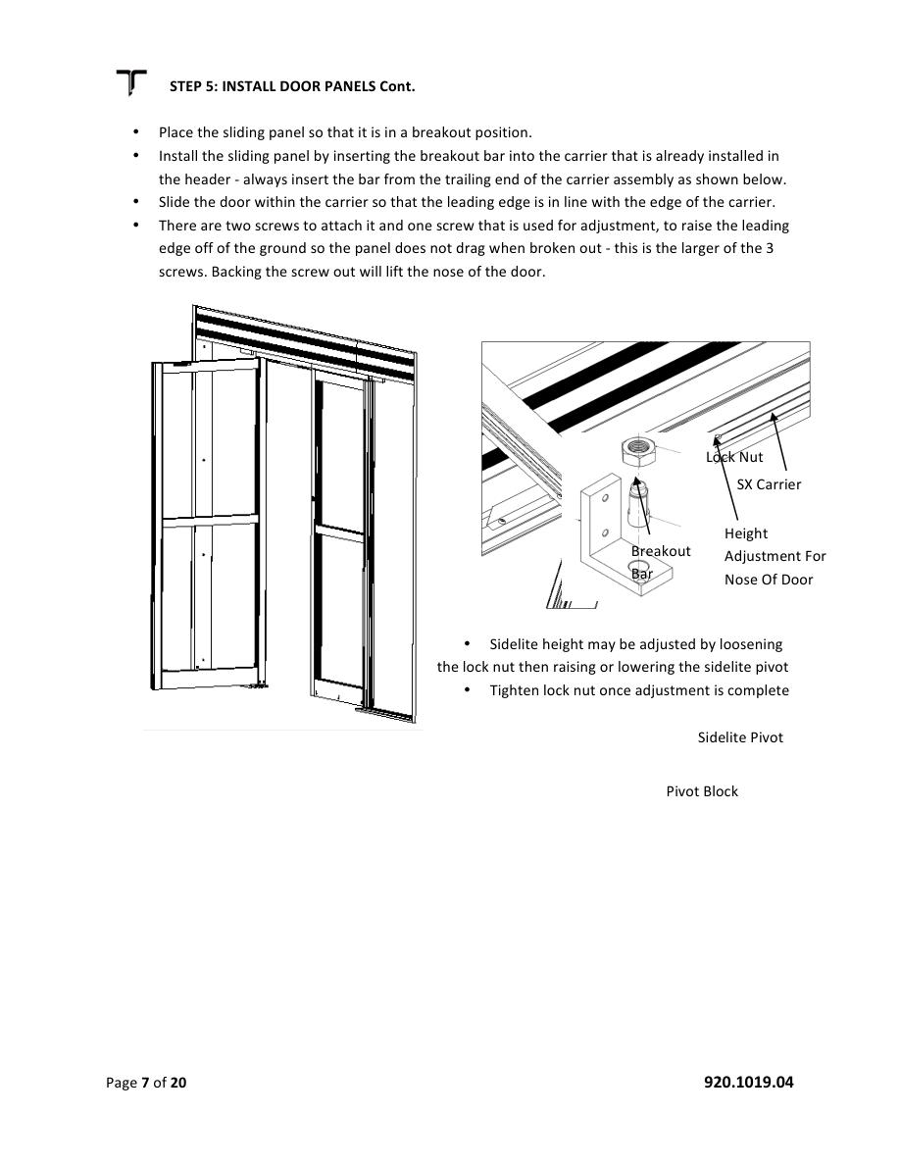
Source figure (Tucker p.7) — carrier, breakout bar, height screws. Replace.
Height and bottom guide
- Panel height is factory-set. If a slight adjustment is needed:
- Raise or lower the leading edge with the height adjuster at the leading edge of the door(s). This raises or lowers the steel travel rod.
- Loosen the adjuster mount bolt, turn the adjustment nut, check lock-to-strike alignment (single slide = jamb; bi-part = opposing panel), retighten the mount bolt.
- Insert the bottom guide into the track.
- Adjust so the bottom of the slide block is about 1/8" above the track. Tighten the set screw in the heel of the door (hardware pack).
- Door must slide freely when finished.
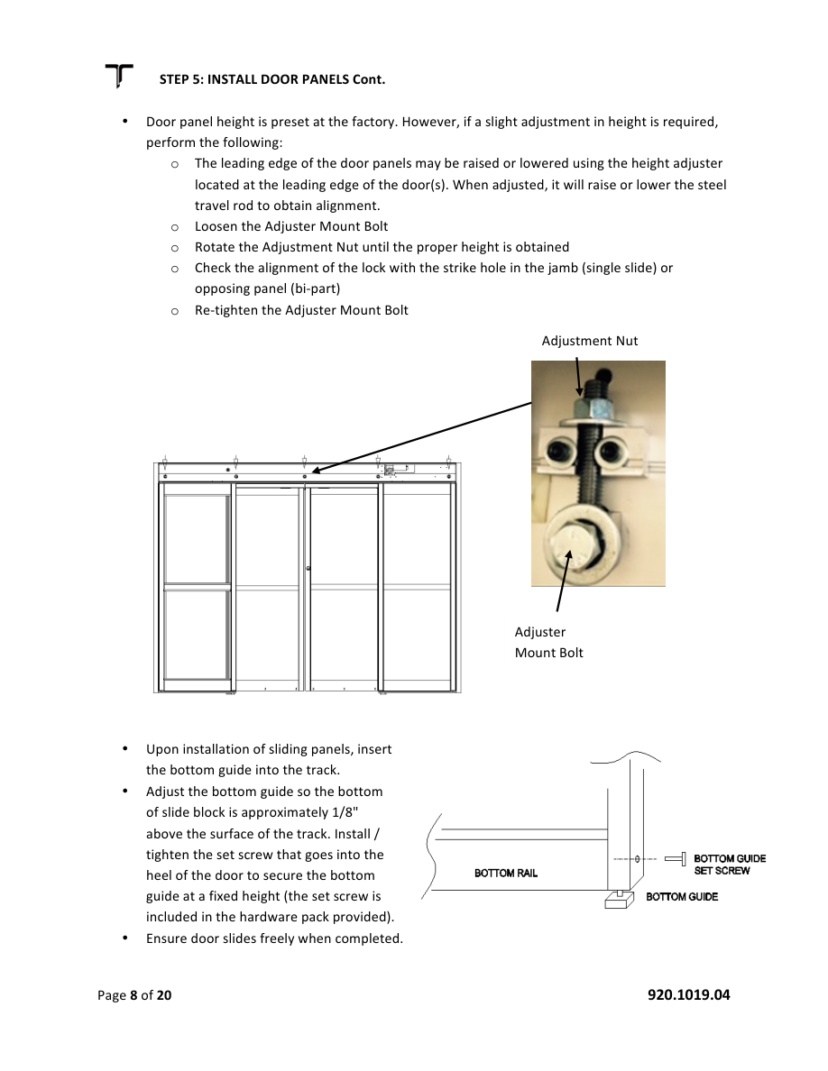
Source figure (Tucker p.8) — adjuster mount bolt / nut and bottom guide. Replace.

Step 6 — Electrical connections
- 120 VAC input: green / white / black to a single-phase 15 A circuit — dedicated whenever possible.
- Motor / encoder and control are pre-wired from the factory.
- Peripheral inputs vary. Use the chart on the face of the control and the Doortronix FBO / FSL wiring diagram for this job.
- All “common” terminals are common to each other.
EDIT — Delete any Stanley Stan-Guard / Doromatic Look-See notes if you do not use those sensors. Point installers to your FBO and FSL wiring PDFs.
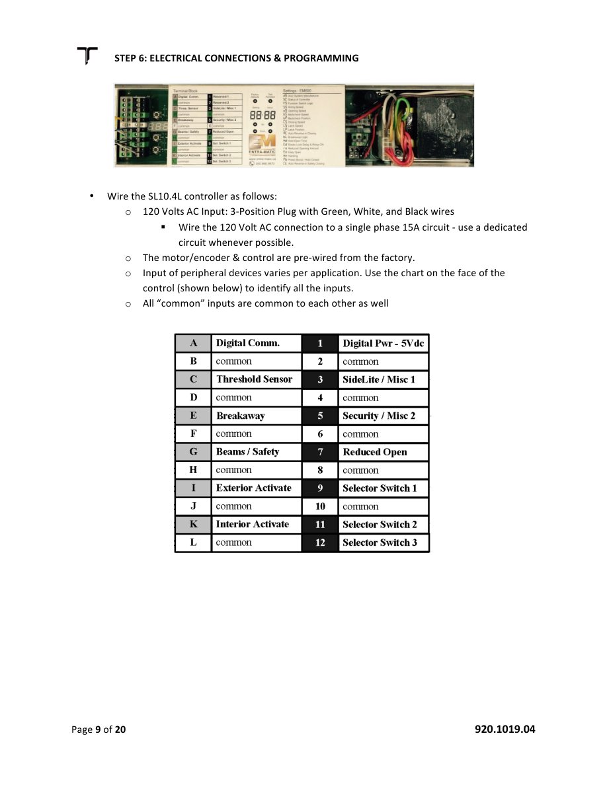
Source figure (Tucker p.9) — controller face. Replace with Doortronix controller photo.
Controller terminals (typical — confirm on your board)
Term | Function | Notes
A | Digital output | EDIT — Tucker: Stan-Guard / Look-See only. Remove if unused.
C | Threshold sensor | Overhead safety; may be used with A.
E | Breakaway | N.C. Open circuit kills operator. Jumper to common if no breakaway.
G | Safety / beams | Hold-open when active. Disabled at fully closed. Dry contacts.
I | Exterior activate | With 1-way switch, acts like safety when closed.
K | Interior activate | Activation input.
1 | Not used
3 | Sidelite / misc 1 | Sidelite safety → slow speed.
5 | Security / misc 2 | Activates regardless of selector (morning entry / access).
7 | Reduced open | Use with ro function.
9, 11, 12 | Selector switch | Rocker or 5-position rotary.
B D F H J L / 2 4 6 8 10 | Common | All commons tied.
T | Relay N.O. | Aux / electric lock.
U | Relay common | Aux / electric lock.
V | Relay N.C. | Aux / electric lock.
W X / Y Z | 12 VAC accessory | 1 amp total for W–Z.

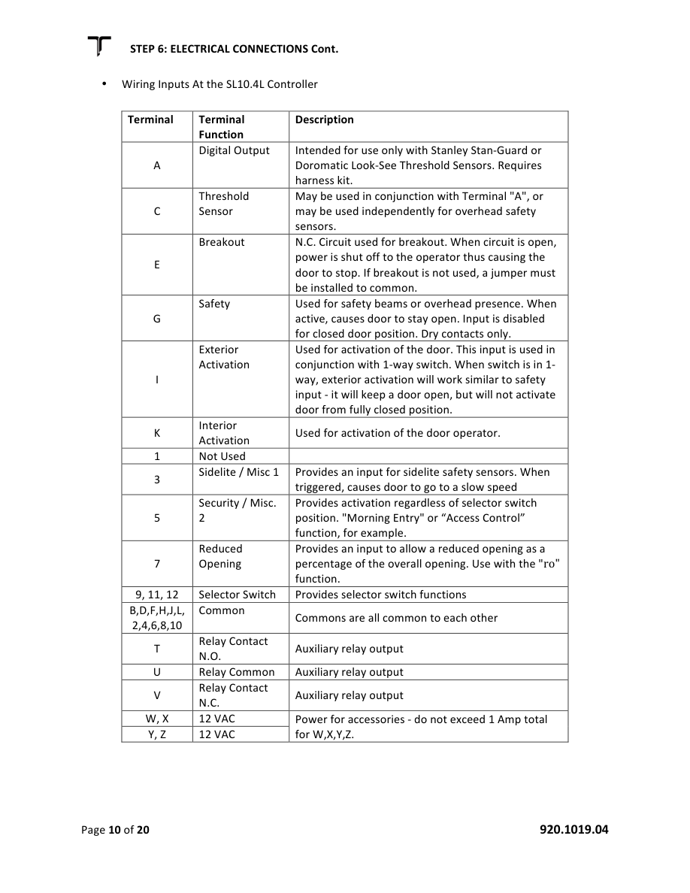
Source figure (Tucker p.10) — terminal chart. Replace with your chart if silk-screen differs.
Selector switch
- Doortronix wiring sheets: 3-position rocker FS = 03. 5-position rotary FS = 04.
EDIT — Tucker manual said FS = 07 for their rocker wiring and FS = 04 for 5PSW. Use YOUR values (03 / 04) unless you confirm otherwise on the bench. Replace the switch wiring drawing.
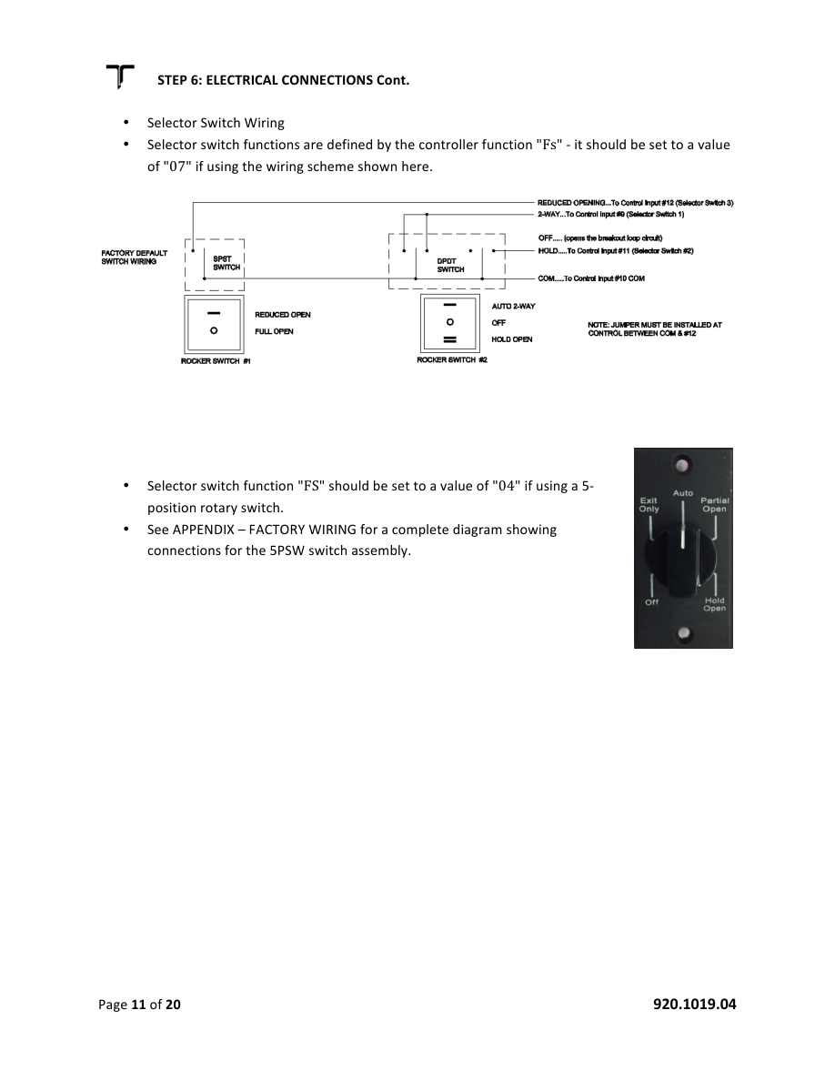
Source figure (Tucker p.11) — selector switch wiring. Replace.

Step 7 — Power on and programming
- Clear the travel path. Apply 120 VAC.
- There may be no LED until you press TEST.
- Press the upper-right TEST button. The door should complete a learn cycle, then be ready for adjustments.
- If it will not learn, enter program mode and scroll to SC (real-time status). See Step 8.
Enter program mode: press and hold both lower buttons until program mode enables. Use UP / DOWN to scroll functions and values. Mode times out to normal in about 3 minutes.
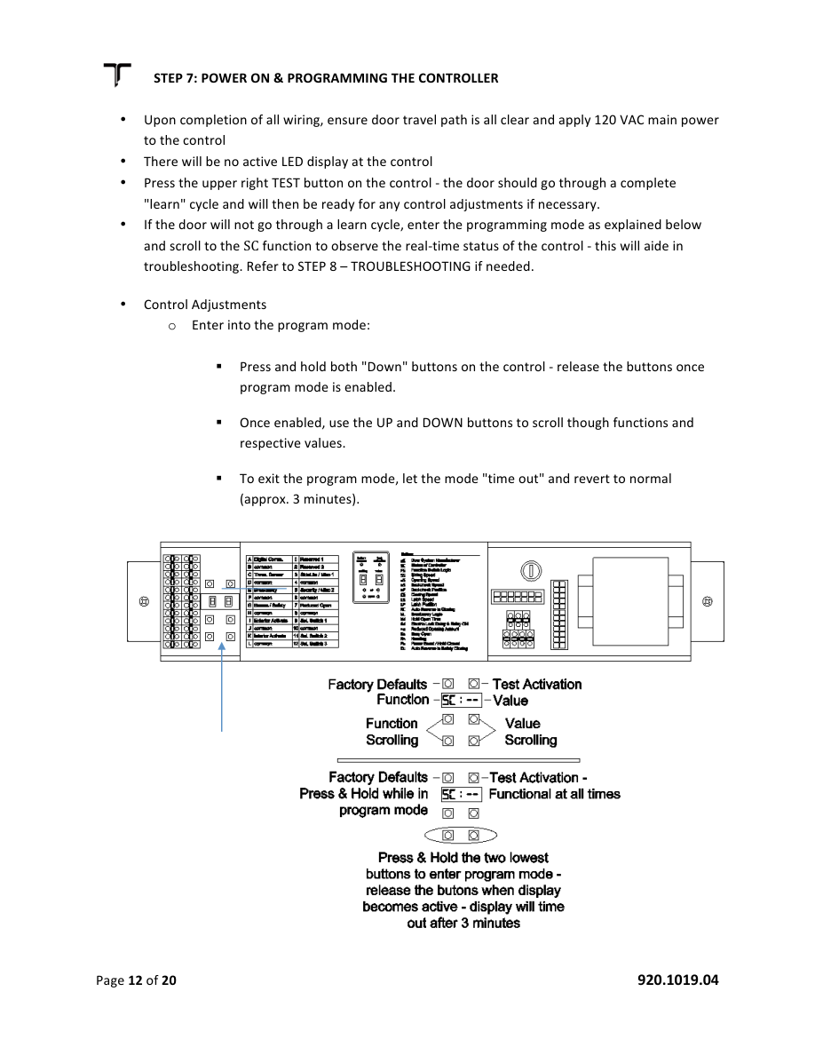
Source figure (Tucker p.12) — keypad / TEST. Replace with your controller photo.
Function table — confirm factory defaults on a Doortronix board before publishing
EDIT — dS = 07 was Entramatic SL10.4L. Confirm Doortronix door-system code. SH “do not use with SL10” — delete if not applicable. FS rocker: your sheets say 03, not 07.
Code | Function | Range | Typical | Notes
dS | Door system | 01–09 | EDIT | Was 07 for SL10.4L.
FS | Function selector | no–24 | 03 / 04 | 03 rocker, 04 five-position rotary. Reset after defaults.
SH | Sensor harness | Y–n | n | EDIT — Tucker said do not use on SL10.
SS | Sizing speed | 01–05 | 08* | Speed during sizing / after obstruction. *confirm range.
oS | Opening speed | 01–10 | 06
bS | Backcheck speed | 01–05 | 04
bP | Backcheck position | 01–06 | 03
CS | Closing speed | 01–10 | 05 | Never exceed 1 ft/s.
LS | Latch speed | 01–05 | 04
LP | Latch position | 01–06 | 02 | Latch check at least 2".
AC | Auto closing reverse | 05–99 | 50 | Closing force never exceed 30 lbf.
bL | Breakaway logic | nC–no | nC | Matches Doortronix wiring notes.
Hd | Hold-open delay | 01–30 | 00 | Set per ANSI A156.10.
Ed | Electric lock delay | Y–n | n | Enables lock relay.
ro | Reduced opening | 50–80 | 70 | Percent of opening.
Eo | Easy open | Y–n | y | Manual push → slow open.
Hn | Handing | lh–rh | rh | Motor rotation.
SC | Status | — | — | Live status in program mode.
PB | Power boost | no–3 | 01 | Hold-close force. Doortronix sheets: 01–04.
PF | Position feedback | — | En | Do not change (encoder).
CT | Check torque | 05–99 | 80 | Latch-check reverse sensitivity.
OT | Opening torque | 05–99 | 90
MP | Motor power | Lo–Hi | hi | Do not change.

After any adjustment, field-test to ANSI.
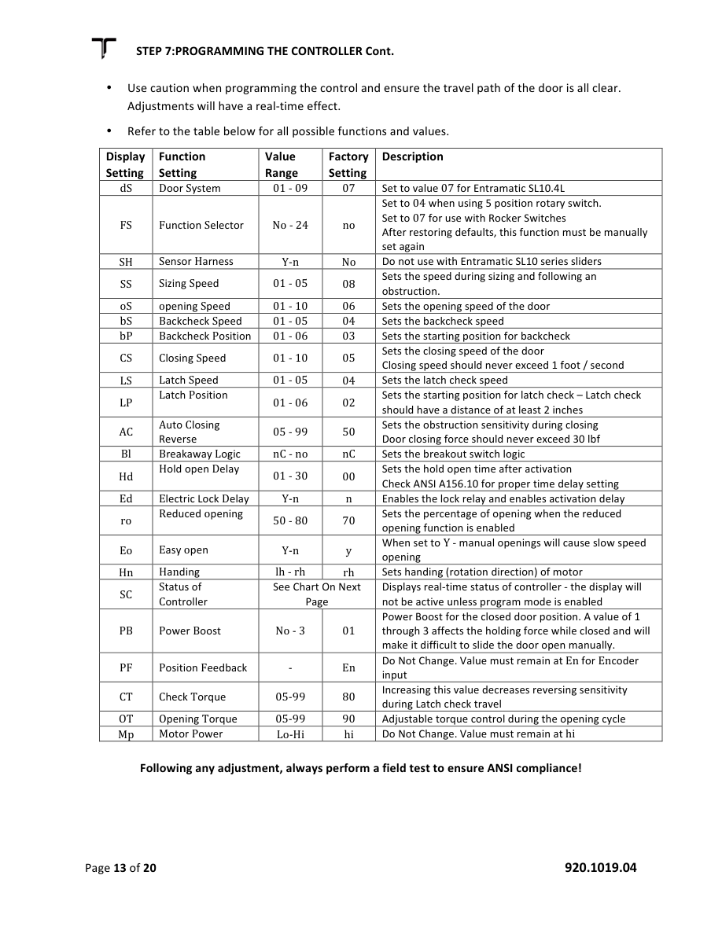
Source figure (Tucker p.13) — function table. Replace if your sticker differs.

Step 8 — Troubleshooting
- Enter program mode. Read SC. Use that code to decide the next check.
- Example: SC = bA means breakaway is active — a panel is broken out or the E circuit is open.
SC | Meaning
id / 1d | One-way / 1-directional. Switch in 1-way, door closed.
2d | Two-way. Switch in 2-way, door closed.
bA | Breakaway active — panel out or input E open.
EA | Exterior activate — input I.
Eo | Easy open (push).
Fc | Fully closed (if no selector).
Fo | Fully open.
Ho | Hold open.
IA | Interior activate — input K.
LC | Learn closing.
Ld | Locked door, or motor/encoder fault.
Ln | Length (inches) after sizing.
Lo | Learn opening.
LS | Learn stall — obstruction during sizing.
oF | Selector OFF.
oP | Opening during closing.
o5 | Opening speed mode.
Po | Partially open.
ro | Reduced opening.
SA | Safety beams.
SC | Slow closing.
SE | Security entry.
St | Stalled.
tA | Test activate.
tS | Threshold sensor.
US | Undersized.

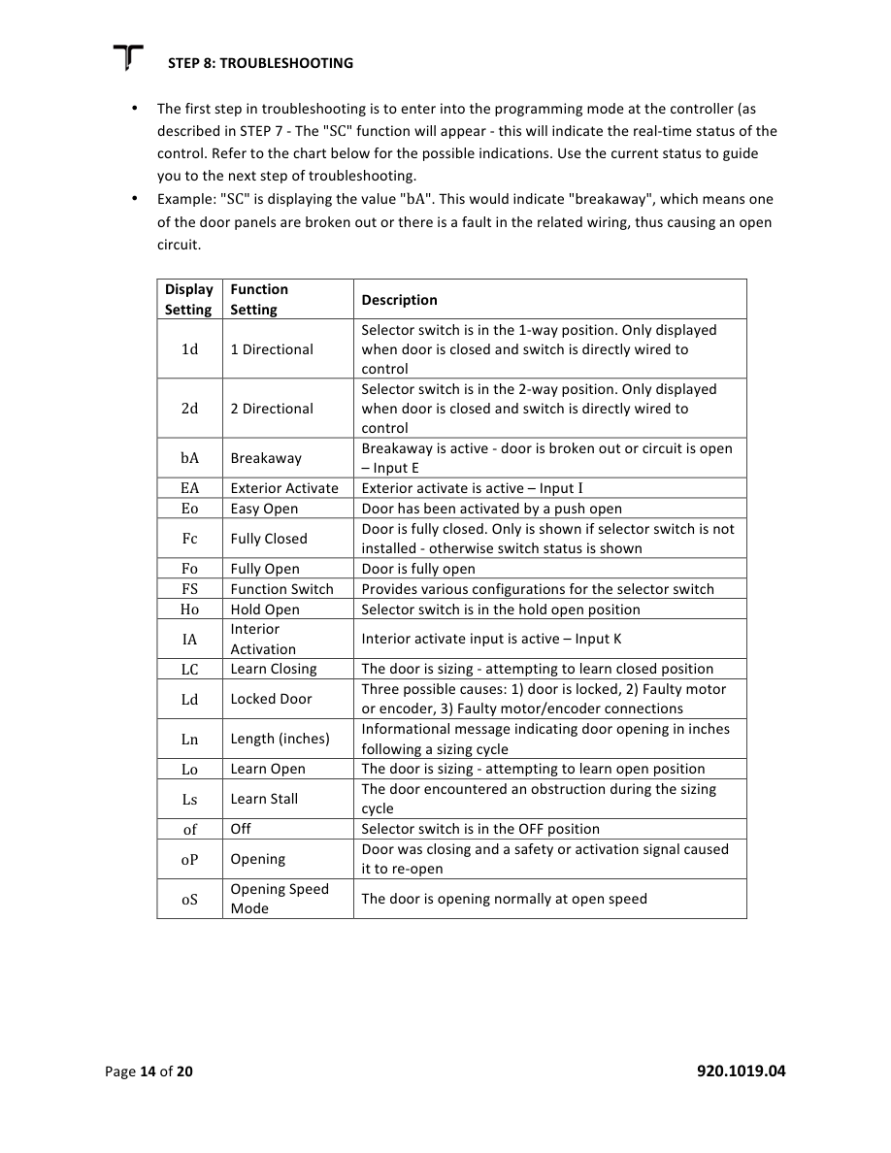
Source figure (Tucker p.14) — SC chart. Replace with your diagnostic list if needed.
Common field problems
- 5-position rotary does not work: FS must be 04. See motor lock appendix if used.
- Electric motor lock dead: Ed = Y; T/U/V change state; 24 VDC lock supply present.
- Won’t close fully after learn: no obstruction; increase LS slightly; reduce LP slightly; MP = Hi; interlocks aligned.
- Won’t open fully: no obstruction; switch not in partial open; increase bS slightly; reduce bP slightly.
- Erratic / won’t learn stroke: encoder connection and snap-fit at back of motor.
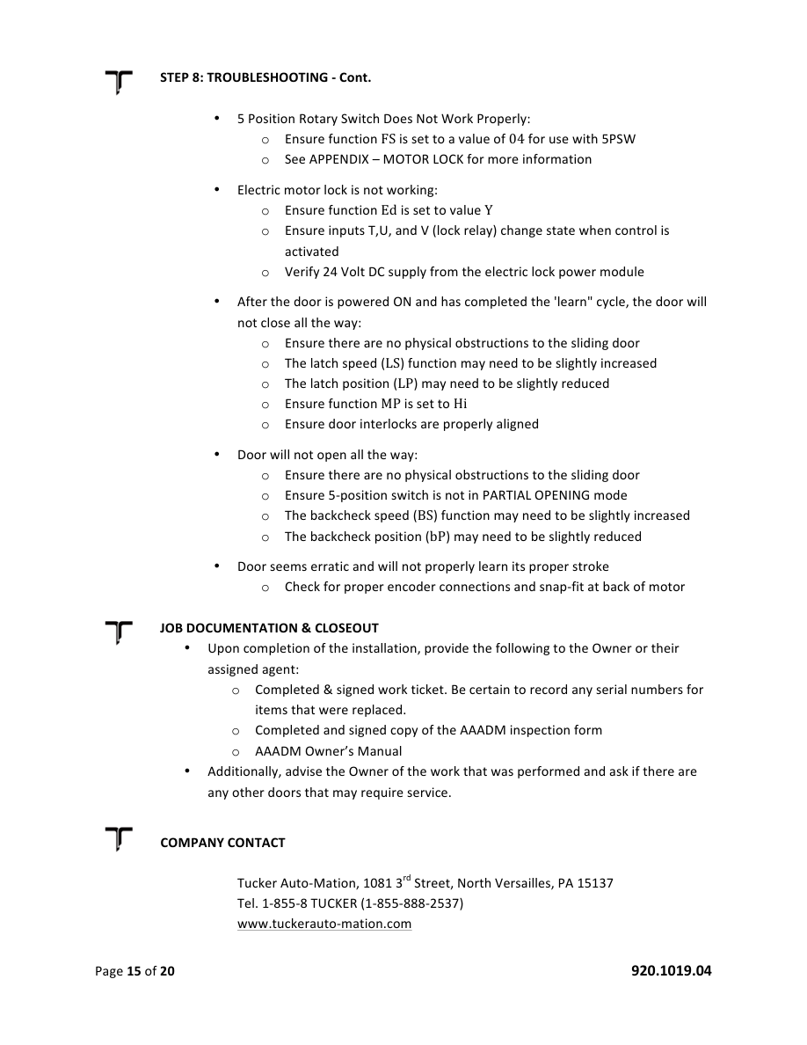
Source figure (Tucker p.15) — troubleshooting. Replace if your lock/encoder differs.

Job documentation and closeout
Leave with the owner or their agent:
- Completed, signed work ticket (record serial numbers of anything replaced).
- Completed, signed AAADM inspection form.
- AAADM owner’s manual.
Advise the owner of the work performed and of the daily safety check.

Appendix A — Motor / electric lock
- 24 VDC magnetic assembly. When engaged, motor cannot turn (door will not slide).
- Not field-repairable — replace as an assembly.
- Fail-safe only: power loss unlocks.
- Set Ed = Y.
With 5-position rotary: OFF and Exit Only — locked when closed. Auto / Partial / Hold Open — unlocked. To have UNLOCKED in OFF, add a maintained key switch that interrupts the breakaway circuit.
EDIT — Only keep this appendix if Doortronix sells this lock. Replace the lock / 24 VDC supply photo.
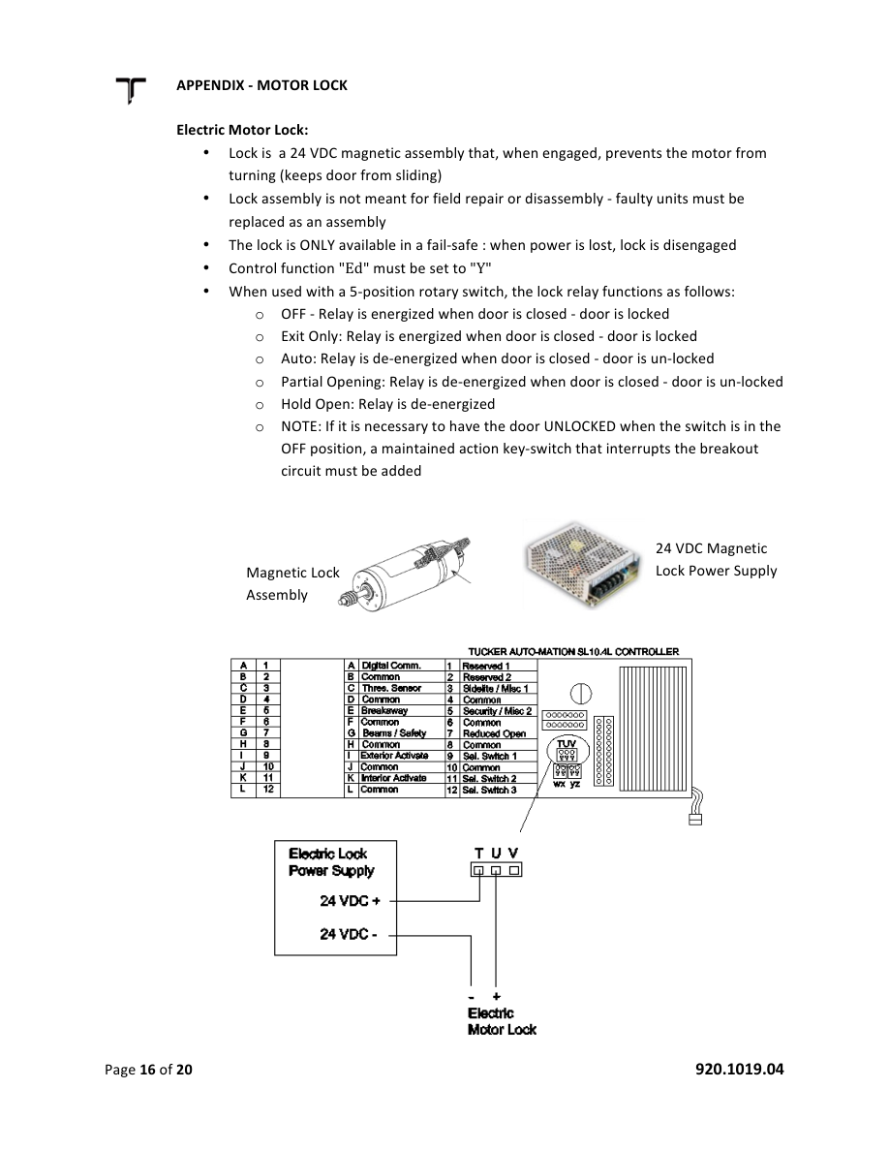
Source figure (Tucker p.16) — magnetic lock assembly. Replace.

Appendix B — Decal and label placement
- A — CAUTION AUTOMATIC DOOR: yellow/black, visible both sides, 55" ± 5" AFF.
- B — STAND CLEAR: yellow/black, visible on the sliding-door side of the sidelite. Exact location not specified by ANSI.
- C — THIS DOOR TO REMAIN UNLOCKED WHEN BUILDING IS OCCUPIED: black/white, visible each lockable side.
- D — IN EMERGENCY PUSH TO OPEN: red/white, visible from the side opposite breakout.
- E — AAADM DAILY SAFETY CHECK: white/black, typically on the jamb near the selector switch.
- Apply all signage at job completion. If glass is not in yet, tell the owner signage must go on after glazing.
- If the owner refuses signage, explain ANSI. If they still refuse, note it on the work order.
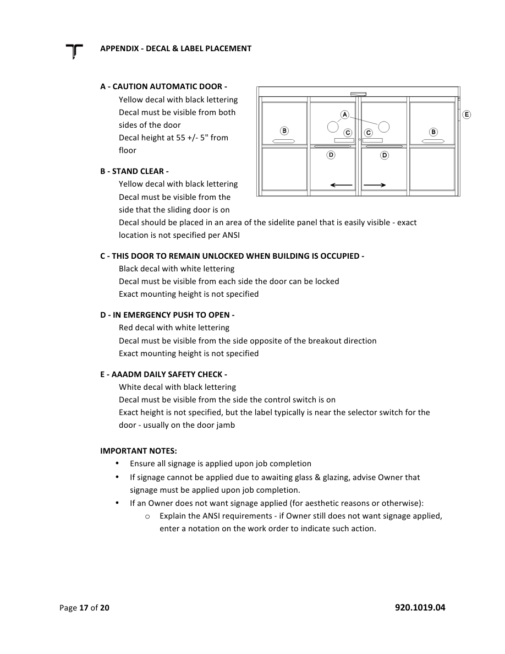
Source figure (Tucker p.17) — decal layout. Replace with Doortronix elevation.

Appendix C — Factory / field wiring
Use the Doortronix FBO or FSL wiring diagram for the configuration on this job. Do not mix the two.
- FBO: docs/DOORTRONIX SLIDE WIRING DIAGRAM_(FBO).pdf
- FSL: docs/DOORTRONIX SLIDE WIRING DIAGRAM_(FSL).pdf
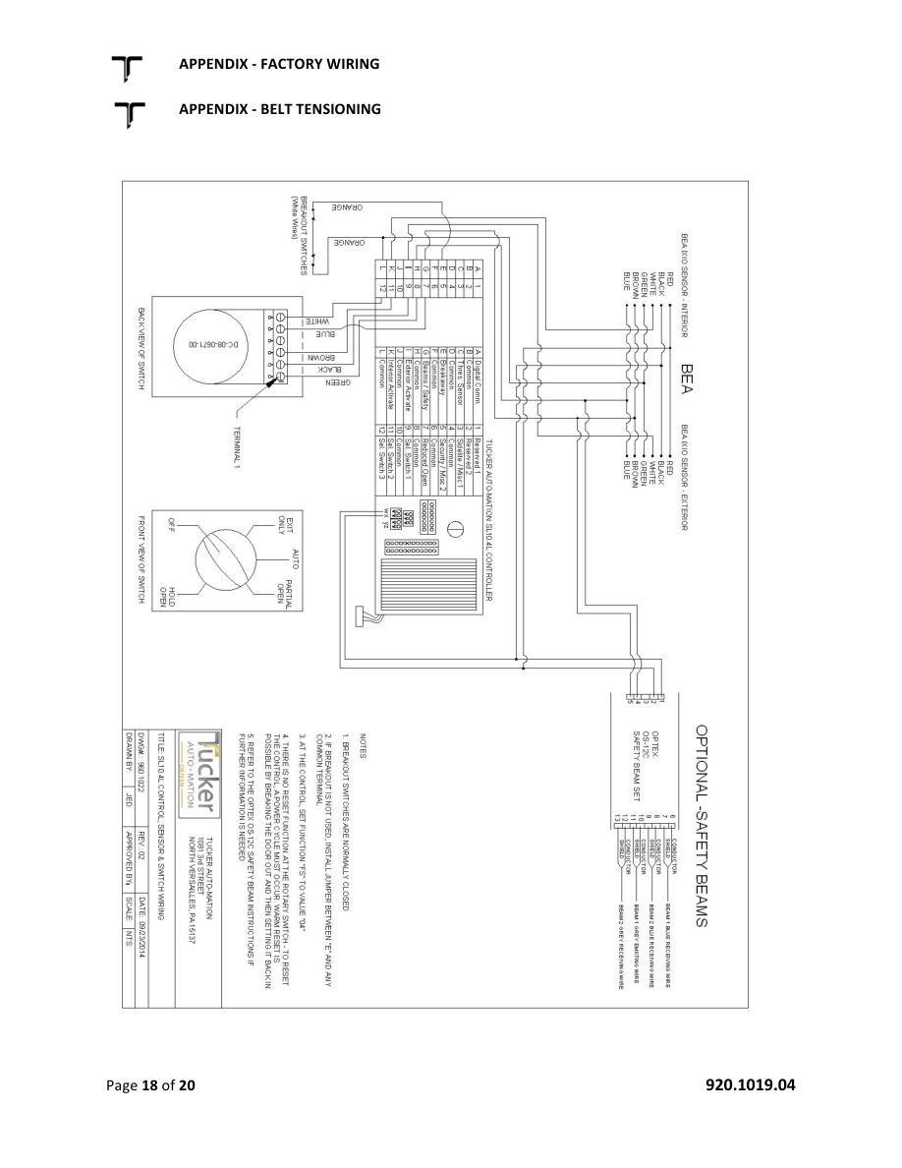
Source figure (Tucker p.18) — factory wiring / belt page. Replace with your wiring sheet.

Appendix D — Belt tensioning
When properly adjusted you should be able to squeeze the top and bottom run of the belt together so they touch.
- To tighten: loosen the pulley nut.
- Rotate the tensioner nut clockwise to draw the pulley back.
- Retighten the pulley nut.
EDIT — Confirm Doortronix uses this tensioner. If your drive is different, rewrite this page and swap the photo.
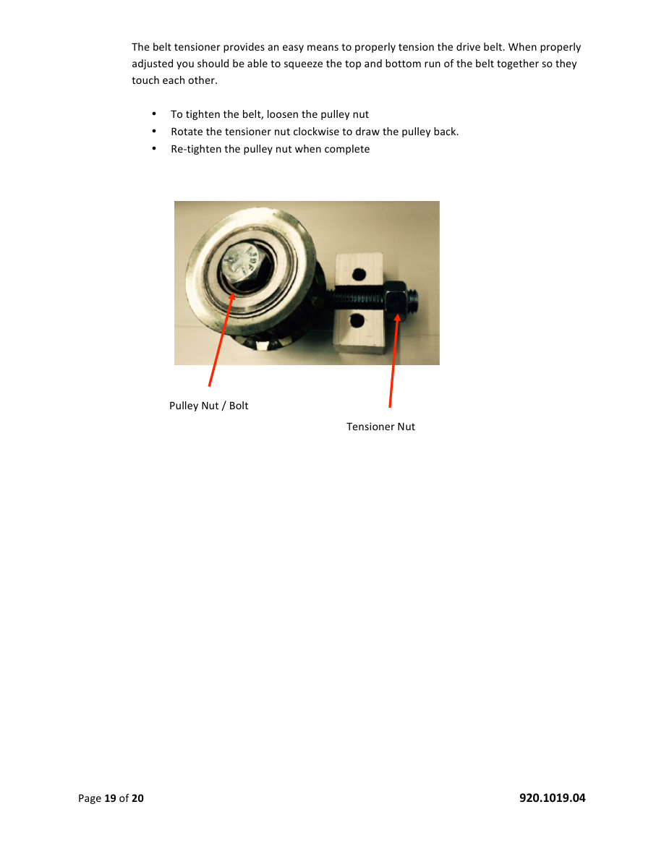
Source figure (Tucker p.19) — pulley nut / tensioner nut. Replace.

Appendix E — Telescopic packages
EDIT — Delete this entire appendix if Doortronix does not sell telescopic. Tucker notes: two drive belts, 2:1 dual-output gearbox; FBO telescopic panels must fully interlock.
- Step 1 — Install sidelite SO.
- Step 2 — Install SX2 and adjust to fully interlock in the SO panel.
- Step 3 — Install SX1 and adjust to fully close against jamb or opposing bi-part panel.
- Insert the breakout bar into the top carrier and shift it so panels fully interlock when closed.
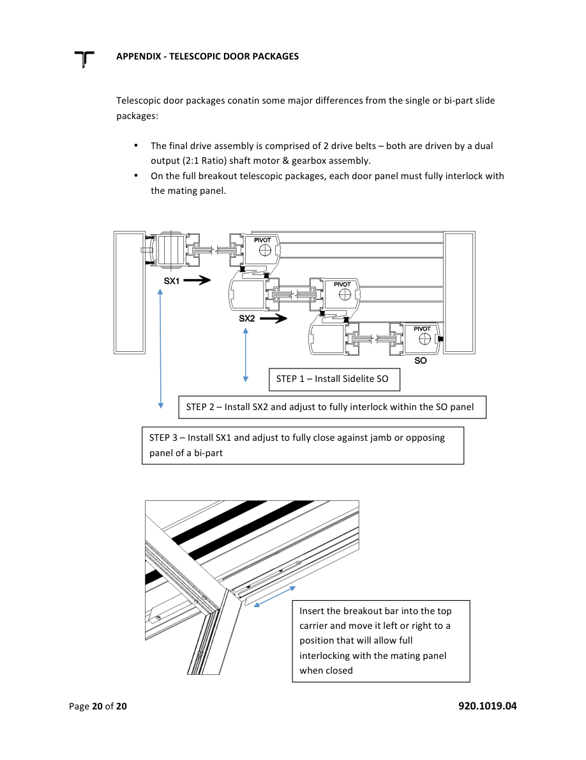
Source figure (Tucker p.20) — telescopic sequence. Replace or delete.

Company contact
Doortronix USA
5783 County Road 1219, Malakoff, TX 75148
Phone (888) 453-5196
www.doortronixusa.com · info@doortronixusa.com

