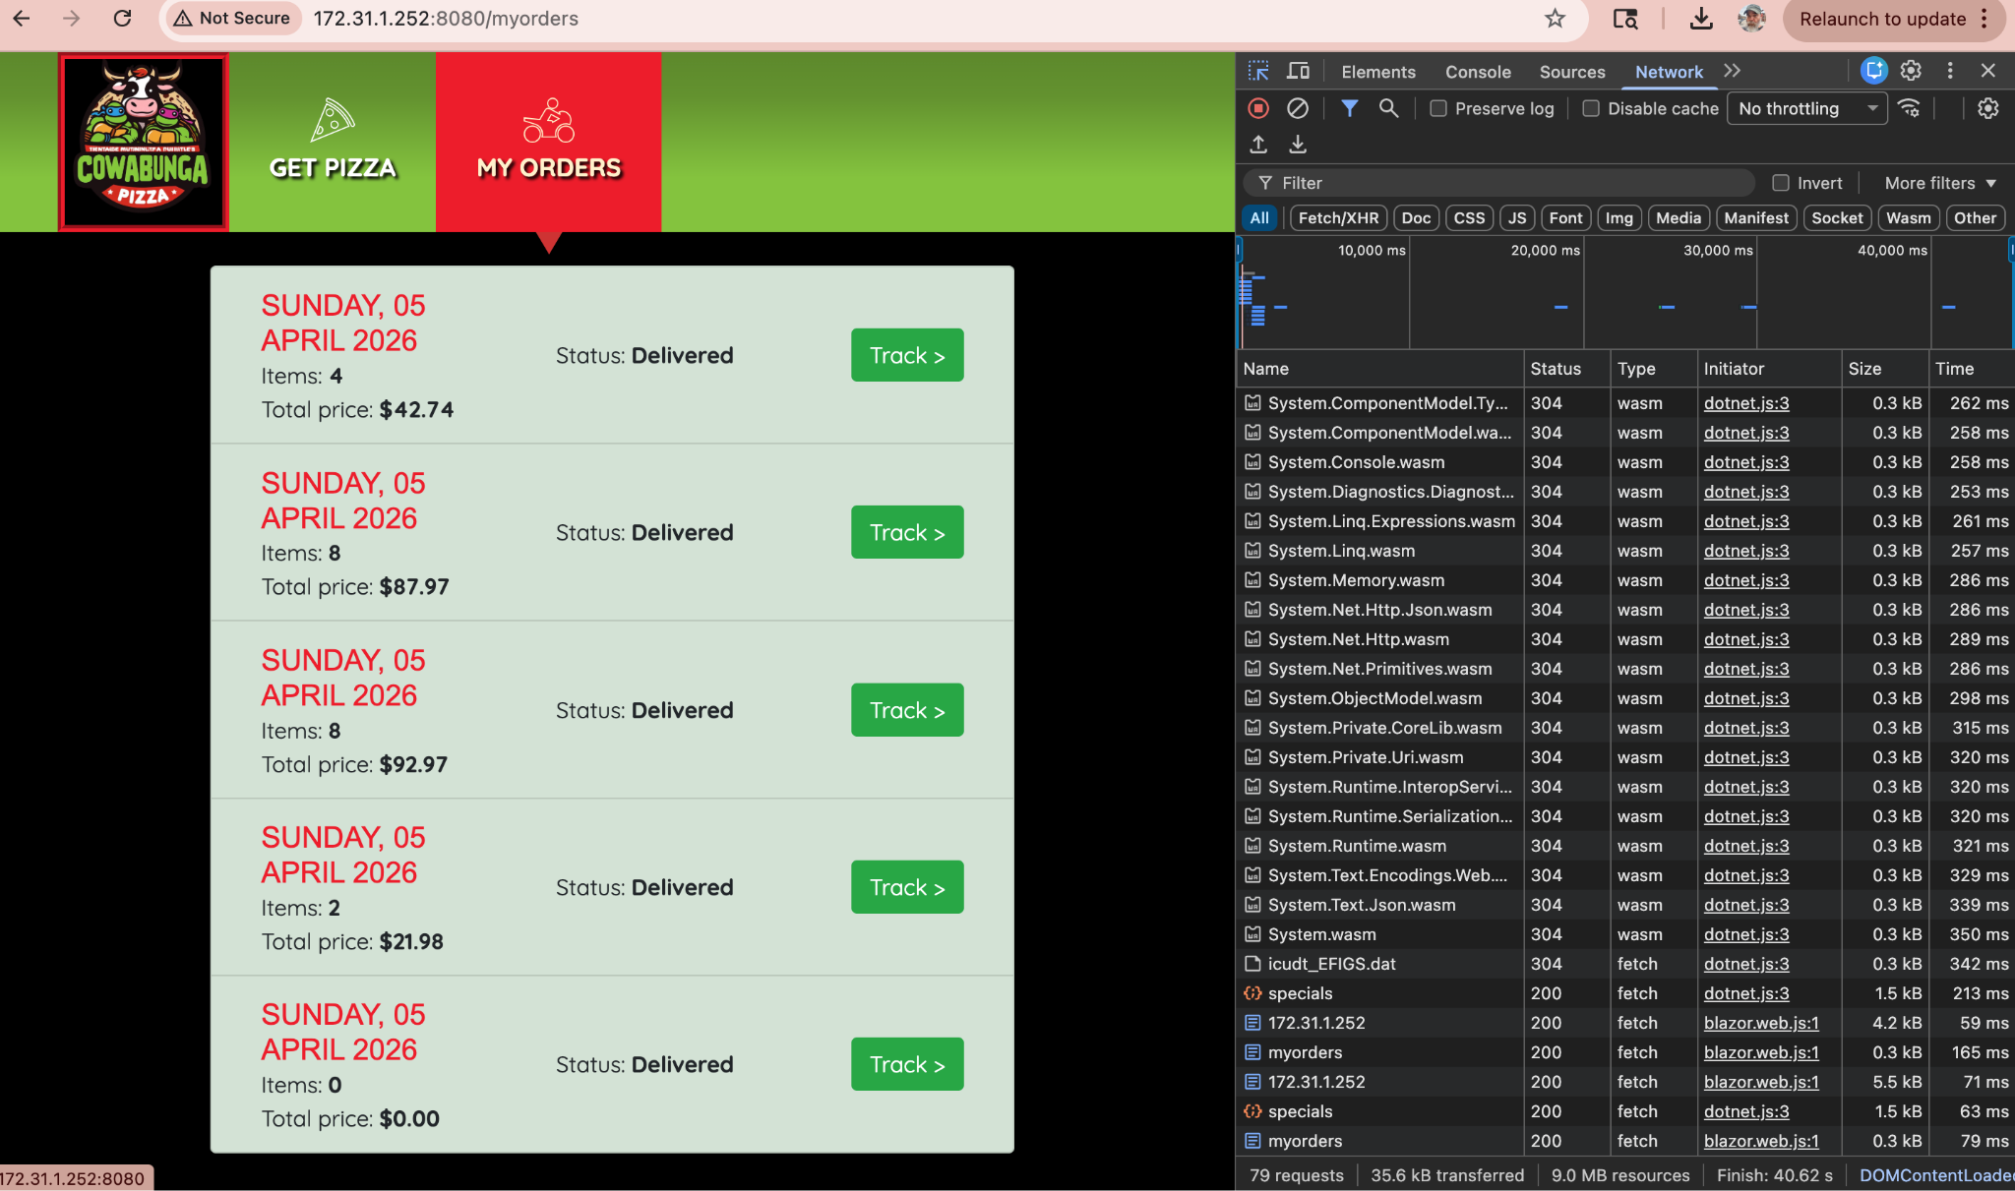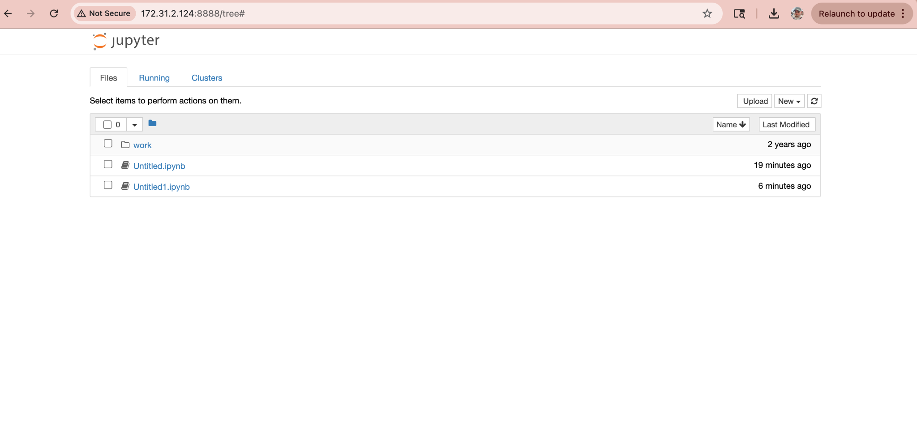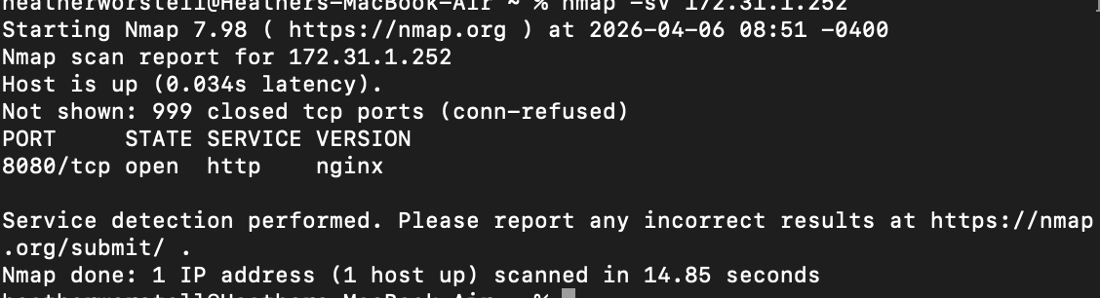
Port 8080 open
Service detected

accessed the endpoint
It returned data
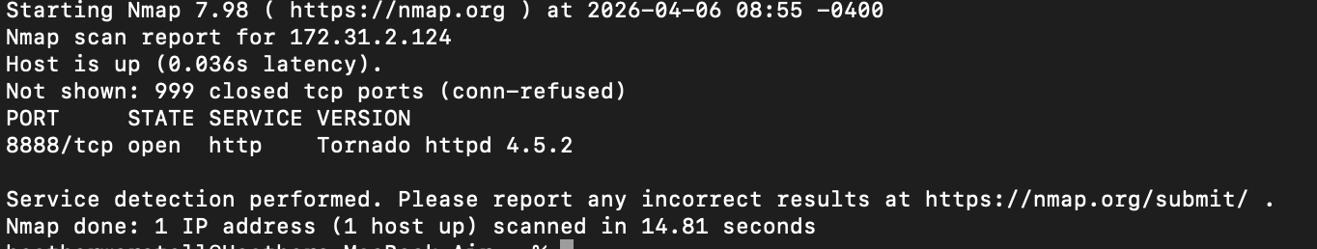
- Port 8888 open
- Jupyter service
After connecting to the VPN, I knew I needed to:
- Find active machines on the network
- See what services were running
- Identify anything vulnerable
I had already discovered one system (172.31.1.252), so I continued checking other IP addresses in the same network range (172.31.x.x).
Running nmap -sV 172.31.2.124
helped me:
- Discover a new system
- Identify a vulnerable service
- Move to the exploitation phase
