The URL of our site would be https://hallamDomain/~followedByUsername/Shay/web-src/earth.html
Iso Safi, Shayam Suhansa, Lavyansh Rathod
Usage:
The project can also be pulled from github(which I will keep up for a few weeks before privating it) at : https://github.com/steeno17/celestial
simply pull the project and local host it with either a python or npx http-server (navigate first to Shay/web-src/earth.html)

Iso Safi:
My main contribution is the detailed Stars and constellations, Earth and Moon pages, which all involve some form of rendering, using both D3-celestial and globegl. Multiple interactive components, and a number of external links. I vendored every library that I used, and all assets, so nothing is being fetched over the internet (so that I had no dependencies).
A much more extensive documentation that I used for my own benefit throughout the project can be found in the celestial-main/web-src/nts directory.

Shayam Suhansa:
Full author of the landing page, and responsible for the hyperlinks, connecting everyone's pages together. And responsible for constructing the project directory.
Some of the libraries that I used are: three.js, Bootstrap and the Google font API
A very detailed documentation is in my directory, /Shay/web-src/Webpage Documentation.docx

Lavyansh Rathod:
Full author of the Gustav Holst page, site has a button back to the landing page, and also an option to play background music, also wikipedia links to Gustav Holst, and multiple audio buttons to play songs at the bottom of the page.

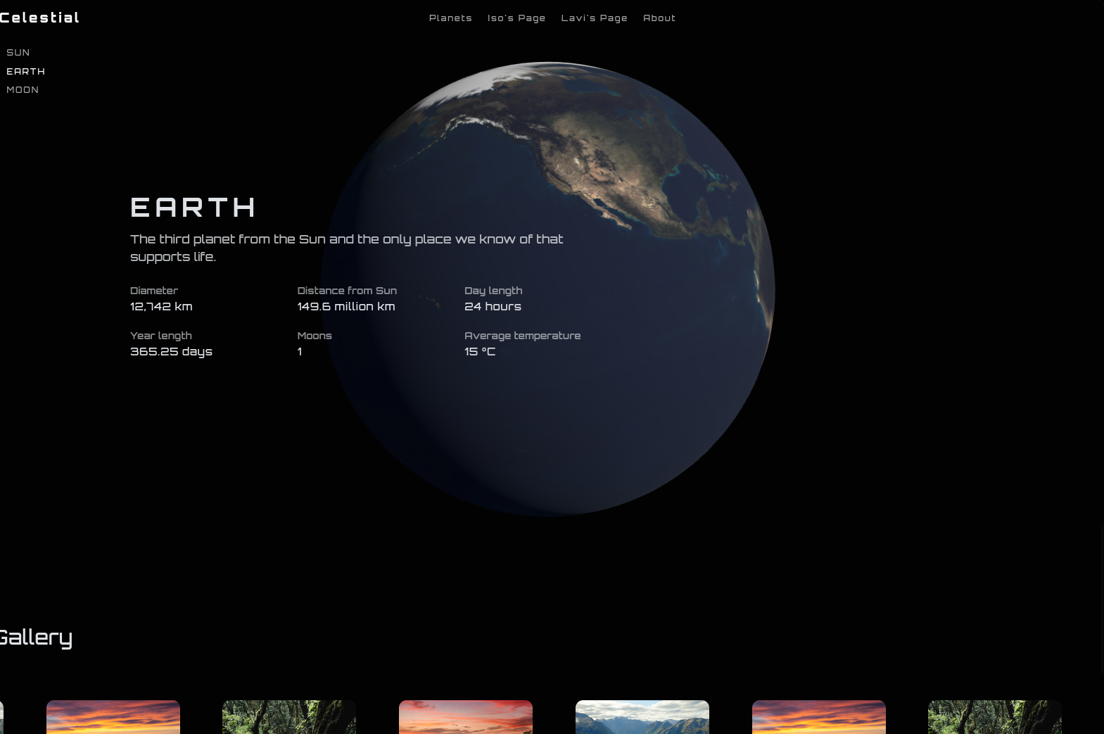
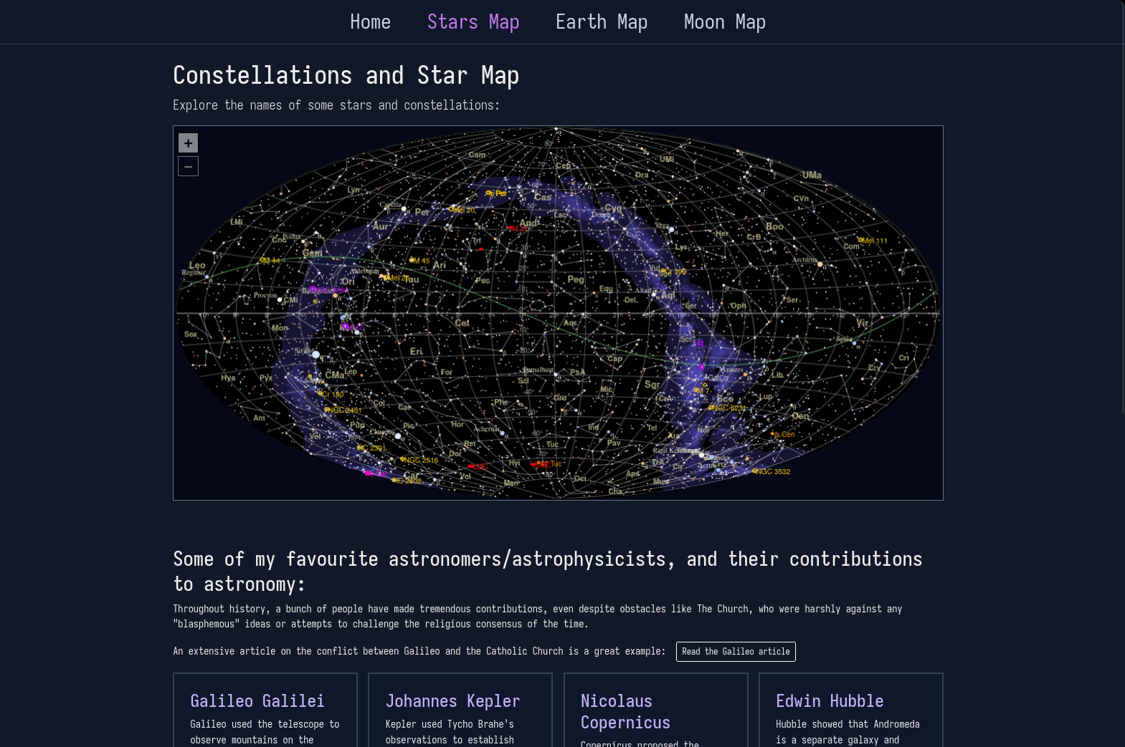

AI transparency statements per group member:

Iso Safi:
LLMs were used for fetching descriptions of the astronomers on my stars page, and to also find information about exoplanets, like the Keplers, which are part of the Earth page.

Shayam:
AI was used for research and for facts, the rest of the codebase has been followed by YouTube tutorials mostly.
Lavyansh:
I used AI for finding information about Gustav Holst and also for debugging

