**Data structure of MoTrPAC RNAseq data for Phase-1 PASS (1360 RNASeq measurements)**

The following is based on "20200309_rnaseq-meta-pass1a-stanford-sinai_steep.txt" sent by Alec on April 20.

This file contains meta data for 1360 RNAseq experiments from two Sites and five Batches.

**1. Samples and "Sample_category": ref vs study.**

The first important divide in the data are "sample_Category". The entire set of 1360 experiments include (1) 34 RNAseq experiments on 22 unique reference samples, and (2) 1,326 RNAseq experiments on 1326 unique study samples. (In discussion we often use "samples" to refer to RNAseq experiments. This is okay for study samples but not reference sample, because some were measured 2+ times.)

The 34 ref samples cover 10 tissue types (one of them is called "Paxgene"). They are not from the rats collected in the study. Their distribution by Tissue and Batch are



(Color codes explained later)

The 1326 study samples cover 16 tissue types in 78 animals.



**2. Animal groups**

The BID provided 78 unique IDs for animals, each producing 16 tissue samples (15 plus either testis or ovary). Most were measured once, except Gastro and Lung were measured in both MSSM and Stanford, and Ovaries and Testes were measured only in female and male animals.



**3. Timing of the nine experiential groups.**

Each group of 10 or 6 animals were processed in two subgroups, for the two sexes separately. This led to the bimodal pattern of the sample collection time. I calculated the average of the two modes as the collection time (for both the time of exercise and the time of tissue collection).

The nine groups did not have an orderly distribution along the actual time (the human time of the day, aka Zeitgeber time, ZT):

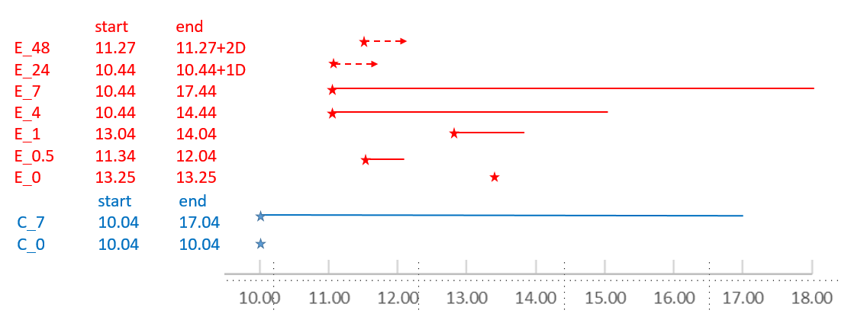

Each star indicates the averaged Time of Exercise (or the imagined exercise for the control group). The end of the line is the Time of Collection. Importantly, because of their stagger exercise time, the nine groups do not have exercise taking place at the same time in ZT. If we take 10:44 am as the "typical" exercise ZT, the two control groups had exercised at one hour before: -1 on ZT, while the E_0 and E_4 had exercised two hours later: +2 on ZT.

We recommend that we always speak clearly of the **different time frames**:

i. The real time (e.g., 10 am), and its shifted circadian time ZT (usually 9 am is ZT=0, sunrise for humans, lights-out for nocturnal animal)

ii. IPE (interval post exercise), which is the difference between Exercise Time and Collection Time. As there was a 3+ hour difference among the nine groups' Exercise Time, they experience different circadian effects (if any). Further, E-24 and E-48 have similar circadian phase as other groups but much longer IPE.

iii. Interval after feeding and Feeding Time. Due to the mid-day feeding, the seven groups have a set of IPFs (F for Feeding) that are different from IPEs.

**4. RNAseq QC measures compared across Batch and Tissue.**

To continue