PASS1A Analysis Plan Jun Li, 9/29/2021

This document attempts to lay out the first draft of a PASS1A data analysis plan. For clarity, we separately discuss Data Coordination (Section 1, Data Inventory and 2, Data Cleaning) and Data Analysis (Temporal Modeling in 3). For considerations to incorporate PASS1C data when relevant, see 3D.

The document has not included downstream tasks such as building biological interpretation ("story-telling") based on data analysis output from 3.

1. Data Inventory

1A. At the highest level, the Inventory is a tabular manifest of all the datasets, arranged as a grid of Tissues by Data Types.

Some omics data types, such as the metabolomics data, are further divided by Targeted and Untargeted, with the latter divided into Named and Unnamed. Figure 1 shows an example of PASS1A metabolomic data, with 205 datasets.
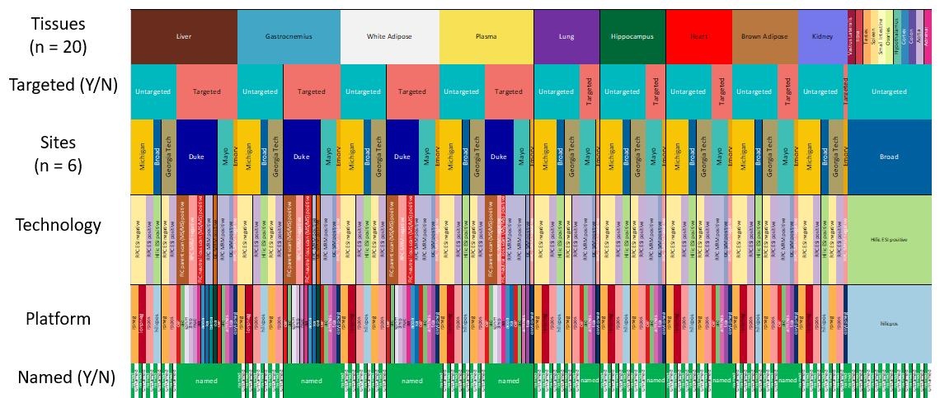
Figure 1. PASS1A metabolomic data Inventory. The 2nd and the last row indicate (Un)Targeted and (Un)Named.

Datasets of the same data type and from all tissues of the same animals constitute a Data Group. Figure 2 shows an example of two Data Groups for PASS1B Targeted metabolomic data, with 5 and 4 datasets, respectively.
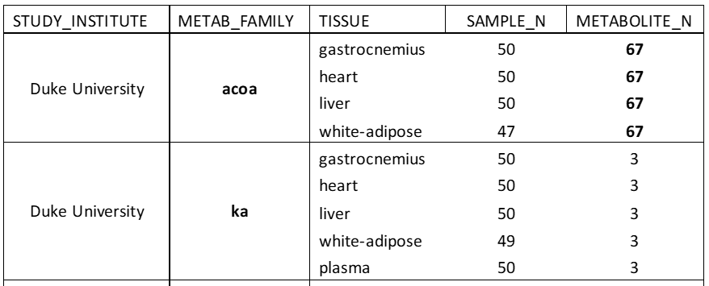
Figure 2.

1B. Each dataset is a sample-feature data matrix, with P features and N test samples (sometimes including a series of Reference samples). The test samples are Bioanalytes, each linked to its Sample Metadata, such as experimental batch and RNA quality measures.

1C. Animal metadata - not to be confused with the sample metadata - include sex, age, and exercise group of the animals (such as IPE, IPE-1h, etc.). Multiple tissues are collected from each animal, thus each animal maps to many tissue samples. In a structured database schema, sample and animal metadata would be separated.

1D. The importance of having a reliable and complete data inventory is to ensure that discussions about data cleaning, data analysis (methods, results, and interpretations) can be made specifically for the tissue and the data type. A generic discussion without specifying tissue and datatype may lead to confusion.

2. Data Cleaning

2A. Quality assessment starts with initial tasks to identify potential outliers and experimental batches and, if found, make decisions about how to address them. These procedures may be intertwined with normalization approaches.

2B. Data cleaning decisions must be made for each tissue and each data type separately. We will strive to keep full documentation, using accurate terminology and clear diagrams.

2C. Biologically assigned groups (such as T = 1hr after exercise) and technical batches may confound each other. Some datasets were collected by randomizing samples from different biological groups across experimental batches (or by Run Order). For other datasets, the confounding is embedded by the lack of randomization; there is a greater risk of over- or under-correction of the batch effects.

2D. Whether the outliers or batch effects are "big" or "small" cannot be spoken without context. It depends on the empirically observed magnitude of these effects in comparison to the biological effects of interest and, crucially, for that tissue and for that data type. In this regard the data cleaning decisions can be indirectly related to the downstream data analysis tasks (3. Temporal modeling). For instance, among several normalization methods, one method may bring a larger number of significant male-female differentially expressed genes. And this can become one of the reasons for choosing this method (for the tissue and for the data type as warranted).
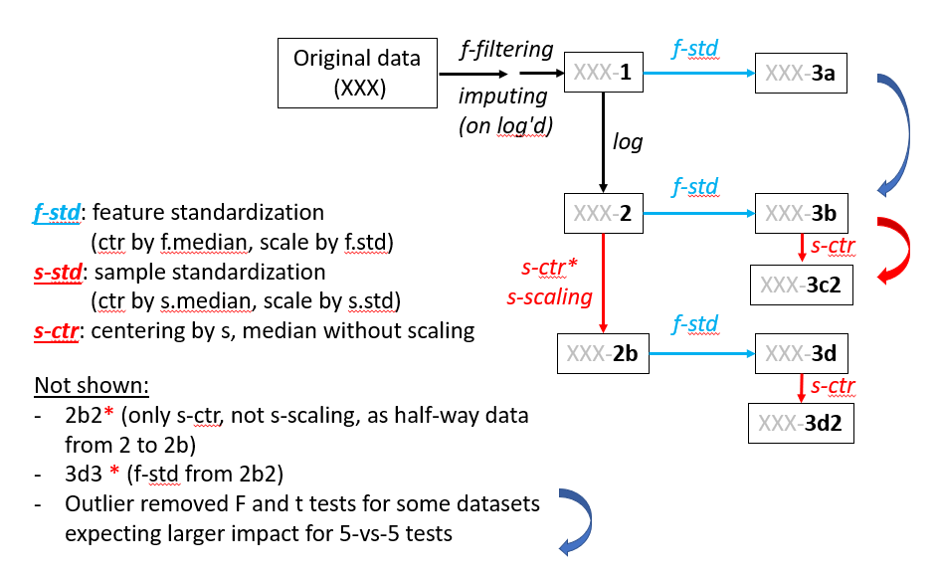
Figure 3. Data cleaning workflow used for PASS1B Untargeted Named metabolomic data.

In general, we want to reduce the reliance on using the number of significant genes in a prescribed DE comparison to inform data cleaning decisions. The metric - the number of significant genes - depends on the statistical cutoff, and is tied to that specific contrast. For task-agnostic evaluation of data cleaning methods, we adopt measures of reproducibility by (1) comparing repeated experiments on the same samples (when available, as is the case for metabolomic data) and (2) reporting within-group and between-group variance, without relying on a specific two-group comparison.

2E. MoTrPAC has gained recent experience for cleaning metabolomic datasets by working through PASS1B (an example of the workflow is in Figure 3). The order of running outlier/batch identification, normalization, and imputation is one of the difficulties we have wrestled with. We also developed a two-tiered outlier designation, with some samples marked as Removed and others as Flagged.

The features driving the outlier samples or experimental batches remain to be studied, to understand if they reflect shared chemical properties or shred biological function. Shared chemical properties would suggest that these samples may have been handled together in the laboratory as a batch, at a certain step along the chain of experimental steps, not necessarily corresponding to the steps we have information for. Conversely, shared biological function would suggest that the animals have been treated differently, such as been exercised to a greater level of intensity, and this led to the concerted changes of molecules in the same biological pathway.

For transcriptomic and proteomic data we need to set up their own procedures, beginning with a written plan.

During data cleaning for each dataset, there are opportunities to compare across tissues and across sites/platforms. The strategies vary by dataset, and depend on the measurement technology and the use of different kinds of reference samples.

2F. Sample-QC and Feature QC are-related processes, and may need to be done iteratively until the results converge. Two examples are:
- Removing outlier samples may alter the definition of outlier features, and vice versa.
- Batch effects in samples are usually driven by a set of batch-driving features, and vice versa.

2G. Features will be evaluated and filtered by the joint use of several attributes. (1) mean and variance - whether it has sufficient information to inform either technical or biological effects; (2) cohesion within biological groups - often measured by comparing between-group and within-group variance; (3) for temporal data, a measure of 'smoothness' - whether adjacent time points are more similar than distant timepoints. Sometimes a high-variance feature will show a lack of smoothness. This property is affected by the fact that we have a pseudo-time-series, not a true longitudinal series (see 3A1 below).

2H. Missing value distribution and imputation strategies need a separate set of analysis plans.

3. Data analysis: temporal modeling (i.e., finding features that respond to acute exercise)

The main goal of this step is to identify features that exhibit a response after acute exercise. The analysis plan will be based on the sampling pattern already implemented in PASS1A and PASS1C. Adoption of published tools and lessons from literature needs to be aware of the unique challenges in our sampling scheme.

3A. Challenges brought by the PASS1A sampling scheme.

3A1. MoTrPAC's PASS1A/1C data are not true longitudinal data, which would entail measuring the same animals repeatedly during an extended period. While some physiological data (such as body weight) were collected longitudinally, almost all the molecular profiles were from different animals, each presenting one time point. That is, across K time points, the K exercise groups consist of different animals.

As such, we have a pseudo-time-series, formed by independently sampled data. The notion of autoregressivity across time points is much weakened. However, a notion of smoothness of data trajectories can still be developed, assuming that the animals are indeed similar enough to be biological replicates of each other. In other words, if the assumption of replaceability among animals holds, the group means across time can be treated as a longitudinal series.

3A2. Due to practical constraints, the sampling points are not evenly spaced. We covered IPE (aka E0, for 0h after exercise) and 0.5h, 1h, 4h, 7h, 24h and 48h after exercise. There are 7 time points. As they are concentrated in the first 4 hrs, PASS1A is designed to discover features that respond quickly: within the first 4-7 hours. To discover features that respond in the 7h-24h window would require a different sampling scheme.

3A3. There are shifts in the real time at which the exercise runs were conducted, as shown in Figure 4. For instance, the E_0 animals were exercised at a later time of day than the E_0.5 animals. Here the left ends of the horizontal lines are the stopping time of exercise (denoted by *), and the right ends are the time of tissue collection.
Figure 4.

The lack of synchrony in real time among the exercise groups becomes a complication when we consider potential contributions of baseline physiological changes due to feeding and circadian rhythms (more below, in 3C).

Note that when we talk about potential contributions of circadian rhythms we refer to the impact at the time of tissue collection (right end of the lines in Figure 4), not the time of exercise (left end). The alternative question, how the hour of exercise could affect the observed responses would require a different study design.

(Details of feeding time and related concerns can be added here)

3A4. Temporal modeling requires a minimal number of effective sampling points for a given functional pattern. For instance, a 3rd order polynomial function, ax³+bx²+cx+d, has 4 parameters. One of them is the baseline: coefficient "d", hence there are 3 degrees of freedom. A 4th order polynomial can model more complex "waveforms", but will cost one more degree of freedom. The advantage of polynomial functions is that they do not prescribe the likely shape of the trajectories. However, a drawback is that later timepoints tend to exert a greater weight if not properly supervised.
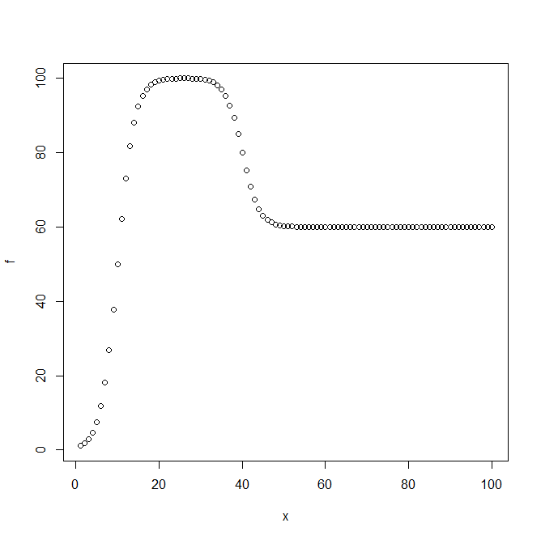
Figure 5.
An "Impulse" function (Figure 5) with a sigmoidal up-phase and sigmoidal down-phase would need 3 parameters for the magnitude (the level before, peak, after), 2 for the time of change (midpoints of up- and down-phase), and 2 for the rate (up-rate and down-rate), for a total of 7 parameters, even without modeling the curvature of the sigmoidal functions.

Circadian pattern can be modeled, in its simplest form, as a sinusoidal curve with an assumed 24h period, with 3 parameters: baseline, magnitude, and phase. An equivalent function is: a + b*sin(x') + c*cos(x'), where x' is 2*pi*T/24, T is the real time of tissue collection in the day, not the interval after exercise, x, used in the polynomial or Impulse function described above.

PASS1A has 7 sampling points for modeling the response function, with the challenge that they are concentrated in the first 4 hours. For the Impulse function, the model is identifiable if we have at least 3 points describing the up-phase and at least 3 points describing the down-phase. Since we only have 7 points plus a pre-exercise baseline: C0, IPE (E0), E0.5, E1, E4, E7, E24, and E48, features that do not show an up-and-down pattern in the middle of the series will not be adequately modeled (see below, 3B).

For modeling circadian patterns we have 7 exercised groups and 2 control groups (Figure 4). But since 24h and 48h are considered nearly the same as the 0h control point, and due to the uneven distribution, the true effective number of sampling points is much fewer than 7, covering 10 am, 11am-noon, ~1 pm, and 5-6 pm.

To jointly model both the 3rd order polynomial (or Impulse) model and the circadian pattern would incur 6 (or 9) parameters, difficult to do with our 7-point time series.

A key component of the analysis plan is to deploy the right algorithms based on the understanding of the waveforms to be modeled and the inherent limitations of the sampling scheme.

3B. Evaluating robustness of the modeling algorithms

If we deploy two alternative approaches, (1) the polynomial function and (2) the "Impulse model", to estimate the functional parameters, we need to systematically test the algorithms for the robustness of estimation. Broadly speaking, we face two tasks: model selection and parameter estimation; identifiability for the former, uncertainties for the latter.

We need to use simulated, truth-known data to benchmark the computational algorithms. Given a simulated temporal trajectory based on a known function of known parameters, we want to know if the computational modeling can (1) identify the true functional form amidst other, similar forms, and (2) accurately estimate the parameters, which are known only to the creator of the simulations.

The plan is to (1) generate a large family of simulated data to cover the functions and their parameter space, and (2) run the model to obtain the best estimates.

This will start with the easiest case, with low levels of within-group noise (using n=5 per group, to mimic most of our experiments), and denser or evenly spaced sampling points. Gradually, we add difficulty in a controlled way, in at least two directions. The first is to increase the level of within-group noise, measured in relation to the between-group "signal". The second is to reduce the sampling points to mimic our real sampling points, which are sparse and distributed in the front-heavy way.

The performance from the simulated data will inform the expectations when we analyze real data. A given feature in a given real dataset will have a measurable level of difficulty, based on its empirically observed noise level, smoothness, and putative signal levels. We will use the performance of the algorithms in simulated data to learn the expected robustness of the results.

3C. Expected findings from PASS1A, and situations in which PASS1C is helpful.

3C1. For a given dataset (a certain data type for a certain tissue), we may find N features to be responsive to acute exercise. They are characterized by a P value (where the null is No Response), and a series of effect size measures for individual time points. Heuristically, the trajectories of these N features may be loosely grouped by their principal patterns, such as
- fast up and down
- slow up and down
- fast up and stay up
- fast down and up
- fast down and stay down
- ...

Since the sampling points are concentrated in the first 7 hours, here "fast" refers to peaking at 1h or 4h, and returning at 7h; "slow" means peaking at 7h and returning at 24/48 hr. The study design is not equipped to find other types of dynamics, especially not the up-and-down in the 7h-24h window.

3C2. The number of features deemed responsive and their principal curves will vary by tissue and by data type. We will document them separately. This is the first level of results. Note that the computational results are not yet Findings, which require us to state the biological interpretations (as stated in Footnote-1, p.1).

3C3. The feature-level results will be extended to pathway-level results to support the biological interpretation at both levels. A different set of expertise will be needed in the working groups to turn statistical results into themes and talking points. In this perspective, the collected statistical summaries from 3C1-2 are not the results per se; they are stepping-stones towards stating what we have found, and what findings are new.

3C4. The feature-level and pathway-level results will be compared (1) across tissues for a given 'ome, (2) across 'omes for a given tissue, (3) across both 'omes and tissues, with plans to uncover "slanted" interactions: correlations across tissues, with possibly a temporal lag, and across to a different 'ome. These higher level analyses do not replace the analysis of individual datasets (described in 3C1-3), but will build on them. There are many "slices" along the different axes of data and results, and require consortium-wide coordination. Such coordination entails both bottom-up self-volunteered groups and top-down prescriptions that provide both organizational and statistical oversight.

It would be a mistake to aim for the most ambitious integration across tissues and omes without building a foundation of solid results for individual omes and tissues. Other axes of biological variation include sex and age. A basic principle is: run merged analysis only after we have run stratified analyses AND found homogeneous results across strata.

3D. Limitations of PASS1A and potential benefits from PASS1C data.

A major concern for PASS1A was whether some of the findings could be driven by the dynamic patterns due to feeding, light cycle, and circadian rhythms. The most direct way to address the concern is to run a series of no-exercise animals in parallel, with group-wise matching to the 7 exercised groups. Such a dataset will establish the naturally occurring baseline pattern for the animals. However, in PASS1A we only have C0 and C7 for the no-exercise controls. The next question is: how much should we be concerned?
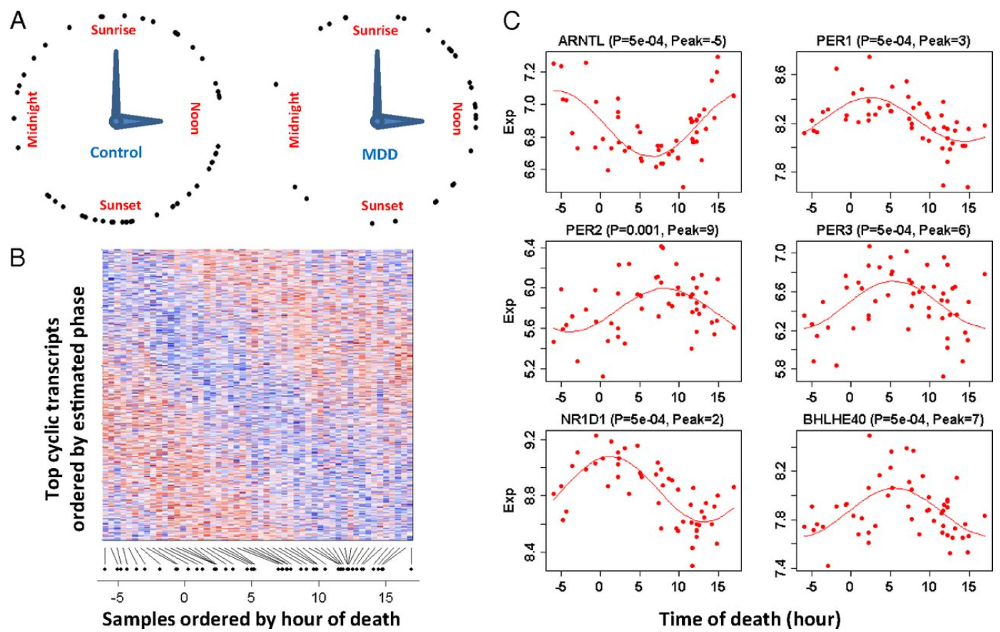
Figure 6.
3D1. Hypothetically, for a certain dataset, if we find (say) 100 features to be "fast" responders, it's possible that 30 of them exhibit circadian patterns (30 is a guess for the moment, for advancing a line of argument). While there are only dozens of genes to be known drivers of circadian patterns, some tissues have a far large number of followers that show 24h cyclicity. In literature, while some reference data exist for circadian genes, they are mostly for human and mouse, concentrated on some easily accessible tissues. We still lack directly relevant reference data for the rat, for most of the tissues we analyze, and for data types such as the metabolome. To establish such a reference data has not been a focus of MoTrPAC (PASS1A's control samples only covered 0h and 7h). Nonetheless, it is a reasonable guess that a minority of the fast-responding features, here put at 30 of 100, would show circadian patterns.

To continue this hypothetical case: for these 30 features, it is possible that only 5 (again a guess) show fast circadian changes. For instance, my past work (PMID: 23671070) on human brain gene expression patterns revealed that most circadian genes are not fast (Figure 6).

Out of the 5 fast circadian genes, it is possible that only 1 is also making the fast change in the same time window that we run most of the sampling; the other 4 will be peaking in another time window around the clock.

Thus in this hypothetical example, out of the 100 fast-acting features, only 1 is confounded by fast-acting circadian pattern in the same window, assuming that the magnitude of its circadian pattern is on par with the exercise-induced effect.

This feature would benefit from the PASS1C data, assuming that we are not hampered by the potential batch effects.

The other 4 fast-circadian features cannot by resolved with PASS1C data.

This hypothetical example invoked a 70-25-4-1 split of the 100 findings, with the 1 as a potential beneficiary of PASS1C data. In real data, the number of findings and the proportion of these categories will vary by tissue and by dataset. It remains an empirical question.

Stepping back: if we have another 100 slow responding features, some of them may be confounded by slow-circadian features. PASS1C data do not resolve them, as it requires more sampling points in the 7h-24h window. Importantly, the C7 and E7 groups in PASS1A are well positioned to resolve many of them.
Figure 7.
An example of apparently slow-acting effect is gene expression of Artl in kidney (Figure 7). It continued to rise in 4h-7h, can be explained well by the sine-cosine function, and show similar patterns between C0 and IPE, and between C7 and E7. It can be ascribed to circadian pattern even without additional control samples.
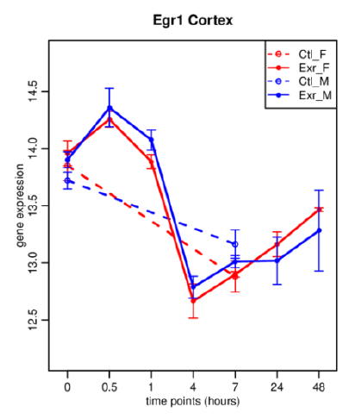
Figure 8.
An example of apparently fast-acting effect is cited in the written proposal for PASS1C (Egr1 in Cortex, Figure 8). It peaks at E0.5 and returned at E4, and a concern was raised as to whether circadian pattern could have caused it. PASS1C added sampling points to address this concern.

In summary, PASS1C is designed to identify a special subset of features potentially confounded by the circadian effect: fast acting, in the same time window, and of sufficient magnitude. Slow-acting circadian patterns, and those fast-acting but in another window, would remain potentially confounded (at last not resolved by PASS1C). While which scenario is probable (and which is merely possible) will vary by dataset, a large fraction of exercise-induced features in PASS1A will likely NOT be affected by the concern. We have been waiting to mine these findings for fear of widespread confounding by circadian patterns.

Note that PASS1C does not support a full time-course modeling by covering all the 7 points in PASS1A. It will be used as a post hoc screening for some of the patterns found in PASS1A.

3D2. How can PASS1C data help address PASS1A's limitations? The question can be stated differently: for which dataset (for a certain tissue, 'ome, platform) do we have many fast responding features? And further: how likely are these fast-responding features also fast-circadian features?

For the PASS1A findings that are fast-responding, PASS1C (Figure 9) offers 1C_E0.5, 1C_E1 and their matched controls: 1C_C0.5, 1C_C_IPE (assuming it is intended for the PASS1A's IPE, although it could also be intended to match E1, as 1C-C1). Another control sample in PASS1C is intended as the pre-exercise control, here denoted as 1C_C0. The fourth control sample is 1C_C4. In all, PASS1C controls covered ~5 hours. The prefix 1A is omitted for PASS1A samples.

Among the PASS1A fast-acting features, which ones could have been affected by fast-circadian effect can be assessed by the two "temporal deltas" observed in PASS1C, 1C_E0.5 versus 1C_C0 and 1C_E1 versus 1C_C0. They will be compared to the two matched control temporal deltas: 1C_C0.5 versus 1C_C0 and 1C_C_IPE versus 1C_C0. The four deltas from 1C can be compared to the corresponding exercise-only deltas from PASS1A: E0.5 versus C0, and E_IPE versus C0 (or E1 versus C0). This comparison of the within-1A and within-1C temporal effects is done without merging the data between PASS1A and PASS1C. This is called a meta-analysis, albeit limited to comparing the fast-patterns between PASS1A and PASS1C, not for the full time course analyzed by PASS1A.

There are a few other options of meta-analysis that involve less well matched data at 4h. Here we have PASS1A's E4 versus PASS1C's 1C_C4, without a C4 from PASS1A or 1C_E4 from PASS1C. This comparison can be useful if batch correction is successful.

3D3. How to assess how well batch correction works?
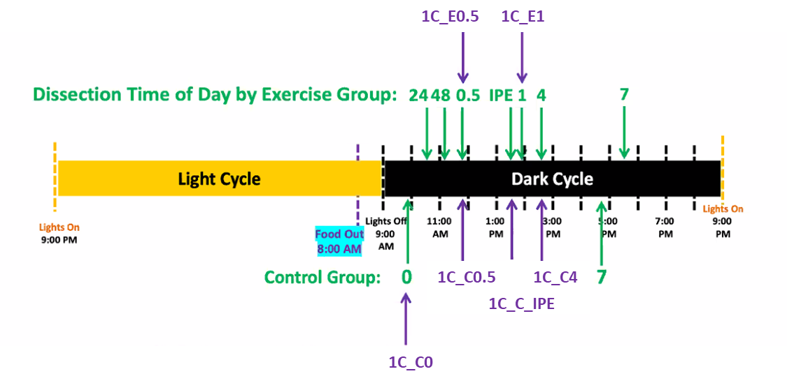
Figure 9.

The three matched pairs: E0.5 vs. 1C_E0.5, E1 vs 1C_E1, and C0 vs. 1C_C0, provide three estimates of the PASS1A-PASS1C batch effect. If they agree well for most features, relative to the effect of interest such as 1C_E0.5 versus 1C_C0 or E0.5 versus C0, we may merge them to obtain a consensus batch-correction factor, and apply it to both the 3 matched and the 3 unmatched sample groups in PASS1C. If they don't agree well, we have group-specific batch effect, and the utility of PASS1C data in merged analysis will be limited.

This limitation would also manifest in the meta-analysis, because they are mathematically equivalent: if A1-C1 does not match A2-C2 (divergent batch effect between time-1 and time-2), we know that A1-A2 would not replicate C1-C2 (divergent 1-2 difference between batch A and batch C).

3D4. Starting plan. To evaluate whether batch correction is feasible or not we will start by analyzing a few data groups, such as RNAseq data for a few tissues, and compare between PASS1A and PASS1C. Similarly we will analyzed the metabolomic data for the same tissues. Currently the PASS1C RNAseq data have not released for comparison.

Potential outcomes are:

1. PASS1A slow-acting features. They do not benefit from incorporating PASS1C data.
2. PASS1A fast-acting features. Mata-analysis may divide them into two groups: confounded, not-confounded.
3. PASS1A fast-acting features cannot be adequately divided, due to PASS1C data bringing group-specific batch effect (or equivalently, batch-specific temporal patterns). This outcome pertains to the fast changes in the 0h-1h window, and possibly to 4h if E4 versus 1C_C4 comparison is useful.

3D5. Other considerations

We need to develop an intuition as to which effect is bigger than which other, and which ones matter for a given task. Across most ome's, different tissues are expected to show moderate to large differences, especially for functionally dissimilar tissues. Whether such tissue effects are on par with sex differences or aging effects will vary by tissue and by omic data types. Whether batch effects and circadian rhythms *matter* will depend on the relative magnitude of exercise effects, assessed in conjunction with the sex and age effect.

RNAseq is expected to have a relatively small batch effect, so long as the laboratory protocols for making RNAseq library are stable. If PASS1A and PASS1C RNAseq data are so different as to rival the tissue or sex differences, we should see it as a notable surprise.

In comparison, metabolomic data may indeed bring 1A-1C batch effects that are on par with tissue and sex effects, especially if different reference samples were used in PASS1A and PASS1C. Common reference samples across tissue or across 1A-1C, if indeed adopted at some Sites/Platforms, will be extremely valuable to separate technical effect from true biological differences (see Footnote 3, p.3).

An important caveat to keep in mind is that PASS1A and PASS1C do not share the same animals or bioanalyses. Three experimental groups are repeated as matched pairs (E0.5 vs. 1C_E0.5, E1 vs 1C_E1, and C0 vs. 1C_C0), but using different animals.

(Comments on feeding effect...)

It was reported that male 6-month animals in PASS1C may be under-exercised based on lactate measures. We will see if the RNA, protein, and metabolomic data confirm the lower strength of perturbation for this group, compared to the females or the 18-month males.

We should be cautious in using the number of DE genes at a certain p value cutoff as a measure of *distance* among data groups. A certain level of difference, say 2-fold larger separation in PCA, may show >10 fold more DE genes, or the same number of DE genes. PCA plot and sample-sample correlation matrix maintain 2-by-N and N-by-N information, respectively, and both depend on many features - an advantage. Many approaches need to be tested when discussing which effects are large enough to warrant a change of data processing/analysis decisions.

The reason for separating Data Inventory/Cleaning from Temporal Modeling is that they call for somewhat different skillsets. The former involves coordinated data exploration, and will deliver a data freeze without being locked in by a certain analysis task, such as a specific set of differential expression (DE) analyses. The latter involves pre-declared analysis goals and plans, with the understanding that different stories can be built from the same data freeze. The two can be related, such as when we refer to DE results to evaluate data processing decisions (with key caveats discussed in 2D).
For metabolomic data, it is often the case that the same set of samples (for a certain tissue from the same group of animals) have been analyzed by multiple technologies in multiple Sites, with shared features across datasets. In such cases we have the opportunity to exploit the de facto technical replicates to compare data processing decisions.
If the same reference samples have been used across different tissues, they can be used as index samples in inter-tissue comparisons. Likewise, if the same reference samples have been used in both PASS1A and PASS1C, they are extremely valuable for assessing potential batch effects between 1A and 1C. We need to find out if such samples exist.
We will treat the multiple time points in the time series as an ordered series. Here we do not consider the alternative approach of testing each timed group against a baseline group separately, as if they are unordered, independent categories.
In this document we use "fast" to refer to responses that peaked before 4 hr; "slow" for those did not peak by 7h.
This is because x³ and x² are much larger than x for large x's, such as x=24 and 48. The usual approach of linear modeling will try to minimize the total squared error over all time points, therefore will overfit the 24h and 48h data.
If we assume that the on-slope and the off-slope are equal, the model is reduced from 7 to 6 parameters.
Note that the sine-cosine function above does not accommodate fast changes, either due to sudden changes in a narrow time window, or twice-daily rhythms (i.e., ultradian patterns).
Comparing C7 and E7 can provide valuable information about which slow-responding features could be due to circadian effects in the same 7h window, and whether the effect is large. How well this works needs to be assessed for each dataset: does it occupy a "reasonable" space in relation to C0, E7 and E_IPE? Does C0-C7 genes capture many of the known circadian genes, and that these are in phase with each other according to literature?

