Hi Eben and Dom,

The evidence in the paper and its data is exciting!

In the following remarks, I’ll focus on one major critique, then provide a strategy to address it. It may have already been addressed/considered. This initial critique will not focus on spelling/grammar/ or even how the concepts are communicated. Instead, it will focus on the paper’s primary message and how that can be strengthened with data already generated and with minimal effort might have a big impact.

The paper provides evidence for an exciting claim: that birds in separate environments underwent separate evolution associated with feralization.

In reading the paper, these were the 3 major claims that I understood:

* 1. Feral birds (of domestic origin) from Bermuda and Kauai underwent evolutionary pressures, separately.
  2. Regions of the genome that underwent significant mutation, measured by different methodologies (e.g., selective sweeps), were shared between the feral birds of Kauai and Bermuda but less shared between modern sequenced birds of their recent (domestic founders) and distant (red junglefowl) ancestry.
  3. Genes within the above shared selective sweeps were involved in neuron development, growth/developmental genes in general, and chromatin remodelers. A discussion of these genes involved numerous hypotheses about how they may contribute to (cause) feralization (effect).

There were other claims, but I’d like to stick to these 3 for the time being because they represent the paper’s foundation. Below, I’ll address each claim, provide an opinion of the strength of the evidence for the claim, and if appropriate, suggest a strategy that offers maximum return on energy expended to strengthen the claim. I looked at limited mutation data, but at first glance, I agree with all your claims and I think they are pretty cool!

1. Feral birds from Bermuda and Kauai underwent evolutionary pressures, separately.

This paper provided an education in the evolution of birds from Bermuda and Kauai; that these both birds have similar recent evolutionary backgrounds—domestic chickens (although birds in Kauai were outcrossed with wild relatives). Also crucial, is that these birds adapted, *separately,* to become feral*.*

This counterfactual came to mind: What if feralization occurred in one island population and then spread to the other island population?

Is there evidence in literature and is this a commonly held and accepted belief?

Then, does the paper’s data support this narrative?

The dendrogram from Figure 1, provided enough evidence for me to discern that feralization from Kauai did not spread to Bermuda, because, in ‘B’, the Bermuda bird cluster is so close to the domestic bird cluster believed to have founded both island populations, and because the Kauai cluster is more distant from the domestic founders because of the outcrossing that occurred with Kauai feral populations.

And it’s convincing that domestic chickens in Kauai mated with feral Kauaian chickens before any risk of feral Bermuda chickens being introduced.

It still leaves the possibility that feral chickens from either population were later introduced to the other, which brings us to the second and third claims:

1. Regions of the genome that underwent significant mutation, measured by different methodologies (e.g., selective sweeps), were shared between the feral birds of Kauai and Bermuda but less shared between modern sequenced birds of their recent (domestic founders) and distant (red junglefowl) ancestry.
2. Genes within the above shared selective sweeps were involved in neuron development, growth/developmental genes in general, and chromatin remodelers. A discussion of these genes involved numerous hypotheses about how they may contribute to (cause) feralization (effect).

If mutations occurred only once in these loci/genes and was somehow later shared between these two island populations, then they should be highly identical. If only SNPs were considered, hypothetically, a high degree of the mutant SNP alleles should be identical between Bermuda and Kauai genomes. However, if these mutation events occurred independent of each other, then it would be expected that the proportion of identical mutant SNPs would be less identical.

To identify the mutations that occurred in these selective sweep regions with high confidence and demonstrate they were *similar* (in functional impact) *but different* (in location and allele) would help support claims 1 and 2.

If by extension, those high confidence mutations were annotated in 3 ways: proximity to or within the gene, potential effect on the gene product, and whether the location was evolutionarily conserved; then this would provide further evidence for some of the hypotheses that mutations in these genes cause feralization.

Here is an example of such an annotation from Marek’s disease lymphomas. In the two nearly identical Figures and the Table below, I demonstrate that non-synonymous mutations target the DNA-binding region of *IKZF1,* and that these mutations both are deleterious and occur in highly conserved regions across species. The evolutionarily most distant modern species with *IKZF1* is sea lamprey. Notice that the conservation is measured by amino acid sequence (bottom of Supp Figure 2), which was appropriate for this example (rather than nucleotide sequences).

Similarly, if you could demonstrate that alternative alleles thought to “drive” feralization were conserved in all genomes, except Bermuda and Kauai, but that these mutated alleles differed between Bermuda and Kauai, then this would be very compelling evidence for all the paper’s claims. If the mutations were non-synonymous and in conserved regions, then similar figure(s) and compelling stories could be generated.

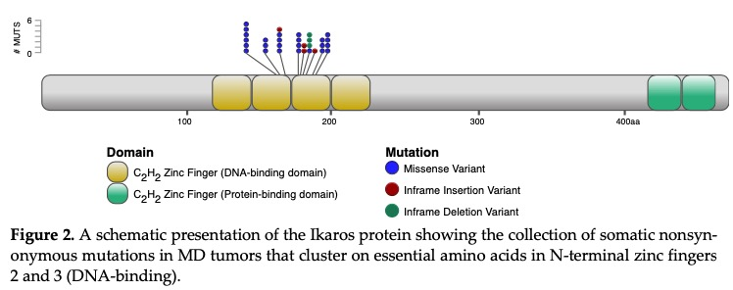

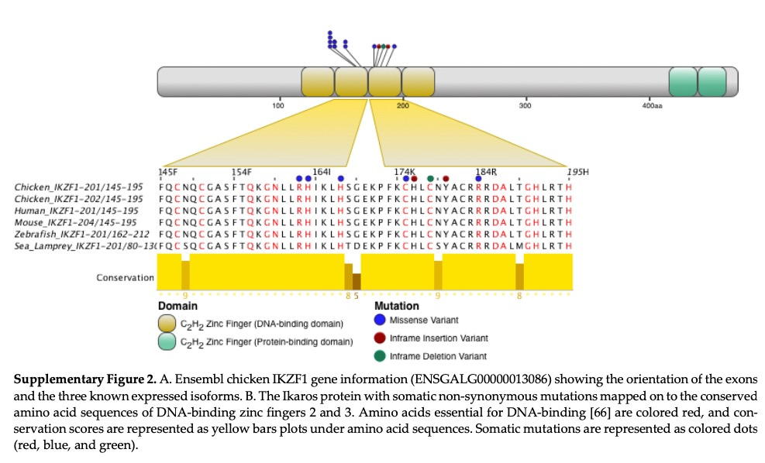

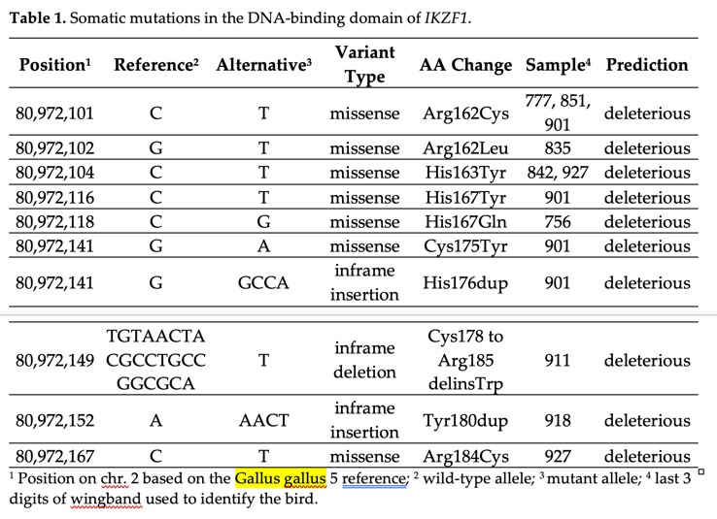

I still have a handful of VEP annotated VCF files that I generated from your experiment back in 2017 and I wanted to see if there was any preliminary evidence for this—it turns out that there just might be. I examined the genes and their mutations mentioned in Table 2 of your manuscript. The majority were intronic, upstream, or downstream; however, there were missense mutations in CCDC102B, the intronic region of 7SK which is an exon of a gene called “ICK”, and SCN3A—that’s a cluster of (or lone) missense mutations in 1 gene per sweep loci; never were there multiple nonsynonymously mutated genes in the same sweep region—just one.

If you would be interested in investigating this: I have the pipelines already constructed for chicken that could do this is short order.

Therefore, the recommendation is to examine nonsynonymous SNPs and Indels in these selective sweep regions (they are just SNPs). Demonstrate, hopefully, that they differ between Bermuda and Kauai in their locations and alleles, but that their impact on the gene product is functionally identical. If everything lined up, the nonsynonymously mutated genes could be hypothetically classified as functionally relevant and their adjacent genes as hitchhikers. It would also be helpful to visualize the mutational hotspots in these regions and hope they center on the nonsynonymous mutations that are evolutionarily conserved.