|  |  |
| --- | --- |
| **CONTROLS** | |
|  | Move the cursor (Navigate mode) Change order of adjacent pieces (Change mode). |
|  | Change the cursor to “Navigate” mode to “Change” Mode.   |  | | --- | |  | |
| or | Pause the game. |

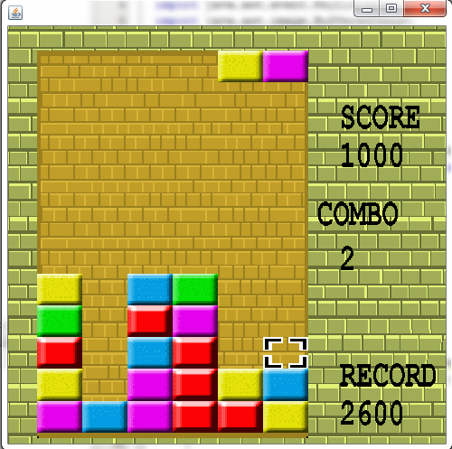 **Game Rules:**

The player can move the cursor and change the order of adjacent spaces, selecting a color block with space, then press any direction. The game constantly drops pieces formed by 2 blocks, the game ends when one colored block touch the top line of the board. You gain points in accordance to you make chains, combos of chains and.



**Menu Navigation :**

Press the number keys for select that option Example: press “1” for start.