ABC User Image Upload Site

High Level Architecture

Introduction
The purpose of this document is to provide sufficient information to developers and designers to allow them to create detailed Technical and Functional specifications for the proposed ABC Image Upload System.

The scope of this document consists of detailing the proposed architectural solutions for the sites. Some important information lies outside the scope of this document, notably details regarding security of cross domain form submission as well as any internal systems in place for approving submitted images before displaying on the public ABC sites.

Overview
The Image Upload System is designed to allow users to upload their own images for display within ABC controlled sites. Each upload site will be associated with an ABC sub-site (such as ABC Darwin or JJJ) and should maintain design and user experience fidelity within the sub-site. Storage of the associated data will be hosted on a central repository and storage of approved images can be hosted on flickr if server storage is required to be kept to a minimum.

The following image illustrates the high level architecture for the proposed system.
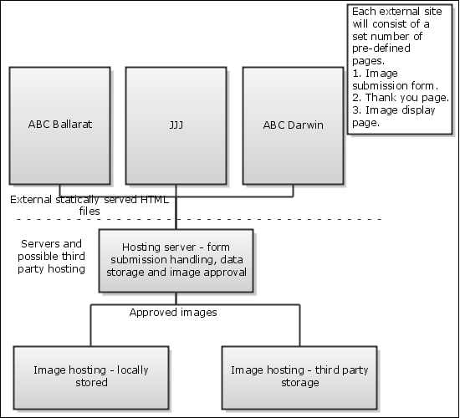

Proposed Architecture

Two possible solutions, depending on image hosting are illustrated below.

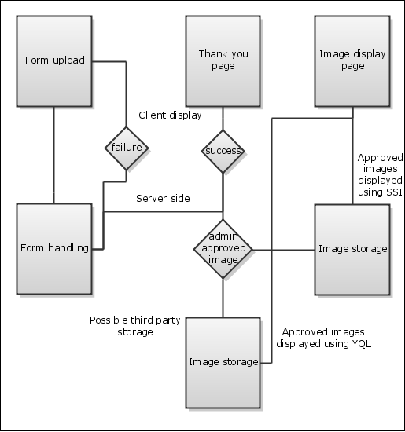

Requirements

Functional Requirements
The following functional requirements have been confirmed for the system
- The user upload experience should occur within static sub-sites which have no server side scripting available
- Users should be able to view submitted images within static sub-sites which have no server side scripting available
- All content should be submitted to a single central repository which is capable of server side scripting

Non-Functional Requirements
The following non-functional requirements have been confirmed for the system
- Reliable
- Maintainable
- Good user experience
- Efficient to develop
- Efficient in ongoing resource usage

Implementation

Sub-site architecture
The sub-sites will consist of three main static html pages.
- The form submission page. This is the page which users will select the image they wish to upload and fill in any additional required information to submit to the dynamic server. The dynamic server will redirect back to this page if the form is found to contain any errors. Errors will be displayed via Server Side Includes.
- A thank you page which the user will be redirected to upon successful uploading of an image notifying the user of a successful upload and that their image is currently awaiting approval from and ABC administrator.
- Either:
  - An image display page which will use Server Side Includes or an iframe to display the correct, approved images for each particular sub-site if the images are hosted on ABC controlled servers.
  - An image display page which uses YQL (Yahoo! Query Language) via javascript to query a flickr pool of ABC approved images for each particular sub-site.
This will provide a good balance between user-experience and ease of developers being able to add extra sub-sites to the system as required.

Server side architecture
The dynamic server is responsible for handling form submissions and database storage of the submitted content.
- Handling form submission, if the form contains errors pass the form back to the sub-site with details of the errors. If the form submission is successful the form details are stored in a central database and the user is redirected to the thank you page of the appropriate sub-site.
- ABC admin approval of images – Images which have been successfully uploaded need to be approved by an ABC moderator before they can be displayed on the public facing ABC sites. Specific details of the moderation system are outside the scope of this document.
- Possible storage of approved images – Approved images may be stored on external third party sites and removed from the ABC servers to improve resource usage.
- Retrieval of approved images for display – The dynamic server will retrieve approved images, either from flickr or local storage, for display on relevant sub-sites either via Server Side Includes or, if cross domain includes are prevented, by an iframe on the static sub-site display page.

Requirements/Conformance Matrix
Requirement | Implementation Solution | Solutions summary
The user upload experience should occur within static sub-sites which have no server side scripting available | 1) | Maintain an external upload form on each sub-site
Users should be able to view submitted images within static sub-sites which have no server side scripting available | 3), 4. | Two possible solutions that focus on different requirements depending on importance
All content should be submitted to a single central repository which is capable of server side scripting | 1., 2. | Central storage and administrative capabilities
Reliable | 3) b) | Requires client enabled javascript
Maintainable | 1), 2) | Ensure consistent static pages and structure for ease of maintainability
Good user experience | 1), 2), 3) | Allows a consistent experience across a wide variety of ABC sub-sites while allowing ease of developer maintenance
Efficient to develop | 1. | A single form submission page allows developers to maintain consisted forms and error messages across multiple sub-sites
Efficient in ongoing resource usage | 3) b) | External hosting of images allows the ABC to pass on the cost of hosting large media files and places responsibility on a site specifically designed to serve image files

Final Considerations
- If an external image storage solution is utilised there will need to be consideration regarding the availability of those stored images to the general public – that is, once uploaded to a site such as flickr those images may be available to whoever wishes to view them which may not be intended.
- If a YQL solution is used to bypass the need for either an iframe or SSI in the image view pages it should be noted that users will need to have javascript enabled in their user-agents to view the resulting images.

