Task-4

Creating WEB UI FORM:

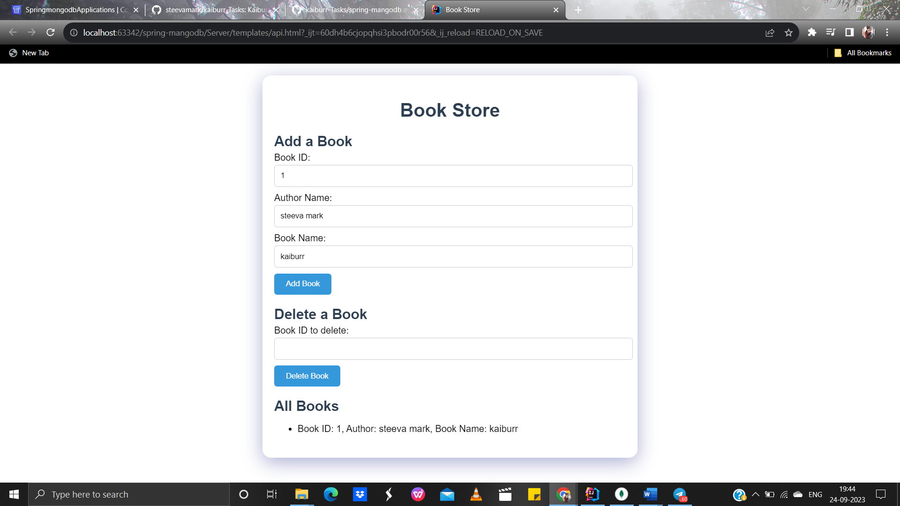

Adding book:

Deleting the book:

