
Information & Design
www.infodesign.com.au

[Project Name]

User Interface Description

Gerry Gaffney
Copyright © 2002 Information & Design
May be freely distributed, modified, and used.

Table of Contents

Table of Contents 2
Version Information 2
Introduction 3
About this document 3
References 3
Graphic treatment 3
Structure and Navigation 4
Navigation 4
Page Descriptions 6
1.1.2 Train Timetable 7
Description 7
Navigation 7
Issues 7
Elements 8

Version Information

Version 1.0 Information & Design May 1 2002

[Version control is important if the document is to be the formal repository of the user interface specification.]

Introduction

This document describes the User Interface for the [project name] website.

About this document
The remainder of this document is divided into the following sections:

- Structure and Navigation describes the structure of the application, and the ways in which users can navigate.
- Screen Descriptions, which comprises the main part of the document, contains a detailed description of each scree and its component parts.
- The Appendix contains a list of all accompanying files.

References
Refer also to the following documents:

[Project] Design Brief, dated February 8 2002.

[Project] Preliminary Design Workshop report, dated March 8 2002.

[Project] Usability Walkthrough report, dated March 24 2002.

Graphic treatment
No graphic treatment has been conducted. Therefore, the screen representations in this document should be considered as indicative of the elements to be contained within pages; rather than a representation of their appearance.

Structure and Navigation
The overall structure of the application is relatively simple, as shown in the following diagram.

Note: Numbers in the diagram provide a cross-reference to individual screens described in this document.

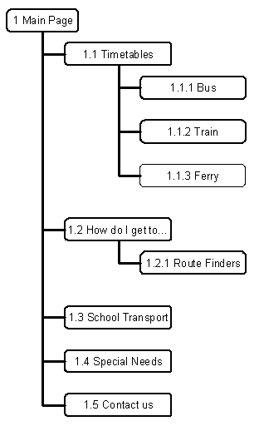

There are four primary elements in the site, and each of these may be accessed directly from the main page (in addition to the ‘Contact us’ information).

The structure is further broken down in the following diagrams.

[Diagrams]

Navigation
Within the pages, primary navigation is provided on the top of the screen, in a horizontal list of graphical links. Secondary navigation is provided on the left, in a vertical list of text links.

[Diagrams]

Pages are displayed in a single browser window, with the exception of indivdual timetables, which are shown in a pop-up. The pop-up contains no browser controls. Links are provided to Close and Print.

[Diagram]

Page Descriptions
This major part of the document contains detailed descriptions of each screen in [Project name].

Unless otherwise noted, no graphic treatment has yet occurred.

1.1.2 Train Timetable
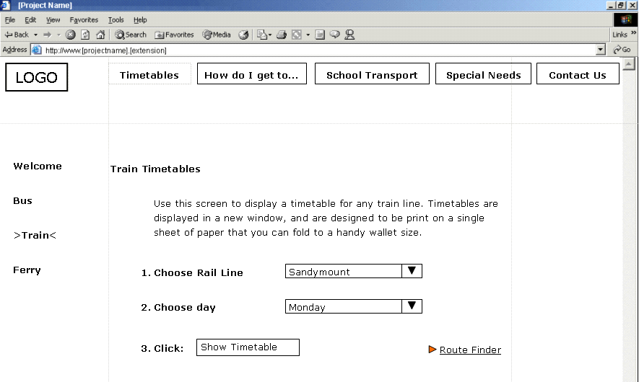

Description
The Train Timetable screen enables the user to specify a rail line and day of week.

On submitting, the [project name] displays the requested timetable in the popup window.

Navigation
[A brief description of how this page or screen is accessed.]

Navigation to the screen is by clicking the ‘Train’ link in the secondary navigation area.

Note that this page is also reached from multiple external sites.

Issues
[List any unresolved issues or special conditions or considerations.]

- The list of rail lines does not specify direction of travel (for example, Northbound). Further exploration is recommended.

- The URL of this page should be kept stable because of the number of external links.

Elements
The following is a list of all elements in this screen.

[Some sample elements included here. Use a pro-forma to ensure consistent treatment for all elements in any set.]

‘Rail Line’
Type: | Dropdown list box
Label: | ‘Rail Line’
Content: | List of all rail lines, sorted alphabetically, preceded by the default.
Default: | ‘Choose from this list’ if the user has accessed the page from an external link, or without previously choosing a rail line.  A specific rail line if the user has chosen one on a previous screen.
Behaviour: | Standard.
Comment: | None.

[Option button set]
Type: | Option (‘radio’) button set.
Label:
Default: | .
Behaviour:
Comment:

[Field]
Type: | Field.
Label:
Length:
Default: | .
Validation: | [Describes valid entries.]
Behaviour:
Comment:

[Text link]
Type: | Text link.
Behaviour: | [Describes what happens when the link is clicked.]
Comment:

