Team **11**

Ștefan Bud, Aykut Emre Çelen, Benjamin Sherlock,

Davide Tudose, Thijs van der Valk, Ruthvik Allu

**OOPP'23**, version: Feb 24, 2023

**Talio: Your personal Task List Organizer**

**Backlog Draft**

### 

### ***Stakeholders:***

* **User**: a person who wants to use the application to keep track of their tasks
* **Admin**: the person that is able to start the server of the application and can manage all the users and their boards

### ***Terminology:***

* **Board**: A unique container containing lists, having a title and being identified by a key.
* **List (Column)**: A container containing 0 or more cards. A list is located on a board. A list represents the status of the collection of cards that it contains. A list has a name, representing the task-status the list represents.
* **Card:** A container representing a specific task. A card is located in one and only one list.
* **Tag**: A label containing a short description that can be attached to a card.

### ***User Stories:***

## *MUST* Requirements (Basic Features)

As a **user**, I want…

* to have a board, so that I can visually organize my tasks in a way that I have a clear overview of what should be done and can see the status of each task.
* to give the board I have a title, so that I can get an idea of what tasks the board consists of.
* to access my board without any registration, so I don’t have to log in.
* my board to be able to be accessed and modified by multiple users, so that I can collaborate with other users in organising my/their/our tasks.
* to add a card to the board by putting it in the left-most column, so that I can represent any new tasks I have on the board I already created.
* to remove a card from the board, so that I can clear up the board from cards that don’t represent my tasks at a given moment anymore.
* to add a list to the board, so I can organise my cards, and therefore also my tasks, by the current status of my tasks.
* to give a list a name, so that I know what status the list represents, of the cards it contains.
* to remove a list from the board, so I can clear up the board from lists that don’t represent valid status’ of any of the cards on the board anymore.
* to edit a card, so I have the flexibility to change a task without deleting it.
* to edit a list, so I have the flexibility to change a status without deleting it.
* to immediately see if someone writes or edits something on the board (auto synchronization), so there are no conflicts in boards from different users and all updates on the board are immediately visible.
* to drag and drop cards within a list, so I can sort my tasks by priority.
* to drag and drop cards between lists (from list to list), so I can sort my tasks by status.
* that all the actions I have made on a board are saved in a database, so I can view exactly where I left of the next time I use the application.

As an **admin**, I want …

* to (re)start the server without losing the boards.
* that the server does not crash when a user drops out, so I can just leave the server running in the background.

## *SHOULD* Requirements (Advanced Features)

As a **user**, I want…

* to add descriptions to cards, so I have more context/ extra information of the task at hand.
* to add a nested task list by splitting up the task at hand in smaller subtasks, so I know which activities need to be completed to complete the task at hand as a whole.
* that a subtask when created/ by default shows that it is not completed, so I know what I still have to do to complete the (parent)task.
* to set whether a subtask of a given (parent)task is completed or not, so I can modify my progress of the given (parent)task.
* to set tag(s) to any task, so I have a way to group my tasks based on the characteristics of the tasks themselves.
* to remove tag(s) of a task, so I have the flexibility of removing the task out of a certain grouping, without having to delete the task.
* to use keyboard shortcuts within the application, so I can work with the application more efficiently.
* to change the background color of the board, so I can work on a board with an appearance that I prefer.
* to change the color of tags, so I can easily distinguish tags from one another, and therefore also the groups in which the tasks (containing tags) fall under.
* to be able to create multiple boards to organise different kinds of tasks on different boards, so that I can keep each individual board more clear.
* to be able to access another user's board, so that I can work together with other users in organising my/their/our tasks, on boards I didn’t create.
* to allow other users to be able to access my board, so that I can work together with other users in organising my/their/our tasks, on the board I created.
* that the board I created has a unique key, so that other users can use the key of the board to access it.
* that the boards other users have created have unique keys, so that I can use the keys of those boards to access them.
* to see no board if I search for a board using an invalid/non-existing key.
* to be able to have password protected boards, so that other users who don’t have access to the password of these boards can only view them, and therefore not modify them.
* to be able to edit boards after unlocking them by password, if they are password protected.
* to be able to change the password after unlocking a board, so that anyone who has the password of a board has full access in modifying that board.

As an **admin**, I want …

* to unlock password protected boards and edit them
* to delete boards which are inappropriate

## *COULD* Requirements (Extra features)

As a **user**, I want to …

* see if someone else drags and drops a card live, so I have an idea of what others are doing on the board I am working on/ using.
* see an overview of the boards, so I can get an idea of all the tasks from all the boards I have at a given moment.
* add a deadline to a task, so I can keep track of when the tasks I have created should be completed.
* see upcoming deadlines, so I can make sure I have completed a certain task on time.
* change the name of a board, so that I don’t always have to create a whole new board just because I want one with a different name from those of already existing boards.
* avoid duplicate cards/ cards containing the exact same information, so my board remains organised.
* see how many other people are looking at the board, so I know if there are other people currently looking at the board.

As an **admin**, I want to …

* block people by ip-address if necessary, so they cannot use a certain board due to conflicting behaviour.
* ban users on their ip-address, so they cannot use the application from the same network due to conflicting behaviour.

### ***Mocks:***

Mockup of *MUST* Requirements

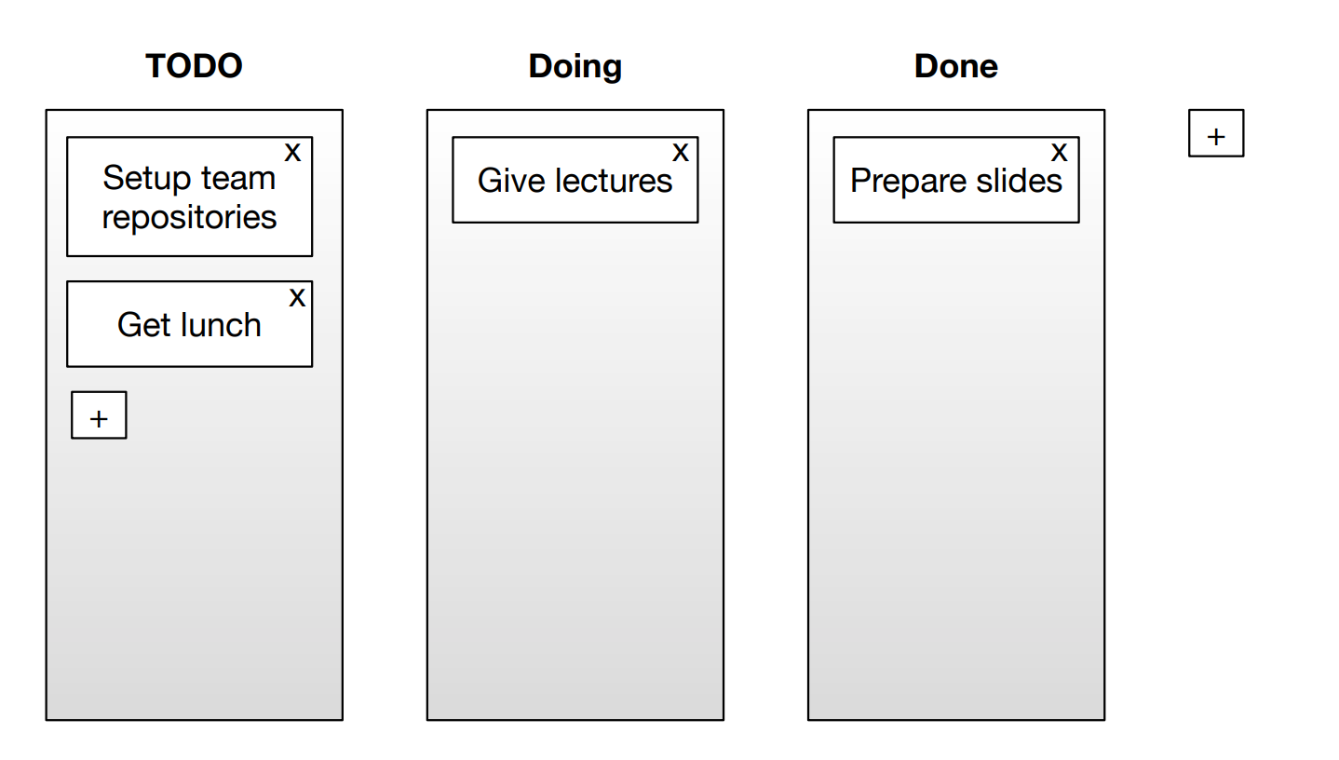

Mockup of *SHOULD* Requirements

