1. **Nume explorer: Stefan Toma**

**Track: Java**

**Nume proiect: Joc video (2D FIGHTING GAME)**

## Structura documentului:

1. **Overview**
2. **User Flows / User Stories**
3. **Technical details**
4. **UI Wireframe**
5. **Referinte**

## **Fighting Game**

Fighting Game is a 2D fighting video game which has as objective to entertain the player by having an unique experience that puts him/her under the pressure of defeating the enemy.

### User Flows

1. **The player**  opens the game that is showing the Title Screen;
2. **The player** has to choose between 4 options:
   1. 1 Player - it changes the game mode so the player has as rival an AI;
   2. 2 Players - it changes the game mode so the player has as rival a friend;
   3. OPTIONS - it gives the player the ability to:
      1. change the difficulty from easy to medium or hard, the background music and the music volume;
      2. see the control buttons and change the keybounds;
   4. QUIT- it Quits the game;
3. **The player** is sent to the character selection to select with what character wants to play;
4. **The first or second player** can choose the second character who will be the rival of the first one;
5. **The player** is sent to the background image selection to select what background image will be shown;
6. **The player** is sent to the fighting arena to fight with his opponent by using the keyboard buttons available as action keys;
7. The player is sent to a GameOver Screen where he/she can choose to:
   1. Play a new game with the same options;
   2. Return to the main menu;

### Technical Details

#### **Architecture**

This is a 2D java game which was made by using JFrame and JPanel. The base of the game is the loop function known as delta loop method which was called by a thread along with the runnable implementation. For drawing, I overrode the method repaint adding the Graphics2D. For every entity and image I created a specific class;

#### **Problems I encountered**

1. Creating a solid area for each entity and checking the collision between them or the screen borders;
2. Making an AI that has a specific difficulty with who the player can fight;
3. Creating the character and background selection screen as the player can see all the characters and backgrounds available;

### UI Model

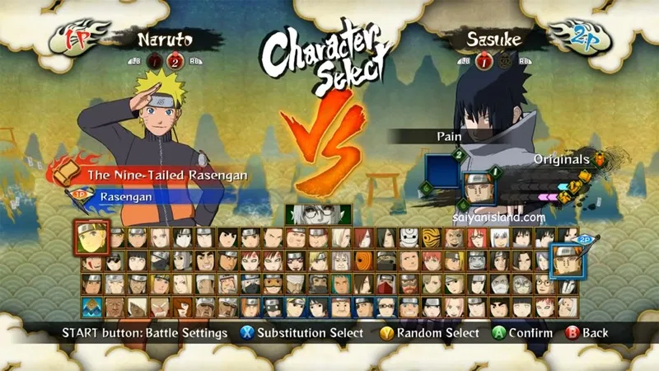

### Reference

For the first steps I watched a tutorial playlist on YouTube on how to make a 2D game in java: <https://www.youtube.com/watch?v=om59cwR7psI&list=PL_QPQmz5C6WUF-pOQDsbsKbaBZqXj4qSq>

Although was an RPG game tutorial it helped me a lot in building the base of the game;