Project Final Report
Planet Bromaron
Version 1.0

Contact: | Cameron L Ogden | 100857888
Contact: | Stephen Bakalian | 100851983

Revision History

Revision Number | Description of Revision | Made by | Date
.01 | Initial draft | Stephen | December 01, 2014
.02 | Update to game changes | Stephen | December 10, 2014

Project Information Section

Project Name: | Planet Bromaron
Client: | David Mould
Contact: | (613) 520-2600x8975
Alternate Contact: | mould@scs.carleton.ca
Project Team: | Sock Studios

Sock Studios Development Team
Cameron L Ogden 100857888
Stephen Bakalian 100851983

Table of Contents

I. Revision History 1
II. Project Information Section 1
III. Sock Studios Development Team 1
0 Executive Summary 4
0.1 Work Distribution 4
0.2 Mistakes 4
0.3 Accomplishments 4
1 Proposed System 5
2 Technical Features 5
2.1 Camera 5
2.2 Computer-controlled entities 5
2.3 Objects in environment 5
2.4 Collision detection 6
2.5 Hierarchical model 6
2.6 Lighting 6
2.7 Weapons 7
2.7.1 Shared Weapon Logic 7
2.7.2 Weapon 1 Logic 7
2.7.3 Weapon 2 Logic 7
2.7.1 Weapon 3 Logic 7
2.8 Particle systems 7
2.9 Spline 8
2.10 Other 8
3 Game Rules 9
3.1 Controls 9
3.2 Objective 9
4 Game Logic 9
5 Software Design 9
5.1 Objects 10
6 Game Design 10
6.1 World Design 10
6.2 System Design 10
6.3 Content Design 10
6.4 UI Design 10
6.5 Audio Design 10
7 Installation/Setup 10
7.1 Requirements 10
7.2 Setup 11
8 Glossary 12
9 Appendix 12
9.1 Code 12
9.2 Figures 14
9.3 References 15

Executive Summary
This document will break down this projects technical aspects and game aspects. It will explain how to play the game, describe how the game addresses the technical requirements, explains the algorithms used along the and list all bugs we are aware of. It will also justify design decisions made by the development team.

Work Distribution
Work distribution was done by posting our objectives on a board and one by one taking coding tasks and implementing them into the game. When a new issue or task came up we added it to the board. This allowed us to visually see how much had to be done and what needed to be focused on. At the end all initial documentation was done by Stephen Bakalian with Cameron Ogden reviewing everything before submission. Most code was done by Cameron while debugging was done by Stephen. We believe at the end we did an even amount of work, but are not satisfied with how much we achieved.

Mistakes
- Taking COMP3004 with COMP3501 and other heavy courses
- Spending too much time making our own 3d models
- Focused more on the coding a little too late (early November)

Accomplishments
- Error handling exists
- Most the API is in but not fully functional
- Half finished computer controlled entity running off a spline trajectory

This section describes the requirements of primary and secondary users related to screen, transmitted, and hardcopy output from the proposed system. This includes but is not limited to: Ad hoc queries; scheduled / batch reports; audit or control reports

This section describes the requirements of primary and secondary users related to screen, transmitted, and hardcopy output from the proposed system. This includes but is not limited to: Ad hoc queries; scheduled / batch reports; audit or control reports

Also included here are:
- Recipient information maps – who gets what information (need to know, should know, wants to know)
- Business rules that govern output generation:
- Who needs to be able to generate the report;
- What data needs to be presented on the report and what is the layout of the report;
- What file type(s) does the report need to be generated in (e.g. pdf, Excel, flat file etc.)
- Where (menu bar, button, screen) should the report be generated from and where does the source data come from;
- When should the report be generated (ad hoc, scheduled at specified frequency);

Proposed System
Planet Bromaron is a clone of the famous arcade space shooter Asteroids. What makes this different is the usual game is a top down space shooter, whereas Planet Bromaron will be third person with ability to camera to first person. The idea of the game will be the same as classic arcade shooter, fly around in space well dodging and shooting asteroids. Asteroids will be flying around in 3D space well a player shoots at them, when an asteroid is shot it will break into smaller asteroids.

Technical Features
This section will break down the features required and any additional features in the game and describe how they were implemented and work within Planet Bromaron.

Camera
In PB the user plays in a first person view of their space craft. This view is made up from a quaternion camera flying freely in open space. Missing from this implementation is the third person camera, but this has nothing to do with lack of knowledge of implementation. We choose not to implement the third person camera due to a lack of an imported ship model, which will be explained further in the document. To change the camera we could have implemented it in two different ways, the first way being is on a click of a mapped button change the camera location to move a little back and a little up in comparison to where the ship model would be loaded. The other way would be to use the XMMatrixLookAt instead of the XMMatrixLookTo function when creating the camera.

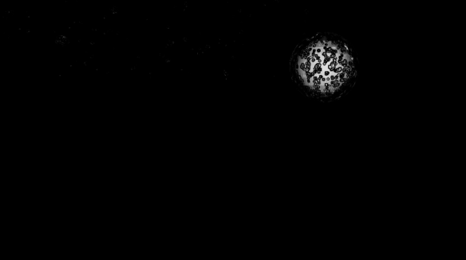
Computer-controlled entities
PB currently doesn't have a fully functional controlled entity. However we spent a lot of time trying to get an A.I which followed a spline trajectory. We currently have this visually shown in the game just to prove it is existent but have failed to get it fully functional. We also disabled collision detection with it and loaded it on top of the player so it is easy to find once the game is loaded. simply move backward to see it or move forward and turn around to see it. Figure 1 A.I on Spline, shows an image of the A.I spline but doesn't show it's actual movement.
Figure 1 A.I on Spline

Objects in environment
The environment in PB contains hundreds of asteroids floating around in space. These objects move around freely based on a random move trajectory calculation (XMVECTOR move = {- rand() % 100 /100, - rand() % 100/100, - rand() % 100/100 };). The asteroids in the distance also give off the effect of stars and objects floating in deep space, this allowed us to get away with not having a skybox and allowed the player to interact with all entities within the game. This can be seen in Figure 2.

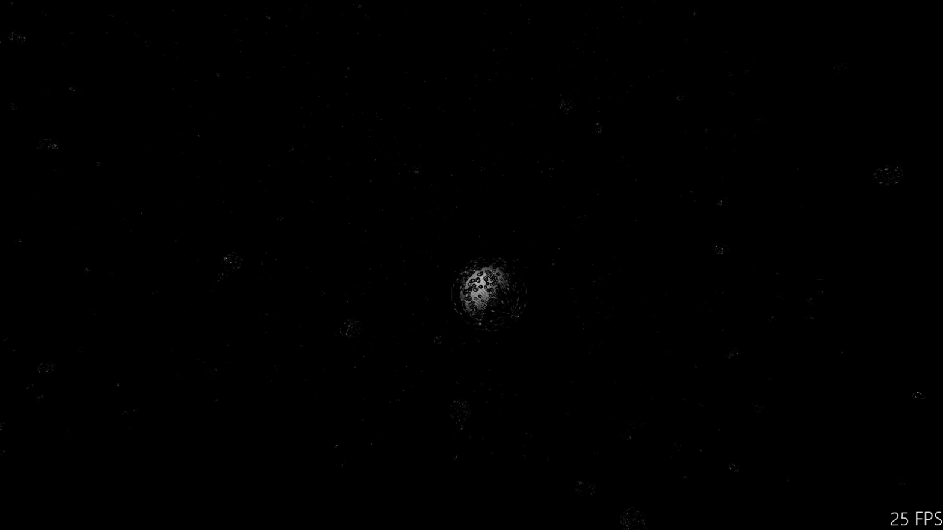
Figure 2 Asteroids
Another thing you'll notice is the darkness of the game, this is due to space being dark. Since this takes place in an area of space with no planets and no sun there is a lack of light, other than the light coming from your ship.

Collision detection
The current state of the game has player to object collision but missing functionality of shooting collision. The code the player and asteroid is sphere to sphere collision and works fully, but the collision between shooting and asteroids doesn't work due to a non functional ray sphere collision detection. Code can be seen in Code 1 Collision in Appendix.

Upon collision the asteroid takes hit points based on the shoot type or type of collision. If the player hits an asteroid the asteroid loses all health, but depending on the type of weapon they take different amount of damage. Once an asteroid loses all health the asteroid dies and isn't drawn.

Hierarchical model
Due to the ship not being in the project (explained in section 2.10) there isn't much for a hierarchical system. The only things that work off this type of system is the shooting. The shots are drawn based off a hierarchical system based off the position of the camera.

Lighting
Then first thing you'll notice in PB is that it is very dark, this is due to the fact that you are in deep dark space. There are no nearby plants, no nearby suns, and your only source of light is the one on your ship. The game uses a blinn phong shading, with its origin being the ship. Once you get close to an object you can easily see it, but until you do you can easily fly into stray asteroids.

Weapons
PB has two functional shots and one as a place holder. this section will break down what makes up a shot and how each type of shooting works

Shared Weapon Logic
All weapons in PB share some common aspects between one another. Firstly they are all used with the same button press but you switch between which one is active. The other main things the shots have in common are they are lasers because of technology used in the game universe. Each shot is a different kind of laser and they do different kinds of damage. Although they share these, it doesn't mean they act the same. The follow sections will break each shot down individually.

Weapon 1 Logic
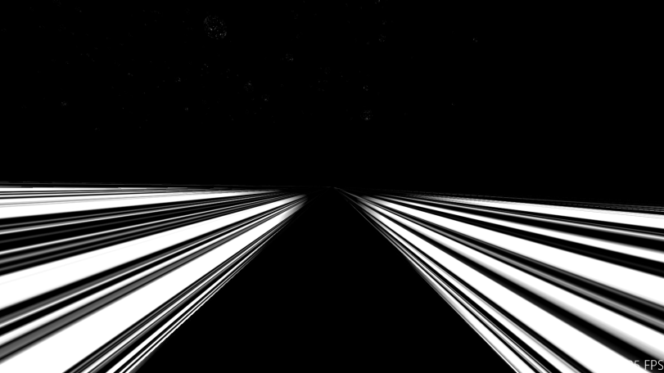
The first type of shooting method is the one defaulted on your ship and can be activated by pressing the '1' key. It is a weaker shot that doesn't do a lot of damage, however there is no reloading or stall time meaning you can fire it forever. This type of shot is useful for taking out asteroids that can't be seen and are at a distance. It comes in the form of two lasers coming from the ship (Figure 3 Constant weak laser), they look like they're touching at the end, but they aren't. This allows you to shoot two asteroids that are close together, but remember it doesn't do a lot of damage to them.
Figure 3 Constant weak laser

Weapon 2 Logic
Currently in the game this shot looks like only the left side of weapon 1. this is a place holder for future shooting methods.

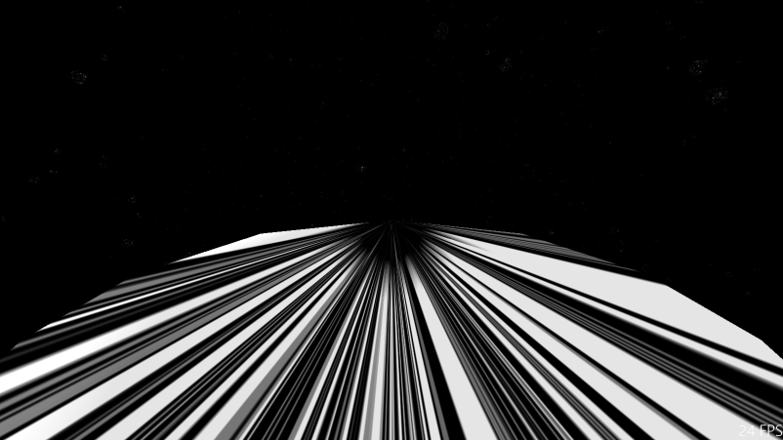
Weapon 3 Logic
Figure 4 Strong burst shot
This weapon can be activated by pressing '3' key. It is the third weapon in your arsenal and it is a lot more powerful than the other weapons. But there is a catch to it being more powerful, it can't be shot very often. After every shot there is a cool down for holding the shot down. However if you use this shot in quick succession it can be shot really fast, as it won't need to cool down. This type of shooting is good for close range when you are about to collide with an asteroid. If you hold fire with this weapon you will only be able to shoot once every 1.5 seconds. This laser is shot from the center of your ship as seen in Figure 4.

Particle systems
PB has code for a particle system within the code, but due to collision detection not working 100% it was never used. the code can be seen below.
Code 1 Particle system
for (int i = 0; i < numParticles; i++)
{
u = static_cast<float>(distro(lotto));
v = static_cast<float>(distro(lotto));
w = static_cast<float>(distro(lotto));

theta = u * 2 * 3.1416;
phi = acos(2 * v - 1.0);
// phi = v * 2 * 3.1416;
spray = maxspray*cbrt(w);// *cbrt(cbrt(cbrt(w))); // cbrt(w);
thisnor = // normal direction
XMFLOAT3(spray*cos(theta)*sin(phi), spray*sin(theta)*sin(phi), spray*cos(phi));

thisone = // position + color of this vertex, now added normal and texcoord
{
XMFLOAT3(thisnor.x*trad, thisnor.y*trad, thisnor.z*trad),
XMFLOAT3(i / (float)numParticles, 1, 0.05),
XMFLOAT3(thisnor.x, thisnor.y, thisnor.z),
XMFLOAT2(0, 0)
};

particledata[i] = thisone; // add to vertex
}

Spline
The way we utilized a spline is very unique and something we are proud of having semi complete. We generated a spline (shown in Code 2) and made our A.I follow the splines trajectory. As mentioned earlier this can be seen by flying backward upon load up or forward and turning around. The spline is generated at random thought the createSpline() call. The generation of a spline works it's the drawing of an object on the spline that is causing issues.

Other
One major aspect of the game we spent a lot of time in (but couldn't get loaded into PB) was the 3D modeled ship we created. The ship can be seen in Figure 5 Space Ship Model and it shows the ship we created. We've included the files in PB, but once again it isn't loaded into the game.
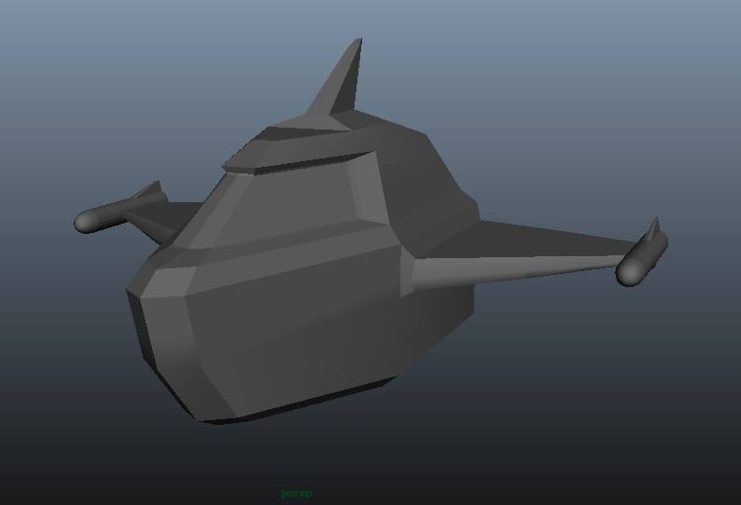
Figure 5 Space Ship Model

Game Rules

Controls
Arrow Down | Move back
Arrow Up | Move forward
Key 'a' | Look left
Key 'd' | Look right
Key 's' | Look down
Key 'w' | Look up
Mouse Left Click | Shoot
Number 1 | Weapon 1
Number 2 | Weapon 2
Number 3 | Weapon 3
Space | Shoot

Objective
Stay alive and destroy all the asteroids.

Game Logic

Software Design
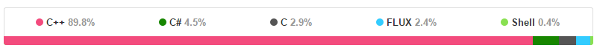

Objects
Code 2 Laser Object
typedef struct Laser
{
XMVECTOR ori;
bool isFiring;
int type;
int draw = 0;
int count = 0;
int power;
};
Code 3 Asteroid Object
typedef struct Asteroid {
XMVECTOR pos; // position
XMVECTOR ori; // orientation
XMVECTOR L; // angular momentum (use as velocity)
XMVECTOR vel; // linear velocity
bool boolDraw = true;
int hitCounter = 0;
};

Game Design

World Design
The world design of or game is that you a lone space mining ship that got separated from the pact in a dark corner of space. The game takes place in a dark lonesome part of space where there are small asteroid debris flying around in which you must destroy in an attempt to stay alive.

System Design
System design is the creation of game rules and underlying mathematical patterns. In PB we've kept back to the original game style of rules. It's simple, just don't die.

Content Design
Basic debris are floating in space in which the user can interact with. There is also the addition the spline ai which is there as proof of concept but no interaction yet.

UI Design
The UI design is the user interactions and feedback. We've kept a minimalist style in which the user can interact and the proper feedback is given. If the user shoots then the ship will fire it's weapon, if the player moves the ship proceeds to move in the desired direction.

Audio Design
Our choice in no audio had little to do with the fact that there is no sound in space.

Installation/Setup

Requirements
- Windows 8.1
- Microsoft Visual Studio 2013
- DirectX SDK

Setup
- Extract the provided zip file
- in the extracted location direct yourself to
...\Project_Bromaron_v1.0.2\fiering\transforms1
- launch transforms1.sln
- if there are popups follow instructions provided
- once loaded in visual studio 2013 press 'f5' key or 'run on local machine'

Glossary

Acronym | Definition
AI  A.I | Artificial Intelligence
PB | Planet Bromaron
UI | User Interface

Appendix

Code
Code 1 Particle system 8
Code 2 Laser Object 10
Code 3 Asteroid Object 10
Code 4 Collision 13
Code 5 Spline 14
Code 4 Collision
bool Sample3DSceneRenderer::collisionDetection(XMVECTOR objectOne, XMVECTOR objectTwo){

XMVECTOR diff = XMVectorSubtract(objectOne, objectTwo);
XMVECTOR length = XMVectorSqrt(XMVector3Dot(diff, diff));

if (XMVectorGetX(length) < 2.5f){
return true;
}

return false;
}

bool Sample3DSceneRenderer::intersectRaySphere(XMVECTOR rO, XMVECTOR rV, XMVECTOR sO, double sR) {

XMVECTOR Q = XMVectorSubtract(sO, rO);
double c = XMVectorGetX(XMVector3Normalize(Q));/* sqrt(XMVectorGetX(Q) * XMVectorGetX(Q) + XMVectorGetY(Q) *XMVectorGetY(Q) + XMVectorGetZ(Q)*XMVectorGetZ(Q));*/
double v = XMVectorGetX(XMVector3Dot(Q, rV));
double d = sR*sR - (c*c - v*v);

// If there was no intersection, return -1
if (d < 0.0) return false;

// Return the distance to the [first] intersecting point
return true;
}

Figures
Code 5 Spline
XMFLOAT4* Sample3DSceneRenderer::createSpline()
{
//Spline Control point set up
DirectX::XMFLOAT4 m_splineArray[64];
float u, v, w;

std::random_device rd;
std::mt19937 lotto(rd());
std::uniform_real_distribution<> distro(0, 1);

//Randomize X, Y, Z
u = static_cast<float>(distro(lotto)) * 200 - 100;
v = static_cast<float>(distro(lotto)) * 200 - 100;
w = static_cast<float>(distro(lotto)) * 200 - 100;

m_splineArray[0] = XMFLOAT4(0, 0, 0, 0);
m_splineArray[1] = XMFLOAT4(u, v, w, 0);
m_splineArray[63] = m_splineArray[0];

for (int i = 2; i < 63; i++)
{
u = static_cast<float>(distro(lotto)) * 200 - 100;
v = static_cast<float>(distro(lotto)) * 200 - 100;
w = static_cast<float>(distro(lotto)) * 200 - 100;

if (i % 4 == 0) m_splineArray[i] = m_splineArray[i - 1];
if (i % 4 == 1) m_splineArray[i] = XMFLOAT4(2 * m_splineArray[i - 1].x - m_splineArray[i - 3].x,
2 * m_splineArray[i - 1].y - m_splineArray[i - 3].y,
2 * m_splineArray[i - 1].z - m_splineArray[i - 3].z, 0);
if (i % 4 == 2) m_splineArray[i] = XMFLOAT4(u, v, w, 0);
if (i % 4 == 3) m_splineArray[i] = XMFLOAT4(u, v, w, 0);
}

return m_splineArray;
}
Figure 1 A.I on Spline 5
Figure 2 Asteroids 6
Figure 3 Constant weak laser 7
Figure 4 Strong burst shot 7
Figure 5 Space Ship Model 9

References
Source | Details
https://github.com/stef52/Project_Bromaron | Our source control

