Radiance data can be calculated from each .CXS file and narrowed down to a scene (H in this case):



From this radiance spectrum, interferogram data can be calculated:



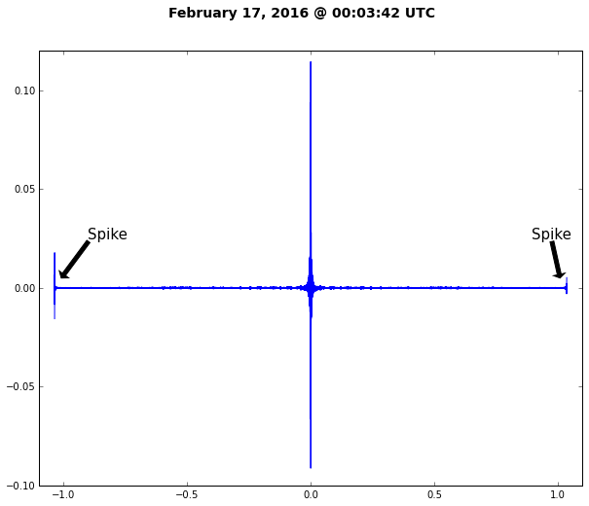From this data, an interferogram plot can be created for each row. If a row contains too large of values at the beginning or end of the data, this row data is spiked and will look similar to this:

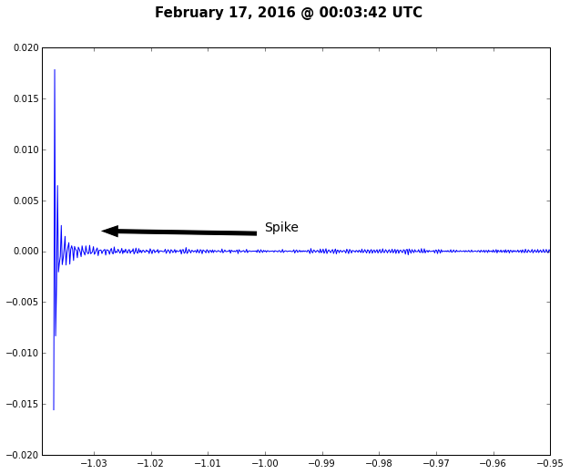**Zoomed In:**

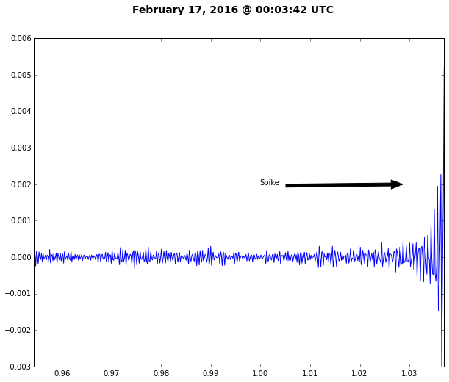

**Data from February 02, 2015 to February 18, 2016 at Radiance Scene H**

|  |  |  |  |
| --- | --- | --- | --- |
| **Collective Totals** | | **Monthly Percentage of Spiked Data** | |
| **Total .CXS Files:** | 1120 |
| **Total Files w/ Spikes:** | 1031 | February 2015 | 2.071% |
| **Total Time Ranges:** | 454043 | March 2015 | 3.621% |
| **Total Time Ranges w/ Spikes:** | 28793 | April 2015 | 4.512% |
| **Percentage of Spiked Data:** | 6.341% | May 2015 | 4.229% |
| **B1 Totals** | | August 2015 | 3.990% |
| **Total B1 Files:** | 280 | September 2015 | 4.716% |
| **Total B1 Files w/ Spikes:** | 277 | October 2015 | 4.524% |
| **Total B1 Time Ranges:** | 120709 | November 2015 | 6.960% |
| **Total B1 Time Ranges w/ Spikes:** | 10904 | December 2015 | 8.194% |
| **Percentage of Spiked B1 Data:** | 9.033% | January 2016 | 11.679% |
| **B2 Totals** | | February 2016 | 9.845% |
| **Total B2 Files:** | 280 |  |  |
| **Total B2 Files w/ Spikes:** | 277 |  |  |
| **Total B2 Time Ranges:** | 120709 |  |  |
| **Total B2 Time Ranges w/ Spikes:** | 10647 |  |  |
| **Percentage of Spiked B2 Data:** | 8.820% |  |  |
| **F1 Totals** | |  |  |
| **Total F1 Files:** | 280 |  |  |
| **Total F1 Files w/ Spikes:** | 207 |  |  |
| **Total F1 Time Ranges:** | 120709 |  |  |
| **Total F1 Time Ranges w/ Spikes:** | 2534 |  |  |
| **Percentage of Spiked F1 Data:** | 2.099% |  |  |
| **F2 Totals** | |  |  |
| **Total F2 Files:** | 280 |  |  |
| **Total F2 Files w/ Spikes:** | 270 |  |  |
| **Total F2 Time Ranges:** | 120709 |  |  |
| **Total F2 Time Ranges w/ Spikes:** | 4708 |  |  |
| **Percentage of Spiked F2 Data:** | 3.900% |  |  |

|  |
| --- |
| **Two things to take note of from this data:** |
| * B1 and B2 Channels contained significantly more spiked data |
| * Spikes occurred more and more often as the data approached the present date |