X16 Edit User Manual

1 Introduction
X16 Edit is a simple text editor written in pure assembly for the Commander X16 platform.
The look and feel of the program is inspired by GNU Nano, but there are, naturally, many differences.
X16 Edit stores its text buffer in banked RAM, which by default is 512 KB, expandable to 2 MB. The program does not use virtual memory or otherwise switch memory to disk. Consequently, it cannot handle text files larger than the available banked RAM.
The program is designed to support large text files with as good performance as may be obtained from an 8 bit computer. A lot of care has been put into the design of the internal memory model. There should be no significant performance drop when editing text files even if they fill almost all of banked RAM. Loading and saving large files may, however, take considerable time.
X16 Edit is not intended to be a word processor. The program has basic features necessary for text file editing. Nothing more. Nothing less.

2 Editor basics
2.1 Entering text
X16 Edit is controlled by the keyboard.
The program is modeless. With two exceptions, characters will be inserted into the text buffer as you type on the keyboard.
Those exceptions are:
- When you hold down the Ctrl key and simultaneously press another key, the program will in most cases interpret the sequence as a command.
- When you press and release the ESC key, the program will interpret the next key as a command.

2.2 Long lines
There is no limit to the length of a line, other than the size of the available memory.
If you type in a line that is longer than the width of the screen, the line will scroll horizontally.

2.3 Keyboard command sequences
Commands are executed by pressing Ctrl+key sequences.
Alternatively, you may first press and release the ESC key and a key linked to the command you want to execute.
Some commands are also available via a function key.
Below is a table showing all available commands:
Ctrl | ESC | F key | Description
G | G | F1 | Display online help screen
X | X | F2 | Exit program
W | W | F3 | Write text to file
O | O | F4 | Open and read text from file
N | N | - | Create new text buffer
Y | Y | - | Page up, moves cursor 27 lines upwards
V | V | - | Page down, moves cursor 27 lines downwards
K | K | F5 | Cut current line and save it to clipboard
B | B | - | Copy current line and save it to clipboard
U | U | F6 | Uncut (paste) all content from clipboard
P | P | F7 | Display current cursor position (line and column)
F | F | F8 | Search and find text (case sensitive)
R | R | - | Replace one or all occurrences of a string (case sensitive)
L | L | - | Go to line number
A | A | - | Toggle auto indent feature on and off
Z | Z | - | Toggle automatic word wrap feature on and off
E | E | - | Change charset: rotates through PETSCII upper case/graphics, PETSCII upper/lower case, and the ISO charset
D | D | - | Set file storage device number, default is 8
- | 1..9 | - | Set tab width
- | C | - | Change text color
- | S | - | Change background color
- | M | - | Show memory usage as number of blocks free; one block may hold a maximum of 251 characters

2.4 Title bar
The title bar is displayed on the first line of the screen.
It shows the program name (left), the name of the currently edited text file (center), and the letters “MOD” (right) if the text buffer has been modified.
If the currently edited text buffer has never been saved to file, the words “NEW BUFFER” are displayed at the center of the title bar.

2.5 Status bar
The status bar is on the line third from the bottom of the screen.
All messages from the program will be displayed in the status bar. Press any key to hide a message.
If the program needs to prompt the user for input, the prompt is also displayed in the status bar. Press Enter key to confirm input to the program. Press ESC to abort the command.

2.6 Shortcut list
The last two lines of the screen contain a list of the most frequently used commands.
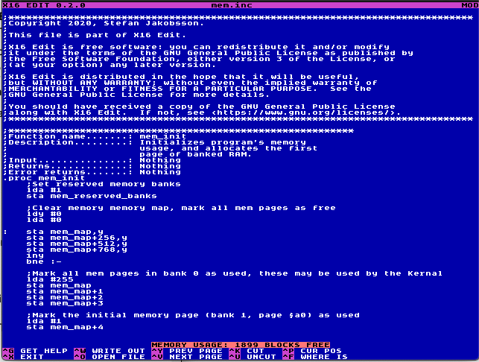
Status bar
Shortcut list
Title bar
Program name
Current file name
Modified indicator
Main elements of the user interface as described above.

3 Built-in help
X16 Edit has a short built-in help screen. To display the help screen, press Ctrl+G.
The help screen contains a list of all commands and a short description of what they do similar to the table in section 2.3 above.

4 Special features
4.1 Tab key behavior
The tab key inserts blank spaces until reaching the next tab stop.
Tab stops are defined by pressing and releasing the ESC key followed by one of the digits 1 to 9. The selected digit indicates the width of a tab stop.

4.2 Auto indent
Use the auto indent feature to keep the level of indentation as line breaks are inserted manually or by the automatic word wrap feature.
The feature works by counting the number of blank spaces at the beginning of a line when breaking it. The same number of blank spaces is inserted at the beginning of the next line.
The auto indent feature is toggled on and off by pressing Ctrl+A.
4.3 Automatic word wrap
The automatic word wrap feature works in a simplified way. When enabled, it inserts a line break when you reach the set margin. The line break happens after the previous blank space. If there is no blank space on the line, it will insert the line break at the set margin.
The word wrap will not be recalculated if you go back and insert text at the beginning of a line or if you delete text from a line.
This feature works fine as you type in text, but if you go back and edit that text, you might have to manually redo the line breaks.
Automatic word wrap is toggled on and off with Ctrl+Z. When toggled on the user is prompted for the column where to wrap.

4.4 The clipboard
The clipboard is used to store lines of text that are copied or cut from the text file. It may hold up to 2 KB.
It’s possible to copy or cut multiple lines without pasting in between. The lines you copy or cut are be stored in the clipboard memory in the order they were copied or cut.
When uncutting (pasting), all content in the clipboard is inserted at the cursor position. Uncutting clears the clipboard memory.

4.5 Character set
X16 Edit supports three different character sets: PETSCII upper case and graphics, PETSCII upper and lower case and ISO character set.
When starting the program, it will try to detect the current character set and continue using that. If the detection for some reason fails, the program will default to ISO character set.
To change character set while running the program, press Ctrl+E. This will rotate through the three supported options.

4.6 Background and text color
You may change both the background and text color used by the editor.
Press and release ESC followed by S to change the background (screen) color.
Press and release ESC followed by C to change the text color.
Each invocation of these functions will increment the color code.

4.7 Line break control character
How line breaks are encoded when you save a buffer to file depends on the active character set mode.
If in ISO mode, LF (decimal 10) is used to mark line breaks. This is the standard used by Unix and MacOs. If in one of the two PETSCII modes, CR (decimal 13) is used. This is the standard used by Commodore 8 bit computers.
The internal representation of a line break in the program is LF. On reading a file, all occurrences of CR will be replaced by LF. When saved to file, line breaks are converted back to CR if you are in PETSCII mode.
Line breaks in Windows text files are encoded with CRLF. If you open such a file, line breaks will be duplicated.

5 File handling
X16 Edit does not support other file handling functions than reading and saving files.
In order to keep the program simple, there are no functions to show directory listings, or to rename, move or delete files. These operations may be handled at the BASIC prompt or with other specialized programs.
To open and read a file press Ctrl+O. You will be prompted for the file name. Enter the file name and press Enter to confirm. Press ESC to abort.
To save a file, press Ctrl+W. You will be prompted for the file name. The current file name will be filled in as default. Edit the file name if necessary, and press Enter to confirm. Press ESC to abort. The program always prompts the user to confirm before overwriting an existing file.

6 License
Copyright 2020, Stefan Jakobsson.
The X16 Edit program, including this manual, is released under the GNU General Public License version 3 or later.
The program is free software and comes with ABSOLUTELY NO WARRANTY. You may redistribute and/or modify it under the terms of the GNU General Public License as published by the Free Software Foundation, either version 3 of the License, or, at your option, any later version. For detailed terms see license file distributed with the program. Also available from <https://www.gnu.org/licenses>.

