Dataset documentation: A feasibility study for validating robot actions using EEG-based error-related potentials

**Manuscript:** A feasibility study for validating robot actions using EEG-based error-related potentials

**Author: Stefan Ehrlich <stefan.ehrlich@tum.de>**

**Last revised: 23.03.2019**

Citation: Ehrlich, S. K., & Cheng, G. (2018). A Feasibility Study for Validating Robot Actions Using EEG-Based Error-Related Potentials. *International Journal of Social Robotics*, 1-13.

DOI: 10.1007/s12369-018-0501-8

# Introduction

The purpose of the experiment was the investigation of perceived machine error in human-robot interaction. As the specific shape of such error-potentials (ErrPs) is different in different interaction scenarios (human-human, human-computer or human-robot) and only little work has been done to investigate error-potentials in human-robot interactions, this dataset investigates exactly this case. If ErrPs can be reliably classified from the EEG recording of the robot’s operator they provide an intuitive way to evaluate the robot’s actions in an unwitting and non-interrupting way. Furthermore, they can also be used to improve the system performance by detecting wrong robot behavior.

# Scenarios

The experiment consisted of two scenarios which implemented different human interaction scenarios. In the first scenario (cursor scenario), the participants were involved in a human-computer interaction, where the computer exhibited randomized erroneous responses to the participants commands with a certain probability (pErr). In the second scenario (robot scenario), the participant had control over a humanoid robot and hence participated in a human-robot interaction. Besides the representation of the interaction and the feedback (moving square on screen versus head-movement of the robot) all other parameters such as the EEG hardware and EEG setup or the recording environment were the same in both scenarios.

# Trial structure

|  |  |
| --- | --- |
| a | Trial start |
| b | target stimulus presentation (in this case up) |
| c | participant response in form of arrow key press, start robot head movement |
| d | end robot head movement |
| e | target border feedback presentation (correct: green; incorrect: red) |
| f | disappearance target and start robot head turning back |
| g | ongoing robot head turning back |
| h | end of robot head turning back, updating average reaction time and error count |

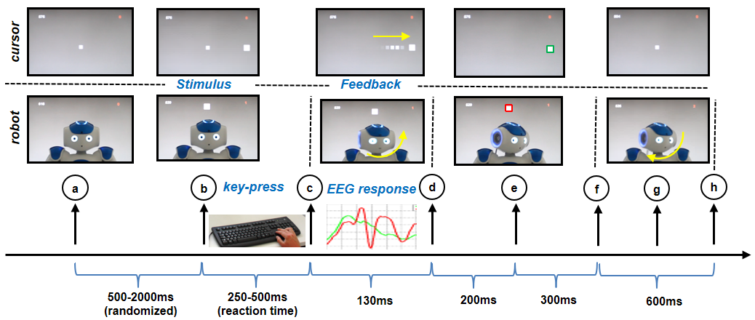

# Study protocol

|  |  |
| --- | --- |
| Number of subjects | 12 (age: 30.3±7.3, 5 females, 8 males) |
| Number of scenarios | 2 (cursor, robot) |
| Number of sessions | 2 (one per scenario, conducted on after the other) |
| Number of blocks per session | 10 (duration ~2.5 min) |
| Number of trials per block | 50 |
| Total number of trials | 500 per subject and session |
| Total duration | ~60 min |
| Number of error trials | ~175 per subject and session |
| Number of non-error trials | ~325 per subject and session |
| Error probabilities | pErr1 = 20% and pErr2 = 50% (pseudo-randomized and equally distributed) |

# Hardware

|  |  |
| --- | --- |
| EEG amplifier and electrodes | Brain Products actiChamp amplifier; 32 active electrodes |
| Sampling rate | Recorded with 1000 Hz; downsampled to 256 Hz |
| Electrode placement | According to 10-20 system |
| EOG channels | Central forehead (EOG3), left (EOG1) and right (EOG2) outer canthi |
| Referencing | Average of TP9 and TP10 (average mastoids referencing); same reference for both for EEG and EOG channels |
|  |  |
| Robot (in scenario 2 ‘robot’) | Softbank Robotics NAO, 58cm tall humanoid robot with 21-25 degrees of freedom |
| Temporal data-linking | LED + photodiode at the back of robot’s head |

# Trigger/Marker information in EEG data:

|  |  |
| --- | --- |
| S1 | Presentation of stimulus – left |
| S2 | Presentation of stimulus – up |
| S3 | Presentation of stimulus – right |
| R1 | Response arrow key – left |
| R2 | Response arrow key – up |
| R3 | Response arrow key – right |
| S4 | Feedback no error |
| S5 | Feedback human error |
| S6 | Feedback machine error |
| FB1 | Feedback left |
| FB2 | Feedback up |
| FB3 | Feedback right |
| S7 | Appearance of feedback (color-frame) |
| S8 | Start robot head moving back |
| S9 | End of trial |

# Dataset organization:

|  |  |
| --- | --- |
| Filename | Description |
| s02_cursor.set/.fdt | Subject s02, cursor-scenario |
| s03_cursor.set/.fdt | Subject s03, cursor-scenario |
| s04_cursor.set/.fdt | Subject s04, cursor-scenario |
| s05_cursor.set/.fdt | Subject s05, cursor-scenario |
| s06_cursor.set/.fdt | Subject s06, cursor-scenario |
| s07_cursor.set/.fdt | Subject s07, cursor-scenario |
| s08_cursor.set/.fdt | Subject s08, cursor-scenario |
| s09_cursor.set/.fdt | Subject s09, cursor-scenario |
| s10_cursor.set/.fdt | Subject s10, cursor-scenario |
| s11_cursor.set/.fdt | Subject s11, cursor-scenario |
| s12_cursor.set/.fdt | Subject s12, cursor-scenario |
| s13_cursor.set/.fdt | Subject s13, cursor-scenario |
|  |  |
| s02_robot.set/.fdt | Subject s02, robot-scenario |
| s03_robot.set/.fdt | Subject s03, robot-scenario |
| s04_robot.set/.fdt | Subject s04, robot-scenario |
| s05_robot.set/.fdt | Subject s05, robot-scenario |
| s06_robot.set/.fdt | Subject s06, robot-scenario |
| s07_robot.set/.fdt | Subject s07, robot-scenario |
| s08_robot.set/.fdt | Subject s08, robot-scenario |
| s09_robot.set/.fdt | Subject s09, robot-scenario |
| s10_robot.set/.fdt | Subject s10, robot-scenario |
| s11_robot.set/.fdt | Subject s11, robot-scenario |
| s12_robot.set/.fdt | Subject s12, robot-scenario |
| s13_robot.set/.fdt | Subject s13, robot-scenario |