Zadatak 1:

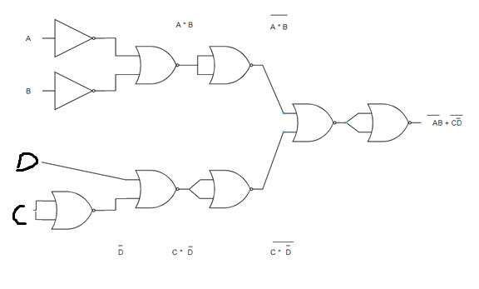

Zadatak 2:

AB + C = AB * 1 + 1 * 1 * C =

_ _ _

= AB (C + C) + (A + A) * C * (B + B)

_ _ _ _ _

= ABC + ABC + ABC + ACB + ACB + ACB

_ _ _ _ _

= ABC + ACB + ACB + ACB

Zadatak 3:

F(1) = {0, 2, 4, 6}

1,3,5

F(A, B, C)

|  |  |  |  |
| --- | --- | --- | --- |
| A | B | C | F : |
| 0 | 0 | 0 | 1 |
| 0 | 0 | 1 | 0 |
| 0 | 1 | 0 | 1 |
| 0 | 1 | 1 | 0 |
| 1 | 0 | 0 | 1 |
| 1 | 0 | 1 | 0 |
| 1 | 1 | 0 | 1 |
| 1 | 1 | 1 | 0 |

SDNF :

_ _ _ _ _ _ _ _

A * B * C + A * B * C + A * B * C + A * B * C

SKNF :

_ _ _ _ _ ­­_ _ _

(A + B + C) * ( A + B + C) * ( A + B + C) * (A + B + C)