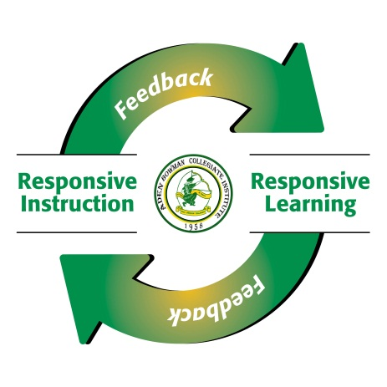
Robotics 10 20 30 - Mr. Scott
In this course, you will explore a variety of related disciplines: Design and Manufacturing, Electronic Components and Circuit-Building, and Logic and Coding. Combining the ideas from these areas will allow us to investigate and create robotic systems.

As in all classes, being present and on time each day is a crucial ingredient for your success. Please be pro-active about communicating any absences that will take place and take the steps necessary to be caught up for when you return. To help your organization, assignments and course information will be posted on our Canvas classroom, making them available anywhere that you have internet connectivity.

Computer Use:
In this course, you will be spending a considerable amount of time working on school computers and using the internet for research. Use your computer time wisely, and refrain from unnecessary use of social media and websites that are not part of the class resource list.

Equipment Use:
In this class, you’ll be using a wide array of equipment, from small electronics components to a laser engraver and 3D printer. In order to keep this class sustainable, I’m counting on you to take care of all equipment and do your part to keep it organized. Please treat all school equipment with care so that others may use it after you!

Safety:
A variety of hand and craft tools will be used while constructing projects in this class (soldering irons, dremels, hot glue guns) along with larger manufacturing tools (laser cutter, CNC, 3D printer). As well, low voltage DC power supplies will be used frequently. Before first using any of these tools, we’ll discuss any associated risks and how to use them in a safe manner for ourselves and others. Working safely at all times is essential for those who take this class. Any behaviors that result in an unsafe situation for yourself or others may result in removal from the course.

Evaluation:

In this course, you will be evaluated on the work you do, and the way you do it. Skill development will be assessed regularly using mastery challenges and graded assignments.
Knowledge of the vocabulary and techniques will be reviewed with exit and entrance slip quizzes as well. Larger projects will be used to demonstrate how different knowledge and skills developed in the course can be combined in a sophisticated way.

Mark Distribution:

Quizzes 15%
Assignments 40%
Major Projects (3) 45%

Outcomes Covered:

Throughout the semester, the following curricular outcomes will be studied in this course. The objective number is listed with each item. The percentage listed with each outcome grouping corresponds with the amount of course time and weight apportioned to those areas.

History, Background,
Ethics, and Careers 10%
General Safety 1
History of Robotics 2
Ethics and Law 3
Societal Impact 4
Careers in Robotics 64

Electrical 20%
Electrical Safety 9
Electrical Theory 10
Basic Electricity 11A
Solderless Breadboards 12A
Electronic Components 13A
Drawing Circuits 14A
Measuring Instruments 15
Soldering 18

Software 10%

File Management 24
Psuedocode 25A
Block-Based Coding 26A
Syntax and Organization 27
Coding 28A

Autonomous Robotics 20%
Sensor Theory 31A
Ultrasonic Sensors 34A
Infrared Sensors 35A
Line Sensors 32A
Sound Sensors 36A

Power Sources 40A
Drive Systems 41
Motors 44
Servos 45
Stepper Motors 46
Motor Controllers 48A
Machining | Manufacturing 10%

Properties of Materials 51
Fasteners 52
Fabricate 53A, 53B
3D CAD Basics 54
3D Printing 55A
CNC Manufacturing 56

Projects 30%

Design Thinking 7A
Physical Space Management 61
Major Projects 63A, 64A,
65A

