# Greenlight Power Coding test

Our platform main technologies are:

* JQuery
* Gulp
* SAAS
* BEM

And we want to see how comfortable are you with those technologies. We have provided you with framework and all you need to do is:

Install Node, Bower & Gulp, then run ***npm install*** from the terminal

# Requirements

Build functionality as it is displayed in the image. Background image is attached(*banner_bg.png*) 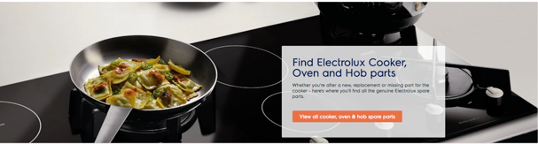

## Objectives:

·  Responsive

·  Maintainable/Re-usable

·  Cross browser compatible

·  Use SASS

·  Use the BEM naming convention

# After Task completion

Please zip completed task with your name_surname_date.zip and upload it to www.wetransfer.com