Exam Preparation I
Submit your solutions here: https://alpha.judge.softuni.org/contests/exam-preparation-i/4512

1. Unit Test: Dictionary Intersection
Test a given method which takes in 2 <string, int> dictionaries and finds the intersection of the two.
The method is found in the DictionaryIntersection.cs file:
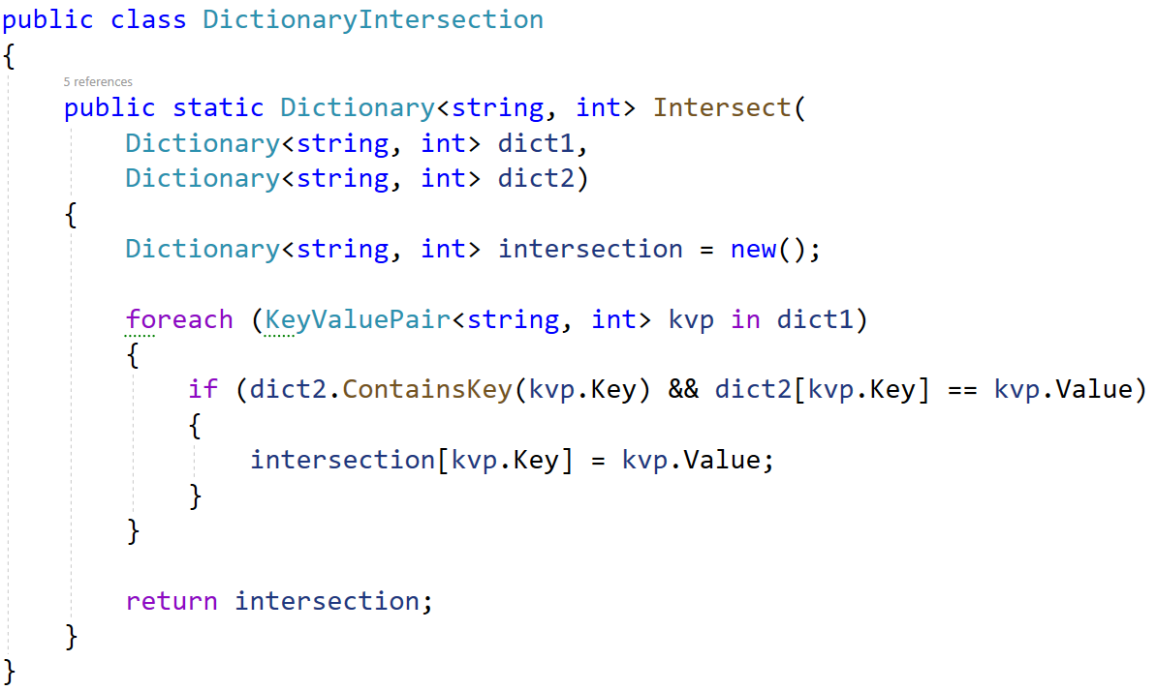
You are given a test file DictionaryIntersectionTests.cs containing 5 empty tests. Implement all tests:
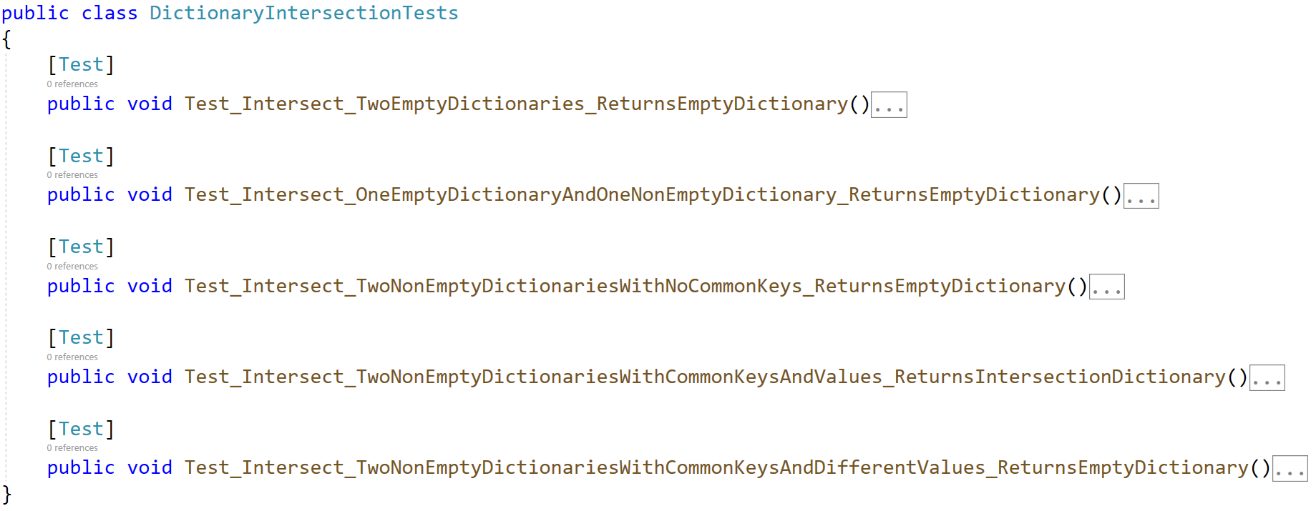
When you are ready make sure your tests run:
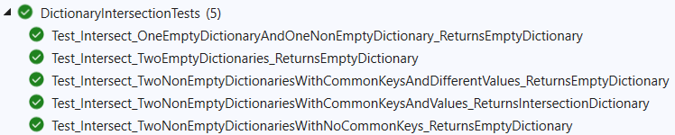
IMPORTANT: DO NOT REMOVE OR CHANGE ANY NAMESPACES AND USINGS.

2. Unit Test: Product
You are given a folder of 2 classes - Product and ProductInventory. The Product class is just a helper class:
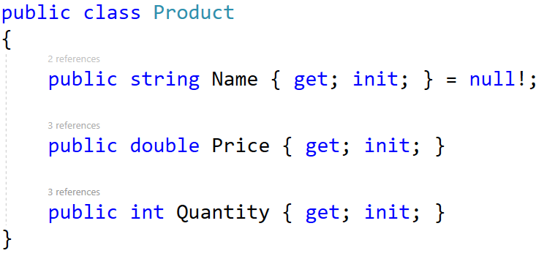
The ProductInventory class holds a list of products and methods for using the list that you will test:
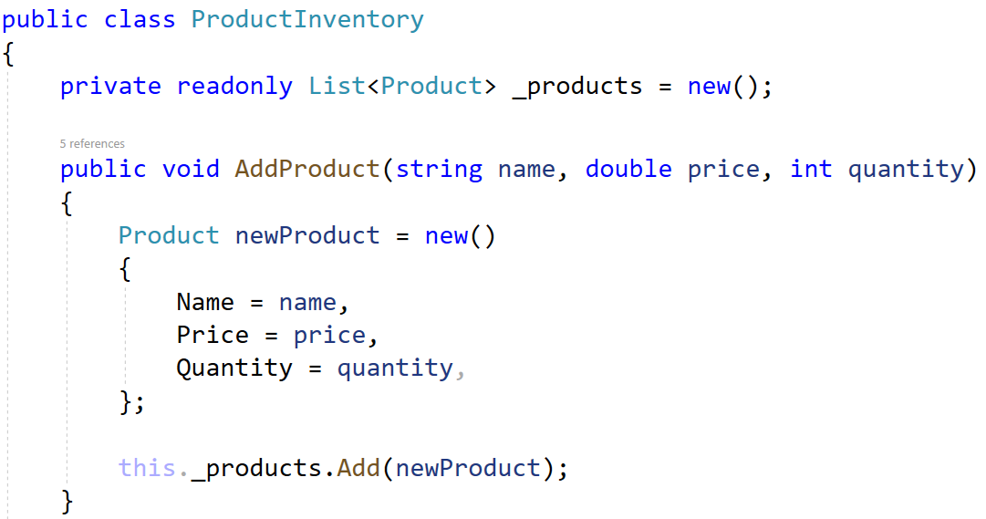
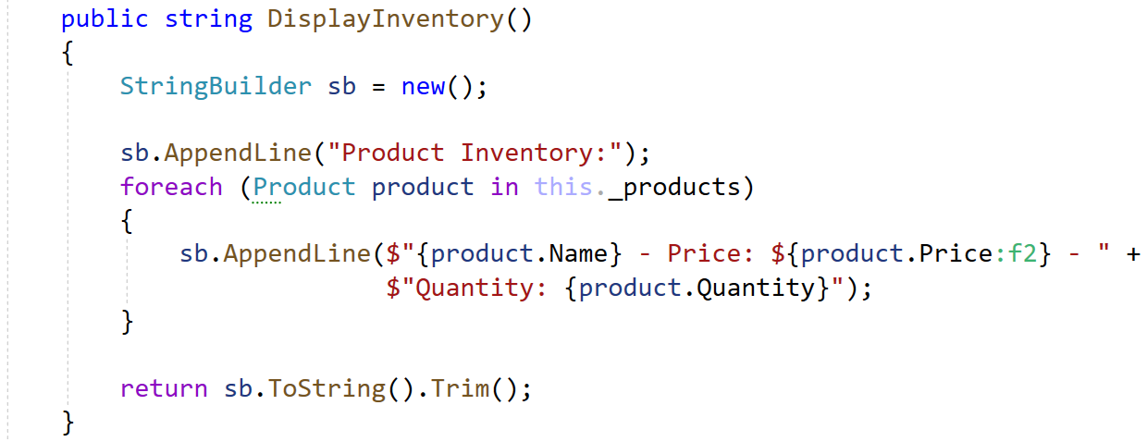
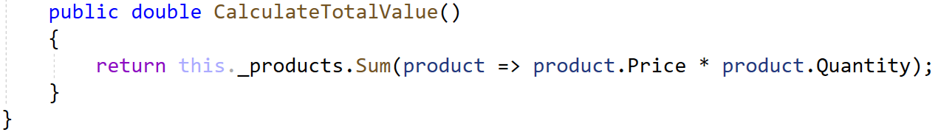
You will need to use the test file ProductInventoryTests.cs, inside they are 5 empty tests with a setup method:
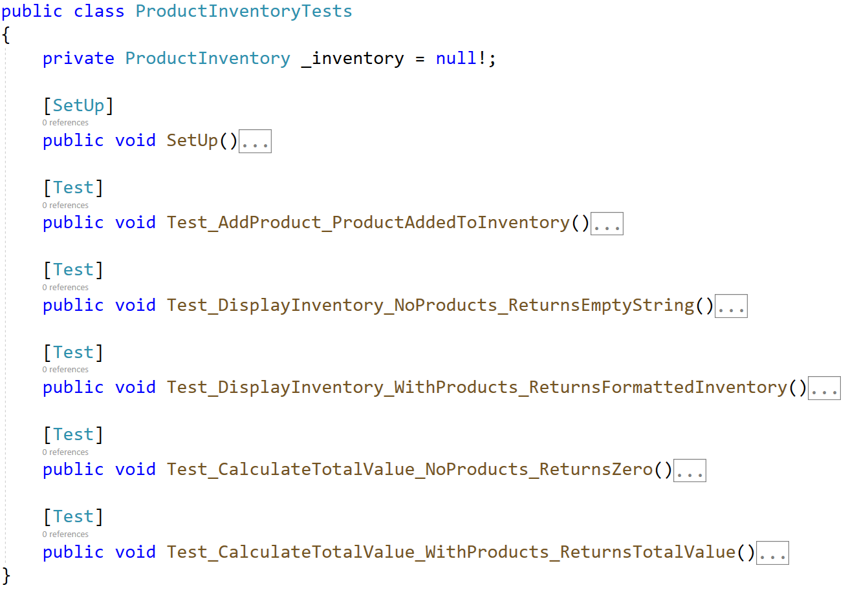
When you are ready make sure your tests run:
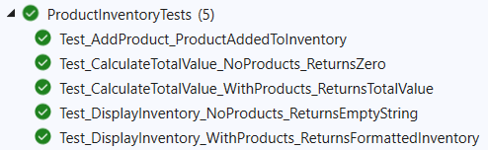
IMPORTANT: DO NOT REMOVE OR CHANGE ANY NAMESPACES AND USINGS.

3. JS Unit Testing
After opening the project, run npm install in the console.

Your Task
Using Mocha and Chai write JS Unit Tests to test a variable named findNewApartment, which represents an object. You may use the following code as a template:
describe("Tests …", function() {
describe("TODO …", function() {

it("TODO …", function() {
// TODO: …
});
});

// TODO: …
});

The object that should have the following functionality:
- isGoodLocation (city, nearPublicTransportation) - A function that accepts two parameters: string and boolean.
- If the value of the string city is different than a "Sofia", "Plovdiv" or "Varna"
return :
"This location is not suitable for you."
- If the value of the boolean nearPublicTransportation is false
return :
"There is no public transport in area."
- Otherwise, if the above conditions are not met, return the following message:
- "You can go on home tour!"
- You need to validate the input, if the city and nearPublicTransportation are not a string and boolean, throw an error: "Invalid input!".
- isLargeEnough (apartments, minimalSquareMeters) - A function that accepts an array and number.
  - The apartments array will store the area of the apartment in square meters ([40, 50, 60…])
  - You must add the area of apartment in resultArr if is equal or bigger than minimalSquareMeters.
- Finally, return the changed array of apartments.
  - There is a need for validation for the input, an array and number may not always be valid. In case of submitted invalid parameters, throw an error "Invalid input!":
    - If passed apartments parameter is not an array.
    - If apartments is empty array.
    - If the minimalSquareMeters is not a number.

- isItAffordable (price, budget) - A function that accepts two parameters: number and number.
- You need to calculate if you can afford buying the apartment by subtracting the price of the apartment from your budget.
- If the result is lower than 0, return:
"You don't have enough money for this house!"
- Otherwise, if the above conditions are not met, return the following message:
"You can afford this home!"
- You need to validate the input, if the price and budget are not a number and price and budget are less or equal to 0, throw an error: "Invalid input!".

JS Code
To ease you in the process, you are provided with an implementation that meets all of the specification requirements for the findNewApartment object.

Submission
Submit your tests inside a describe() statement, as shown above.

