Exam Preparation II
Submit your solutions here: https://alpha.judge.softuni.org/contests/exam-preparation-ii/4513

1. Unit Test: Fruits
Test a given method which takes in a <string, int> dictionary representing fruits and a string fruit name. It returns the quantity of the fruit.
The method is found in the Fruits.cs file:
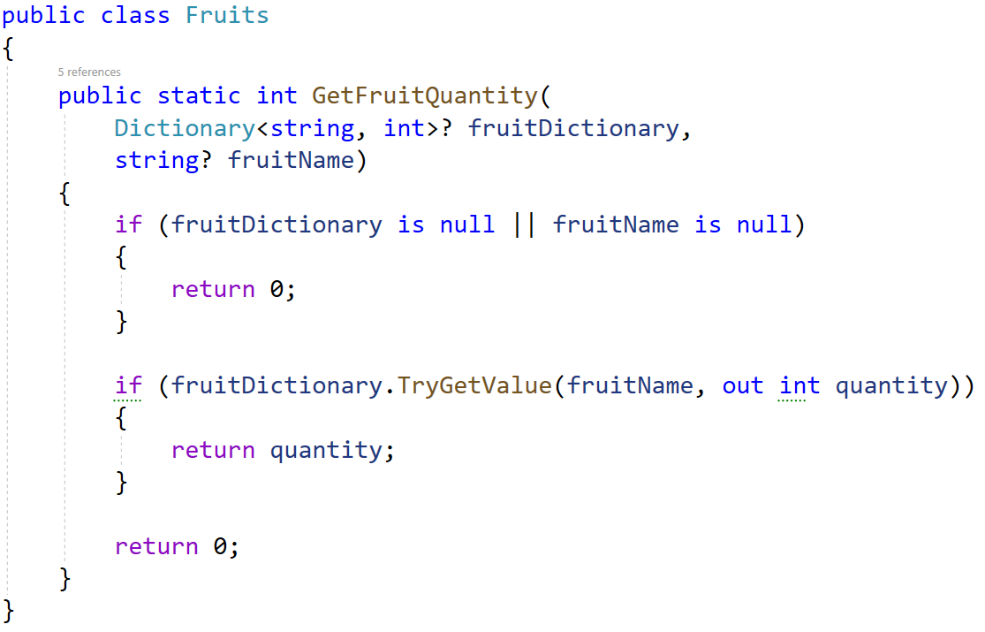
You are given a test file FruitsTests.cs containing 5 empty tests. Implement all tests:
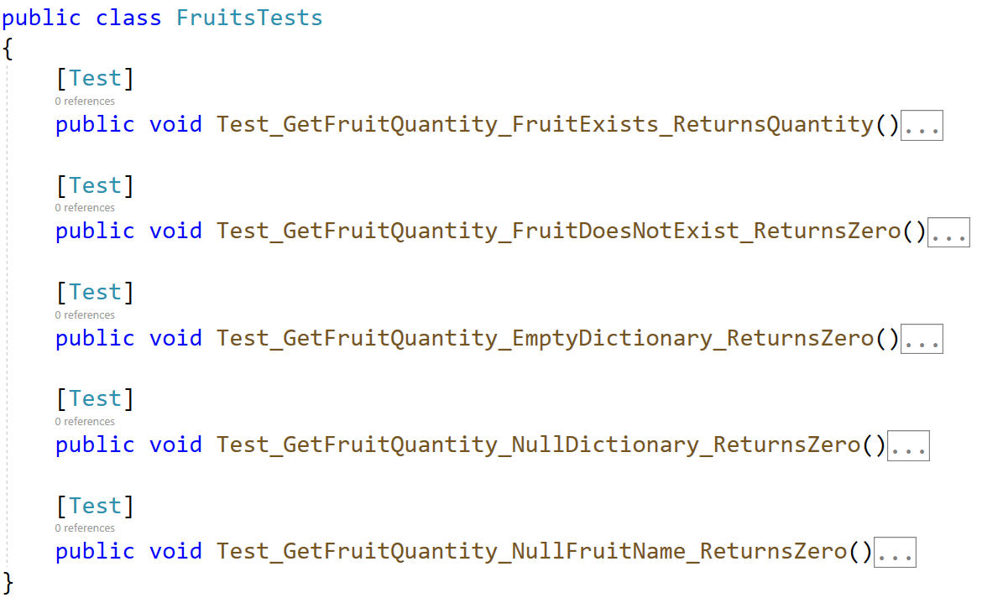
When you are ready make sure your tests run:
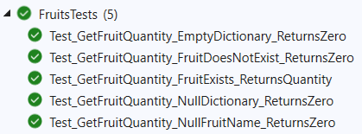
IMPORTANT: DO NOT REMOVE OR CHANGE ANY NAMESPACES AND USINGS.

2. Unit Test: ToDo
You are given a folder of 2 classes - TaskItem and ToDoList. The TaskItem class is just a helper class:
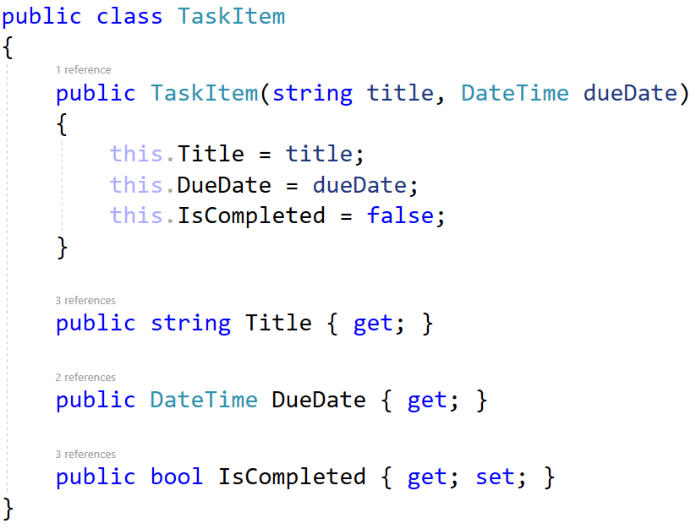
The ToDoList class holds a list of tasks and methods for using the list that you will test:
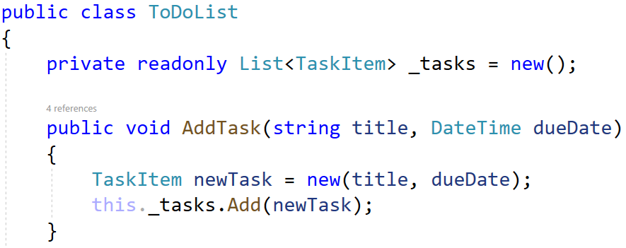
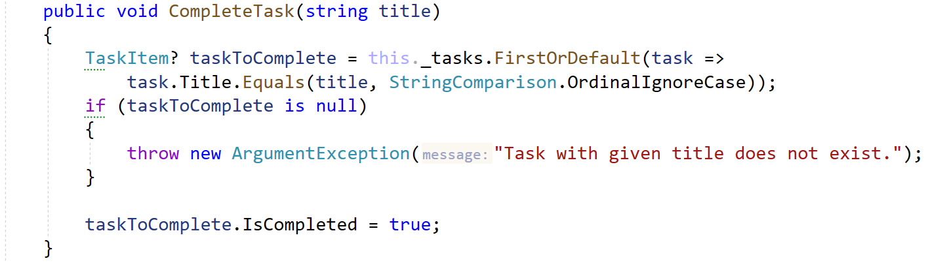
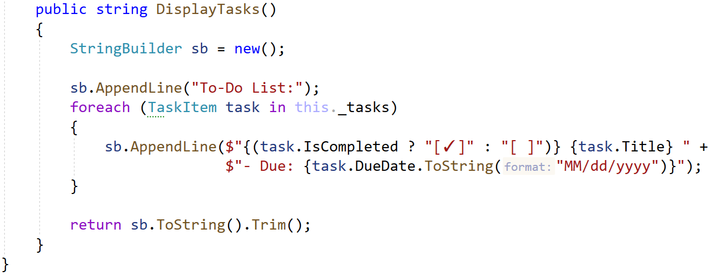
You will need to use the test file ToDoListTests.cs, inside they are 5 empty tests with a setup method:
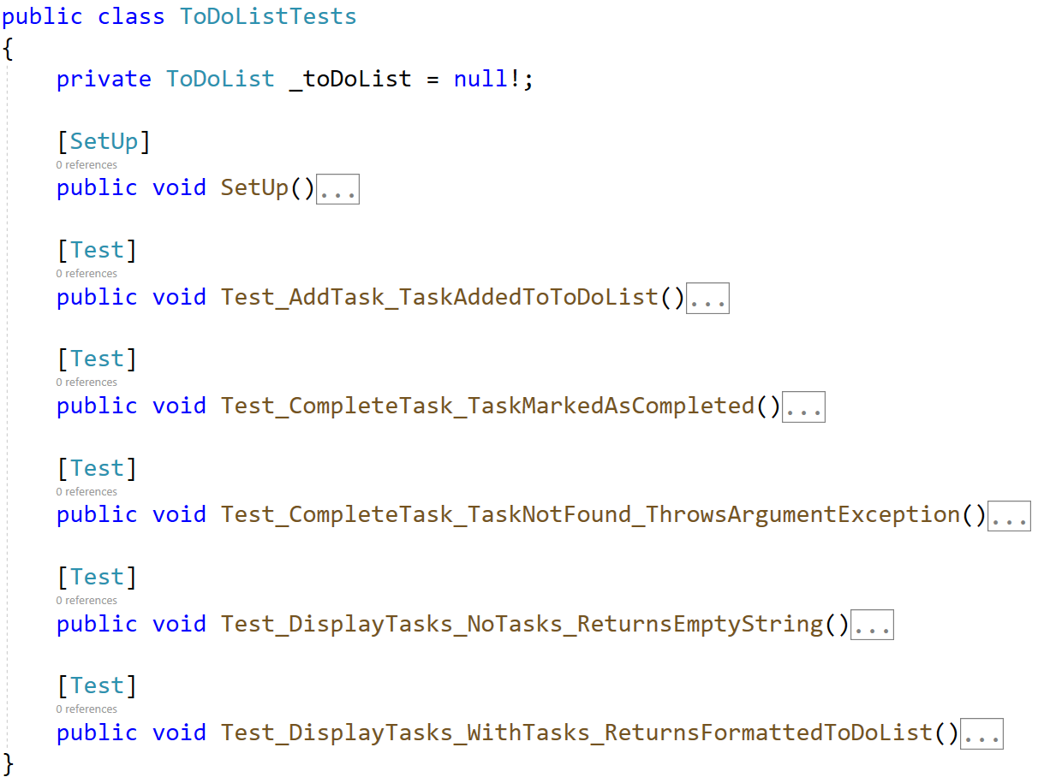
When you are ready make sure your tests run:
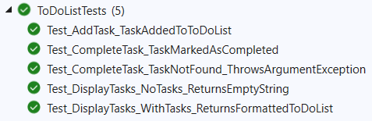
IMPORTANT: DO NOT REMOVE OR CHANGE ANY NAMESPACES AND USINGS.

3. JS Unit Testing
After opening the project, run npm install in the console.

Your Task
Using Mocha and Chai write JS Unit Tests to test a variable named chooseYourCar, which represents an object. You may use the following code as a template:
describe("Tests …", function() {
describe("TODO …", function() {
it("TODO …", function() {
// TODO: …
});
});
// TODO: …
});

The object that should have the following functionality:
- choosingType (type, color, year) - A function that accepts three parameters: string, string, and number.
- If the year is less than 1900 and the year is more than 2022, throw an error: "Invalid Year!"
- If the value of the string type is different from "Sedan", throw an error: "This type of car is not what you are looking for."
- To be picked, the car must meet the following requirement:
  - If the year of the car is greater or equal to 2010, return the string:
"This ${color} ${type} meets the requirements, that you have."
- Otherwise, if the above conditions are not met, return the following message:
"This ${type} is too old for you, especially with that ${color} color."
- There is no need for validation for the input, you will always be given two strings, and number.
- brandName (brands, brandIndex) - A function that accepts an array and number. The brands array will store the brand names (["BMW", "Toyota", "Peugeot"…]).
  - You must remove an element (brand) from the array that is located on the index specified as a parameter.
  - Finally, return the changed array of brands as a string, joined by a comma and a space.
  - There is a need for validation for the input, an array and index may not always be valid. In case of submitted invalid parameters, throw an error "Invalid Information!":
    - If passed brands parameter is not an array.
    - If the index is not a number and is outside the limits of the array.

- CarFuelConsumption (distanceInKilometers, consumptedFuelInLitres) - A function that accepts two parameters: number, number.
- You test drive the car to find out what its consumption is.
- You need to calculate liters per 100 kilometers consumption by dividing the fuel consumption by 100 and then multiply by distance.
    - The result must be formatted to the second digit after the decimal point.
- If the liters/100km is less or equal to 7L. return the following message:
"The car is efficient enough, it burns ${litersPerHundredKm} liters/100 km."
- Else, return the following message:
"The car burns too much fuel - ${litersPerHundredKm} liters!"
- You need to validate the input, if the distanceInKilometers and consumptedFuelInLitres are not numbers, or are negative numbers, throw an error: "Invalid Information!".

JS Code
To ease you in the process, you are provided with an implementation that meets all of the specification requirements for the chooseYourCar object.

Submission
Submit your tests inside a describe() statement, as shown above.

