Stefan Knott
HW4

Data File Name: localhost:/home/stefan/Downloads/Morrison.dem
Database comment: Driver: USGSDEM/USGS Optional ASCII DEM (and CDED)
File Format: GDAL_1.0
How many meshes are there and what are their names: 10, mesh, elevated/mesh, lower_res/resolution_0537x0695,elevated/lower_res/resolution_0537x0695,lower_res/resolution_0268x0347, elevated/lower_res/resolution_0268x0347, lower_res/resolution_0134x0173, elevated/lower_res/resolution_0134x0173,
lower_res/resolution_0067x0086, elevated/lower_res/resolution_0067x0086
What is the mesh type for the elevated/mesh: Unstructured Mesh
How many Spatial Dimensions does it have: 3
How many Topological Dimensions does it have: 2
What are its Spatial extents: not set
Question: 64 high res grid patches per low res patch
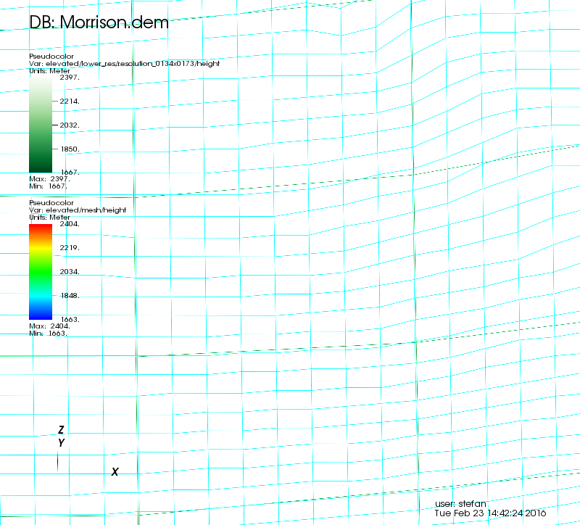

Question: Perhaps because there is more data relating to one color. For example, in areas where green is more prevalent maybe there is more low resolution data that high resolution – or perhaps high resolution data for those areas is non existent.

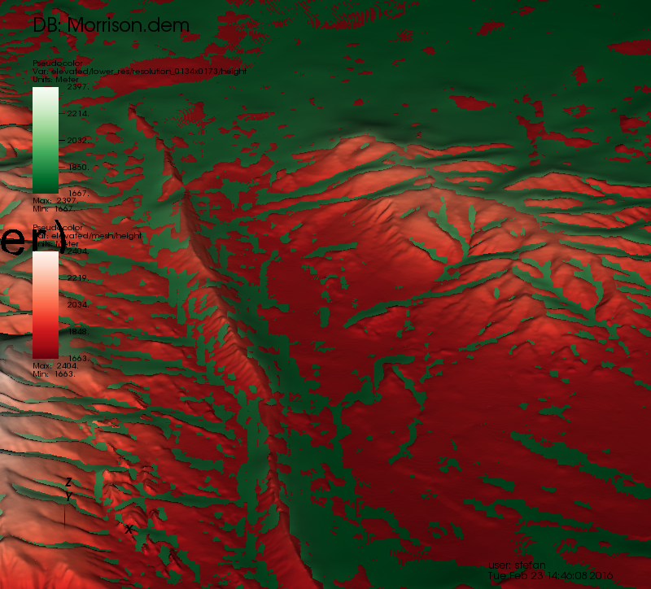

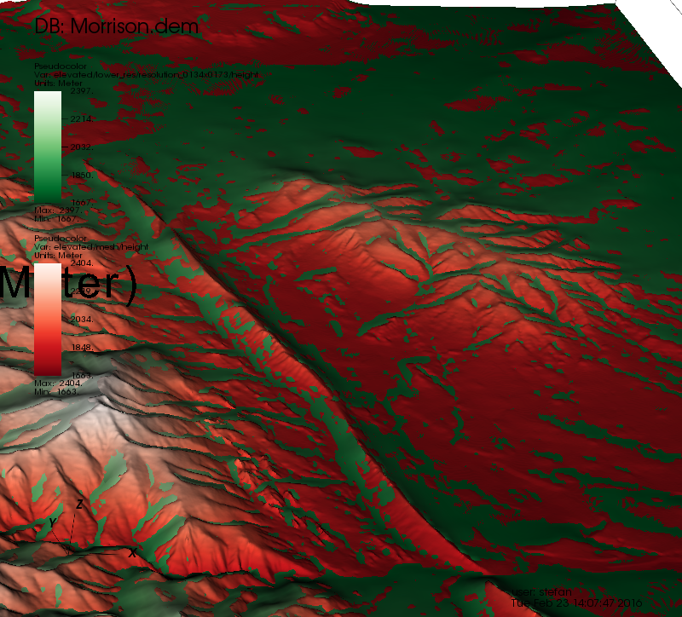

Question: All of the data points have been smoothed – making it so the data isnt represented in a rough, blockish way. I think that internally VisIt is perhaps creating a finer mesh for the data to be represented on. Or perhaps VisIt is just outlining the rough depiction with no smoothing, and then just filling in the negative space caused by the data grid.
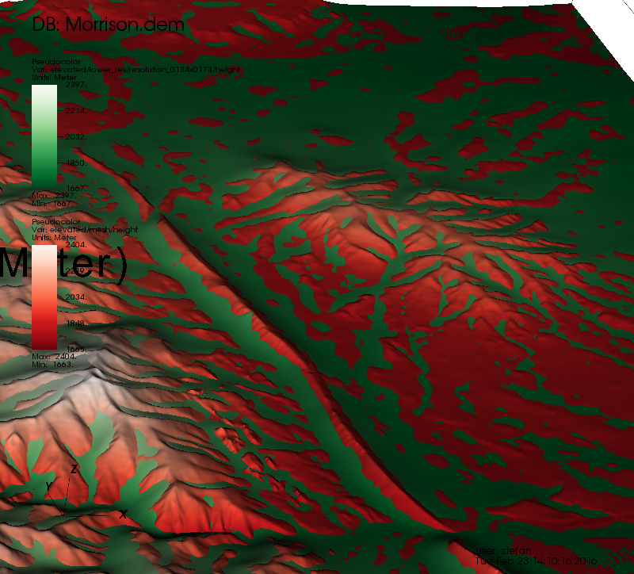

Question: I believe that the visualization with high smoothing is the best to use in this situation. This is because it seems to provide a more consistent visualization (solid greens and reds are smoothed together more than in fast) The high setting also helps the two data meshes work together in an efficient manner for visualization.
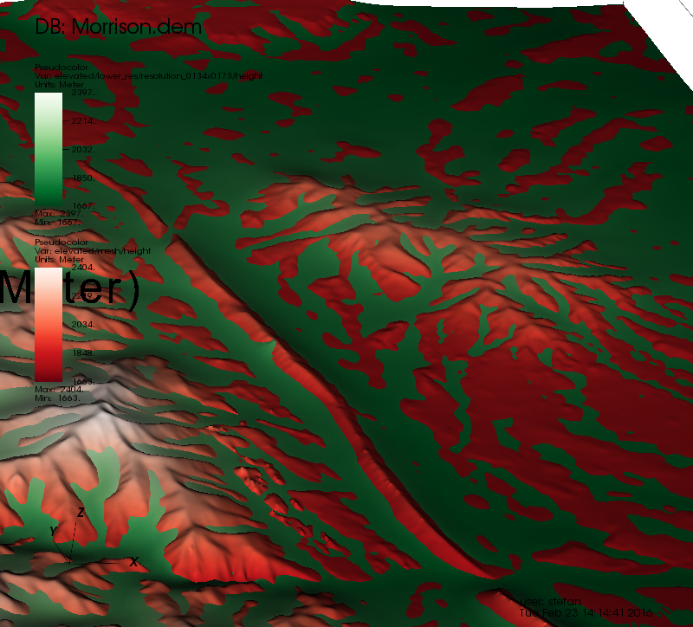

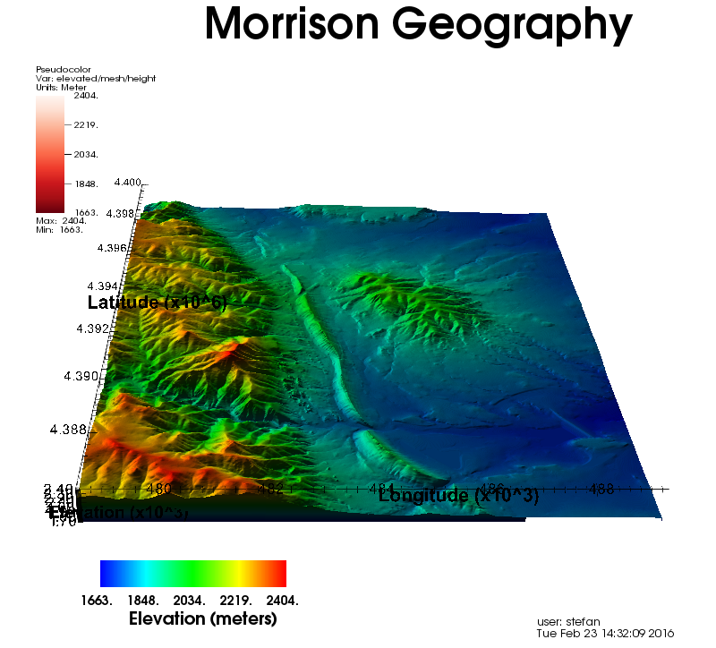

Question: MASSIVE LIE
Question: Problem with axis labels, ho wto fix

