**Built-in Functions**

 Returns the length of the given string.



 Converts the letters of the parameter to lower/upper case.

 Takes a number of letters starting from the left/right side of the string.

Trims from white spaces from the left/right.

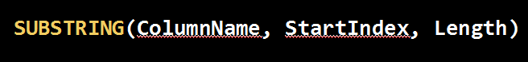

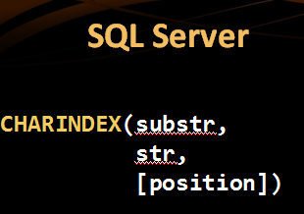

Returns the start index of the substring in the big string. Returns 0 if no index is found.



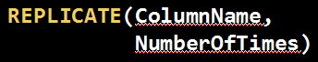 Repeats the given string, given number of times.

 Reverses the given string

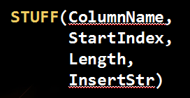Deletes length number of symbols starting from the given start index and then inserts the given insert string at the start index.



, , 

, 

 - Returns (-1, 0, 1) depending on the sign of the number.





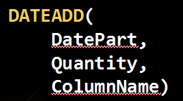 Add a number of “intervals” to the date.

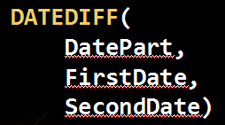 In SQL Server, returns the difference of the given date part.

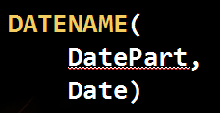 In SQL Server, returns what the desired date part is.

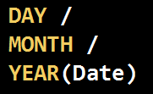 



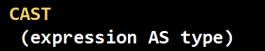



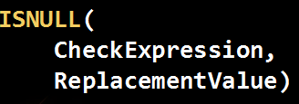 Converts from one type to another



