**IT3708 BIO-Inspired AI**

**Project 4 Report - Job Shop Scheduling Problem**

**Stefan Sobczyszyn Borg**

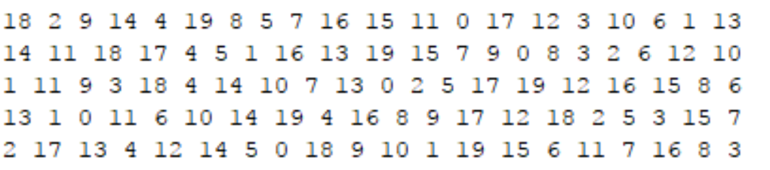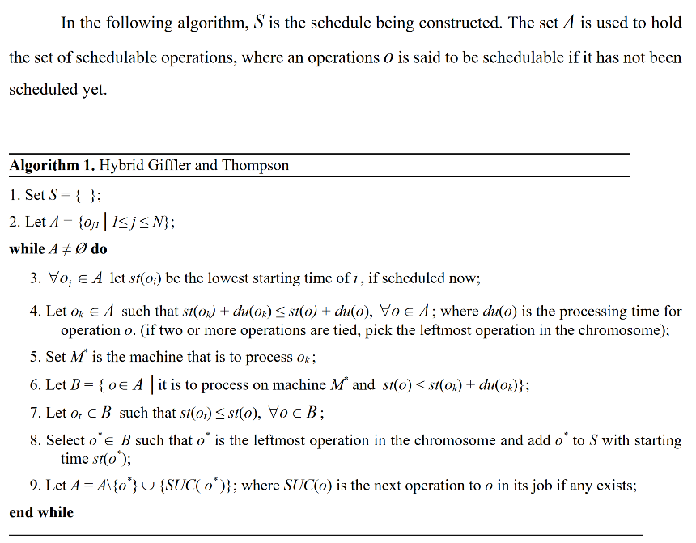The solution representation is the same for all the algorithms. Individuals are represented with a preference-list for each machine, and uses the Giffler Thompson algorithm to build an active schedule from the representation. The GT algorithm keeps track of the next operation for each job (given by the input specification). It then selects the machine, m, with the potential earliest finish time given the possible operations. The next step is to identify all operations which have a starting time before the finish time on m and are performed on m. If there are several operations satisfying the mentioned conditions, there is a deadlock. Deadlocks are resolved by the preference list representation. The preference list contains an identifier for each job. The operations (and their corresponding job) in deadlock are compared to their place in m’s preference list, and the operation from the first occurring job is added to the schedule. The makespan of the generated schedule is decided by the ordering of jobs in the preference list.

Figure 1: Preference list representation of a solution for problem 3 from the test data. Each row represents the machine and each column represents a job. This means that for the first machine, if there is a deadlock between job 18 and job 2, job 18 will have preference. This representation yielded a makespan of 1232.

Figure 2: Pseudocode for the Giffler Thompson algorithm for building active schedules from a preference list representation

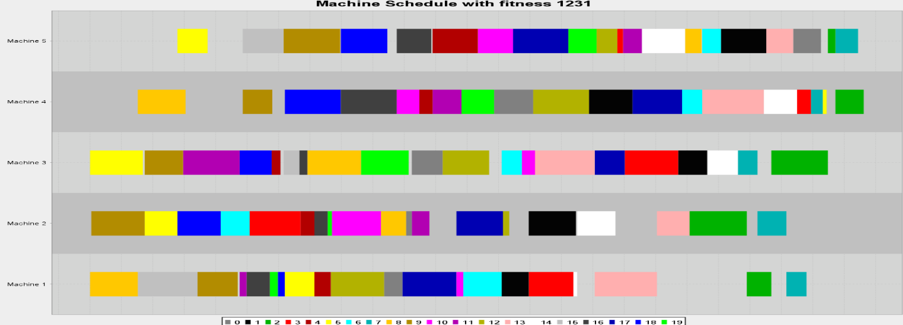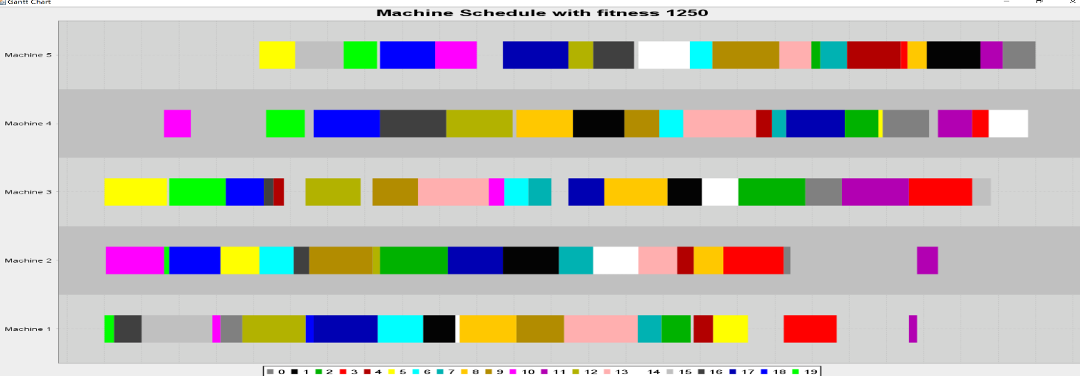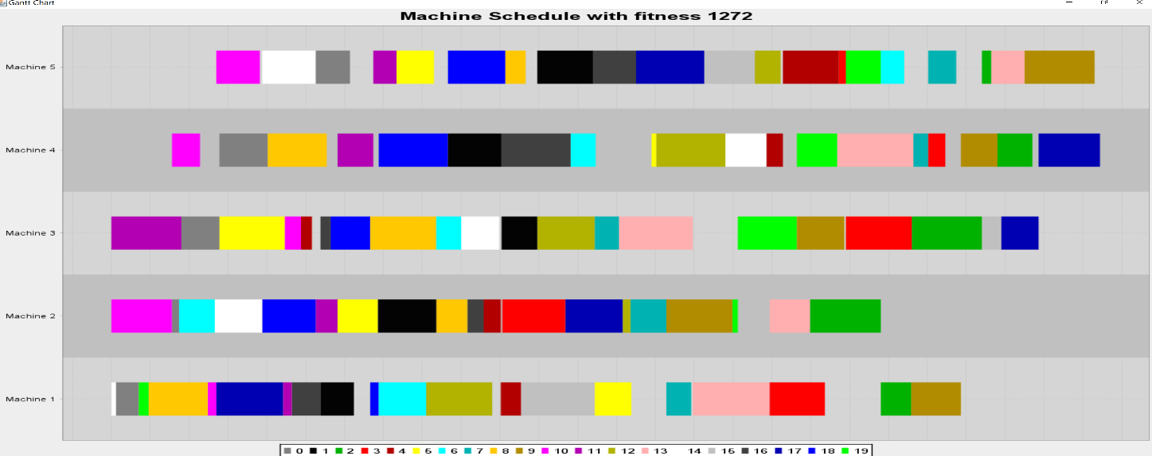

Figure 5: Schedule found for problem 3 using ant colony optimization algorithm (ACO). Makespan found: 1231

Figure 4: Schedule found for problem 3 using particle swarm optimization algorithm (PSO). Makespan found: 1250

Figure 3: Schedule found for problem 3 using bee’s algorithm (BA). Makespan found: 1272