Assignment 1a

- Not wait longer in the queue than 5 minutes

- Average 12 customers arrive per hour

- Each customer needs 4 minutes service time on average

#### Question 1: Assume that only one service register is installed. Calculate the average queuing time w of the customers using queuing theory.

By using formula (1) and the fixed values, we get:

λ = arrival rate = 12/60 min = 1/5 min

μ = service rate = 15/60 min = 1/4 min

w = average queuing time = (0.2)/((0.25)*(0.25-0.2)) = 16 min

#### Question 2: Why should you always run multiple replications of a terminating simulation that uses stochastic data?

We ran multiple replications to get a more exact result, because each replicate can vary a lot.

#### Question 3: Assume that only one service register is installed. What percentage of customers wait longer than five minutes?

60 % of the customers will wait longer than 5 minutes. See attached files (Pic 1).

#### Question 4: How many service desks would be needed to guarantee that on average over 95% of the customers will wait less than 5 minutes for service; using a) an own queue for each service register and b) a shared queue for all service registers? Which queuing strategy would you recommend to CC?

a) 6 desks will give you that less than 5 %  
b) 2 desks gives you approx. 4.8 % - 5.0 % of the customers which is waiting over 5 min. (Pick 3 desks to be extremely sure that you’ll never get a percent over 5 %.  
I would recommend strategy b to CC, see Pic 2.

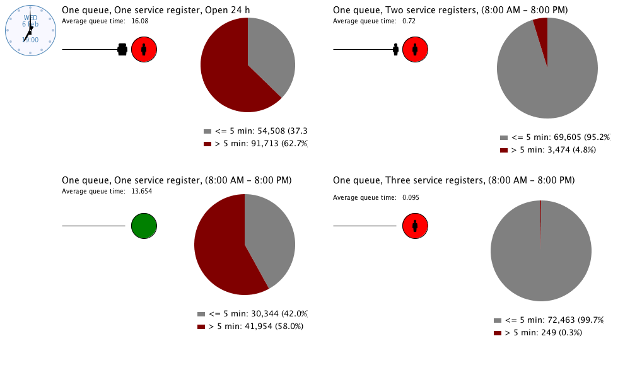

Pic. 1

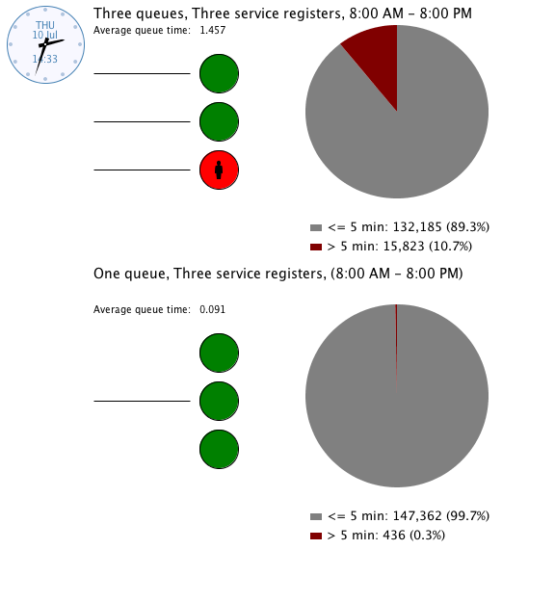

Pic 2.