Virtual Meet

Team members:

Calinciuc Laura

Gavrila Denisa

Puiu Andrei

Turcu Mihai

Virna Stefan

Similar products & Relevant links

Name: Stardoll

Url: <https://www.stardoll.com/ro/>

Relevant Features

- live communications

- create own character

Name: Sims

Url: https://www.ea.com/games/the-sims?isLocalized=true

Relevant Features

- meet people

- make new friends

- enjoy free time

Name: Teams

Url: https://www.microsoft.com/en-us/microsoft-teams/log-in

Relevant Features

- meetings

- live communications

Name: Among US

- join party rooms

- creating own room

Main Features

1. User will be able to join meeting rooms with different themes depending on the purpose of the meeting.

2. Users will have to choose an avatar before entering each room.

3. The participants will be able to use or move the objects in the room.

4. Avatars will have the option to change their place in the room, talk to others and express their feelings through emojis

5. The meeting host will be able to choose a color theme and a background sound

User Journey

Moodboard

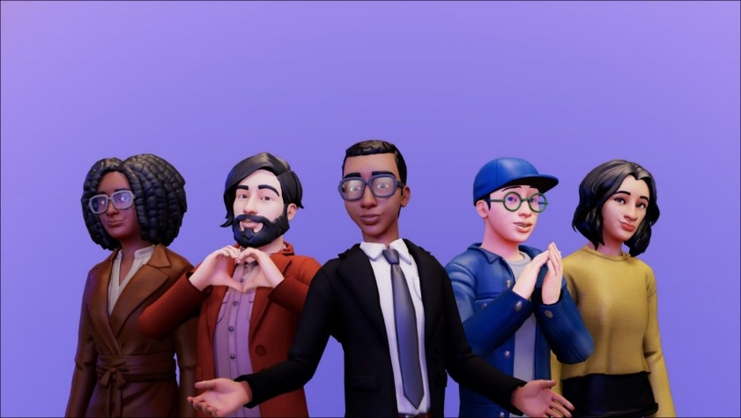

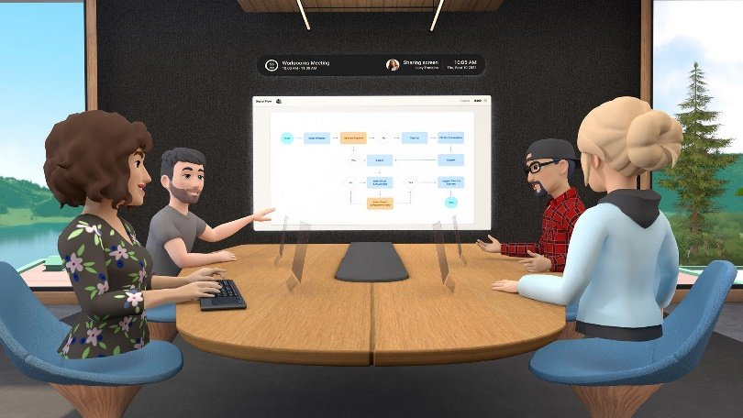

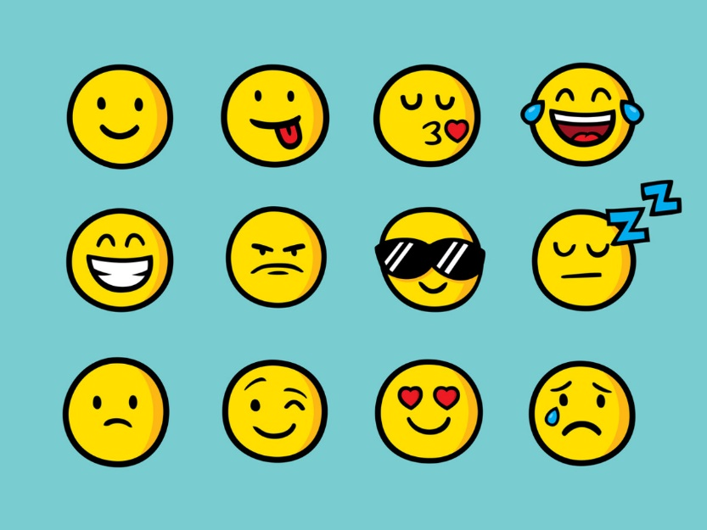

Technologies, Libraries, Assets

Application Engine: Unity

Modelling/Animation: Blender

Libraries:

SignalR: <https://dotnet.microsoft.com/en-us/apps/aspnet/signalr>

Adobe Photoshop: <https://www.adobe.com/ro/products/photoshop>