Checklist for ERT equipment

Computer | Laptop GETAC (large) | There are 3 of them, numbered 0, 1, 2.  “0” works for ERT
Computer | Laptop wall plug charger
Computer | Laptop car charger adaptor
Computer | Spare laptop batteries
Computer | Separate GETAC battery charger for 2 x laptop batteries | 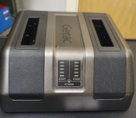
Computer | USB dongle if license is needed for 2d-inv
Station | TIGRE station | (in medium size black box)
Station | Cable for battery connect
Station | Cable for laptop Ethernet connect
Station | User manual
12 V Batteries | 1 + 1 spare | 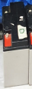
12 V Batteries | Wall plug 12 V charger 2x | 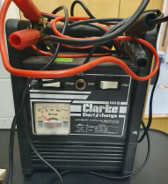  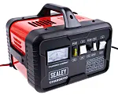  +
Spools and electrodes | 64 setup:  2 x large boxes (32+32el & 1+1 spool)
Spools and electrodes | 128 setup:  add 2 x boxes  add 2 x extension cables
Measuring tools | Trundle (measuring) wheel
Measuring tools | Tape measures
Positioning tools | GPS rover emlid receiver
Positioning tools | GPS base emlid receiver
Positioning tools | 2 x Poles for GPS receivers  not mandatory if GPS on ground level
Positioning tools | Emlid app on smartphone
Positioning tools | Passwd: emlidreach
Positioning tools | Save CSV to smartphone!!
Transporting gear | 2-wheeled sack truck
 | Open frame backpack
 | Puncture-proof wheel cart
First aid kit
Hi-vis jackets

