Checklist for Geode seismic kit equipment

Computer | Laptop GETAC (large) | One of 0, 1, 2.
Computer | Laptop wall plug charger
Computer | Laptop car charger adaptor
Computer | Spare laptop batteries
Computer | Separate GETAC battery charger for 2 x laptop batteries | 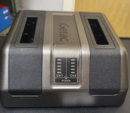
Computer | USB dongle if license is needed for 2d-inv
Station | Geode station | (medium yellow box)
Station | Cable for battery connect
Station | Cable for laptop Ethernet connect
Station | Interface laptop/station | Grey small box with blue led
Station | User manual
12 V Batteries | 1 + 1 spare minimum | 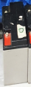
12 V Batteries | Wall plug 12 V charger 2x | 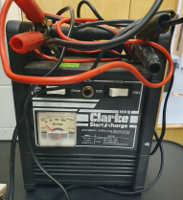  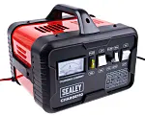  +
Spools | 1 x large black spool | Black with red connectors, two electrodes on each connector
Geophones | At least 24 working geophones.  P high freq. (standard).
 | Special use: S geophones
 | Special use: low freq P geophones
Sledgehammer+trigger | One sledgehammer with working trigger
Trigger cable | One cable to connect trigger far from station | Blue medium spool
Measuring tools | Trundle (measuring) wheel
Measuring tools | Tape measures
Positioning tools | GPS rover emlid receiver
Positioning tools | GPS base emlid receiver
Positioning tools | 2 x Poles for GPS receivers  not mandatory if GPS on ground level
Positioning tools | Emlid app on smartphone
Positioning tools | Passwd: emlidreach
Positioning tools | Save CSV to smartphone!!
Transporting gear | Puncture-proof wheel cart
First aid kit
Hi-vis jackets

