Checklist for SmartSeis seismic kit

Station | SmartSeis station | (large yellow box)
Station | Cable for battery connect
Toolkit | Fax paper for printing, keyboard, usb floppy disk external reader, spare floppy discs | Plastic toolbox
Computer | Any computer w usb port. not needed in field, but used to readout data from floppy at end of day.
12 V Batteries | 1 + 1 spare | 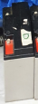
12 V Batteries | Wall plug 12 V charger 2x | 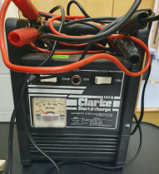  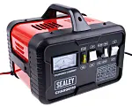  +
Spools | 2 x large yellow spool | Yellow large spools. Red connectors with 2 electrodes on each connector
Geophones | At least 24 working geophones.  P high freq. (standard).
Geophones | Special use: S geophones
Geophones | Special use: low freq P geophones
Sledgehammer+trigger | One sledgehammer with working trigger
Trigger adaptor | Adaptor fro trigger plug on smartseis
Trigger cable | One cable to connect trigger far from station | Black medium spool, thin cable
Measuring tools | Trundle (measuring) wheel
Measuring tools | Tape measures
Positioning tools | GPS rover emlid receiver
Positioning tools | GPS base emlid receiver
Positioning tools | 2 x Poles for GPS receivers  not mandatory if GPS on ground level
Positioning tools | Emlid app on smartphone
Positioning tools | Passwd: emlidreach
Positioning tools | Save CSV to smartphone!!
Transporting gear | Puncture-proof wheel cart
First aid kit
Hi-vis jackets

