Department of Earth Sciences, University of Durham
Fieldwork Geophysics
VES – Resistivity with Vertical Electrical Sounding

1) SCHULMBERGER COFIGURATION
Use the ABEM resistivity meter with the electrodes in the SCHLUMBERGER configuration:
C1
P1
P2
C2
2l
L
L

C1 and C2 are current electrodes (connect to C on the instrument) and P1, P2 are the potential electrodes (connect to P), and the electrodes are equally spaced apart. If this spacing is a, the measured value of the potential difference (between P1 and P2) is ΔV , and the current input is I, then the apparent resistivity is give by:
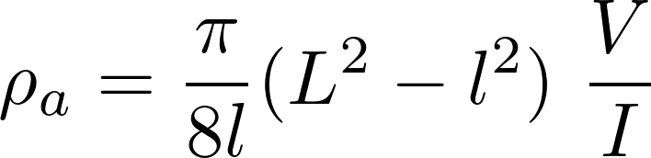
where 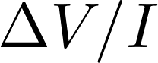is resistance in Ohms. (Note that if L>> l then the approximate formula may be used: 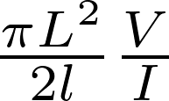, but better to use the one above that covers all cases).

Electric sounding is carried out by expanding the size of the array to allow current to penetrate deeper into the ground. Ideally this is done with a constant spacing on a log scale (for example 0.5, which gives a factor of sqrt(2) between successive spacings) but you could use a factor of 2 and double the spacing: 0.25, 0.5, 1, 2, 4, 8 m, to keep things simple. Start with a spacing of 0.125 m. Expand the array until you have the largest array that will fit on the site (L=128 m). Work out before you start where the centre will be!
To carry out a sounding experiment with the Schlumberger array, P1 and P2 are fixed close together (try l = 0.125 m), and C1, C2 are expanded symmetrically outside them (try starting with L = 0.5 m). If the readings become unstable then repeat the reading with an increased value for 2l but remember to repeat at least two readings with both values of 2l so you can compute the shift.
As spacing increases, eventually you may need to increase the inner spacing l to get large enough readings. To take account of this change, measure two points with the same L but with both the old and the new l. This will give overlapping but slightly offset profiles, and you should shift the one with larger l to be continuous with the other.
To set up the array, push the steel stakes (electrodes) into the ground up to the bend, then connect them to the appropriate terminal on the meter. Keep the horizontal part of each stake aligned at right angles to the line of the array. It is easiest, for an expanding spread experiment, to have the reels of cable near the meter at the centre of the array, and to use the shorter cables for the potential electrodes. Be careful to ensure that the right connections are made, and keep the polarity the same. (If the first reading is negative, you should reverse the polarity of either the P or C connections). It is good practice to keep the cables as far from the electrodes as possible (run them away from the electrodes at right angles to the line of the array). Be very careful in handling the cables and their connectors – it is quite easy, but very annoying, to break off the clips! Take particular care when reeling in or unwinding the cables, not to let the clips flap and bang into the reels, or to twist the wires.
Safety note: the ABEM that we use produces only small currents which should not normally be hazardous. However, good practice (which you should adopt) is always to ensure that no-one is touching the electrodes or other live components while a measurement is being made. Some professional resistivity sets produce lethal combinations of current and voltage.
Make a reading by pressing the button on the meter, and reading the resultant value of AV/ I from the LCD display. Note the units – either Ω (ohms) or mΩ (milli-ohms).. Start with the minimum current setting and a 4-cycle setting (instrument makes 4 separate measurements), and write down the four readings. If they significantly disagree this may indicate that the signal level is too low and noise is significant, so increase the current setting, there is a connection problem or probe is not making good contact with the ground . If the resistivity readings are similar and stable, you should have a good signal to noise ratio. Together with each set of readings, be sure to record the electrode spacing. It is also good practice to record the time of each measurement, and you must also note the current and other instrument settings at the start and if any of them change. Also note the weather and general ground conditions, and the precise location of the survey so it could be repeated, or related to other features, if necessary. Include a map and schematic plan in your report, this need not be drawn precisely to scale, but should include enough detail to allow the measurement positions to be relocated.

2) WENNER CONFIGURATION
Use the ABEM resistivity meter with the electrodes in the Wenner configuration
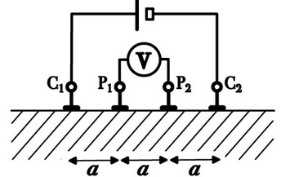

The apparent resistivity is
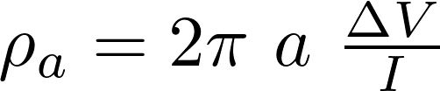

3) DIPOLE-DIPOLE

This is used with fixed electrode separation and for quick 2D profiling to identify a vertical boundary such as a fault or edge of land-fill.
Line electrodes with constant separation along profile, take measurement (like in Wenner above). Once the measurement is complete, roll the array along by moving one electrode, eg C1, to a new location distance a in beyond of of electrode P2, then move all the clips up one so the newly planted electrode becomes P2, old P2 is new P1, old P1 is new C2, and old C2 is new C1. To sound deeper increase the distance between C2 and P1 by an integer multiple of a.
Schlumberger indicative L distances
Here is a list of electrode spacings from centre for different values of L assuming we are increasing separation on a power of √2.
Schlumberger L distances  Example electrode spacings from centre for different values of L assuming separation increase of √2. | Wenner Array distances  Here is a list of electrode spacings from centre for different values of a
  0.125
  0.177
  0.250
  0.354
  0.500
  0.707
  1.000
  1.414
  2.000
  2.828
  4.000
  5.657
  8.000
  11.314
  16.000
  22.627
  32.000
  45.255
  64.000
  90.510
  128.000
  a(m) | P | C
  0.125 | 0.063 | 0.188
  0.177 | 0.088 | 0.265
  0.250 | 0.125 | 0.375
  0.354 | 0.177 | 0.530
  0.500 | 0.250 | 0.750
  0.707 | 0.354 | 1.061
  1.000 | 0.500 | 1.500
  1.414 | 0.707 | 2.121
  2.000 | 1.000 | 3.000
  2.828 | 1.414 | 4.243
  4.000 | 2.000 | 6.000
  5.657 | 2.828 | 8.485
  8.000 | 4.000 | 12.000
  11.314 | 5.657 | 16.971
  16.000 | 8.000 | 24.000
  22.627 | 11.314 | 33.941
  32.000 | 16.000 | 48.000
  45.255 | 22.627 | 67.882
  64.000 | 32.000 | 96.000
  90.510 | 45.255 | 135.765
  128.000 | 64.000 | 192.000

