Droplet
User Manual
Version 0.1.2

www.droplet.at
Updated: 26.01.2014
Copyright
This document is subject to the copyright © 2013. The contributings are listed below. You may use this document under the condition of GNU General Public License (http://www.gnu.org/licenses/gpl.html), Version 3 or higher, or the Creative Commons Attribution License (http://creativecommons.org/licenses/by/3.0/), Version 3.0 or highe, to change and/or give away.
Productname and trademarks
All product names mentioned in this document, registrated or not registrated trademarks are only fort he purpose of the identification mentioned and are the exclusive property of there owners.
Contributers/Authors
Stefan Brenner stefan.brenner@gmx.at www.stefanbrenner.com
Feedback
Comments or suggestions to this document can be send in german or english to discuss@droplet.at.
Date of the publication and software version
Published at 26.01.2014. Based on Droplet version 0.1.2.
Remarks for Windows users
Some button occupancies (hot-keys) and menu entries are different between Macintosh version and the one’s of Windows-and Linux-Computers. The following table gives you some basic indications for it.
Macintosh | Corresponds to Windows | Effect
⌘ (Command) | Ctrl (Control)  or Strg (Steuerung) | Hot key in combination with other shortcuts
⌘ + , | Edit → Preferences | Droplet settings

Inhalt
Kapitel 1: Introduction
What is Droplet? 5
Kapitel 2: Installation
Prerequisites 6
Mac OS X 6
Windows 7
Linux 8
Arduino 9
Source Code 10
Error handling 10
Kapitel 3: Introduction to Droplet
Communication 11
Device Setup 11
Processing 14
Logging 16
Toolbar 16
Preferences 17
Shortcuts 17
Kapitel 4: Droplet Serial Communication Protocol (DSCP)

Introduction
High speed photography makes special demands to the photographer and his equipment. The events which should be fixed are running in extreme short periods in the area from milli- or microseconds and are not visible for the sluggishly human eye.
Example of high speed events of the daily life:
- Bursting balloon
- objects falling to the ground and burst
- object falling into a liquid
- waterdrops
- impact of a gun bullet into an object

Within this part of photography it is absolute necessary to find the one right moment of the photography and this by a very short lightning time (1/1000 to 1/30.000 second) for freezing the event.

What is Droplet?
Droplet is a tool collection for the microcontroller supported high speed photography with special attention on the drop photography and liquid art. By the help of the microcontroller many of different equipments are steered exactly for the millisecond and combined for a defined workflow.

Installation

Prerequisites
For using of Droplet you need the following:
- Arduino microcontroller (for more information look at http://arduino.cc)
- USB cable A/B for connecting the pc with the microcontroller
- Microcontroller steered equipment which (for example solenoid valves, flash light , cameras, …)

Mac OS X

System requirements
- for Droplet’s current version at least is recommended Mac OS X 10.5 (Leopard)
- Java installed Java Runtime Environment (JRE) version 1.6 or higher

Install Droplet
One double click on the downloaded image file (dmg) activates the package as a new volume and a finder-window with the Droplet’s program-icon appears.
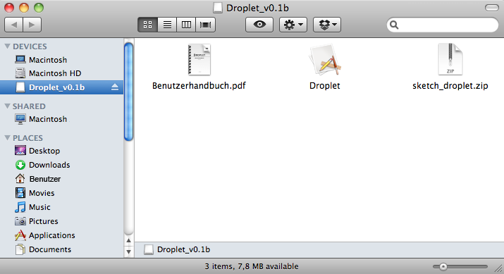

Now move the program with the mouse in the „Applications“ place.
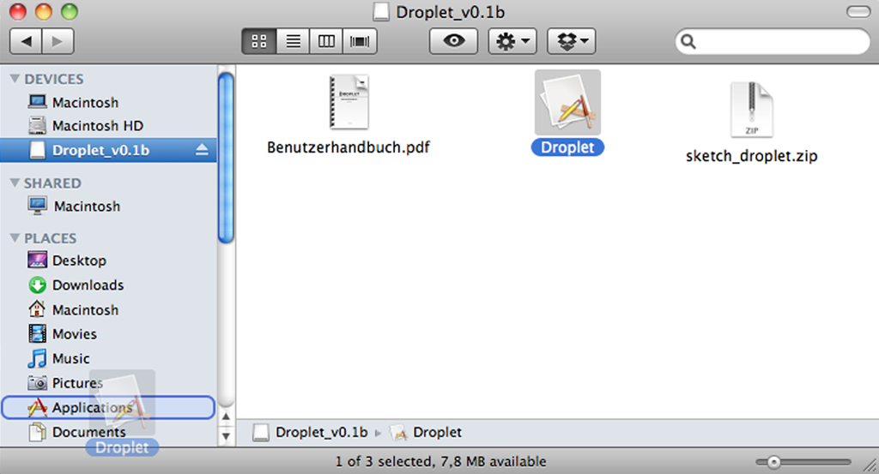
Afterwards cast the image.

Launch Droplet
You start Droplet by a double click on the program icon.

Windows

System requirements
- Windows XP, Windows Vista or Windows 7
- Java – installed Java Runtime Environment (JRE) version 1.6 or higher

Install Droplet
For installation please execute the Setup file. If you have installed a 32bit Java, please use setup_x86.exe and if you have installed an 64bit Java use setup_x64.exe. To find out which version of Java is installed please proceed as follows:

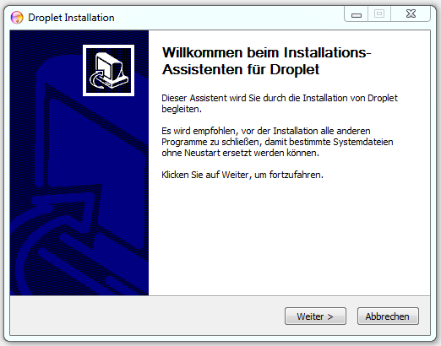
Select the place on your pc at which Droplet shall be installed. Afterwards you can produce an entry for Droplet in Windows Startup menu. From this place you are able to start Droplet comfortably.
Click on installing and wait until the installation process is ended. This should not last longer than a view seconds.
Congratulations, you have installed Droplet on your system successfully and you are now able to use it.

Launch Droplet
The easiest way to start Droplet is to start it from Windows StartupMenu. Click on the link Droplet. After a few moments the main screen of Droplet should appear.

Linux
For the usage of Droplet under Linux some basic knowledge of the shell is required.

System Requirements
- Droplet is just testet on Ubuntu 13.10
- Java – installed Java Runtime Environment (JRE) minimum version 1.6

Install and Run Droplet
Unpack the downloaded archive into a folder of your choice. Afterwards you can start Droplet with the included shell script.
sudo apt-get install openjdk-6-jre | (optional) Installation of the Java runtime
sudo apt-get install librxtx-java | Installation of the required RxTx library
tar -xvzf droplet-0.1.2.tar.gz | Unpacking Droplet
chmod a+x droplet.sh | Configuring the shell script
./droplet.sh | Run Droplet
java -jar droplet.jar | (optional) Alternative start of Droplet

Arduino

System requirements
- Arduino IDE (recommended is at least version 1.0)
- Droplet Arduino Sketch (included) or
- crazyMachine as of version 0.3a (optional)

Droplet Arduino Sketch
Droplet is delivered with a ready to use Arduino sketch, which you upload to your Arduino microcontroller and with Droplet you are able to control it by your pc. This sketch is made for the special dynamic claims of Droplet and (theoretically) arbitrarily much equipment can be controlled with it. The actual number depends on the used Arduinoboard.
Arduino Board | Possible devices | Amount actions per device
Arduino Nano  (ATMega168) | 14 | ca. 5 (1KB)
Arduino Nano  (ATMega328) | 14 | ca. 10 (2KB)
Arduino Uno  (ATMega328) | 14 | ca. 10 (2KB)
Arduino Duemilanova  (ATMega168 or ATMega328) | 14 | ca. 3 (1KB) (ATMega168)  ca. 5 (2KB) (ATMega328)
Arduino Mega 2560  (ATMega2560) | 54 | ca. 30 (8KB)

HINT | I assume that you know how an Arduino Sketch is uploaded to a Arduino Board. Further informations about this topic you will find under http://arduino.cc/en/Guide/HomePage
Unpack the enclosed zipfile sketch_droplet.zip, open the sketch in the Arduino IDE and afterwards upload it to your Arduino board. To test if the upload was successful, you can open the serial monitor in the Arduino IDE and send the character string H;13 to the board. Pay attention that the data rate is 9600 baud and that the character string is ending with newline (see Illustration 1: Serial Monitor – Connection test). Afterwards the small orange led which is coupled to the pin 13 should shine. With the character string L;13 you can switch off the led.

You have done it and now you are able to steer your Arduino Board with the help of Droplet.
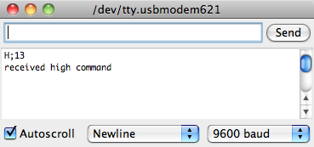Illustration 1: Serial Monitor – Connection test

crazyMachine
Alternatively you can steer the crazyMachine developed by Nicolai Korff by Droplet. Exact informations about it you find under http://crazymachine.nicolai-korff.de

Source Code
Droplet is a open source project on GitHub. If you like to participate at the project you can download the sourcecode at https://github.com/fuxi83/Droplet.

Error handling

Introduction to Droplet
Droplet’s user interface consists of the sections communication, device setup, processing, logging and the toolbar. The elements of the surface and their functionality are described in the following chapter.

Communication

In this section the connection to the microcontroller is done. Choose from the list of all serial interfaces the one connected to the microcontroller. Beside the list is shown the actual status of the connection.

Attention | The microcontroller must be connected before Droplet is started.

Device Setup

This is the main section of Droplet where the equipment and actions can be defined and configured. With Droplet a unlimited number of equipment and each with a unlimited number of actions can be configured. By the way the following equipment and action types are distinguished:
Device Type | Action Type | Relevance
Valve | Offset / Duration | A valve can be opened at a defined offset for a defined duration
Flash | Offset | A flash can be released at a defined offset
Camera | Offset / Duration | A camera can be released at a defined offset for a defined duration. That ensures that the continuing shooting mode of the camera can be used.

All time data in Droplet are done in milliseconds (1000ms = 1sec).
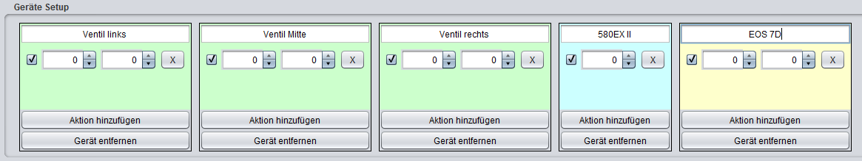Illustration 2: example-setup with three valves, one flash and one camera

Time management
Using an example the different possibilities of the time management with Droplet are represented.

Example 1)
The example setup contains two valves and one camera. The accompanying equipment setup is shown in illustration 3 and the accompanying time diagram can be seen in illustration 4.
Workflow description:
- The first valve opens at the start of the run. Then it is opened for a duration of 130 ms and is then closed. After another 30 ms the first valve opens again and this time it is open for a duration of 50 ms.
- The second valve opens 60 ms after start of the process and is open for a duration of 100 ms.
- The camera triggers after 250 ms after the start for a duration of 100 ms.

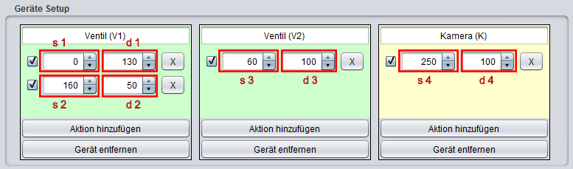Illustration 3: Device setup for example 1
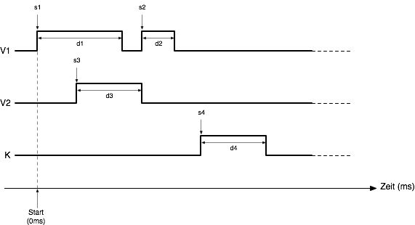Illustration 4: Time diagram for example 1

Shutter impuls of the camera
To ensure a reliable triggering of the camera it is necessary to intend the end solving impulse for a maintaining time. This duration is different for every camera model. Becomes this duration at least to low the camera ignores the impulse and solves correspondingly not fallen.
INFORMATION | If you have problems releasing your camera, check if you set enough time for the shutter impuls.
In the following you find a survey of collected empirical values and end solving impulses which are required of different camera models:
Camera | required  shutter impuls (ms)
Pentax K-5 | 300
Canon EOS 7D | 100

Pre-focusing of the camera

Besides the compliance with the required duration for the shutter impulse of a camera under circumstances it can also be necessary, to send a second impulse befor sending the shutter impulse to ensure a correct shutter release.

By the connector of the cable release of the modern DSLR the autofocus and. If an impuls is send to autofocus the camera tries ( if the lens of the camera is in AF mode) to put keenly on the object. Only if this process is ended successfully by another impuls the shutter will released.

At some camera models it can be necessary that pre-focusing impulse is sent also if the camera is in MF mode. Without this impulse the camera would not release the shutter. In picture 13 there is a configuration of pre-focusing of the camera.

ATTENTION | Although the camera/lens is set to MF mode, it may be neccessary to use pre-focusing to ensure that the camera can be released!
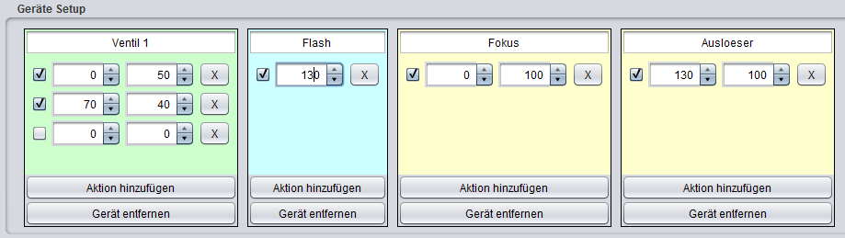Illustration 5: Device setup of prefocusing of a camera before releasing the shutter

Processing

In this section the automatic award of metadata to the produced pictures can be activated. There comments and keywords can be allocated. In addition the configured times can be written un the metadata. In table 1 you see the fields keywords and description in the metadata of a picture filled suitably for illustration 6.

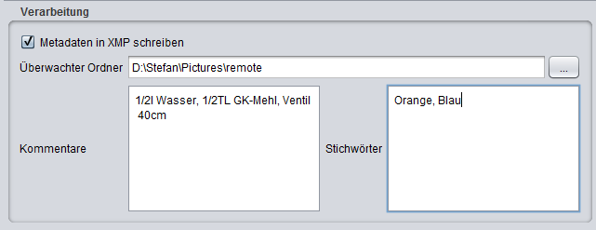Illustration 6: Processing – example of automatic build metadata

Keywords  (IPTC Core) | Orange, Blau
Description  (IPTC Core) | 1/2l Wasser, 1/2TL GK-Mehl, Ventil 40cm, Behaelter 120cm  This picture was created with the help of Droplet - Toolkit for Liquid Art Photographer  Droplet Serial Communication Protocol  S;2;V;0|82;147|90^319  S;6;C;280|100^380
Table 1: metadata of the picture

Functioning

The metadata are not directly stored into the image files but in the XMP ((Extensible Metadata platform) files with the same name like the image files have and with .xmp ending. These metadata can then be read and processed by other programs ( like Adobe Bridge, Adobe Photoshop Lightroom, Aperture, …).

Filename | Content
20120101_Bild-01.CR2 | Original image file
20120101_Bild-01.xmp | Metadaten for the image

Droplet is now able to supervise a folder and for every new image file added to this folder a XMP file is added into this folder. There fort he supervised folder must be defined in field Watch Folder.

ATTENTION | the automatic award of metadata only works, if images are directly submitted by remoteshooting to the PC and the target folder location is configures in Droplet as a monitored folder!

Example: Workflow in connection with Adobe Photoshop Lightroom
In the following an example workflow is shown of the use of the automatic metadata award into combination with it Remote Shooting and Adobe Photoshop Lightroom.
- camera shutter releases
- RAW/JPEG imageis saved in folder /Pictures/remote
- Droplet recognizes that a new picture in the folder /Pictures/remote
- Droplet builds a XMP file with same name as the original image in folder /Pictures/remote
- Lightroom recognizes that a new image is available in folder /Pictures/remote
- Lightroom moves the new image incl. the accompanying XMP file into the target folder /Pictures/library/Auto Imported Photos and imports the image inclusive metadata in the catalog
- After that the image can quit normally be processed in Lightroom

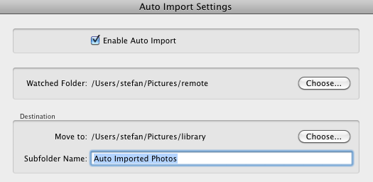Illustration 7: Lightroom - Auto Import Settings

Logging

Here are presented the most important news and reports including timestamps. With the help of the button Ent or Del the contents of the message console can be emptied.

Toolbar

From here you can control the important actions of Droplet:

- Control Devices: opens a dialog where the defined parameters of the defined device can be changed. Also each device may be directly switched on and off. This may be useful for cleaning a solenoid valve or for testing a flashlight and to release the camera shutter. You the device number can be declared for identification.
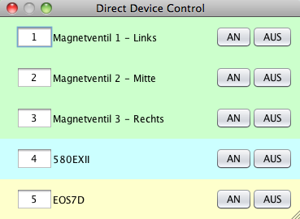Illustration 8: Direct Device Control
- Show: gibt die aktuelle Konfiguration des Mikrocontrollers in der Nachrichtenkonsole aus
- Send: sends the current device configuration to the micro controller
- Start: startet die in Runden definierte Anzahl an Ausführungen. Wenn mehr als eine Runde ausgeführt werden soll, kann zusätzlich noch eine Verzögerung definiert werden. Diese gibt an, wie viel Millisekunden zwischen den Ausführungen der einzelnen Runden pausiert werden soll.
Illustration 9: Beispiel für 3 Runden mit 1,5sec Verzögerung
- Cancel: is stopping the running Operation after having done the actual round

Preferences
In the settings of Preferences of von Droplet the used communication service and new protocol can be defined.
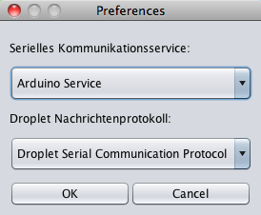Illustration 10: Droplet Preferences
The communication service is responsible for the communication between Droplet und microcontroller. In version 0.1 only the Arduino is supported.
The event protocol is controlling the event, which is transfered between Droplet and the microcontroller. In version 0.1 is only supported the Droplet Serial Communication Protocol (see chapter 18).

Shortcuts
You find here a listing of the most important key combinations:
Tastenkürzel | Menü | Aktion
⌘ + N | File → New | New Droplet configuration
⌘ + O | File → Load... | Load Droplet configuration
⌘ + S | File → Save | Save current configuration
⌘ + Shift + S | File → Save As... | Save current configuration as
⌘ + Q | File → Exit | Exit Droplet
F1 | Help → About | Show the help
F3 | Edit → Add device | Add new device
F4 |  | Start
⌘ + , | Edit → Preferences | Droplet Preferences

Droplet Serial Communication Protocol (DSCP)
For the communication between Droplet and the microcontroller the Droplet serial communication protocol was developed. Under consideration of the special requirements on a serial communication with the microcontroller and to make the character string to be transported as short and efficient as possible.
Befehl | Bedeutung
Set | Send a configuration to the micro controller
Release | Start the configuration
High | Switch ON a device connected to the micro controller
Low | Switch OFF a device connected to the micro controller
Info | Get information about the current configuration
Reset | Reset microcontroller

Definition of DSCP in EBNF

Protocol = SetCommand | ReleaseCommand | HighCommand | LowCommand | "I" | "X" ;

SetCommand = "S" FieldSeparator DeviceConfig ;
ReleaseCommand = "R" Number [ FieldSeparator Number ] ;
HighCommand = "H" FieldSeparator DeviceNumber ;
LowCommand = "L" FieldSeparator DeviceNumber ;

DeviceConfig = DeviceNumber FieldSeparator Device FieldSeparator Times ChksumSeparator Chksum ;
DeviceNumber = DigitWithoutZero ;
Device = "V" | "F" | "C" ;

Times = Time { FieldSeparator Time } ;
Time = Offset TimeSeparator Duration ;

Offset = Number ;
Duration = Number ;
Chksum = Number ;

FieldSeparator = ";" ;
TimeSeperator = "|" ;
ChksumSeparator = "^" ;

Number = DigitWithoutZero { Digit } ;
DigitWithoutZero = "1" | "2" | "3" | "4" | "5" | "6" | "7" | "8" | "9" ;
Digit = "0" | DigitWithoutZero ;

