**Friend**: So, what do you work on? How is your research useful?

**My research papers**: 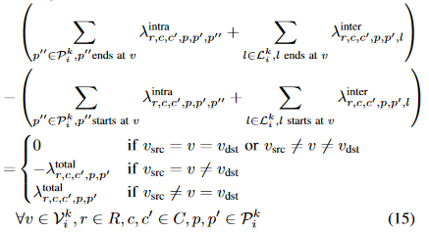

**Friend**: