LANTERN LIBRARY
LOANS SYSTEM

Relational Database Design
Normalisation · Logical Model · Physical Model

Project Type | Database Design
Domain | Library Management System
Methodology | UNF → 1NF → 2NF → 3NF
Notation | Crow's Foot ERD

Executive Summary

This document presents the complete relational database design for Lantern Library's loans management system. The goal was to replace an ad-hoc loans process with a well-structured, normalised relational schema that supports a web-accessible application, multi-item loans, inter-library borrowing, fine tracking, and item categorisation.

The design was developed through a structured normalisation process — progressing from raw Unnormalised Form (UNF) through First, Second, and Third Normal Forms (1NF, 2NF, 3NF) — resulting in a clean, scalable schema free of data redundancy and update anomalies. The final deliverables are a Logical Model expressed as a Crow's Foot Entity-Relationship Diagram, and a Physical Model specifying SQL data types, constraints, and key relationships ready for implementation.

Key Metric | Detail
Entities designed | 8 (Member, Staff, Loan, LoanItem, Item, ItemType, Publisher, Library)
Normal form achieved | Third Normal Form (3NF)
ERD notation | Crow's Foot (Logical & Physical)
Key design patterns | Associative entity (LoanItem), nullable FK (Publisher), surrogate PKs throughout

Project Overview

Context
Lantern Library is a mid-sized public library providing lending services to the local community. Its catalogue spans books, journals, magazines, DVDs, and vinyl records. The library also participates in inter-library loan arrangements with partner institutions.

At the time of this design, loan transactions were managed manually or through a non-normalised system, creating risks of data inconsistency, duplicated records, and difficulty reporting on fines or overdue items. The library required a replacement system with the following capabilities:

- Support for loans containing multiple items in a single transaction
- Staff-processed check-in with a full audit trail
- Per-item due dates, return dates, and fine calculations
- Item categorisation by type
- Publisher records for books and journals
- Inter-library loan tracking
- Accessibility via a web application

Design Approach
The design follows a systematic top-down normalisation methodology. Starting from a single Unnormalised Form (UNF) relation capturing all loan data, the schema was progressively decomposed through each normal form, with explicit justification at each stage. This approach ensures every design decision is traceable and defensible.

All primary keys use artificial (surrogate) integer identifiers rather than natural keys. Natural keys — such as member names or item titles — cannot be guaranteed unique over time, introduce coupling between identity and data, and complicate foreign key references. Surrogate keys avoid all of these issues.

Normalisation Process

The eight core entities were identified by analysing the library's operational requirements: Members, Items, Loans, LoanItems, Staff, ItemTypes, Publishers, and Libraries. The following sections document how these entities were derived through each normalisation stage.

Unnormalised Form (UNF)
The UNF relation captures all loan data in a single flat structure, reflecting how the data would appear in a raw operational record — for example, a paper loan slip. It contains repeating groups (multiple items per loan) and multivalued attributes, which are the primary targets for normalisation.

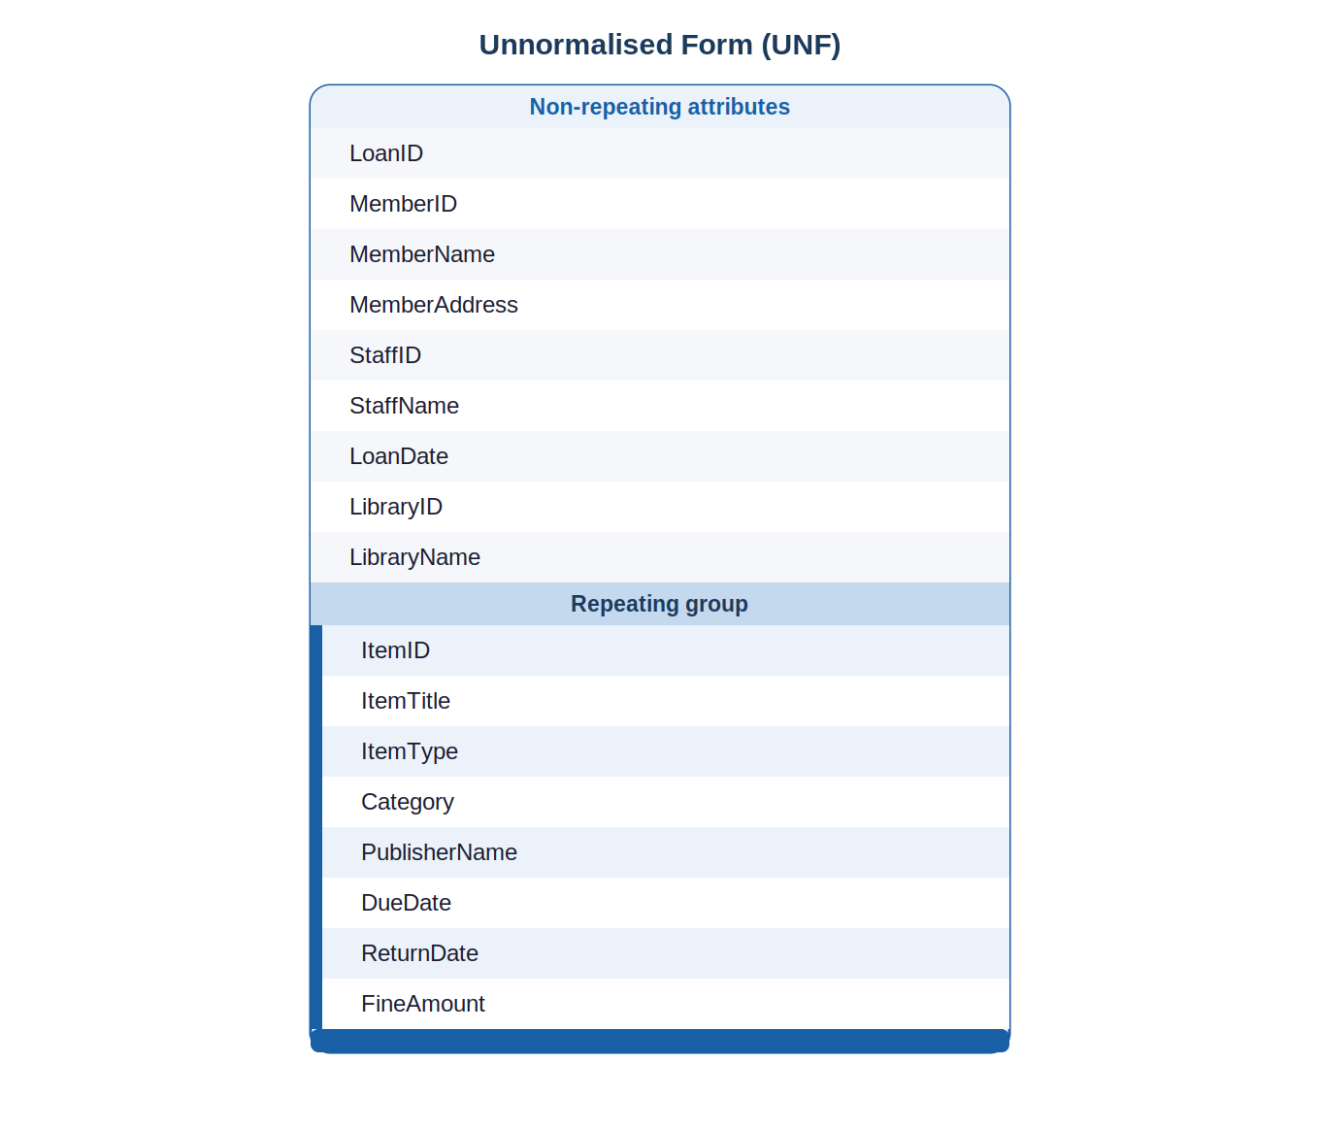

Design Decisions
- Surrogate ID columns (e.g. LoanID, MemberID) are introduced at this stage to uniquely identify each record. Natural keys are not used as they cannot be guaranteed unique.
- The repeating group consists of item-related attributes (title, type, due date, return date, fine). A single loan can contain multiple items, so these attributes repeat within one loan record.
- Non-repeating attributes — member details and staff details — appear once per loan, as each loan is initiated by one member and processed by one staff member.
- A Library entity is included from the outset to support inter-library loan tracking.
- Due date and fine amount are placed at the item level, not the loan level, because different items within one loan may be returned at different times and incur different fines.
- Publisher is retained as an attribute on items at this stage, with the understanding that it will only be populated for applicable item types (books, journals). Items such as DVDs and vinyl records will have a null publisher — this is resolved formally in 3NF.

First Normal Form (1NF)
1NF requires that every cell holds an atomic (indivisible) value and that every record is unique. The UNF relation violates 1NF because the item-related attributes repeat within a single loan record.

To achieve 1NF, the UNF relation is decomposed into six separate relations, each with a single-valued primary key and no repeating groups:

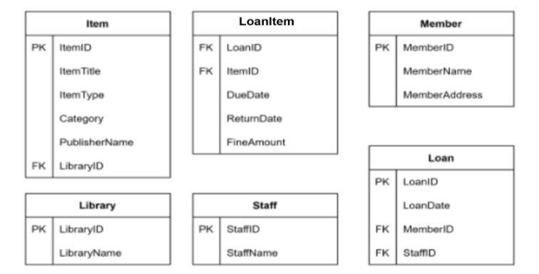

Design Decisions
- The many-to-many relationship between Loan and Item is resolved by introducing the LoanItem associative entity, allowing each item within a loan to be recorded as a distinct row.
- DueDate, ReturnDate, and FineAmount are placed on LoanItem rather than Loan, as these values are specific to each item within a loan.
- Foreign keys are introduced to enforce relationships: MemberID and StaffID on Loan; LibraryID on Item; LoanID and ItemID on LoanItem.
- MemberName is treated as a single atomic attribute. The system requirements do not call for querying first and last names separately, so splitting them would add complexity without benefit.
- Publisher remains within the Item relation at this stage and may be null for item types that do not have a publisher.

Second Normal Form (2NF)
2NF requires that the schema is in 1NF and that every non-key attribute is fully dependent on the entire primary key — eliminating partial dependencies. Partial dependencies can only exist in relations with composite primary keys.

Analysing the 1NF schema, only LoanItem has a composite primary key: (LoanID, ItemID). All of its non-key attributes — DueDate, ReturnDate, and FineAmount — describe the specific pairing of a loan and an item, and therefore depend on the full composite key rather than on either attribute alone. No partial dependencies exist.

All other relations use single-attribute surrogate primary keys, making partial dependencies structurally impossible. The 1NF schema is therefore already in 2NF with no changes required.

Third Normal Form (3NF)
3NF requires that the schema is in 2NF and that no non-key attribute is transitively dependent on the primary key — that is, no non-key attribute determines another non-key attribute.

Two transitive dependencies were identified in the 2NF schema:

Dependency | Problem | Resolution
ItemType → Category (within Item relation) | Category is determined by ItemType, not by ItemID — a transitive dependency. | Extract ItemType and Category into a new ItemType table, referenced by ItemID via a foreign key.
ItemID → PublisherName, PublisherContact (within Item relation) | Publisher attributes describe the publisher, not the item. Multiple items share one publisher. | Extract Publisher into a standalone table. Item references it via PublisherID (nullable — not all item types have a publisher).

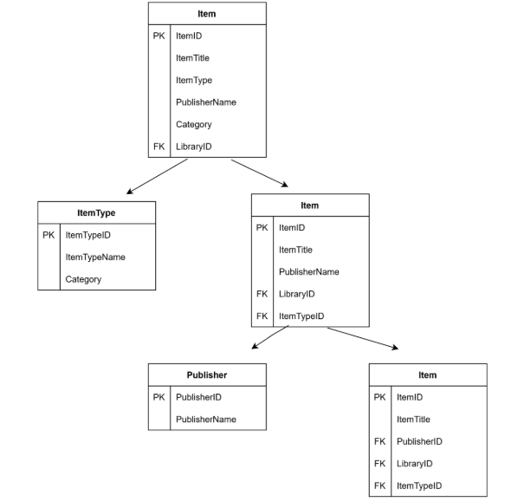
These changes eliminate all transitive dependencies. The schema is now in Third Normal Form.

Logical Model

The Logical Model (Figure 4) presents the final 3NF schema as a Crow's Foot Entity-Relationship Diagram. It defines entities, their attributes, primary and foreign keys, and the cardinality of all relationships — independent of any specific database platform or implementation detail.

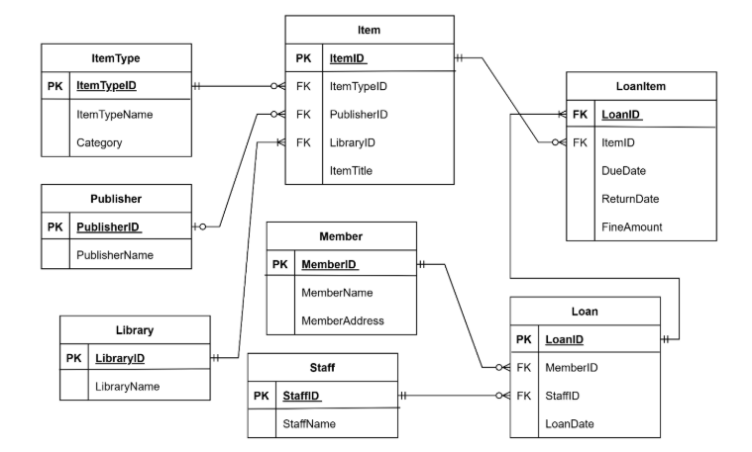

Relationship Summary
Relationship | Cardinality & Business Rule
Member → Loan | One member may have zero or many loans. Each loan must belong to exactly one member.
Staff → Loan | One staff member may process zero or many loans. Each loan must be processed by exactly one staff member.
Loan → LoanItem | One loan must contain one or more LoanItem records. Each LoanItem belongs to exactly one loan.
Item → LoanItem | One item may appear in zero or many LoanItem records. Each LoanItem references exactly one item.
ItemType → Item | One item type is associated with one or many items. Each item must have exactly one item type.
Publisher → Item | One publisher may publish zero or many items. An item may have zero or one publisher (nullable for DVDs, vinyl, etc.).
Library → Item | One library may own zero or many items. Each item must belong to exactly one library, supporting inter-library loan tracking.

Physical Model

The Physical Model (Figure 5) translates the Logical Model into a platform-ready schema by assigning SQL data types, defining nullability constraints, and specifying column lengths. It is intended as a direct implementation reference for a relational database such as PostgreSQL or MySQL.

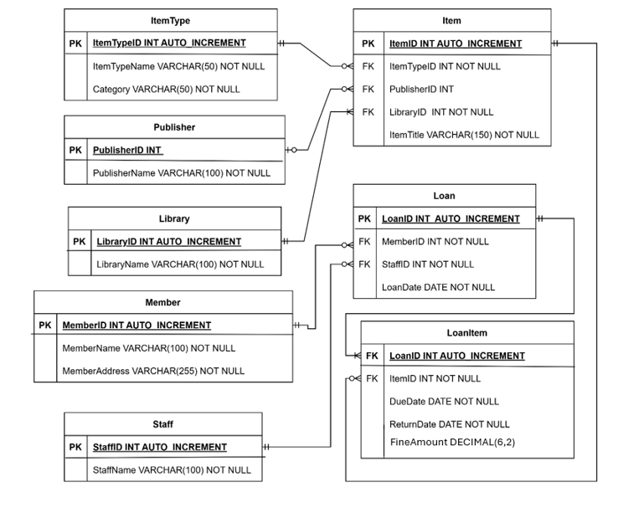

Data Type Decisions
Data Type | Applied To | Rationale
INT | All primary & foreign keys | Provides a large range of unique integer identifiers. No maximum character length is needed.
VARCHAR(100) | Names (member, staff, publisher) | Variable-length storage avoids padding waste. 100 characters accommodates all realistic name lengths.
VARCHAR(150) | ItemTitle | Longer allowance for full item titles including subtitles.
VARCHAR(50) | ItemType, Category | Sufficient for enumerable category and type labels.
DATE | DueDate, ReturnDate, LoanDate | Date-only precision is appropriate; no time component is required for loan tracking.
DECIMAL(6,2) | FineAmount | Supports fine values up to £9,999.99 with two decimal places — appropriate for currency.
BOOLEAN | IsActive (Member) | Enables soft-deletion of member records without data loss.

Nullability Decisions
Columns are marked NOT NULL unless there is a specific business reason for allowing a null value. The key nullable columns are:

- PublisherID on Item — null for item types such as DVDs and vinyl records, which have no publisher.
- ReturnDate on LoanItem — null until the item is physically returned, indicating an active loan.
- FineAmount on LoanItem — null until a fine is assessed; a null value is semantically distinct from a £0.00 fine.

Future Considerations

The current design provides a solid, normalised foundation. The following enhancements would be considered for production deployment:

Indexing Strategy
- Index foreign key columns (MemberID, StaffID, ItemID, LoanID) to accelerate JOIN operations on the most frequently queried relationships.
- Add a composite index on (LoanID, ItemID) in LoanItem to optimise loan detail lookups.
- Index FineAmount and ReturnDate on LoanItem to support efficient overdue and fine reporting queries.

Schema Extensions
- A Reservation table could extend the schema to support advance item reservations.
- MemberName could be split into FirstName and LastName if personalised communications (e.g. fine reminder emails) are introduced.
- An audit log table recording all loan state changes would support compliance and dispute resolution.

