List the rooms booked for each training event showing the room name, the event name and the event date.

Figure 31., showcases an INNER JOIN between Room and Event table through the foreign key RoomID. As Bush (2020) explains, an INNER JOIN retrieves only rows where a matching value exists in both tables, making it suitable where the foreign key is defined as NOT NULL. INNER JOIN is appropriate as Event table contains RoomID which is NOT NULL:
- FROM code starts with Event table (referred to as e), as it contains the booking to room link through its RoomID foreign key.
- INNER JOIN, code joins the Room table (referred to as r) to retrieve the room name, matching under the shared RoomID key.
- SELECT code, showcases three columns as per scenario (room name, event name and event date).

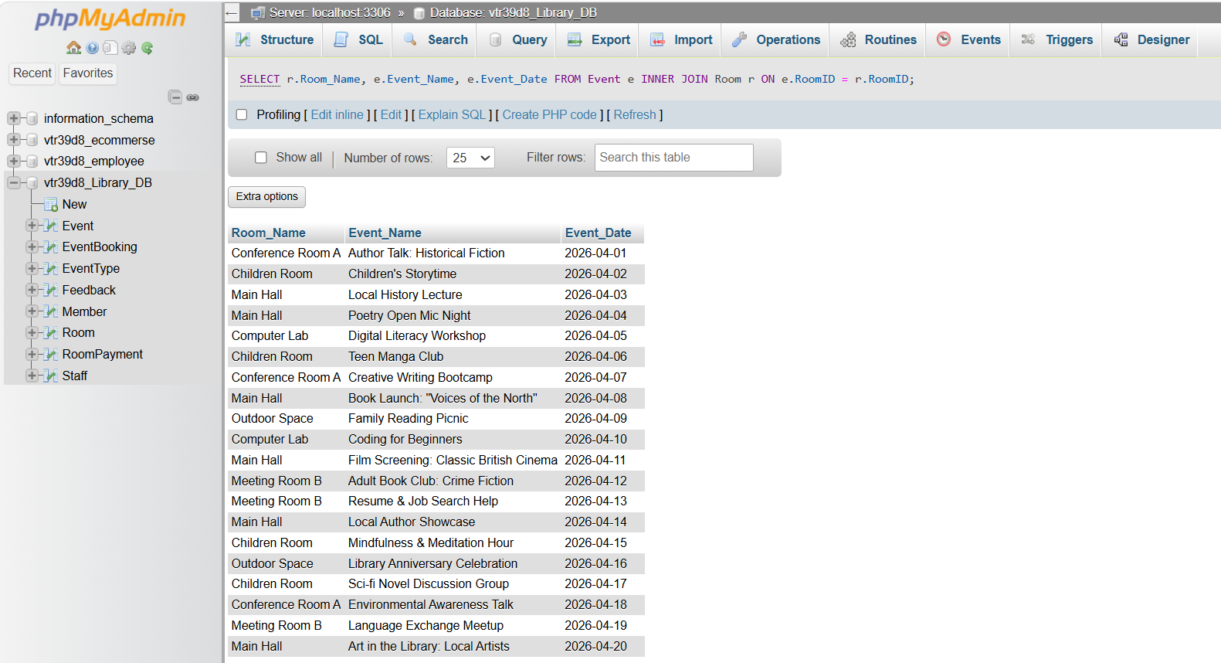
Figure 31. Rooms booked.

Demonstrating the efficiency of searching to the head librarian, searches have been created based on the criteria mentioned below.

a. Fall the events in the database sorted by event type. Show the event name, event date and event type description.

Figure 32., displays an INNER JOIN between Event and EventType because description is stored in EventType. EventTypeID in the Event table is defined as NOT NULL, so INNER JOIN is appropriate.
- FROM Events query is used as that is where all the event names and dates are stored.
- SELECT code, showcases three columns as per scenario (event name, event date and event type description).
- Joins Event to EventType on the shared EventTypeID foreign key to get the description.
- ORDER BY et.Description sorts alphabetically by event type.

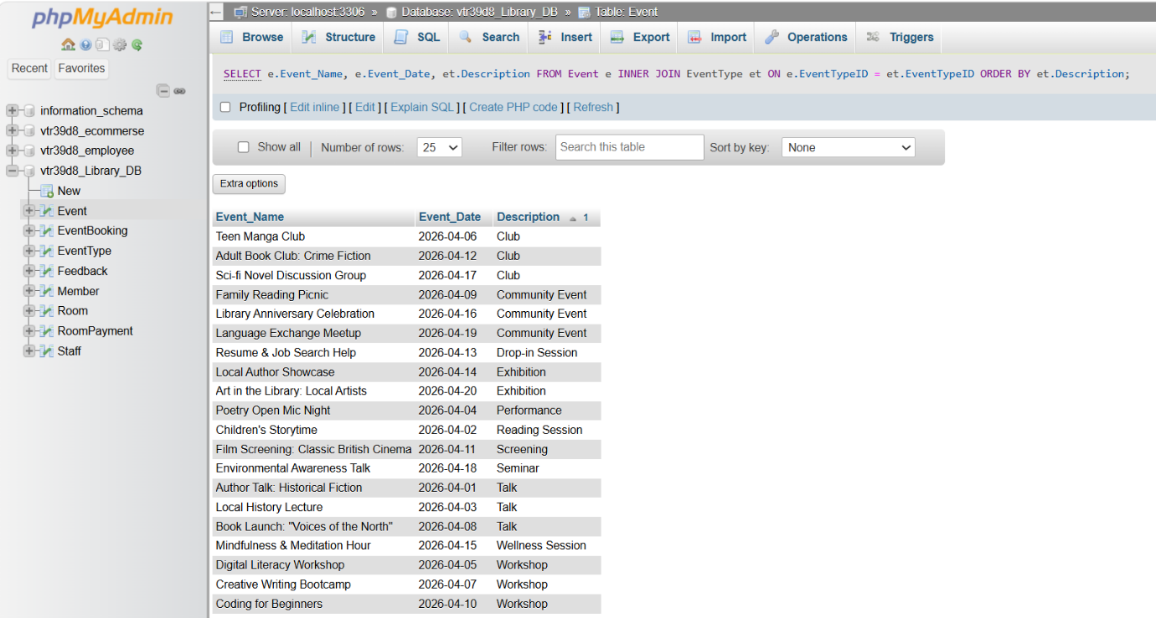
Figure 32. All Events.

b. Find events based on price. For example, events with ticket cost less than £5.
Figure 33. displays Event names and Ticket prices for events that cost less than £5.
- SELECT query displays two columns as per scenario.
- FROM statement selects Event table as it contains all the information required.
- WHERE clause filters to only rows below £5.

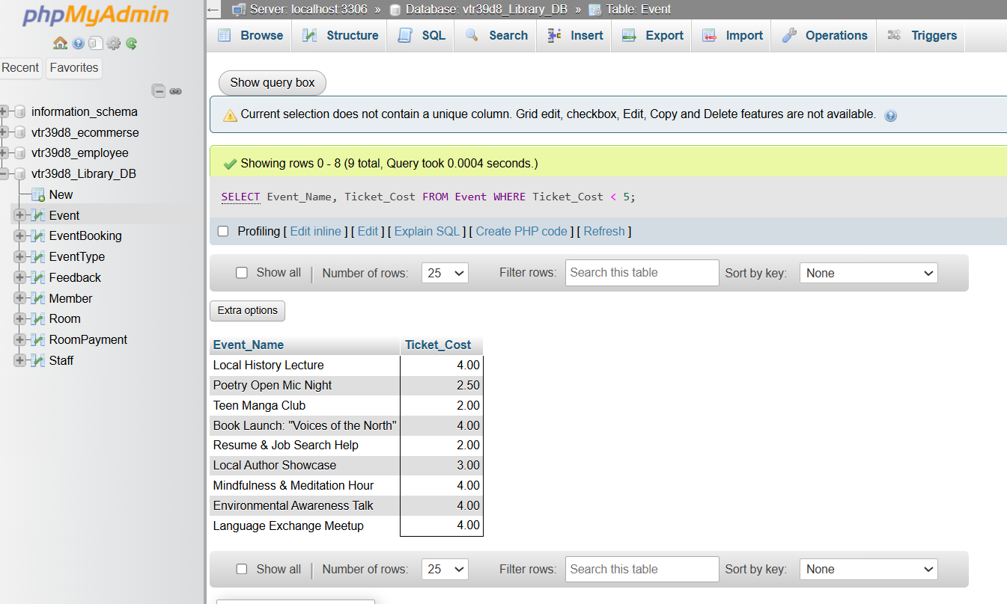
Figure 33. Tickets under £5.

The events that Lantern Library offers have changed. The queries below reflect these changes in inventory.
Figure 34., displays all the data from Events table before being updated in the following tasks.

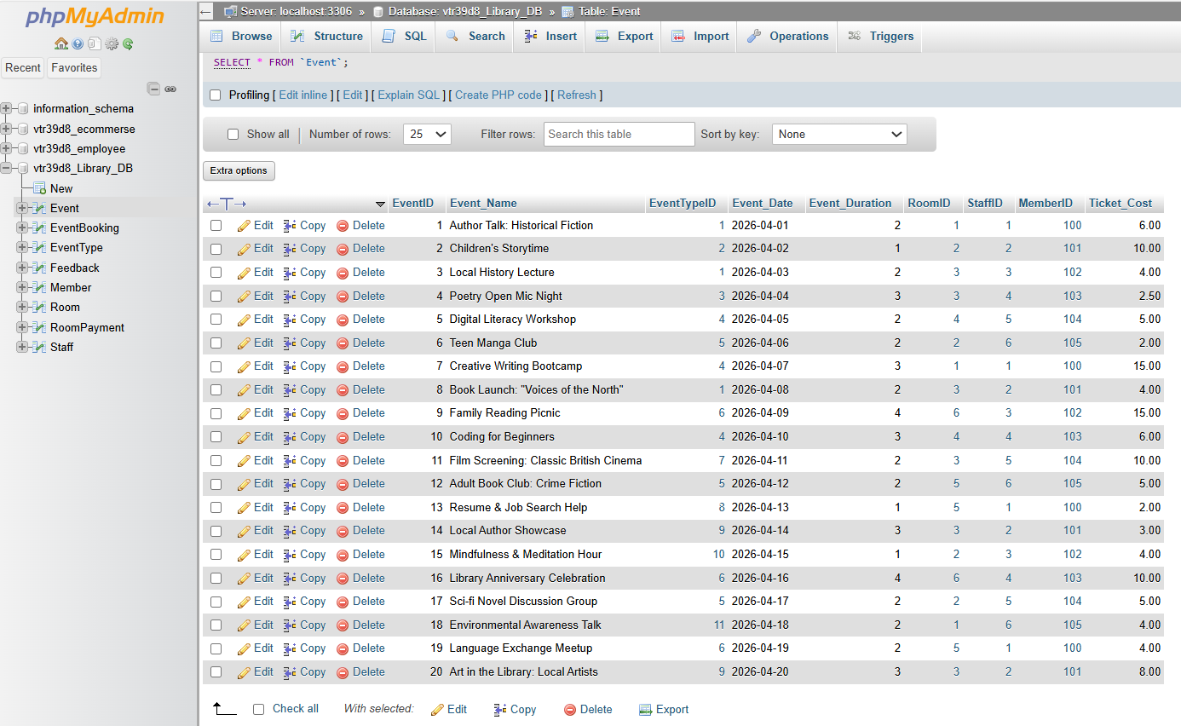
Figure 34. “Events” data.

a. The Family Reading Picnic has been renamed Community Reading Picnic, and the ticket price has been changed to 20 pounds.
Figure 35. Displays the query used to update the Event table. SET function specifies the two columns being changed and WHERE query ensures that just the specific record is updated.

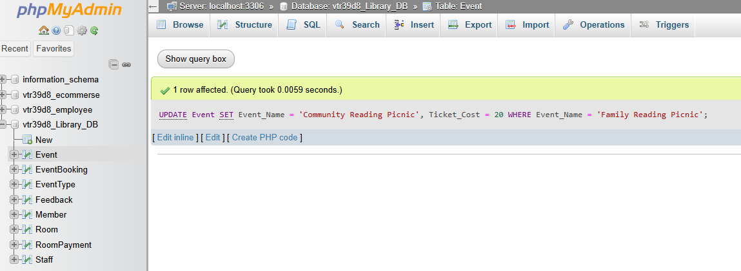
Figure 35. Update query.

Figure 36., showcases the successfully updated values (Community Reading Picnic, Ticket_cost).
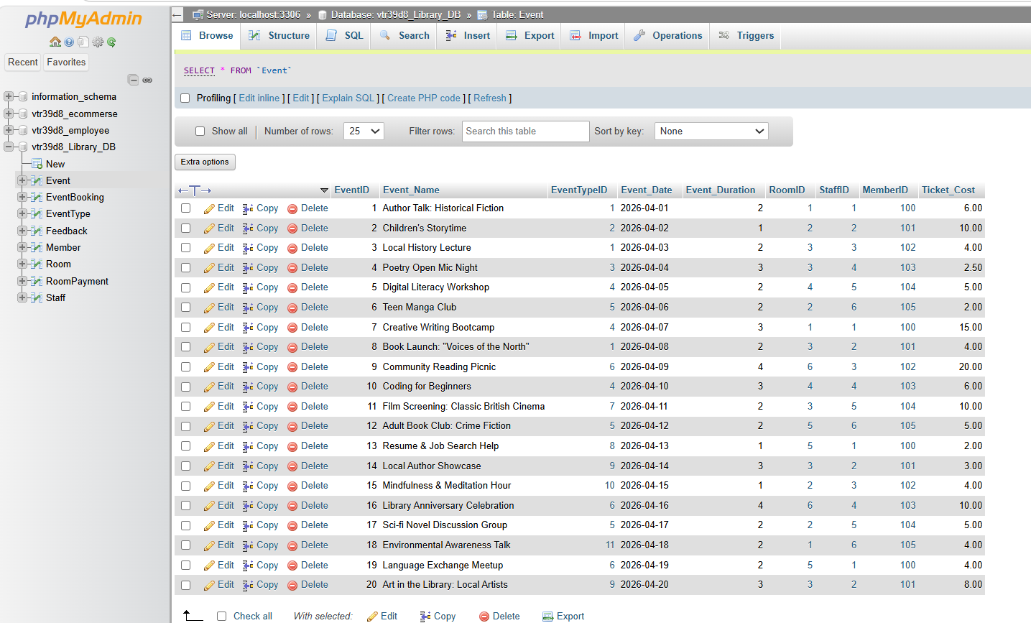Figure 36. Updated values

b. The Local History Lecture no longer running.
As Connolly and Begg (2015) stated, to delete a parent row (event from Event table) the child records (event from EventBooking, Feedback, Roompayment) need to be deleted first.
Figure 37., showcases the deletion of Local History Lecture record from Eventbooking table. As displayed in Figure 36., Local History Lecture is identified in Eventbooking table as “EventID 3”.

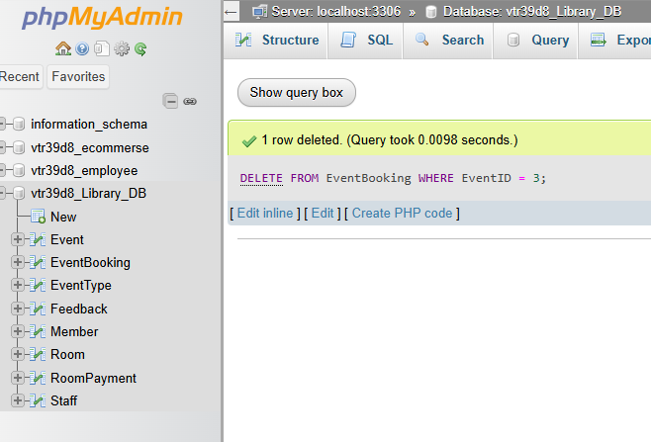
Figure 37. Deleting from “Eventbooking”

Figure 38., showcases deletion of Local History Lecture record from the Feedback table. As displayed in Figure 36., Local History Lecture is identified in the Feedback table as “EventID 3”.

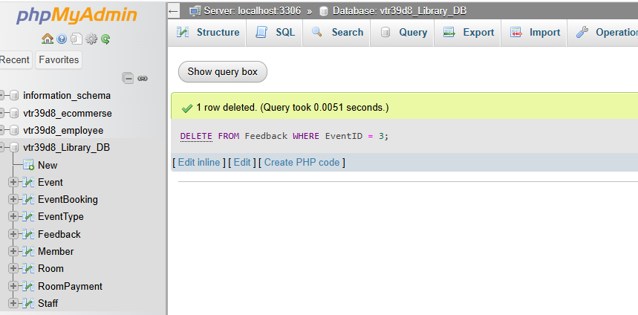
Figure 38. Deleting From “Feedback”
Figure 39., showcases the deletion of Local History Lecture record from RoomPayment table. As displayed in Figure 36., Local History Lecture is identified in the RoomPayment table as “EventID 3”.

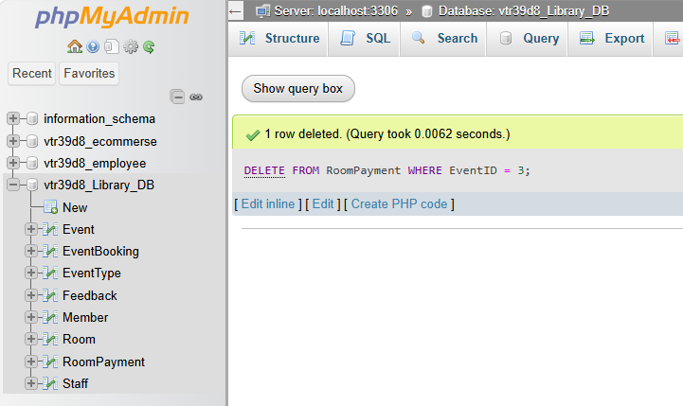
Figure 39. Deleting from “RoomPayment”

Figure 40., displays the deletion of “Local History Lecture” event. This is possible once all the child records have been deleted first.

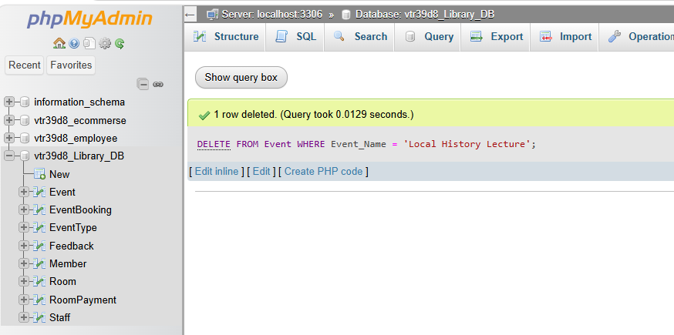
Figure 40. Deleting Event.

Figure 41., showcases the successfully updated table with Local History Lecture record removed.

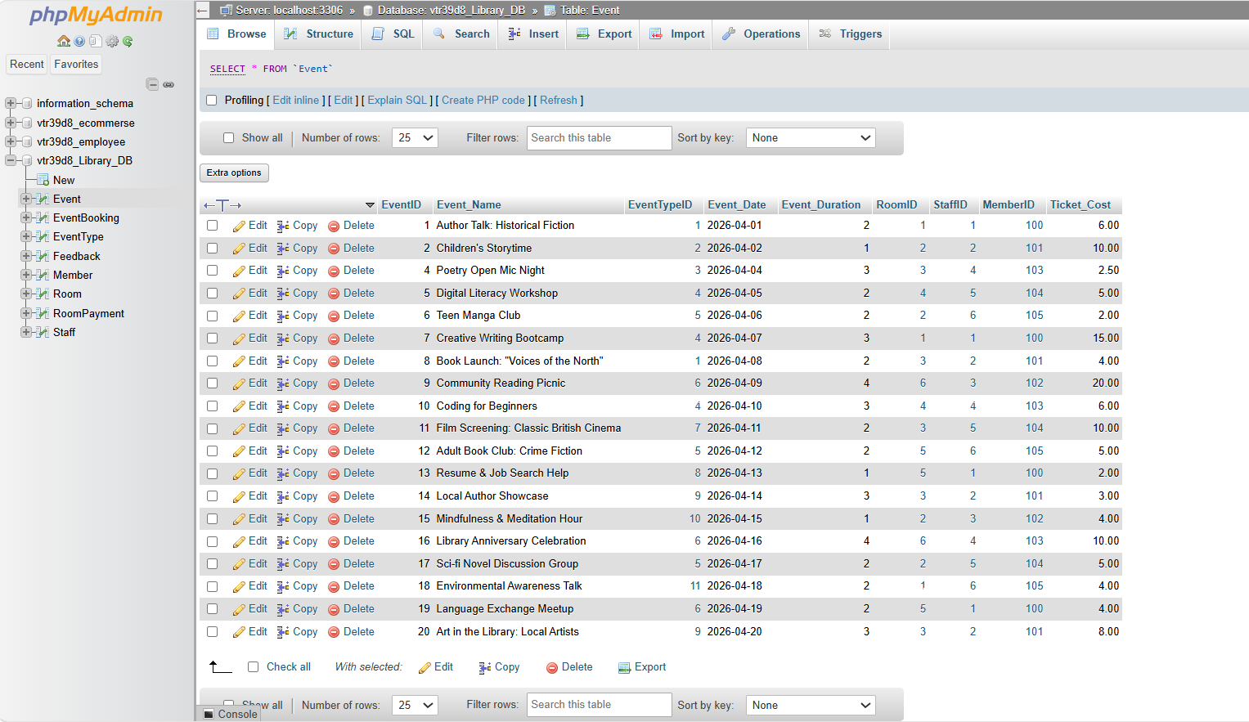
Figure 41. Updated values

Number of bookings for each event type showing the most popular to least popular. Showcasing event type description and the number of bookings.
The query in Figure 42., retrieves the number of bookings for each event type, ordered from most to least booked. It chains three tables together to connect a booking back to its event type category.
- SELECT and COUNT functions select the event type description and count the number of bookings for each type.
- FROM code starts from the EventBooking table as it holds every booking record.
- INNER JOIN Event, first join connects bookings to their events.
- INNER JOIN EventType, second join connects events to their type description, completing the chain EventBooking to Event to EventType.
- GROUP BY code combines all bookings of the same event type into a single counted row.
- ORDER BY function presents results from most to least booked.

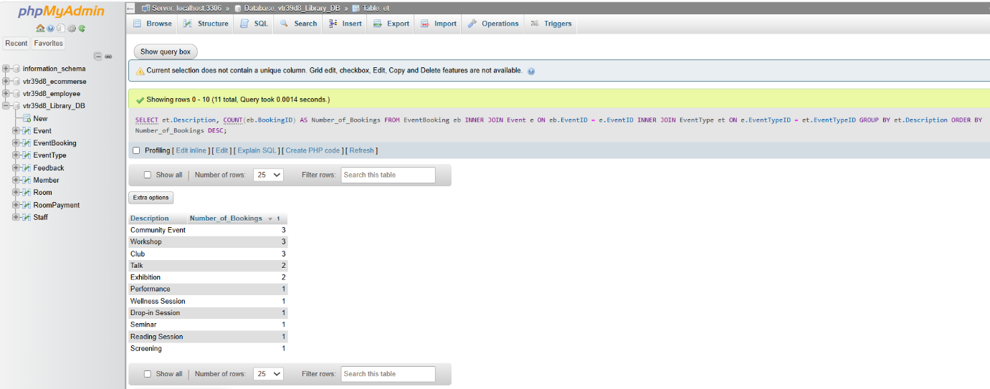
Figure 42. Number of bookings.

The amount of money made for each event from bookings made. Showing the event name and amount of money made from bookings. Showing the earnings in descending order. Earnings will only be on bookings that were confirmed.
The code in Figure 43., calculates the revenue generated per event, only confirmed bookings are considered.
- SELECT, COUNT, SUM functions select the event name, number of confirmed bookings and total earnings for each event.
- FROM code, starts from EventBooking as it holds the status information needed for filtering.
- INNER JOIN, joins to Event to access the event name and ticket cost.
- WHERE query, filters out non confirmed bookings.
- GROUP BY statement, groups result per event, so earnings are calculated individually.
- ORDER BY, ranks events from highest to lowest earner.

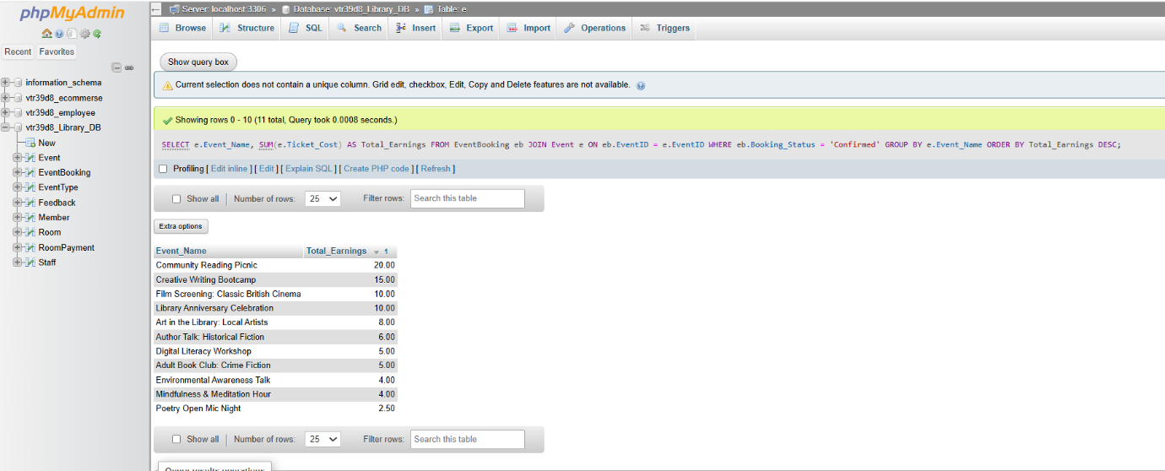
Figure 43. Total Earnings

c.
The query in Figure 44., calculates the total potential earnings for each room across all bookings.
- SELECT and SUM queries, select the room name and sums the ticket costs across all bookings for that room.
- FROM code, starts from Event because it contains the RoomID foreign key that links events to rooms.
- INNER JOIN Room, joins to retrieve the room name.
- INNER JOIN EventBooking, joins to access individual booking records for each event.
- GROUP BY, collapses results to one row per room.
- ORDER BY, ranks rooms from highest to lowest potential earnings for clearer display.

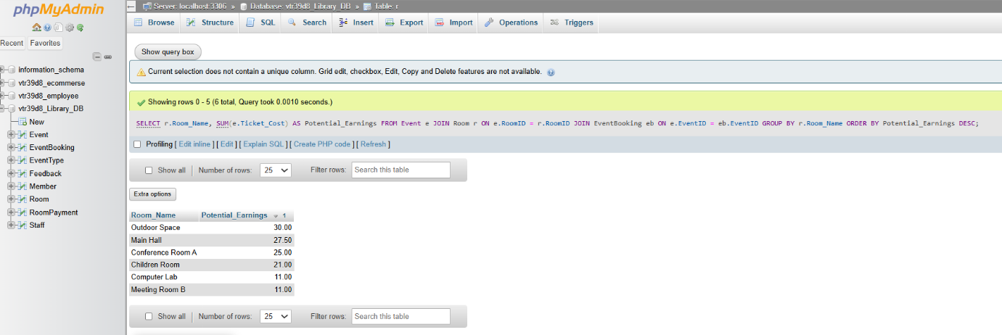
Figure 44. Earnings.

References
Connolly, T. and Begg, C., (2015). Database Systems: A Practical Approach to Design, Implementation, and Management [online]. 6th edition. Harlow: Pearson. Available from: www.pearsonglobaleditions.com/connolly [Accessed 16 March 2026].
Bush, J. (2020). Learn SQL Database Programming: Query and Manipulate Databases from Popular Relational Database Servers Using SQL [online]. Packt Publishing. Available from: https://research.ebsco.com/ [Accessed: 02 May 2026].

