Display

Figure 23. displays the EventBooking table showing each booking's ID, member ID and event ID it is linked to, the date the booking was made, and the status. This confirms the relationships between members and events are being stored. Booking_Status column is distinguishing between Confirmed, Cancelled, and Waitlisted.
SQL Code used to display table is:
SELECT * FROM EventBooking;
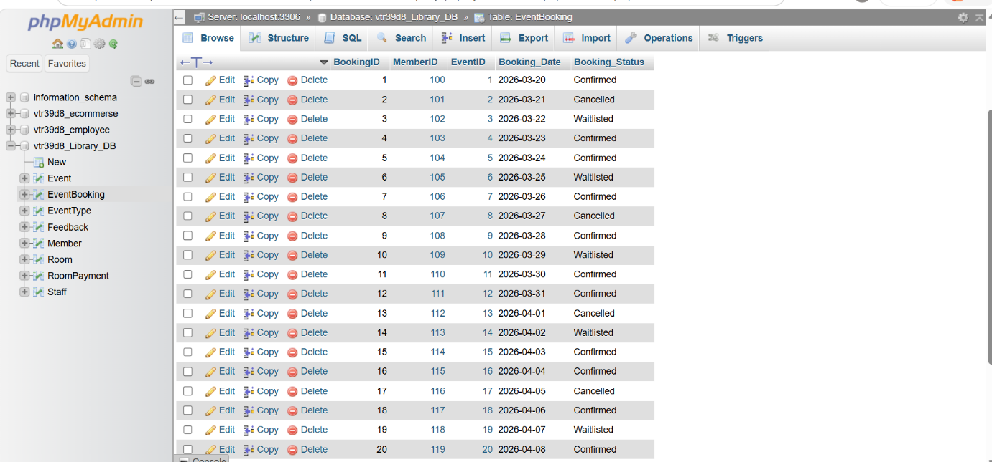 Figure 23. “EventBooking” table.

Figure 24. displays Event table showing each event's ID, name, event type, date, duration, room ID, staff ID, member ID, and cost. This confirms all the relationships between events, rooms, staff, and members are being stored correctly, and that the system is successfully linking events to the appropriate resources.
SQL Code used to display table is: SELECT * FROM Event;.

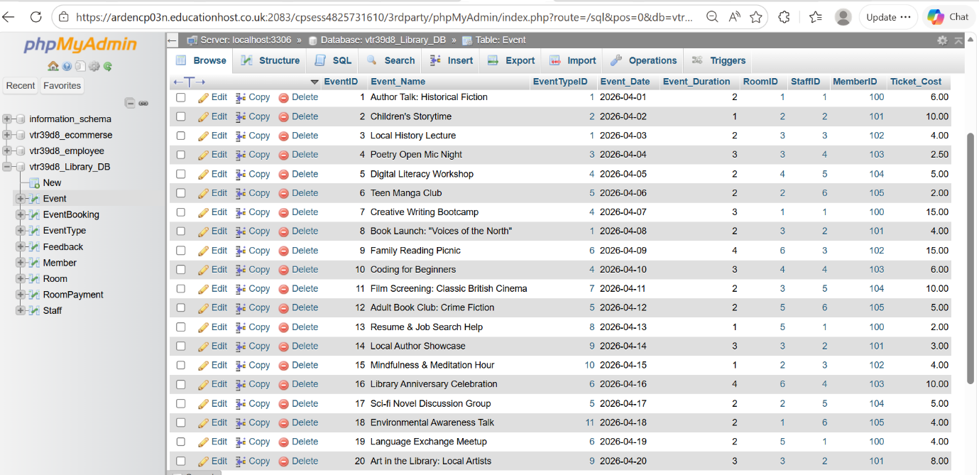 Figure 24. “Event” table.

Figure 25. displays EventType table, showing each event type's ID and description.
SQL Code used to display table is: SELECT * FROM EventType;.
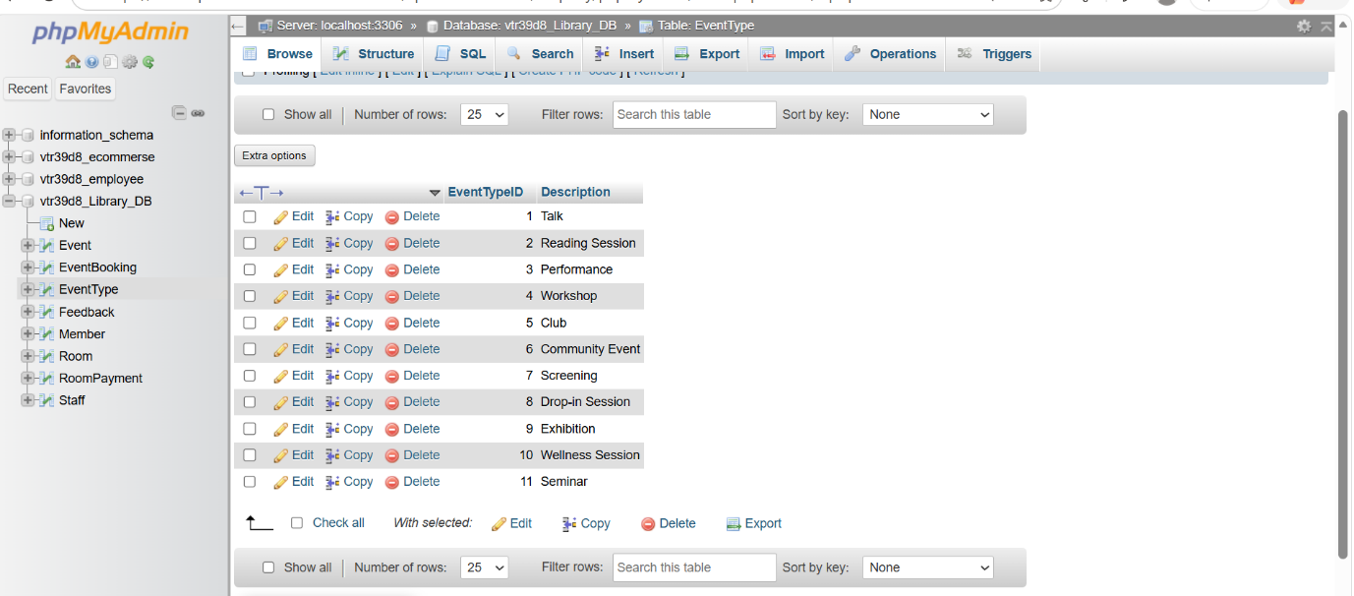 Figure 25. “EventType” table.
Figure 26. displays Feedback table showing each entry's ID, the event it relates to, the date submitted, rating, and a comment. This demonstrates that Feedback table is correctly linked to the Event table through the EventID.
SQL Code used to display table is: SELECT * FROM Feedback;.

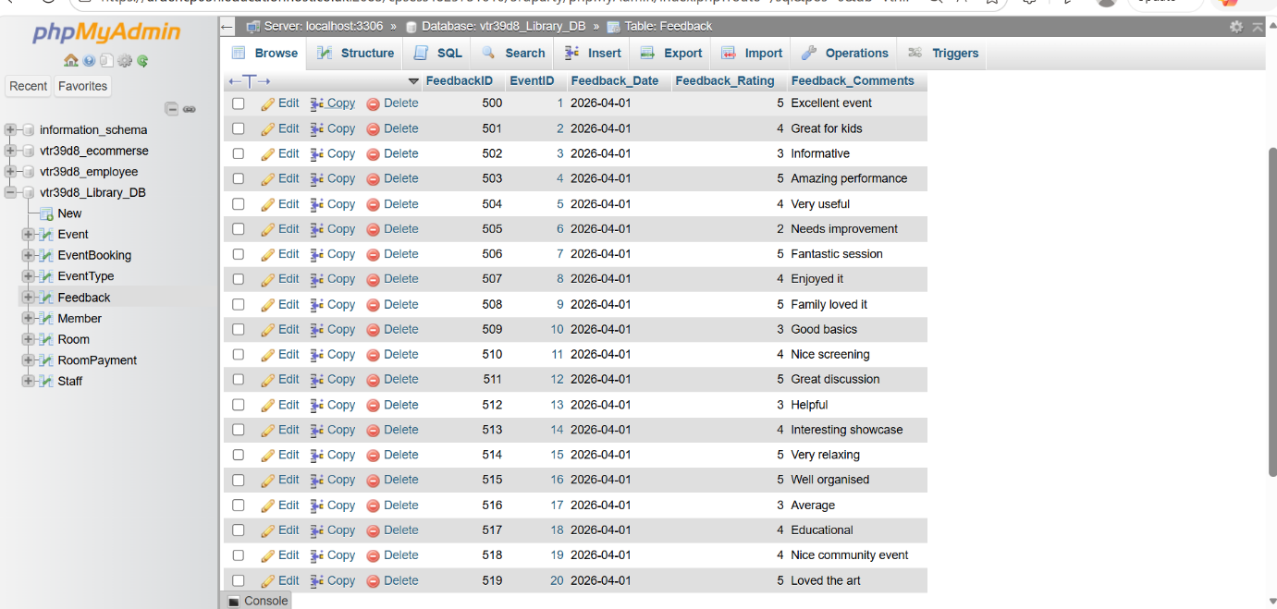 Figure 26. “Feedback” table.
Figure 27. displays Member table. The member IDs begin at 100 to distinguish members from other columns. The Member_Type column successfully categorises each member as Student, Adult, or Senior.
SQL Code used to display table is: SELECT * FROM Member;.

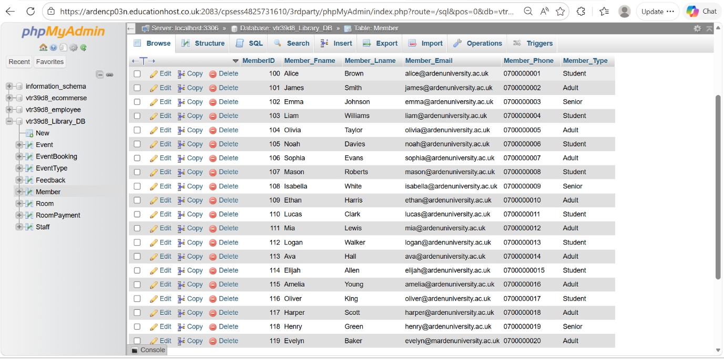
Figure 27. “Member” table.
Figure 28. displays Room table, each record includes a room ID, room name, capacity, hourly rate, and facilities.
SQL Code used to display table is: SELECT * FROM Room;.
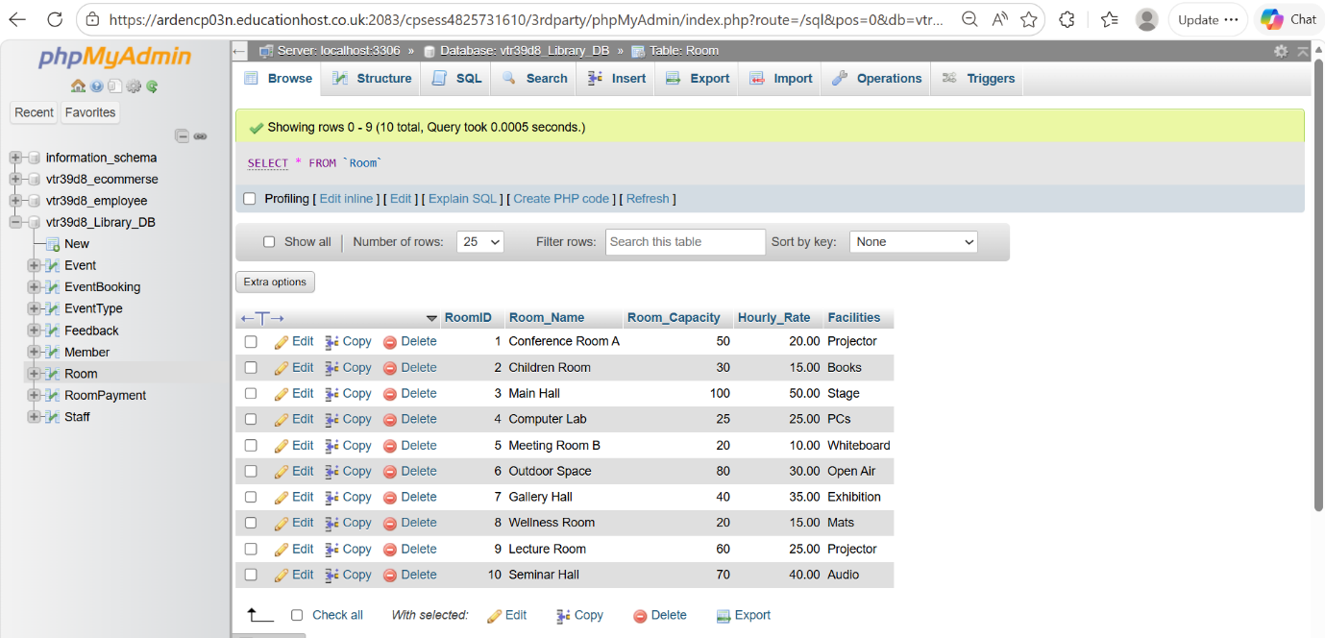
Figure 28. “Room” table.
Figure 29. displays RoomPayment table. The payment IDs begin at 200, which distinguishes payment records from other collumns.
SQL Code used to display table is: SELECT * FROM RoomPayment;.

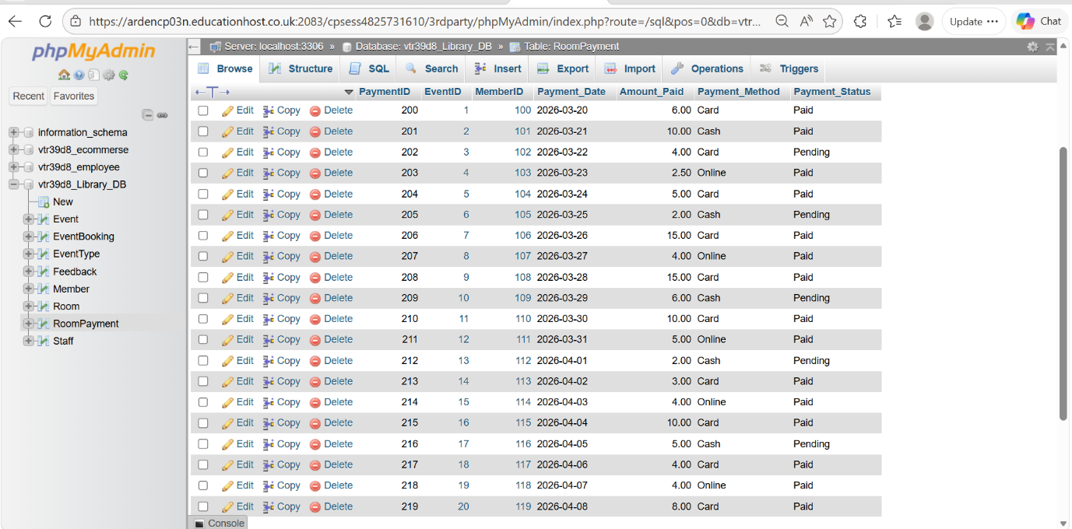 Figure 29. “RoomPayment” table.

Figure 30. displays Staff table. Each record includes a staff ID, full name, and work email, confirming data has been stored.
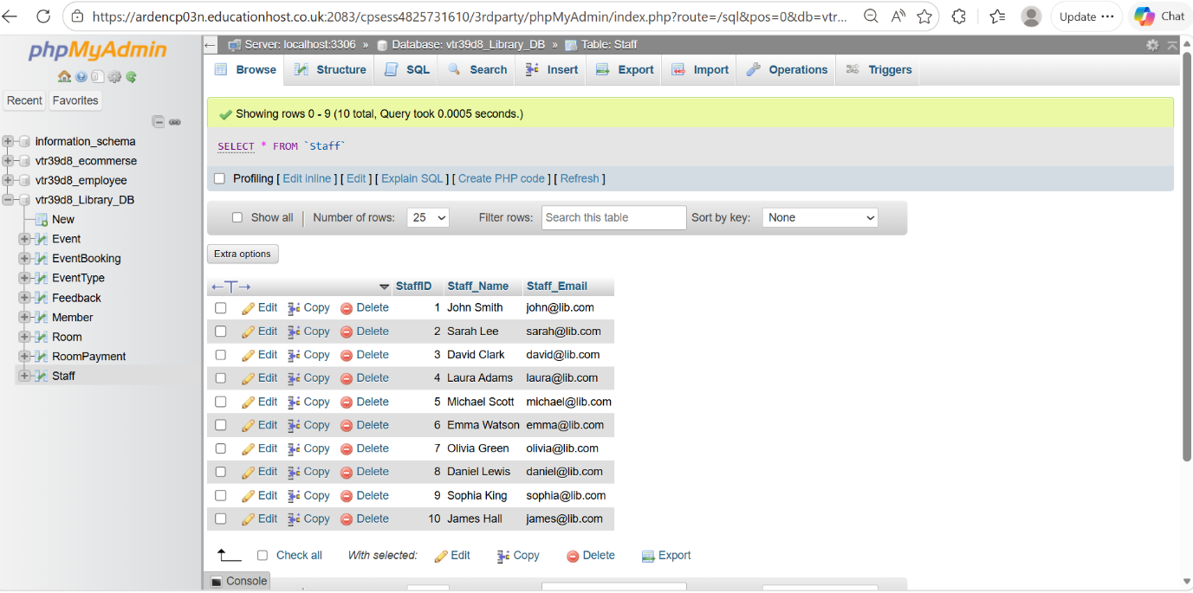 Figure 30. “Staff” table.

