DOCUMENTATION

ASSIGNMENT 2

STUDENT NAME: CHICHIȘAN ȘTEFAN
GROUP: 30441

CONTENTS

1. Assignment Objective 3
2. Problem Analysis, Modeling, Scenarios, Use Cases 3
3. Design 3
4. Implementation 3
5. Results 3
6. Conclusions 3
7. Bibliography 3

Assignment Objective
- Main objective
  - Design and implement an application which simulates and analyses queuing based systems for determining and minimizing clients’ waiting time.
  - The application should simulate a series of N clients arriving for service, entering Q queues, waiting, being served, and finally leaving the queues. All clients are generated when the simulation is started and are characterized by three parameters: ID (a number between 1 and N), tarrival and tservice, generated randomly. The application tracks the total time spent by every customer in the queues and computes the average waiting time.
  - Input data: read from a text file, containing:
  - Number of clients (N)
  - Number of queues (Q)
  - Simulation interval (tsimulationMAX)
  - Minimum and maximum arrival time (tarrivalMIN ≤ tarrival ≤ tarrivalMAX)
  - Minimum and maximum service time (tserviceMIN ≤ tservice ≤ tserviceMAX)
  - Output data: text file containing a log of the execution of the application and the average waiting time of the clients, as shown in the following example.
- Secondary objectives
  - Implementation of the required tasks:
    - Usage of the Java programming language
    - Implementation of classes with maximum 300 lines
    - Implementation of methods with maximum 30 lines
    - Usage of the Java naming conventions
    - Random Client Generator
    - Multithreading
    - One test run and saved
    - .jar file uploaded and configured to run accordingly
    - Appropriate synchronized data structures to assure thread safety

Problem Analysis, Modeling, Scenarios, Use Cases
- Use-cases

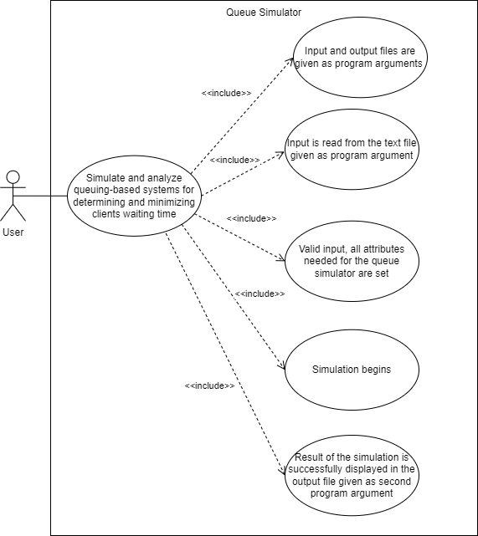
Use-case diagram

  - Use-case #1: simulate and analyze queuing-based systems for determining and minimizing clients waiting time
    - Primary actor: user
    - Main success scenario:
      - Input and output files are given as program arguments
      - Input is read from the text file given as first program argument
      - Valid input, all attributes needed for the queue simulator are set
      - Simulation begins
      - Result of the simulation is successfully displayed in the output file given as second program argument

  - Use-case #2: simulate and analyze queuing-based systems for determining and minimizing clients waiting time
    - Primary actor: user
    - Alternative sequences:
      - Input/output file not found as program argument
        - An exception (IOException) is thrown, warning against the absence of the required files
        - Return to step 1
      - Non-valid input information (for example, correct information given in a bad format)
        - An exception is thrown, warning against the incorrect input found
        - Return to step 1

Design
- Packages
  - UML Package Diagram
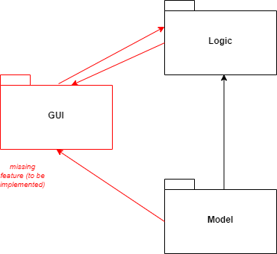
    - Organized based on the Model-View-Controller architectural pattern

  - Packages
    - Model
      - Contains the application’s dynamic data structure, independent of the user interface, managing the data, logic and rules of the application
      - Contains the classes: Task.java and Server.java
    - Logic
      - Visual representation of the model
      - Contains the Scheduler.java, InputHandler.java and SimulationManager.java class
    - GUI
      - Link between the user and the system
      - To be implemented

- Design of the application
  - Using the application requires arguments running from the command line or setting it inside the IDE, and thus the program reads input data from a file.
    - Number of clients
    - Number of queues
    - Maximum simulation interval time
    - Minimum time at which clients are ready to enter the queue
    - Maximum time at which clients are ready to enter the queue
    - Minimum processing time of a client
    - Maximum processing time of a client

  - Generating a number of clients (previously read) whose arrival time (the time when the client is ready to enter the queue) is randomly generated between T_arrival_min and T_arrival_min (read previously from the file), and processing time (the time the client is being processed) randomly generated between t_processing_max and t_processing_min (also read previously from the file) (AUTOMATICALLY GENERATED IN THE CODE). Then, the actual code execution will occur, generating an output file named by the user, which will display each queue at each specific time.

  - In the design of the application the approach involved the use of 5 main classes:

    - Task.java
      - Client class
      - Each client has an id which represents the index.
      - An arrival time (the time when a client is ready to enter the queue, after finishing their ‘shopping’)
      - A processing time representing the duration of processing each client (once the client reaches the front of the queue, they wait for the processing period and then are removed from the queue)

    - Server.java
      - Queue class
      - It has instance variables:
        - A list of clients (each queue has a certain number of clients or 0 if the queue is empty)
        - A variable representing the queue’s waiting time (the sum of the processing time for each client in the queue)

    - Scheduler.java
      - Represents the parent class that adds the client to the appropriate queue and keeps track of which thread (queue) should be started.
      - Instance variables:
        - A list of servers (queues)
        - A variable representing the maximum number of queues.
        - A variable representing the maximum number of clients.

    - InputHandler.java
      - Read class that has a constructor with two parameters representing the file path from which to read and the file path to write the output.
      - Instance variables:
        - Number of clients [int]
        - Number of queues [int]
        - Application runtime [int]
        - Maximum time arrival [int]
        - Minimum time arrival [int]
        - Maximum processing time [int]
        - Minimum processing time [int]
        - Writer [FileWriter]

    - SimulationManager.java
      - A class which has instance variables of a generated list of clients, a Scheduler, and an InputHandler object (representing the file with the data read from the file)

- UML Class Diagram

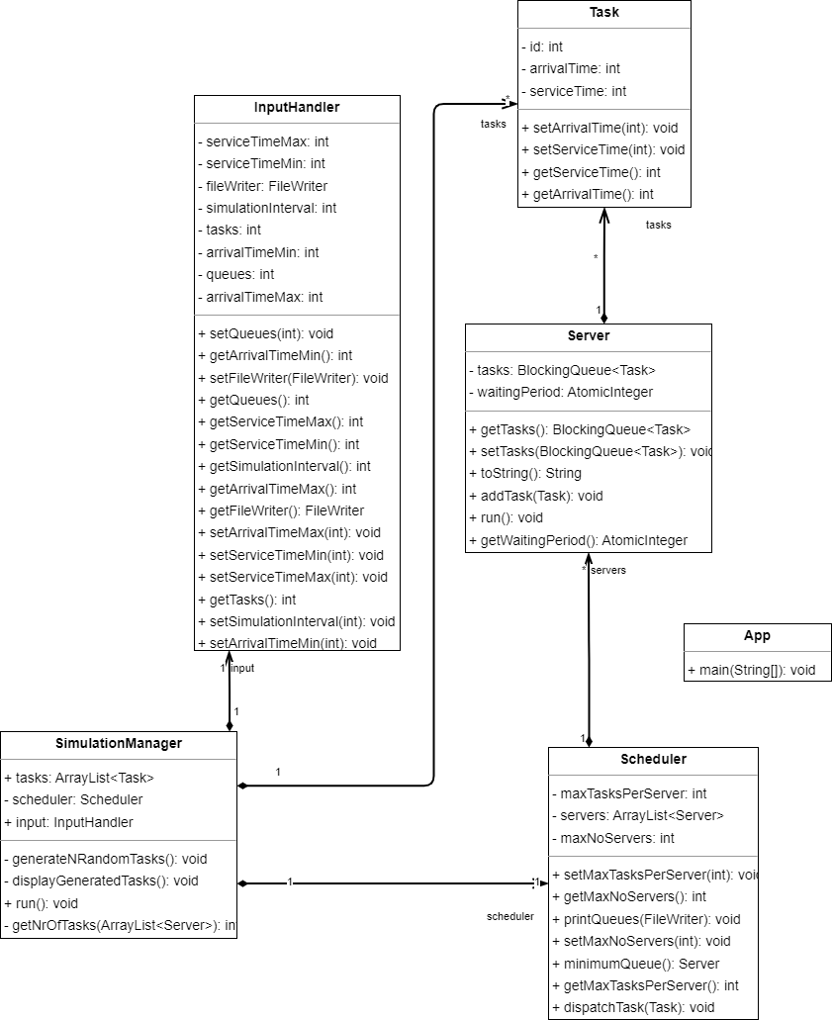

Implementation
- Input handling class – InputHandler.java
  - Class variables
    - It has as instant variables all the data read from the file, i.e., client number, queue number, simulation time, maximum waiting time, minimum waiting time, maximum arrival time and maximum arrival time and the output file.
  - Constructors
    - Public InputHandler(String firstPath, String secondPath)
  - The construct receives as parameters 2 strings as firstPath and the secondPath representing the absolute path to the input file and second path representing the absolute path to the output file.
  - In the constructor the input file is opened, the file is read line by line and if 2 values are found on the same line, the string (line) is split to have access to each element on that line.
  - Then set the instant variables with the values obtained.

- Task class – Task.java
  - Class variables:
    - It has 3 variables instant id, arrivalTime, and serviceTime
  - Constructors
    - Public Task (int id, int arrivalTime, int serviceTime)
  - Methods
    - Generate setter and getter methods for each of these and override the toString method of the Object class thus.
- Scheduler class – Scheduler.java
  - Class variables:
    - This class has as instance variables a list of servers (queues) and 2 variables representing the number of queues and the maximum number of clients in a queue.
  - Methods
    - Presents setter and getter methods for each instant variable and implements the following methods.
    - printQueues
      - Goes through the client list and write to the out file opened in the Input class the queues and everything they contain beforehand.
    - minimumQueue
      - This method scrolls through the list of queues and returns the queue that has the lowest waiting period, so it initializes an int variable with the waitingPeriod of the first queue and a server C queue with the first queue.
      - We go through the list of queues and every time we find a queue with waiting period less than minimum, then mininimum will become the waiting period of that queue and the queue will define that queue and at the end we return the queue that will represent the queue with the lowest waiting period.
      - This method is useful for selecting the queue in which the client will be inserted so if we have 2 queues and in the first queue we have 3 clients and in the second queue we have 1 client we would be tempted to insert the client in the queue with the lowest number of clients but if in the same example queue 2 has waiting time 100 and queue 1 with 3 clients has waiting time 10 then we have to insert the client in the queue with the lowest waiting period regardless of the number of clients in the queue.
    - dispatchTask
      - This method calls the add task method of the server class for the minimumQueue() server.
      - It creates a thread and starts it only once and that is when we enter the queue but before entering that queue was empty, so we avoid the desynchronization process.

- Server class – Server.java
  - This class is one of the two important classes in this project because this class is one of the instances of a thread.
  - This component implements the Runnable interface and overrides the default run() method of this interface but first we present as instant variables a list of Tasks (clients) which is of type BlockingQueue which is a very common data structure in programs that work with threads because it helps to synchronize threads and also a variable of type AtomicInteger waiting period which is also common in programs and applications that use the Multi-Threading programming technique.
  - Methods:
    - The class, besides the getter and setter methods for each instance variable also has the run method mentioned above which will be overridden.
    - addTask
      - As mentioned above the dispatch method of the Scheduler class calls the addTask method of the server class but every time we add a client to the queue, we have to set the waiting period of that queue, we add the current waiting period with the service time of the added client.
    - run
      - As long as the client list (tasks) is not empty (as long as we have a client in the queue) then we put the thread to sleep for one second ( Thread.sleep(1000)) and we start processing the clients so each time we enter the method we decrement by 1 waiting period and also we decrement by 1 service time for the client at the head of the queue but before this we check if it has serviceTime=0 if so we remove it from the queue all these instructions in a block try catch because the Thread.sleep(1000) method in the Runnable interface throws an InterruptedException, so it can be caught.
      - In this while loop we initially called the sleep instruction for the thread because after we add it to the queue it must stay for a period (1000 or 1 second) and only for the next tact period we must decrease the waiting period and also the service time of the first client in the queue if the queue is not empty or it is not 0. If we put the sleep instruction at the end, then once the client was inserted in the queue it was inserted with the service time decreased by 1 but we don't want that.
    - toString
      - It will be overwritten because it is written in the Object class, so we overwrite it and then we check if the queue is not empty if it is empty then we return “Closed” otherwise we go through the list of Task (client) and for each client we call the toString method mentioned above in the Task class and returns the string obtained from concatenating each Task's toString.

- Simulation Manager class – SimulationManager.java
  - The SimulationManager class is the second component that implements the main Thread so it has as instant variable an object of type Scheduler an ArrayList <Task> that will represent the tasks/clients randomly generated according to the values read from the file and at the same time we will have an object of type input that will represent the input/output files and all the values read from the file.
  - In the constructor of this class, we do the reading from the file itself (we instantiate the object of type input which has in its constructor 2 strings (firstPath and secondPath) representing the path to the input file and the path to the output file).
  - We also instantiate the Scheduler object and at the same time in this constructor we call the method of generateNRandomTasks() which will introduce in the ArrayList declaring as instant variable a series of n tasks/clients randomly generated according to the input parameters in the file
  - Methods:
    - generateNRandomTasks
      - Declare a new object of type Random and iterate through ArrayList<Task> and add to it the generated tasks/clients whose arrivalTime is in the range arrivalTimeMax and arrivalTimeMin read from the file and service time will be in the range service time max is service time min read from the file.
    - displayGeneratedTasks
      - We iterate through the ArrayList declared as an instant variable where we added the tasks/clients and for each one we call the toString method overridden from the Object class in the Task class.
    - onClose
      - We compute the average waiting time and average service time and write it to the output file.

    - getNrOfTasks
      - We iterate through the servers and save in a variable the number of elements of Servers found.
    - run
      - We have handled all cases for introducing tasks/clients when starting the thread.
      - Thus in this method we declare a counter time=0 and as long as this counter is less than the maximum simulation time read from the file then we initially screen this counter then we go through the list of task/client generations and if one of them has arrivalTime=time then we call the dispatch method and delete it from the ArrayList so in dispatch we call the add method to add it to the server with minimum waiting time and if before adding a task the queue was empty then we install a thread object and we start the thread. start() so it will execute the code from the run method and initially it will execute the Thread.sleep(1000) method and it will sleep for a second during which time from the run method of the SimulationManager class will increment and check if a new task/client has arrivalTime=time and if so it will add it during the sleep and at this step it will add a new task/client in the queue list and decrease the service time of the task/client already in the queue and update the waiting period of that queue.
      - Also, in this while loop (time < time_simulation_max) we display at each step the list generated by the task/client and the list of queues with their contents.
      - If there are no more tasks/clients in the ArrayList<Task> generated by the previous task/client, we check and when all queues are empty then we display the average time, waiting time and peak hour of the simulation and stop the program (break). Also, we have to do the same calculations if the simulation time expires even if queues were not empty at all.
- Main class – App.java
  - In the main method we create a SimulationManager object whose constructor has 2 strings as parameters (the path to the input/output file) and then we create a new thread object in whose constructor we put the SimulationManager object and start the thread.

Results
- The application will run, and it will generate an output file with the result.
- To test various parameters:
  - Start your IDE platform (IntelliJ).
  - Press Alt+Shift+F10 to enter the Run tab and select Edit Configurations.
  - In the section Build and run, below org.stefan.tuc.App, insert in the box “<file_name_input> <file_name_output>” (e.g. “input.txt output.txt”).
  - Press Run and wait until it finishes.
  - It takes a little bit to finish depending on the size of input.
  - Check the IDE’s terminal for evolution of the time variable.

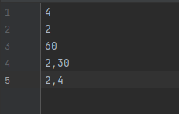
input.txt
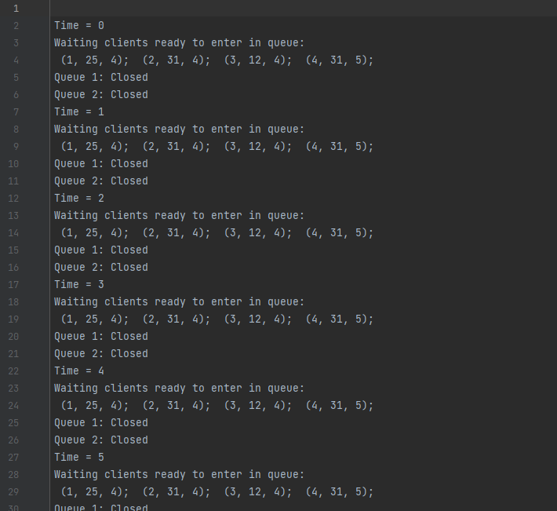
output.txt

Conclusions
- Aspects learnt
  - More in-depth understanding of the functionality of Java Threads and Multi-Threading concept
  - Working with FileWriter which is a class for writing character files.
  - Working with command line arguments.

- Future project development
  - Running more tests on the implemented project
  - Design and implementation of a GUI for the project, where it has a real-time simulation display.
  - A better approach for this project.

Bibliography
- Laboratory resources
- https://www.geeksforgeeks.org/java-threads/
- https://www.youtube.com/playlist?list=PLhs1urmduZ2_ZFO6vu63QNWTL5XHriWKu
- https://www.geeksforgeeks.org/filewriter-class-in-java/
- https://stackoverflow.com/questions/2066307/how-do-you-input-command-line-arguments-in-intellij-idea
- https://www.geeksforgeeks.org/synchronization-in-java/
- https://stackoverflow.com/questions/20545865/visibility-and-order-of-atomic-counter-updates-vs-blocking-queues
- https://www.baeldung.com/java-blocking-queue

