In order to get this project in Eclipse CDT; first go to the "make" directory.
Run the file install_eclipse_cdt.bat.
This will copy the project files needed for Eclipse into the dune2themaker directory.
Next, run Eclipse CDT and click File->Import...
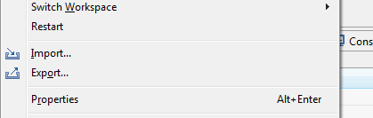

Then, choose: Existing Projects into Workspace
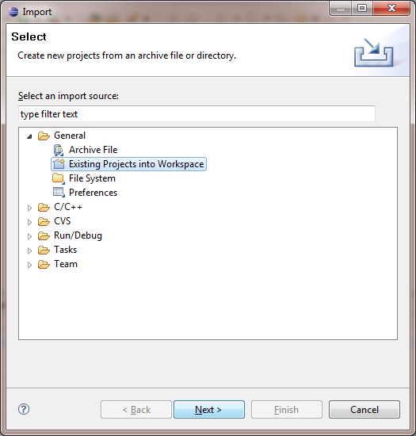
In the next window, give the path to the dune2themaker project, for example:
c:\dev\projects\dune2themaker
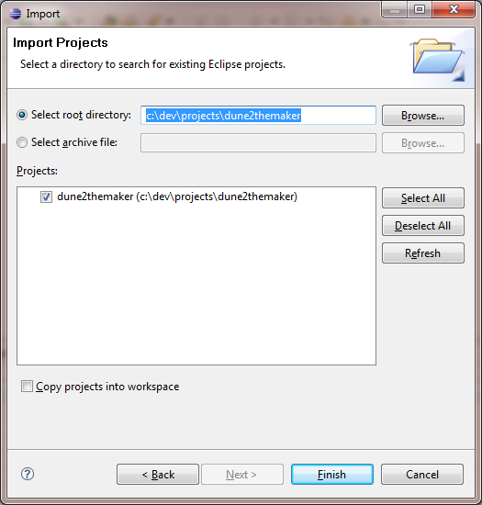
Click "Finish".

