DUNE II – The Maker
How to get the source & get it working…

http://code.google.com/p/dune2themaker/

There are some basic elements you need, in order to get the source and to get the game working. Here is a basic list, and do not worry, everything is explained into detail how to get it.

What do you need:
- a develop environment (MS Visual C++ 2005 (express))
- a SVN client
- the source code
- additional header and lib files

Table of Contents
- Get yourself a develop Environment
- Get yourself the source of D2TM
- Get yourself the libs, headers, … (get it working)
- Get it into action!

Fast Answered Question:
I get the source, I am a project member, what is my username/pass?
In TortoiseSVN you fill in your own gmail account details. Your username/pass is the same as you login to check out your gmail (but do not fill in your entire mail address as your username though).

Get yourself A Develop environment (for free!)
Since the intention is to get this working, with ease, I choose to use Microsoft Visual C++ 2005 Express (further called MSVC 8). It is free (you need to register this though, but it costs nothing) and easy to set up. If you use MSVC 7 , you could try to use the solution file given when you do a checkout of the project through your SVN client. However, since you’re reading this, you either did not get yourself a Develop environment yet, or you’re just curious.

In order to get MSVC 8; go to:

http://msdn.microsoft.com/vstudio/express/visualc/download/

Follow steps 1 to 3, you DO NOT have to download the SDK in order to get D2TM to work. If this is the first time you install an MSVC package, start with step 2 and choose to run the executable file; you may be asked to restart your computer.

Get yourself the source code of D2TM
In order to get the source code, you need a program that is able to do a ‘checkout’ of the project at Google Code. You need a ‘subversion’ client, which is basically a sort of protocol in order to have multiple people working on the same code. You can modify a source and commit, or you can simply choose just to get the latest source via an update (after a checkout).

In short: First you need to checkout a project, after that you update your files every time you want to know if there are updates. After that you can try to commit code you have added/changed. You need to be a project member in order to have the code actually be committed. If you are not a project member, you can always ask to become one.

I recommend Tortoise SVN; grab this client from this direct download link…
http://prdownloads.sourceforge.net/tortoisesvn/TortoiseSVN-1.4.0.7195-RC1-src.zip?download

The actual site is: http://tortoisesvn.tigris.org/

Install the software, you may need to restart your computer, but that would be the last time…

After your computer has restarted, create a folder/directory where your D2TM source will be in. Ie, I choose for :

C:\Projects\Dune 2 – The Maker\source

Now navigate to your D2TM folder , where you see your sub-folder (where the source will be put into) and right-click on it. Then click on “TortoiseSVN->checkout”… Or “SVN Checkout” (i noticed a tiny difference in versions).

And fill in the URL as given in this picture…

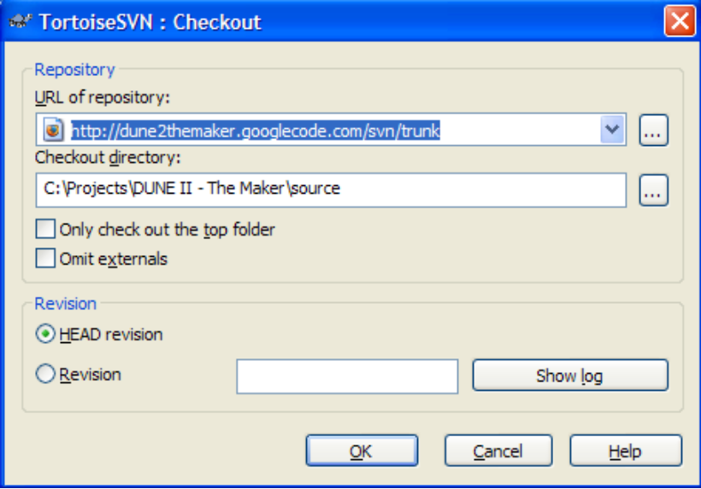

Press OK, and you will see that a lot of files will be downloaded. The first time might take a while!

When its done downloading, you have successfully obtained the source… now lets get it compiling (working..) shall we?

Get yourself the libs and headers(get it working)
Libraries, Headers, DLLs, the names might sound unfamiliar, if so you should follow these steps carefully… If you do know what to do, I will give you an easy description here:

- get the LIB zip file and unpack it in your LIB dir of your Develop Environment
- get the HEADER zip file and unpack it in your HEADER dir of your Develop Environment
- launch the Solution of D2TM and hit COMPILE.
NOTE: If you wonder if you need any DLL files, you do! But they are delivered through SVN to ensure you got the right version. (It might update some day)
If you’re still here; I assume you have no clue how to do the above things on your own…

Step 1: Obtain the files:
Download the 2 zip files, and put them in a folder where you can find them easily. I assume you know how to handle zip files (they are just like folders in XP).
HEADER files: http://arrakis.dune2k.com/downloads/source/3rdpartyincl.zip
LIB files: http://arrakis.dune2k.com/downloads/source/3rdpartylib.zip

Step 2: Put the files into place
The HEADER and LIB packages contain files that will go into almost the same directory structure, so therefore we handle those first.

I assume you have installed MSVC 8 (step 1) and you selected the default install dir. If you have changed this in the install procedure, you will know where to find it.

Open one window where you can easily access your zip files, open another window and navigate it to C:\Program Files\Microsoft Visual Studio 8\VC\

You see a list of folders, one of them is familiar… “lib”

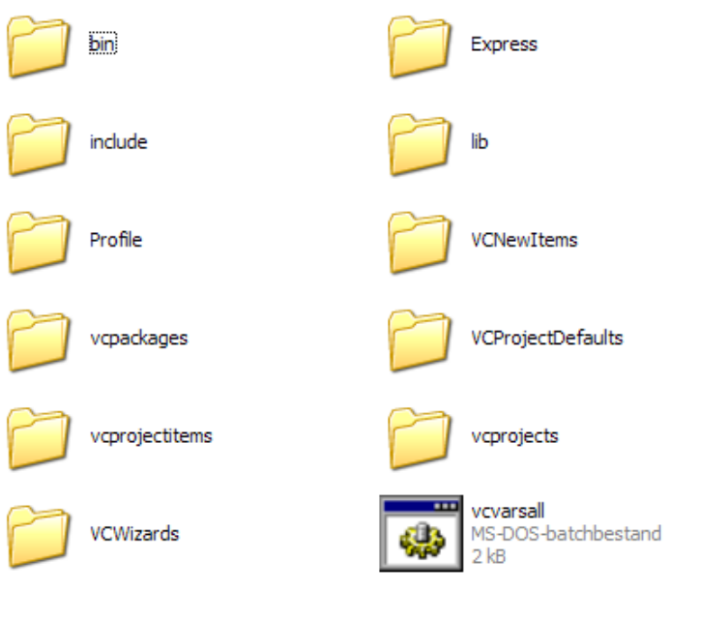

Open up LIB. Now unpack the file : 3rdpartylib.zip into the LIB directory. No files will be overwritten.

Now get back to the VC directory and open up INCLUDE. Now unpack the file : 3rdpartyincl.zip into the INCLUDE directory.

Congratulations, we can now try to get the game compiling and running…

Get it into action!
Now, you’ve been through all this trouble. Lets see if it was all worth it…

Find your source directory and open up DUNE 2.SLN which would look like:
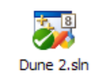

MSVC 8 will start up , open the project and is one step away from compiling the source. Get in the menu “Build” and click “Build solution”.
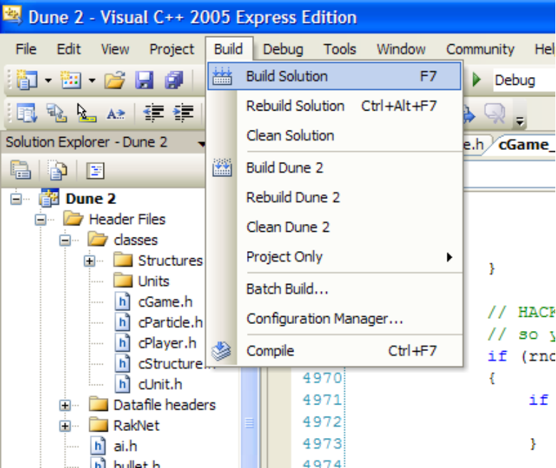

You will see a lot of progress/activity going on at the bottom of the screen. In the end you will see something like this:
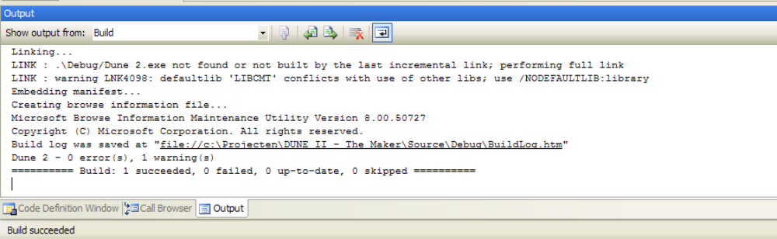

Congratulations, you have successfully compiled the source. If you however, get a lot of errors. You either forgot to copy the HEADER files into the proper directory or the LIB files (you will get LINK errors then).

To run the game: Go to “Debug” and “Start Debugging”, or select “Start without debugging”.
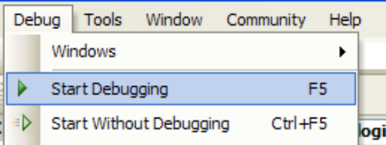

And…
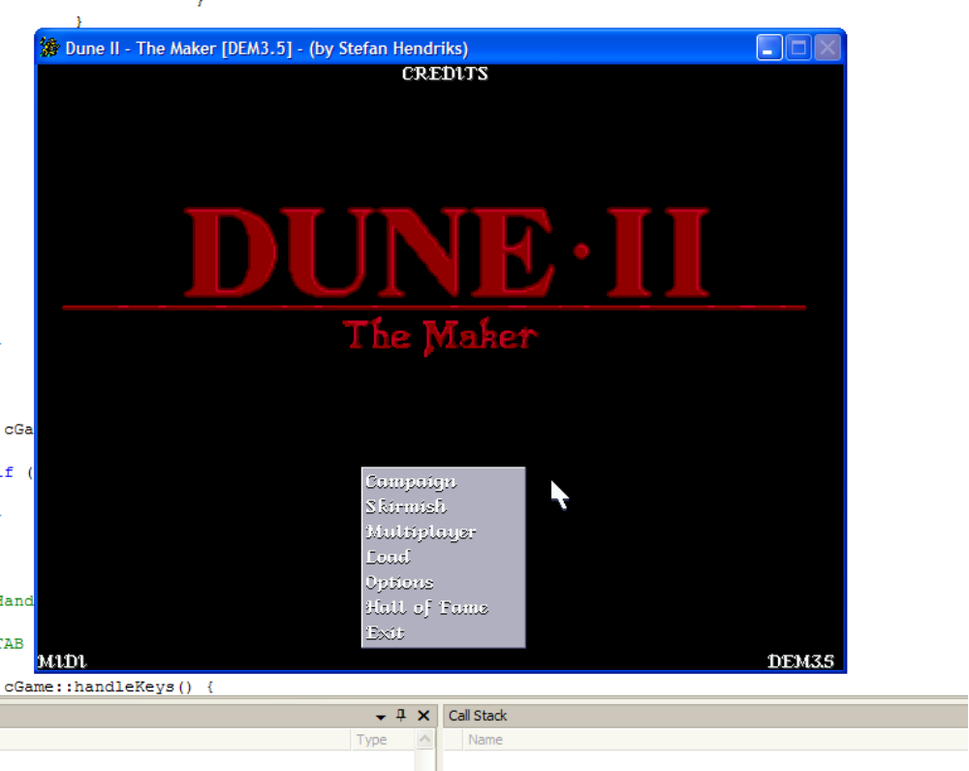

Congrats!

Stefan Hendriks

Version 1.1
Fixed a few words and made it a bit more fancy.
Note added about DLL files.

Version 1.0 – Initial release

