

Event Management

System

Name: Kulcsar Noemi

Group: 30234

Table of Contents

***Deliverable 1 .................................................................................................................... 3***

**Project Specification ................................................................................................................. 3**

**Functional Requirements .......................................................................................................... 3**

**Use Case Model ....................................................................................................................... 3**

Use Cases Identification ................................................................................................................................. 3 UML Use Case Diagrams .............................................................................................................................3**.**

**Supplementary Specification .................................................................................................... 4**

Non-functional Requirements ....................................................................................................................... 4

Design Constraints ......................................................................................................................................... 5

**Glossary ................................................................................................................................... 5**

***Deliverable 2 .................................................................................................................... 5***

**Domain Model ......................................................................................................................... 5**

**Architectural Design ................................................................................................................. 5**

Conceptual Architecture ................................................................................................................................ 5

Package Design .............................................................................................................................................. 5

Component and Deployment Diagram .......................................................................................................... 5

***Deliverable 3 .................................................................................................................... 5***

**Design Model ........................................................................................................................... 5**

Dynamic Behavior .......................................................................................................................................... 5

Class Diagram ................................................................................................................................................ 5

**Data Model .............................................................................................................................. 5**

***System Testing ................................................................................................................. 6***

***Future Improvements ........................................................................................................ 6***

***Conclusion ........................................................................................................................ 6***

***Bibliography ..................................................................................................................... 6***

# Deliverable 1

## Project Specification

This project is a web-based event management system that allows users to create, edit, view, and delete events. The system provides functionalities for event organization, venue management, and ticket allocation. The platform enables users to manage event details, including date, location, and capacity, while ensuring data consistency across the system.

## Functional Requirements

The key functional requirements of the system are:

1. **Event Creation** – Users can create new events by providing event details such as name, description, date, and venue.
2. **Event Editing** – Users can modify existing events, including event details and venue information.
3. **Event Deletion** – Users can remove events from the system.
4. **Event Listing** – The system displays all available events, including their details and associated venues.
5. **Venue Management** – Users can select venues from a predefined list when creating or editing events.
6. **Capacity Synchronization** – If a venue's capacity is modified, the change is reflected across all events using that venue.

## Use Case Model 1

### Use Cases Identification

**Use Case: Create Event**

**Level:** User interaction

**Primary Actor:** Event Organizer **Main success scenario:**

1. User navigates to the "Create Event" page.
2. User fills in event details (name, description, date).
3. User selects a venue from the predefined list.
4. User submits the form.
5. The system stores the event in the database and confirms creation. **Extensions:**

* 3a: If no venue is selected, the system prompts the user to choose one.
* 4a: If invalid data is entered, the system displays an error message.

**Use Case: Edit Event**

**Level:** User interaction

**Primary Actor:** Event Organizer **Main success scenario:**

1. User selects an event to edit.
2. User modifies event details.
3. User changes the venue if needed.
4. User saves the changes.
5. The system updates the event and reflects changes across all instances of the venue.

**Extensions:**

• 3a: If venue capacity changes, all related events update accordingly.

**Use Case: Delete Event**

**Level:** User interaction

**Primary Actor:** Event Organizer **Main success scenario:**

1. User selects an event to delete.
2. System prompts for confirmation.
3. User confirms deletion.
4. The system removes the event from the database. **Extensions:**

• 2a: If the event has active tickets, the system prevents deletion.

UML Use Case Diagrams

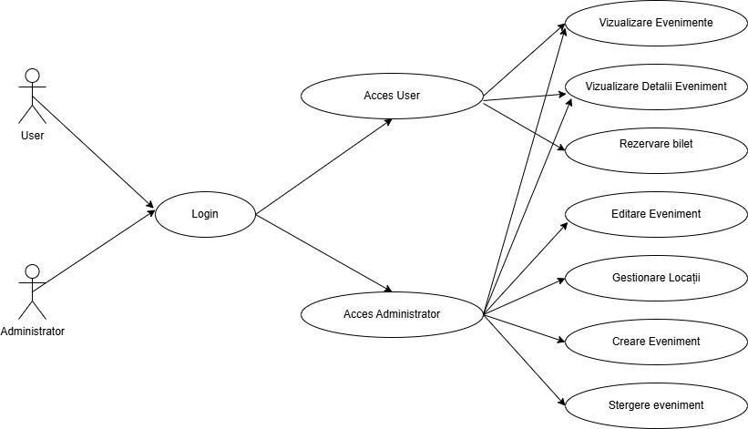

## Supplementary Specification

The system provides additional functionalities such as:

* Ensuring venue capacity remains synchronized across all events.
* Allowing easy selection of venues from a predefined list.
* Displaying event lists with relevant filtering options.

### Non-functional Requirements

**Scalability** – The system must support hundreds of simultaneous users creating and managing events.

**Usability** – The UI must be intuitive, allowing users to create and edit events without requiring technical knowledge.

**Data Consistency** – Changes in venue information must be reflected across all related events.

**Security** – Users should only be able to edit or delete events they created, preventing unauthorized modifications.

### Design Constraints

**Technology Stack**: The system is implemented using Spring Boot for the backend, Thymeleaf for the frontend, and a mock database for development.

**Development Frameworks**: Java 21 with Spring Boot 3.4 is used for backend logic. **Database Management**: Currently, the project uses an in-memory mock database, with potential migration to a SQL-based system.

**Architecture**: Follows an MVC (Model-View-Controller) pattern for clear separation of concerns.

## Glossary

**Event**: A scheduled gathering with a name, description, date, and venue.

**Venue**: A location where an event is hosted, including details like name, address, and capacity.

**Event Organizer**: A user responsible for managing events.

**Mock Database**: A temporary database used for development and testing purposes.

# Deliverable 2

## Domain Model

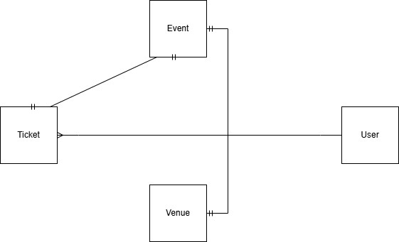

## Architectural Design

### Conceptual Architecture

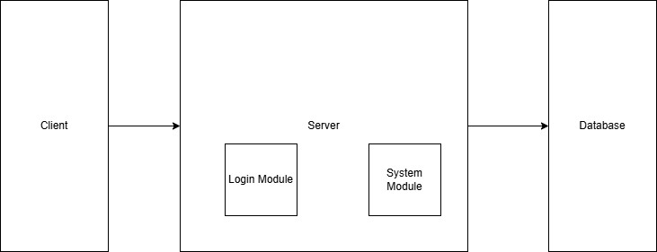

### Package Design

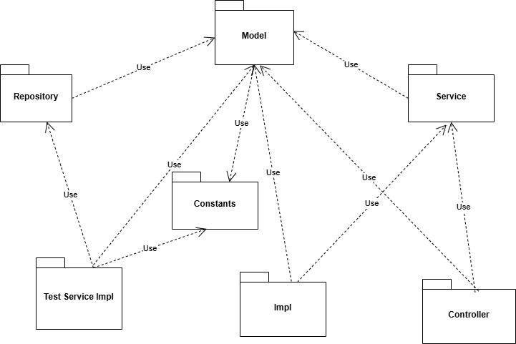

### Component and Deployment Diagram

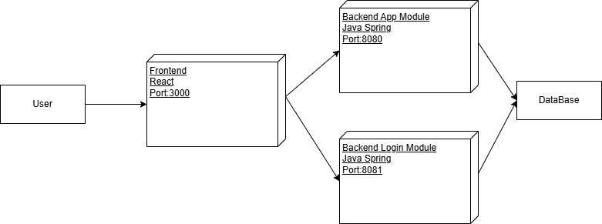

# Deliverable 3

## Design Model

### Dynamic Behavior

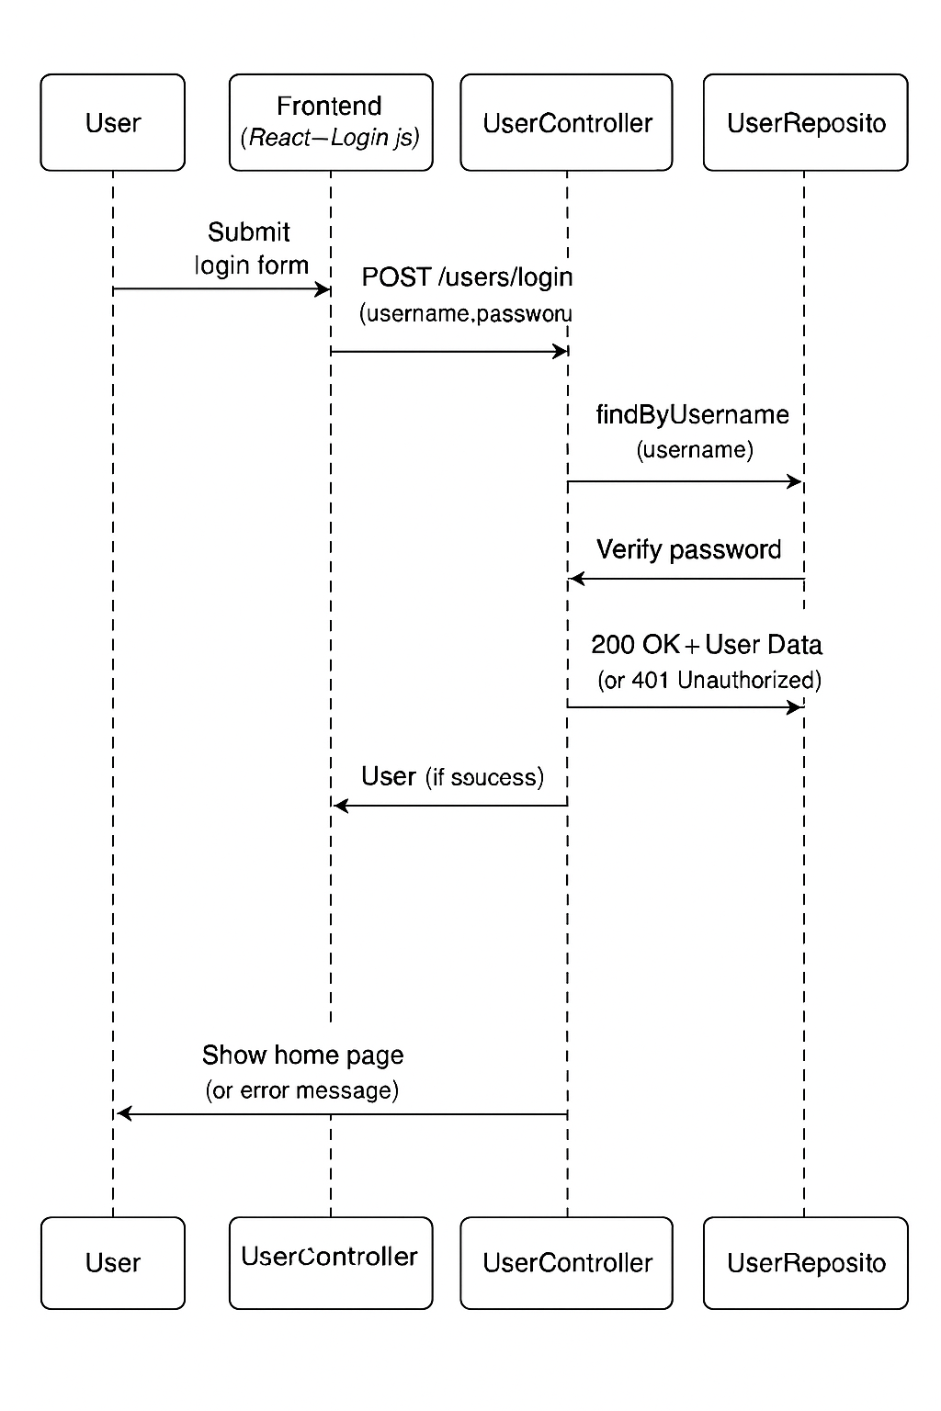

### Class Diagram

**Main Backend Module**

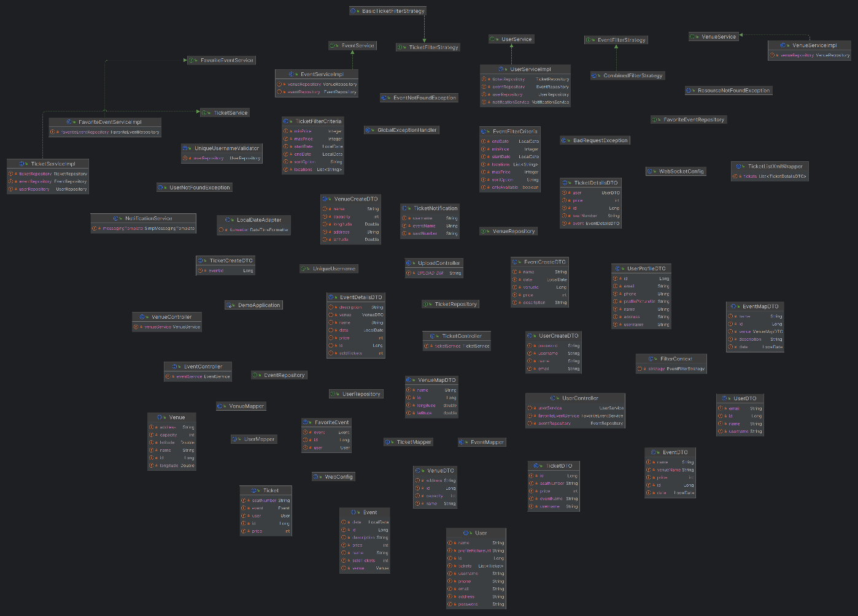

**Login Backend Module**

## Data Model

# System Testing

Testarea sistemului a fost realizată atât automat, cât și manual. La nivel de unit testing s-au verificat serviciile principale, precum UserService și EventService, pentru a confirma corectitudinea funcțiilor individuale. Testarea de integrare a acoperit fluxuri complete precum login, înregistrare utilizatori, filtrarea evenimentelor și cumpărarea biletelor, asigurând comunicarea corectă între module.

Prin testare manuală s-au verificat scenarii uzuale: login cu date valide și invalide, crearea de utilizatori noi, validarea câmpurilor obligatorii și gestionarea erorilor de server. Testele au confirmat funcționarea completă și robustă a aplicației în interacțiunea utilizatorului.

# Future Improvements

* **Implementare resetare parolă**: adăugarea unei funcționalități "Forgot Password".
* **Încărcare efectivă imagini**: nu doar URL de profil, ci upload fizic pe server.
* **Notificări prin email**: pentru confirmare cumpărare bilete.
* **Autentificare JWT**: pentru protejarea endpointurilor API.
* **Sistem de rating pentru evenimente**: utilizatorii pot da stele după participare.
* **Plată reală cu card bancar**: integrare Stripe sau PayPal.

# Conclusion

Aplicația respectă o arhitectură clară MVC, include validări de bază și custom pe backend, oferă fluxuri complete de login, register, event management și tickets, iar designul bazei de date este normalizat.

# Bibliography

* **Spring Boot Documentation** – [*https://spring.io/projects/spring-boot*](https://spring.io/projects/spring-boot)
* **Hibernate ORM Documentation** – *https://hibernate.org/orm/documentation/*
* **Spring Security Documentation** – [*https://docs.spring.io/spring-security/reference/*](https://docs.spring.io/spring-security/reference/)
* **Spring Data JPA Documentation** – [*https://spring.io/projects/spring-data-jpa*](https://spring.io/projects/spring-data-jpa)
* **React Documentation** – [*https://react.dev/*](https://react.dev/)
* **Axios Documentation** – [*https://axios-http.com/*](https://axios-http.com/)