Applied Wireless Network Security
BUS 6000 Dr. Michael E. Wojcik, Professor

Instructions:

This final examination is an “open book” take-home examination worth 350 points, which means Students may consult with any written materials while they are taking the examination. Students may write their answers on the examination itself, or on plain paper, or both. The examination shall be taken on an individual effort basis only. The examination consists of short answer and essay questions. Partial credit will be given to Class members who describe how they arrived at the answer, even though the answer may be wrong. Please submit your exam in the Canvas classroom. Please put your NAME on the exam and state your source for each answer. All the best to you, and contact me via both of my e-mail addresses if you have questions!

Grading
Part | Possible Pts | Actual Pts | Comments
A | 050
B | 050
C | 150
D | 100
Total | 350

Student’s Name: Stefanie Kenyon _____________________________________________________

Part A Short Answer (50 Points) Each question worth 10 points

- Explain the “mesh benefit” of the mesh network. (10 points)?

The benefits of the “mesh benefit” is that they can be self configurable if a node is failing or has a weak signal where and the user can add and/or subtract a node in the network (DeCelle, 2024).

Reference
DeCelle, B. (2024). “What is Mesh WiFi?” NETGEAR. https://www.netgear.com/hub/technology/what-is-mesh-wifi/

- Explain why user throughput is higher on the two-hop path versus the direct path Wireless Mesh Network (10 points)?

The user throughput is higher in the two-hop path because there are greater number of paths in the network for the user. With a direct path, there is only one path that can be taken therefore limiting user throughput (Zheng, 2010).

Reference
Zheng, P. (2010). 7.4 Routing and Scheduling a Given Vector Flow. In Wireless Networking Complete. essay, Morgan Kaufmann Publishers/Elsevier.

- Explain how OFDM increases data throughput (10 points)?

In an OFDM-MIMO system, the OFDM modulated data is transmitted from multiple antennas at the same time and is then decoded by MIMO to retrieve the data from all of the antennas (Zheng, 2010).

Reference
Zheng, P. (2010). 6.5.3 OFDM-MIMO Systems. In Wireless Networking Complete. essay, Morgan Kaufmann Publishers/Elsevier.

- A basic arrangement for IEEE 802.16 networks consists of what components (10 points)?

There are 4 main components of a 802.16 network and they are as follows:
Base Station (BS), Subscriber Station (SS), Mobile Subscriber (MS), and Relay Station (RS) (Zheng, 2014).

Reference
Zheng, P., et al. (2010). 2.3. In Wireless Networking Complete. essay, Morgan Kaufmann Publishers/Elsevier.

- Describe the man in the middle attack and how could it be detected? (10 points)?

A man in the middle attack is a cybersecurity threat where the attacker places themselves between the sender and the destination and it can be detected by either looking at latency issues, deep packet inspection tools and deep flow inspection tools while network monitoring, and intrusion detection and prevention systems for IoT devices (Mohanakrishnan, 2022).

Another tool that could be used is wardriving since we are looking for other networks that are close to us that have the ability to connect to our devices.

Reference
Mohanakrishnan, R. (2022, April 7). “What Is a Man-in-the-Middle Attack? Definition, Detection, and Prevention Best Practices for 2022.” SpiceWorks. https://www.spiceworks.com/it-security/data-security/articles/man-in-the-middle-attack/

Part B Essay (50 Points)

- Discuss the concept of home and foreign agents and how the mobile node away traffic is routed by these agents to enable mobile IP. (25 points)

Source: Zheng, P., et al. (2010). 10.1 The Requirements of Mobile IP. In Wireless Networking Complete. essay, Morgan Kaufmann Publishers/Elsevier.
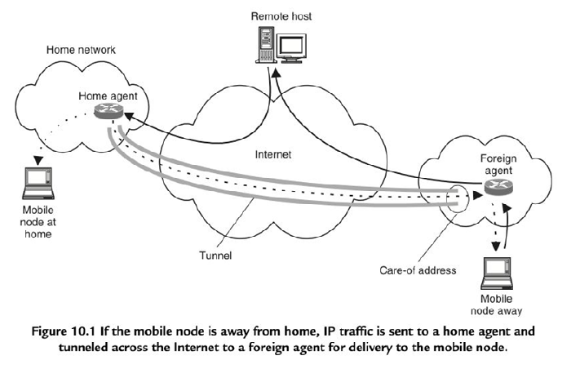
The concept of mobile IP tells us how IPs can change as the mobile node can change their point of attachment. The home agent is a nonmobile node to which “packets targeted at a mobile host are sent to its home network” (Zheng, 2010). The home agent is also where the packets to the host are forwarded. The mobile host provides their location to the home agent. The foreign agent is where “packets must be tunneled across the Internet to a care-of address where the host has registered its attachment” (Zheng, 20210). But this is only the case if the host is attached to the foreign agent. If the mobile host stays with a foreign agent, “the packets are forwarded to the mobile host” via tunneling to a care-of address (Zheng, 2021).
- Using the diagram below, explain the how the Mobile Subscriber handoff between Base Stations works. (25 points total)

Source: Agrawal, D., & Zeng, Q. (2002). 1.3. Handoff Initiation. In Handbook of Wireless Networks and Mobile Computing. essay, John Wiley & Sons, Inc.

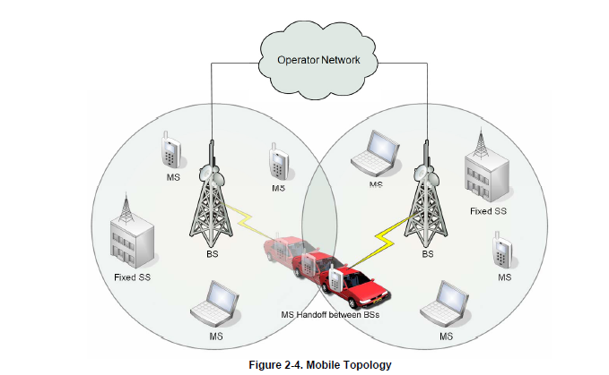

We will discuss, as depicted in the diagram, the MS handoff between base stations. As base stations have limited range, there is a network of base stations that allows for mobile stations to transition over to the next base station. For a handoff, there is a process involved for this, namely, initiation. The initiation process is based off of signal strengths and provided criteria. The general idea is that the mean signal strength of the current base station decreases as the mean signal strength of the next base station increases (Agrawal & Zeng, 2002). The authors Agrawal and Zeng show one example of this called Relative Signal Strength with Threshold. This method shows that “This method allows a MS to hand off only if the current signal is sufficiently weak (less than threshold) and the other is the stronger of the two” (Agrawal & Zeng, 2002). This method shows that a threshold has been set and that the handoff will occur when if the current signal is sufficiently weak and that the next signal is stronger of the two. Once the process is complete, the mobile station will conduct either successfully or unsuccessfully for the handoff. If the handoff is successful, the mobile station will be associated with that base station. Otherwise, the connection is cut off.
Part C Essay (150 Points) – See other attachment for answer.

1. For each of the scenarios below (with a drawing package of choice):
- a. Depict the topology [e.g., STA, LAN Cloud, WPA/Router, and WAN Cloud].
- b. Depict secure access method for each device [i.e., STA to WAP, WAP/Router to WAN]
- c. Depict on the drawing or list under the drawing the security measures to protect each device [e.g., STA, WPA/Router]
- d. Features can be listed on device, topology or paragraph form below SIMPLE LISTS ARE FINE
- e. STA, WPA, Cloud protocols should be listed

 | Network | Stations | Wireless Access | WAN | Comment | Points
1 | SOHO network [Home] | 3 STA | 1 WAP | DSL |  | 25  10 Topology  10  Security
* Place under your Diagram for Grading

2 | SOHO network [Starbucks] | 6 STA  [Starbucks owned]  6 STA [Customers] | 3 WAP  [Connect them for backhaul to one WPA/Router for DSL access] | DSL | Depict secure access for Starbucks owned STA as well as customer owned STA | 25  10 Topology  10  Security
* Place under your Diagram for Grading

3 | Integrate I-phones / Droid and I- Pads into your Enterprise WLAN | 1 I-Phone / Droid  1 I-Pad | depicted at home and work networks | WIFI | Depict secure access for I-Phone / Droid and I-Pad | 50  15  Topology  15  Security
* Place under your Diagram for Grading

4 | Campus wireless network | 6 STA  [Administration]  6 STA [Mobile users Internet access only] | 2 WAP  [1 for Admin and 1 for Mobile Users Internet only] | T1 (Internet Access) | Depict secure access for Admin computers and Mobile Internet only users | 50  15  Topology  15  Security
* Place under your Diagram for Grading

Part D: Mobile Policy (100 Points) – See other attachment for answer.

The Capitol University Research, Inc. (CRC) is considering authorizing the use of personally owned wireless devices on the enterprise wireless network. CRC is considering authorizing the personally-owned devices to access corporate applications such as customer relationship data bases, supply chain management (SCM), and personnel systems.

You are the system security manager and have been tasked with writing a four- page policy and implementation plan which explains how personally-owned wireless devices (POWD) will be implemented to securely access the enterprise network. CRC has selected one of the following personal devices (RIM, iPhone, or Android) and the iPAD for implementation in the plan. You must keep the plan simple using information learned in your BUS 6000 class so that the boss will be clear as how the devices can be used securely. The policy and implementation plan will be typed as a four- page, double- spaced, APA-style document for Designated Approving Authority (DAA) signature. Your implementation plan will be structured, and graded, along the five phase SDLC lifecycle approach as stated in NIST SP 800-97 Chapter 8 in the link below

NIST SP 800-97. http://csrc.nist.gov/publications/nistpubs/800-97/SP800-97.pdf

Grading: | Possible | Actual
- Policy Signature Letter for DAA | 10
- Acceptable Use Policy (AUP) (1 Page) | 10
- Authorized Devices List | 10
Choice of smart phone and iPAD
- Implementation Plan (5 Stages) (5x10=50) | 50
What actions at each phase
- Protective Measures | 10
List for network and device level
- APA Style (optional) | 10
(Title Page, margins, font, page numbers, etc...)
Total | 100

Keep it simple, emphasizing what, and not the how!

