**Plant community compositional persistence over 40 years in a Fraser River Estuary tidal freshwater marsh**

Stefanie L. Lane1, Nancy Shackelford2, Gary Bradfield1, Madlen Denoth1, Tara Martin1

1The University of British Columbia, Vancouver, BC, Canada; 2University of Victoria, Victoria, BC, Canada

Corresponding author: [stefanielane@utexas.edu](mailto:stefanielane@utexas.edu)

# Abstract

TBD per journal – frame premise with respect to issue of global homogenization, exemplified here in a protected area subject to indirect disturbances. Value of study is to observe changes in species composition to inform concepts of habitat stability and community homogenization in the absence of direct (pulse) disturbance pressures.

# Introduction

The importance of climate change drives a need to understand patterns of ecosystem responses through plant community compositional changes. Community stability may be characterized as consistency in species or functional diversity through time and space (Holling, 1973; Donohue et al., 2016). Shifts in community-dominant species, loss of native species diversity, and species turnover (such as greater abundance of invasive species) may indicate loss of functional redundancy. In turn, this may indicate reduced resistance to change or resilient capacity to recover from disturbance (Bai, Han, Wu, Chen, & Li, 2004; Tilman, Reich, & Knops, 2006). Furthermore, the loss of native species may have stronger negative impacts on biodiversity persistence when the regional pool of potential species is reduced or environmentally constrained (Hanski, 1982; Lepš, 2004). Characterization of plant community changes on decadal timescales contributes to observation of meaningful long-term patterns of compositional stability, and is instructive for developing hypotheses to test drivers of disturbance, especially in dynamic landscapes heavily impacted by anthropogenic activities, such as estuaries. (Ovaskainen, Rybicki, & Abrego, 2019; Underwood, Chapman, & Connell, 2000).

Estuaries are at the terrestrial-marine interface where hydrogeomorphic and ecological changes occur on annual, decadal, and millennial timescales (Pasternack, 2009). Because these ecosystems will experience accelerated change under sea level rise, these habitats are of increasing conservation concern (Brophy et al., 2019); understanding estuarine habitat stability can inform climate change resilience strategies. In North America, estuaries are of particular conservation importance in the Pacific Northwest (PNW) because their pathways of retreat or expansion are spatially restricted by fjord geography (Emmett et al., 2000), whereas estuaries along the Atlantic coast may spread along expansive coastal plains. Tidal freshwater marshes (TFMs) are the upper reaches of estuaries dominated by riverine freshwater, and in the PNW they are particularly important as early transitional habitat along salinity gradient for salmonids (Chalifour et al., 2019; Davis et al., 2021). Estuary conservation efforts are intended to protect coastal municipalities and provide sufficient habitat; stability of plant communities within tidal marshes may contribute to the ability of these habitats to resist change or recover from disturbance (Holling, 1973). Loss of species diversity within these habitats reduces the available biodiversity in the regional species pool, as well as potentially reducing functional habitat value.

A challenge of understanding community stability, including within estuaries, is the lack of long-term data. In absence of long-term monitoring, historical datasets can provide a ‘snapshot’ of species compositional variation over time. One such opportunity exists in Ladner Marsh, which is part of the South Arm Marshes (SAM) Wildlife Management Area (WMA) near Delta, BC, Canada (Figure 1). Despite industrialization and municipal expansion within the region, this habitat has escaped development, and to the best of the authors’ knowledge has not experienced major natural disturbance in the past 50 years. Understanding how community composition prior to and since the 1991 establishment of the WMA is important for regional land managers in evaluating benchmarks for conservation and restoration targets. Two historical studies conducted in Ladner Marsh (Bradfield & Porter, 1982; Denoth & Myers, 2007) used similar methods to document floristic diversity. Bradfield & Porter (1982) identified distinct community sub-types (hereafter, “assemblages”), likely driven by edaphic factors such as drainage. Denoth & Myers repeated the sampling to determine whether a non-native species (purple loosestrife) was displacing a species of concern, Henderson’s checkermallow. Henderson’s checkermallow (*Sidalcea hendersonii* S. Watson) is locally abundant in this marsh, and thus stability of habitat conditions is vital for species conservation. While these studies independently characterize different community metrics, these datasets provide the opportunity to repeat observations and characterize long-term plant community changes and habitat stability.

The main objective of this work is to infer stability of plant community compositional structure in the absence of large-scale or direct disturbance in a tidal freshwater marsh. I used three observational datasets spanning four decades to answer the following questions:

(1) Are TFM assemblages continuously characterized by the same dominant species? In the absence of significant environmental disturbance, I expect the same species composition to dominate each assemblage as identified by Bradfield & Porter (1982).

(2) Is the mean species diversity (α-diversity) and variation (β-diversity) within and across assemblages constant between years? If the plant community is stable, I expect little change in α-diversity and β-diversity.

(3) What is the total turnover within each assemblage, and which species gained or lost are driving changes within each assemblage? I expect that increasing abundance of invasive species over time would result in greater number of species lost (and fewer species gained), and thus greater rates of turnover.

# Methods

## Physical & ecological context

The Fraser River drains the largest catchment in British Columbia, and its estuary currently spans 2,814 ha, one-third of which lies within the South Arm Marshes Wildlife Management Area (Schaefer, 2004) (Figure 1). Ladner Marsh occupies approximately 100 ha within the South Arm Marshes, bounded to the east by municipal development and by the Fraser River along its western edge (Figure 1).

Species common to these habitats are generally herbaceous, and the community is largely dominated by sedges and rushes with some salinity tolerance, but a greater diversity of broadleaf flowering species (“forbs”). Forb species such as bogbean (*Menyanthes trifoliata* L.) are tolerant of continuously waterlogged conditions, whereas sedges (*Carex lyngbyei* Hornem.) are better adapted to microsites that are regularly inundated and drained. Grass species such as non-native tall fescue (*Festuca arundinaceae* Schreb.) may prefer the most well-drained sites, although some non-native species such as reed canary grass (*Phalaris arundinaceae* L.) tolerate more saturated soils, and present an invasion threat in tidal wetlands (Sinks, Borde, Diefenderfer, & Karnezis, 2021).

## Vegetation surveys

### 1979-1999

Data were originally collected in 1979 as part of an observational study to characterize dominant assemblage types (Bradfield & Porter, 1982). Eight transects were positioned along a north-to-south gradient, and 1 m2 quadrats (plots) were placed in the center of vegetation patches where species composition noticeably changed, or every 10 m along the transect, whichever distance was shorter (Bradfield, 2019 personal comm.). Cluster analysis and principal components analysis (PCA) distinguished three community associations, each dominated by a distinct species: Lyngbye’s sedge (*Carex lyngbyei* Hornem.), fescue (*Festuca arundinaceae* Schreb.), and bogbean (*Menyanthes trifoliata* L.). Bradfield & Porter (1982) hypothesized that edaphic factors drove assemblages, such as waterlogged soils in the bogbean assemblage, or drainage along channel edges in the fescue assemblage.

A subsequent survey conducted in 1999 recreated the transects and sought to place sampling plots at exact positions sampled in 1979 to test relationships between invasive purple loosestrife (*Lythrum salicaria*, L.) and Henderson’s checkermallow (*Sidalcea hendersonii* S. Watson), which is a Blue Listed species of special concern in British Columbia (Denoth & Myers, 2007). While Denoth & Myers did not seek to test changes in community composition, data were collected according to the same protocols as in 1979, and the data have been made available for comparison. This publication will reference dates the data were collected, rather than publication dates of the preceding studies.

### 2019

No permanent markers were left in Ladner Marsh, so precise transects assessed by Bradfield & Porter (1982) or Denoth & Myers (2007) were not identifiable in 2019. Transect endpoints were approximated within ~5 m by overlaying Figure 1 in Bradfield & Porter’s 1982 publication on a georeferenced basemap, aligning prominent landscape features, and marking GPS locations in Avenza Maps (Avenza Systems Inc., Ontario, Canada, v. 3.2). Transect “Q” (n = 7 plots) was omitted in 1999 and 2019 due to conversion to thick riparian forest with an understory of Himalayan blackberry (*Rubus armeniacus*) since 1979; these plots from 1979 are not included in the present analyses. An additional 18 plots surveyed in 1979 and 1999 were omitted in 2019 due to physical inaccessibility, either due to overgrowth of riparian fringe, widening of tidal channels, or variation in transect placement (Table 3, Supplemental). Despite these decisions to exclude plots, Kopecký & Macek (2015) have demonstrated that uncertainty of plot location does not produce unreliable evidence of plant community changes on decadal timescales.

Vegetation were sampled in the same manner as the 1979 survey by semi-systematically placing 1 m2 quadrats (plots) in the center of patches where species composition changed, or every 10 m of transect length, whichever distance was shorter (Figure 1). Assemblage types were considered if their boundary intersected the transect tape; assemblages tangential to the survey transect (but not intersecting it) were ignored. Assemblages were defined as being dominated >50% by one or two species. If no species was clearly dominant, the area was characterized as “undefined.” No areas of assemblage types were so small that the 1 m2 quadrat was less than 1 m from the boundary of the next assemblage. Along transects where the same assemblage reached > 20 m, quadrats were sampled every 10 m to reproduce a modal distance of 10 m (Bradfield & Porter, 1982).

Individuals were defined as “in the plot” if > 50% of their most basal stem originated within the plot boundary; overhanging stems were not considered. Aerial coverage was considered as percent of the quadrat occluded by foliage; rambling lianas (*Lathyrus palustris* L.) were visually estimated as groundcover (even if climbing vertically). Percent cover of the quadrat was estimated to the nearest 1/64th m2, and later binned into quartile categories (0%, < 25%, 25-50%, 50-75%, and > 75%).

### Taxonomy

Observation of vascular plant species was conducted in all sampling years during early summer (approx. June-July). In all datasets, most plants were identified to species according to Hitchcock & Cronquist (1973), although a few were identified at higher taxonomic levels due to insufficient identifying characteristics (n = 6 to genus, n = 2 to Family; see Table 6, Supplemental). To account for changes in nomenclature revision over time, all datasets were harmonized to use the most recently accepted species name as reported in the PLANTS Database of the United States Department of Agriculture, Natural Resources Conservation Science [USDA NRCS]. In the instance of *Agrostis* species, the judgement to assume *Agrostis alba* identified in 1979 and 1999 is the same as *Agrostis stolonifera* in 2019 was made based on the likelihood that the presence of a species would not be replaced by another of the same genus with similar abundance.

## Analyses

All analyses were performed in R v.4.0.2. Descriptive analyses are used to qualitatively compare changes in community composition. Statistical analyses are not used because data to support causal mechanisms for shifts in composition are unavailable.

To determine dominant community types, cluster analysis was performed for each observation year using Euclidean distance as the measure of plot dissimilarity (“stats,” R Core Team). Bray-Curtis distance may be preferred to account for species identity and to be less sensitive to species absence (Legendre & Legendre, 2012), however Euclidean distance was chosen to facilitate direct comparisons to results produced by Bradfield & Porter (1982). Clusters were cut into three groups, and plots contained within the groups were used subjected to species indicator analysis to determine the dominant species driving clusters (“indicspecies,”De Cáceres & Jansen, 2016). Species were randomized within the assemblage cluster, and those with the greatest statistical correlation within the assemblage were selected as indicators for the cluster. In initial analyses, both Euclidean and Bray-Curtis distances were used to confirm distance measure did not have a major effect on plot clustering and subsequent indicator species analysis; cluster analysis figures and indicator species table using Bray-Curtis distance are available in Table 5 and Figure 4 (Supplemental).

Community diversity calculations followed Whittaker (1975), with α-diversity calculated as the mean number of species per quadrat within an observation year and assemblage, and β-diversity calculated as the total number of species within the assemblage divided by α-diversity. These calculations were also performed on all data recorded for the observation year to generate a community-wide measure of diversity. Community turnover within and between assemblage types were measured using the “codyn” package (Hallett et al., 2016). Total species turnover, appearances, and disappearances were calculated for each assemblage between all timepoints since 1979, where total turnover is a ratio of the sum of species gained and lost to the total number of species observed in both timepoints. Changes in abundance of species gained or lost were visualized using rank clock plots for each assemblage type (“codyn,” Hallett et al., 2016). Only three species most significantly driving assemblage clusters each year, as identified by species indicator analysis, were included in the rank clock plots for visual clarity. All species cover abundance are summarized in Table 6 (Supplemental)

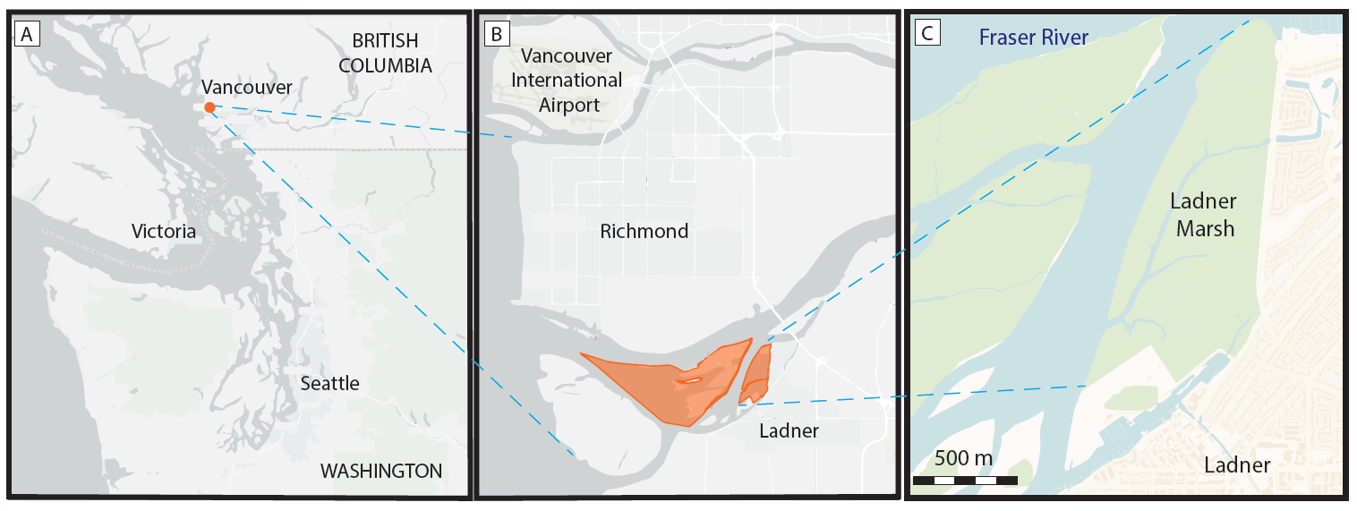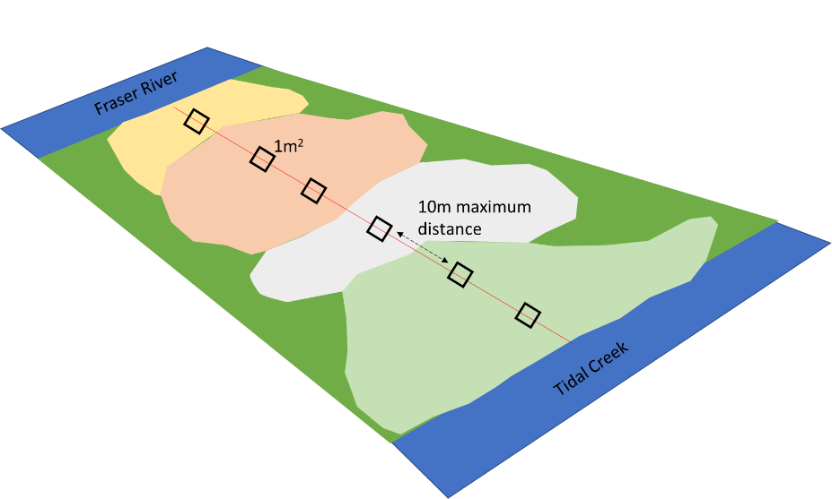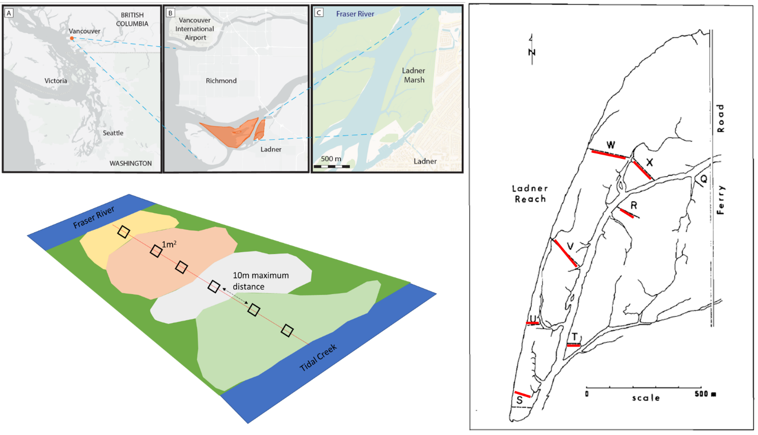

D

E

Figure . Location of the study site in Vancouver, British Columbia, Canada (A), approximately 20 km north of the South Arm Marshes Wildlife Management Area (highlighted in orange, B). Ladner Marsh abuts municipal development on the south bank of the Fraser River (C). Base maps (A, B) generated by iMap published by the B. C. Conservation Data Center (Victoria, BC, Canada, <https://maps.gov.bc.ca/ess/hm/imap4m/>) and (C) OpenStreetMap (OpenStreetMap contributors, 2015, <https://www.openstreetmap.org/>) (*these panels also appear in Lane, 2022, Applications in Plant Sciences), transect locations illustrated in 1982 publication figure (line drawing), which was overlayed on Google Earth basemap to relocate transects in 2019 (red) (D), and semi-systematic plot placement within and between assemblages based on species dominance (E).

# Results

Three main assemblages within Ladner Marsh can be characterized by the same dominant species across all sampling periods, however cluster analysis shows increasing dissimilarity between assemblage types over time. That is, plots are increasingly similar to each other within a given assemblage, but share fewer similarities between assemblages (Figure 2). This may indicate that assemblages are becoming homogenized in terms of species similarity, with greater species heterogeneity between assemblage types. Indicator species analysis shows that the same species are driving cluster groups across all time points, and thus significantly characterizing each assemblage. However, the other species that significantly drive indicators of assemblages change over time (Table 4, Supplemental).

Across the entire Ladner Marsh plant community, two to three species were lost each year following the 1979 survey (Table 1). Within every assemblage alpha-diversity (mean number of species) decreased every observation year, with the greatest loss of alpha-diversity in the Fescue assemblage. This may be in part due to the occurrence of 50% fewer plots clustered as Fescue in 2019 than in 1979, however the Bogbean assemblage had ~20% decrease in alpha-diversity despite an increase of ~47% more plots by 2019. Beta-diversity increased each year for all assemblages, although Bogbean assemblages experienced the lowest increase in variation between plots. (Table 1). Total species turnover between 1979 and 2019 was ~50% in each assemblage (Table 2). Notably, all assemblage types had more species disappear since 1979 in 2019 than in 1999. Only the Sedge assemblage had a marked increase in species appearance in 2019, while the Bogbean community had more species appearance in 1999. The greater rates of disappearance from the assemblages are likely driving homogenization observed in cluster analysis.

Rank clock plots show changing dominance of select species over time (Figure 3). Notably, Fescue assemblage shows ~50% decrease in cover of characteristic non-native species *Festuca arundinaceae*, while cover of non-native *Phalaris arundinaceae* has more than doubled since 1999. In the Sedge assemblage, cover abundance of *Agrostis stolonifera* appears to have decrease by almost half, however cover of assemblage-defining species *Carex lyngbyei* has decreased by about one-third. Bogbean assemblage maintains greatest coverage of its defining species (*Menyanthes trifoliata*), however non-native *Mentha aquatica* accounts for ~50% of plot cover on average by 2019.

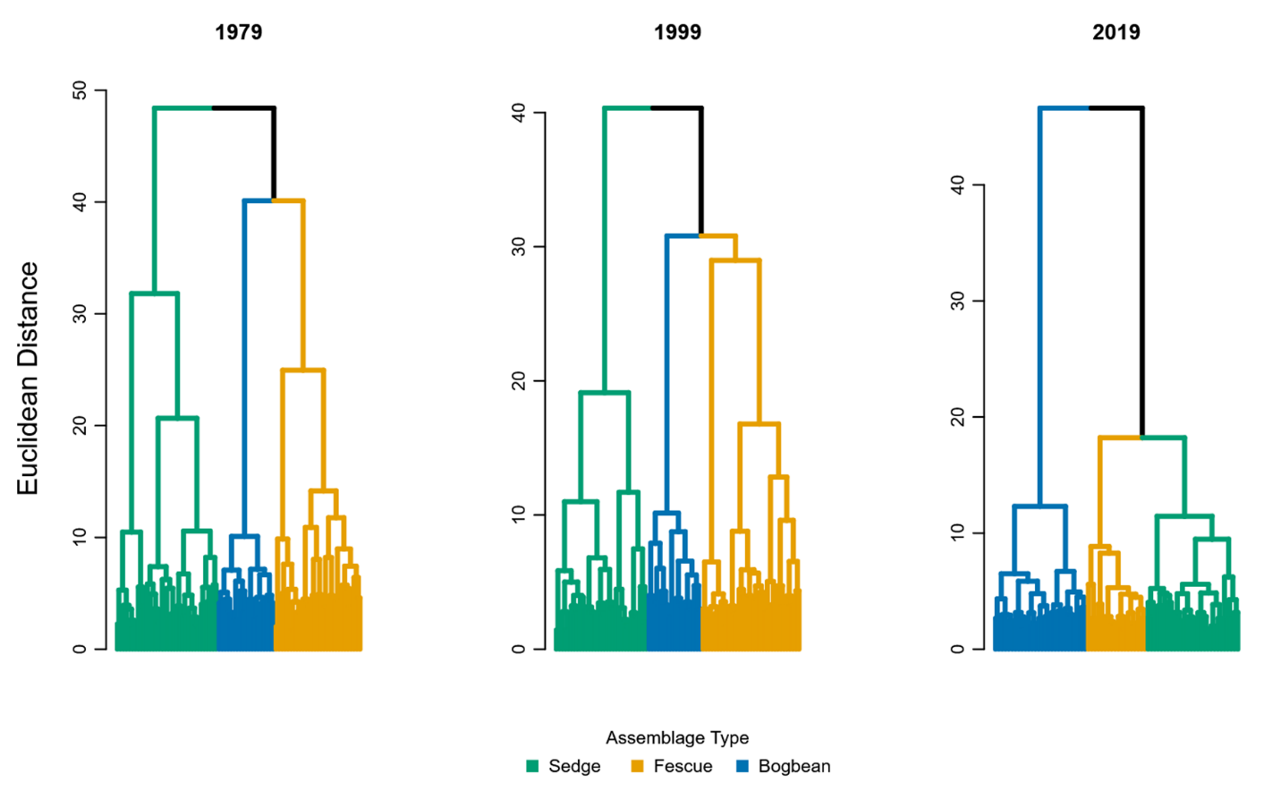

Figure . Assemblage diversity becomes more dissimilar over time, as shown by greater Euclidean distance between assemblage types.

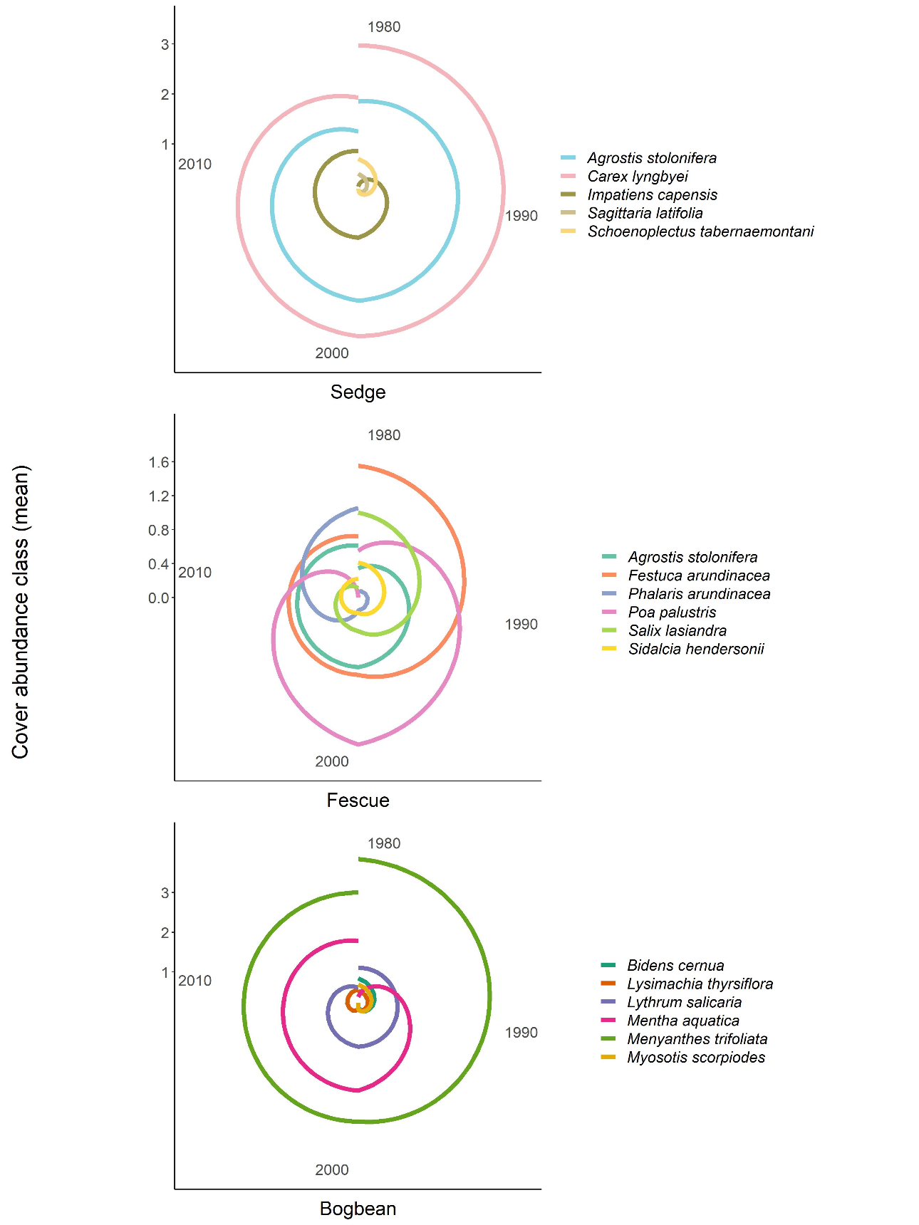

Figure . Rank abundance clocks visualize the changing cover class abundance (y-axis values) of the three most significant indicator species in each observation year. Cover class value is read from center of the plot (0) along a radius extending along y-axis. Oldest timepoints are in the 12 o’clock position, and observation timepoints proceed clockwise, ending at the 11:59 position. (Top) In the Sedge assemblage, Carex lyngbyei becomes less dominant over time, while dominance of non-native species Agrostis stolonifera declines at a slower rate. (Middle) Fescue assemblage is consistently occupied by Agrostis stolonifera, while Festuca arundinaceae is gradually replaced by Phalaris arundinaceae in overall dominance; apparent dominance of Poa palustris in 1999 may be due to misidentification of Agrostis stolonifera. (Bottom) Bogbean assemblage is consistently dominated by Menyanthes trifoliata, however non-native Mentha aquatica becomes dominant.

Table . Between 1979 and 2019, 8 fewer plots and 5 fewer species were observed, resulting in slightly lower α-diversity and greater β-diversity. For each assemblage type, Bogbean is the only assemblage to proportionally gain plots between 1979 and 2019, while the Fescue and Sedge assemblages lost plots.

|  |  |  |  |  |  |  |
| --- | --- | --- | --- | --- | --- | --- |
| **Assemblage** | **No. quadrats** | **No. species** |  | **α diversity** | **α diversity sd** | **β diversity** |
| **Sedge** |  |  |  |  |  |  |
| 1979 | 34 | 36 |  | 8.74 | 2.45 | 3.89 |
| 1999 | 31 | 35 |  | 8.26 | 1.98 | 4.24 |
| 2019 | 28 | 34 |  | 7.89 | 2.69 | 4.31 |
|  |  |  |  |  |  |  |
| **Fescue** |  |  |  |  |  |  |
| 1979 | 29 | 47 |  | 12.83 | 3.87 | 3.66 |
| 1999 | 33 | 41 |  | 9.69 | 3.96 | 4.23 |
| 2019 | 18 | 27 |  | 5.83 | 2.79 | 4.63 |
|  |  |  |  |  |  |  |
| **Bogbean** |  |  |  |  |  |  |
| 1979 | 19 | 32 |  | 12.84 | 3.61 | 2.49 |
| 1999 | 18 | 36 |  | 11.50 | 2.92 | 3.13 |
| 2019 | 28 | 34 |  | 10.46 | 1.90 | 3.25 |
|  |  |  |  |  |  |  |
| **Total** |  |  |  |  |  |  |
| 1979 | 82 | 48 |  | 9.96 | 3.41 | 4.82 |
| 1999 | 82 | 45 |  | 9.55 | 3.30 | 4.71 |
| 2019 | 74 | 43 |  | 8.36 | 3.03 | 5.14 |

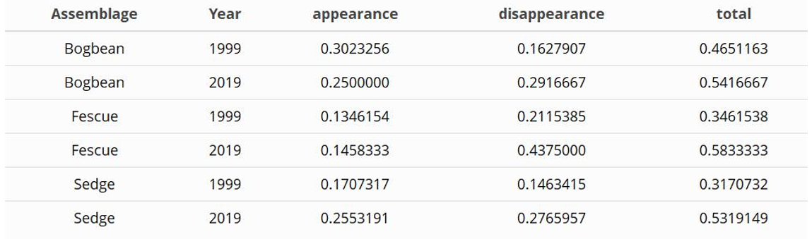Table . Greater proportions of species were lost from all three assemblages in 2019, however more species were gained in 2019 than in 1999 in the Sedge assemblage.

# Discussion

In this study we wanted to identify whether assemblages may be characterized by the same dominant species over time, whether measures of species diversity were stable within and between assemblage types, and whether turnover may be driven by increasing invasive species abundance. We found the three main assemblages have consistently been defined by the same species over the past 40 years, supporting our expectation that these characteristic species should not change in the absence of significant environmental disturbance.

In their 1982 publication, Bradfield and Porter indicated assemblage occurrence was largely driven by edaphic factors, with the Bogbean assemblage occurring in poorly drained areas, Sedge assemblage occurring in regularly flooded and drained areas, and Fescue assemblage along slightly elevated channel edges. *Menyanthes trifoliata* (bogbean) and *Mentha aquatica* are highly adapted to aquatic or poorly drained habitats, and the increased prevalence of plots clustered in the Bogbean assemblage within Ladner Marsh may be indicative of changing edaphic factors such as marsh subsidence. In addition to highly saturated soils, the densely rhizomatous cover of these species may be precluding establishment of new species. Although the Bogbean assemblage had a high abundance of non-native *Mentha aquatica* cover, it also had the highest α-diversity, and lowest β-diversity over time. The Fescue assemblage had the greatest loss of α-diversity, and greatest increase in β-diversity. Of note is the introduction and greatly increased abundance of *Phalaris arundinaceae*, an invasive species of management concern due to its ability to establish near-monocultures in wetland environments (Apfelbaum & Sams, 1987). The overall loss of species, and higher variation between plots in this assemblage may be indicative of potential loss of resilience, and increased susceptibility to invasion.

Total turnover was higher in 2019 than 1999, and only the Sedge assemblage gained more species in 2019 than in 1999. However, greater rates of species lost are concerning for total biodiversity of the habitat. This is especially evident by encroachment of invasive species in the Fescue and Bogbean assemblages. The Fescue assemblage has historically been defined by a non-native species (*Festuca arundinaceae*), however abundance of *Festuca arundinaceae* is being overtaken by *Phalaris arundinaceae*, or reed canary grass (RCG). This presents a management concern for Ladner Marsh, as RCG can be a monoculture-forming species, further reducing species diversity within the community. Similarly, the Bogbean assemblage is increasingly dominated by non-native *Mentha aquatica*, however this assemblage did not lose as much floristic richness as the Fescue assemblage did (Table 6, Supplemental). While this species may have some pollinator value, its vigorous rhizomatous spreading habit and dense canopy may be driving the decline of other native species. Higher turnover, especially greater rates of species disappearance since 1999, indicates loss of biodiversity, which may indicate loss of functional traits and greater susceptibility to invasive species (Tilman, 1999). Increasing abundance of non-native species, paired with cluster analysis showing greater similarity within plots of each assemblage, supports our expectation that homogenization of species composition is being driven by proliferation of non-native species.

Maintaining these transitional estuarine habitats is important for salmon population stability. Therefore, importance of conservation and restoration projects will likely increase as sea levels rise. Understanding historical trends in species composition and assemblage heterogeneity is critical for defining measures of success in restoration projects, and for conserving ecological processes that have yet to be identified. In the absence of ideal reference conditions, use of historical datasets to define target conditions may be used in place of or in addition to current-day assessments of community composition to determine ecologically meaningful benchmarks. Using historical conditions can provide greater understanding of species diversity with respect to functional redundancy, as these community attributes relate to resistance to disturbance and resilience.

## Study limitations

These data do not show variation in population dynamics over time, thus inferences of interannual trends in species gained/lost cannot be explicitly made. However, this snapshot is useful for observing coarse patterns of species shifts, and can be used to refine future questions such as identifying whether high-diversity assemblages, such as the Bogbean assemblage, may be more resistant to invasive species (and thus more stable). Additionally, because permanent transects were not used, transect relocation and sampling method likely alters results. Plots were subjectively placed based on perceived changes in species composition, or every 10 m when no change was discernable, following the original methods of Bradfield & Porter (1982). This means that assemblages characterized by key species, such as the Fescue assemblage, should be proportionately represented in the data if assemblage types remain constant within the community. If plots were laid strictly at the same distance along the tape (as was done in 1999), proportional representation of assemblages may be skewed depending on spatial shifts.

Mechanistic processes to explain changes in species composition or site factors were not tested. However, likely driving factors can be inferred to generate new tests of mechanistic changes in in community stability. Specifically: edaphic factors may be driving species selection by adaptation to saturation or drainage between assemblage patches, more strictly partitioning the diversity of species that can occupy an assemblage. Additionally, recruitment of new diverse individuals into the assemblage may be limited due to dispersal or recruitment limitation.

## Potential mechanisms

A key abiotic driver of tidal marsh development includes sediment deposition that allows plant communities to compensate for changing inundation rates due to sea level rise (Marijnissen, et al., 2020). Sediment delivered by river transport is trapped by vegetation, creating a feedback loop of rising tidal marsh platforms, increased vegetation growth, and increased sediment trapping capacity (Corenblit et al., 2015; Peteet et al., 2018). Sediment starvation in the marsh may be contributing to landform subsidence and/or loss of sediment accretion. Loss of sediment within the Lower Fraser River reaches is driven by a combination of factors, such as increased impervious cover and channel dredging. Disentangling explicit causes for loss of sediment would be difficult, however long-term monitoring of sediment accretion and changes in elevation using a total GPS station would identify which process is occurring. Effects from either of these processes would lead to more saturated patches within the marsh, which would drive prevalence of Bogbean assemblage. Because Bogbean was the only assemblage with greater number of plots identified by cluster analysis in 2019, this suggests that marsh-wide prevalence of this assemblage could be increasing. Edaphic shifts may also be driving homogenization and disappearance of species across all assemblages, as fewer species are able to tolerate increasingly saturated conditions.

Recruitment of new species is dependent on many factors. Regional pools of propagules (seeds, clonal fragments) are required to disperse into a site, and suitable conditions must exist to recruit the propagules into the population. If remnant habitats such as Ladner Marsh are becoming more homogenous, species diversity is being lost from the dispersal network. If edaphic processes are limiting the habitat heterogeneity and conditions sufficient for propagule grounding and recruitment into the community, then diverse species composition is not possible, even if propagules are present.

## Broader impacts & recommendations

Management initiatives such as Canada’s Coastal Restoration Fund or British Columbia’s Salmon Restoration and Innovation Fund or Sea Level Rise Adaptation programs target successes on 50-100 year horizons. Understanding what community stability looks like within this timescale is useful to agency managers wanting to maintain or create shoreline communities for immediate habitat conservation or floodwater protection initiatives.

In the absence of ideal reference conditions, sites with a longer conservation history, such as the South Arm Marshes WMA may be used as ‘reference’ conditions for evaluating restoration success. Before selecting sites to use as benchmarks, it is important to understand rates of change within the site, and whether site characteristics are constant over decadal timescales. Relatively undisturbed sites may be the best extant examples of expected ecological conditions. Wherever these sites exist, land managers should prioritize monitoring to preserve reference to historical conditions, and establish mechanistic explanations for changes over time.

# Acknowledgements

The lead author would like to thank Z. Davis for providing R programming advice; P. Roper for field assistance; B. Staines (Ladner Harbour Authority) for providing watercraft use. Support was provided by Natural Sciences and Engineering Research Council of Canada Discovery Grant RGPIN-2018-03838 to J. Richardson, and research access was granted by The Ministry of Forests, Lands, Natural Resource Operations and Rural Development.

# Literature Cited

Apfelbaum, S. I., & Sams, C. E. (1987). Ecology and Control of Reed Canary Grass (Phalaris arundinacea L.). *Natural Areas Journal*, *7*, 69–74.

Bradfield, G. E., & Porter, G. L. (1982). Vegetation structure and diversity components of a Fraser estuary tidal marsh. *Canadian Journal of Botany*, *60*, 440–451.

Brophy, L. S., Greene, C. M., Hare, V. C., Holycross, B., Lanier, A., Heady, W. N., … Dana, R. (2019). Insights into estuary habitat loss in the western United States using a new method for mapping maximum extent of tidal wetlands. *PLOS ONE*, *14*, e0218558.

Chalifour, L., Scott, D. C., MacDuffee, M., Iacarella, J. C., Martin, T. G., & Baum, J. K. (2019). Habitat use by juvenile salmon, other migratory fish, and resident fish species underscores the importance of estuarine habitat mosaics. *Marine Ecology Progress Series*, *625*, 145–162.

Corenblit, D., Baas, A., Balke, T., Bouma, T., Fromard, F., Garófano‐Gómez, V., … Walcker, R. (2015). Engineer pioneer plants respond to and affect geomorphic constraints similarly along water–terrestrial interfaces world-wide. *Global Ecology and Biogeography*, *24*, 1363–1376.

Davis, M. J., Woo, I., Ellings, C. S., Hodgson, S., Beauchamp, D. A., Nakai, G., & De La Cruz, S. E. W. (2021). A climate-mediated shift in the estuarine habitat mosaic limits prey availability and reduces nursery quality for juvenile salmon. *Estuaries and Coasts*. https://doi.org/10.1007/s12237-021-01003-3

De Cáceres, M., & Jansen, F. (2016). *Indicspecies*. Retrieved from http://r.meteo.uni.wroc.pl/web/packages/indicspecies/indicspecies.pdf

Denoth, M., & Myers, J. H. (2007). Competition between *Lythrum salicaria* and a rare species: Combining evidence from experiments and long-term monitoring. *Plant Ecology*, *191*, 153–161.

Donohue, I., Hillebrand, H., Montoya, J. M., Petchey, O. L., Pimm, S. L., Fowler, M. S., … Yang, Q. (2016). Navigating the complexity of ecological stability. *Ecology Letters*, *19*, 1172–1185.

Emmett, R., Llansó, R., Newton, J., Thom, R., Hornberger, M., Morgan, C., … Fishman, P. (2000). Geographic signatures of North American West Coast estuaries. *Estuaries*, *23*, 765–792.

Hallett, L. M., Jones, S. K., MacDonald, A. A. M., Jones, M. B., Flynn, D. F. B., Ripplinger, J., … Collins, S. L. (2016). codyn: An r package of community dynamics metrics. *Methods in Ecology and Evolution*, *7*, 1146–1151.

Hanski, I. (1982). Dynamics of Regional Distribution: The Core and Satellite Species Hypothesis. *Oikos*, *38*, 210–221. JSTOR.

Hitchcock, C. L., & Cronquist, A. (1973). *Flora of the Pacific Northwest, an illustrated manual*. Seattle and London: University of Washington Press.

Holling, C. S. (1973). Resilience and Stability of Ecological Systems. *Annual Review of Ecology and Systematics*, *4*, 1–23.

Kopecký, M., & Macek, M. (2015). Vegetation resurvey is robust to plot location uncertainty. *Diversity and Distributions*, *21*, 322–330.

Legendre, P., & Legendre, L. (2012). *Numerical Ecology* (3rd ed., Vol. 24). Elsevier.

Lepš, J. (2004). What do the biodiversity experiments tell us about consequences of plant species loss in the real world? *Basic and Applied Ecology*, *5*, 529–534.

Marijnissen, R., Kok, M., Kroeze, C., & van Loon-Steensma, J. (2020). The Sensitivity of a Dike-Marsh System to Sea-Level Rise—A Model-Based Exploration. *Journal of Marine Science and Engineering*, *8*, 42.

Ovaskainen, O., Rybicki, J., & Abrego, N. (2019). What can observational data reveal about metacommunity processes? *Ecography*, *42*, 1877–1886.

Pasternack, G. B. (2009). Chapter 3. Hydrogeomorphology and sedimentation in tidal freshwater wetlands. In A. Barendregt, D. F. Whigham, & A. H. Baldwin (Eds.), *Tidal Freshwater Wetlands* (pp. 31–40). Leiden, The Netherlands: Backhuys Publishers.

Peteet, D. M., Nichols, J., Kenna, T., Chang, C., Browne, J., Reza, M., … Stern-Protz, S. (2018). Sediment starvation destroys New York City marshes’ resistance to sea level rise. *Proceedings of the National Academy of Sciences*, *115*, 10281–10286.

Schaefer, V. (2004). Ecological setting of the Fraser River delta and its urban estuary. In B. J. Groulx, D. C. Mosher, J. L. Luternauer, & D. E. Bilderback (Eds.), *Fraser River Delta, British Columbia: Issues of an Urban Estuary* (pp. 147–172). Geological Survey of Canada, Bulletin 547.

Sinks, I. A., Borde, A. B., Diefenderfer, H. L., & Karnezis, J. P. (2021). Assessment of Methods to Control Invasive Reed Canarygrass (Phalaris arundinacea) in Tidal Freshwater Wetlands. *Natural Areas Journal*, *41*, 172–185.

Underwood, A. J., Chapman, M. G., & Connell, S. D. (2000). Observations in ecology: You can’t make progress on processes without understanding the patterns. *Journal of Experimental Marine Biology and Ecology*, *250*, 97–115.

Whittaker, R. H. (1975). *Communities and Ecosystems* (2nd ed.). New York, NY: Macmillan.

# Supplemental

Table . A total of 25 plots sampled in 1979 and 1999 were not sampled in 2019, mostly due to issues of accessibility. Transect names and plot ID of plots omitted follow Fig. 3 in Bradfield & Porter (1982).

|  |  |  |
| --- | --- | --- |
| **Transect** | **1979/1999** | **Reason omitted in 2019** |
| Q | 1-7 | Transect in dense riparian thicket overgrown with Himalayan blackberry |
| R | 8 | Plot on lower bench (> 1 m lower than marsh platform), vegetation no longer exists |
| R | 17-19 | Plots in 1979 & 1999 sampled across a channel. Ended transect in 2019 at channel edge. |
| S | 33-36 | Transect length in 2019 was shorter than in 1979/1999. Suspect combination of erosion and offset transect relocation altered sampling distance. |
| T | 45 | Transect length in 2019 was shorter than in 1979/1999. Suspect combination of erosion and offset transect relocation altered sampling distance. |
| U | 51-52 | Transect length in 2019 was shorter than in 1979/1999. Suspect combination of erosion and offset transect relocation altered sampling distance. |
| V | 53 | Plot 53 only plot across a channel. Increased channel width and likely erosion made crossing this channel dangerous; ommitted plot in 2019. |
| V | 54, 70-71 | Transect length in 2019 was shorter than in 1979/1999. Suspect combination of erosion and offset transect relocation altered sampling distance. |
| W | 89-92 | Transect length in 2019 was shorter than in 1979/1999. Suspect combination of erosion and offset transect relocation altered sampling distance. |
| X | 93 | Transect length in 2019 was shorter than in 1979/1999. Suspect combination of erosion and offset transect relocation altered sampling distance. |

Table . Species indicator analysis of cluster groups using Euclidean distance identifies the same dominant species in each assemblage type (Sedge, Fescue, Bogbean) as significantly driving clustering of assemblages over time.



Table . Species indicator analysis of cluster groups using Bray-Curtis distance identifies the same dominant species in each assemblage type (Sedge, Fescue, Bogbean), however Bray-Curtis distance identifies different associated indicator species than those identified by Euclidean distance (Table 4).

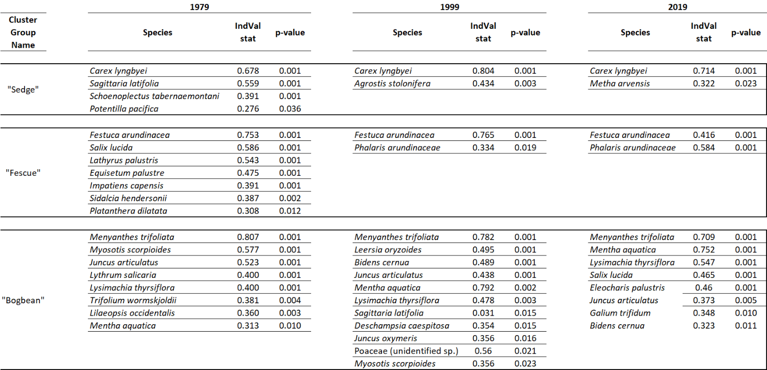

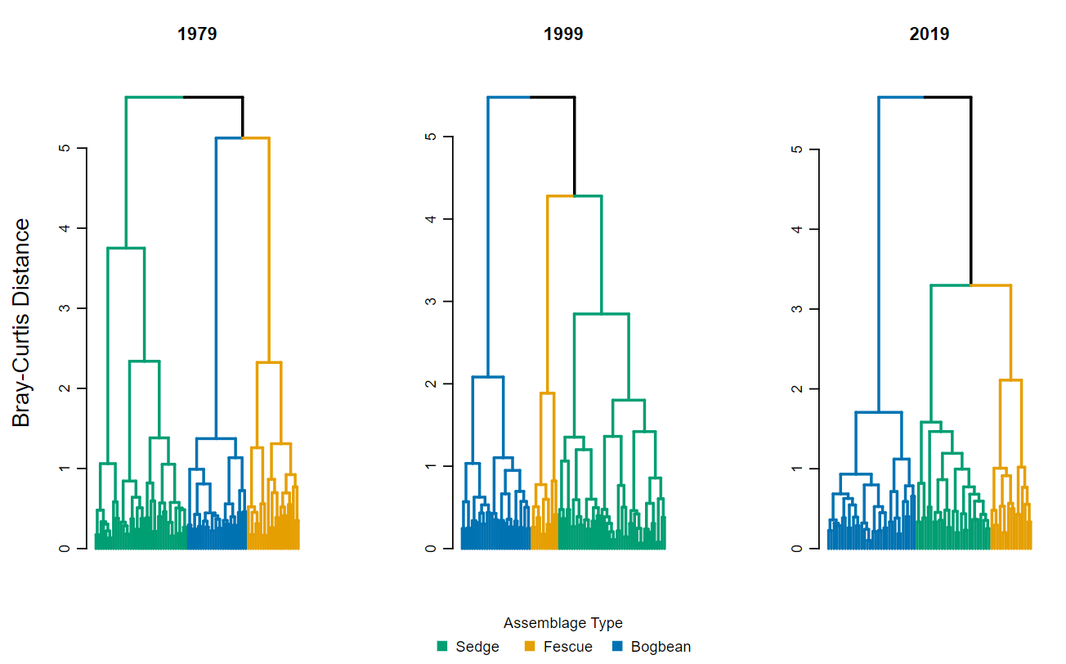

Figure .Bray-Curtis distance shows similar trends of increasing dissimilarity over time as when using Euclidean Distance (Figure 2).

Table . Percent change in mean abundance (cover class) between 1979, 1999, and 2019 datasets for species observed in each assemblage. New species appearances from 1979 to 2019 indicated by (+).

|  |  |  |  |  |  |
| --- | --- | --- | --- | --- | --- |
| **Assemblage** | **Species** | **1979** | **1999** | **2019** | **Percent Change 1979-2019** |
| Bogbean | *Alisma plantago aquatica* | 0.16 | 0.11 | 0.00 | -100.00 |
| *Alopecurus geniculatus* | 0.05 | 0.00 | 0.00 | -100.00 |
| *Deschampsia caespitosa* | 0.26 | 0.22 | 0.00 | -100.00 |
| *Equisetum fluviatile* | 1.37 | 1.17 | 0.00 | -100.00 |
| *Leersia oryzoides* | 0.26 | 0.33 | 0.00 | -100.00 |
| *Lilaeopsis occidentalis* | 0.21 | 0.00 | 0.00 | -100.00 |
| *Oenanthe sarmentosa* | 0.63 | 0.11 | 0.00 | -100.00 |
| *Poa trivialis* | 0.11 | 0.00 | 0.00 | -100.00 |
| *Sium suave* | 0.63 | 0.17 | 0.00 | -100.00 |
| *Juncus oxymeris* | 0.05 | 0.11 | 0.04 | -96.43 |
| *Platanthera dilatata* | 0.05 | 0.06 | 0.04 | -96.43 |
| *Rumex conglomeratus* | 0.05 | 0.00 | 0.04 | -96.43 |
| *Caltha palustris* | 0.95 | 0.22 | 0.07 | -92.86 |
| *Mentha arvensis* | 0.47 | 0.00 | 0.07 | -92.86 |
| *Schoenoplectus tabernaemontani* | 0.16 | 0.00 | 0.07 | -92.86 |
| *Sidalcia hendersonii* | 0.05 | 0.00 | 0.07 | -92.86 |
| *Bidens cernua* | 0.84 | 0.17 | 0.14 | -85.71 |
| *Rumex conglomeratus* | 0.05 | 0.11 | 0.14 | -85.71 |
| *Trifolium wormskjoldii* | 0.95 | 0.11 | 0.18 | -82.14 |
| *Myosotis scorpiodes* | 0.68 | 0.22 | 0.21 | -78.57 |
| *Juncus articulatus* | 0.26 | 0.39 | 0.29 | -71.43 |
| *Symphotrichum subspicatum* | 0.47 | 0.33 | 0.32 | -67.86 |
| *Eleocharis palustris* | 0.63 | 0.78 | 0.39 | -60.71 |
| *Lysimachia thyrsiflora* | 0.53 | 0.22 | 0.57 | -42.86 |
| *Lysichiton americanum* | 1.11 | 1.17 | 0.61 | -39.29 |
| *Carex lyngbyei* | 0.47 | 0.33 | 1.00 | 0.00 |
| *Potentilla pacifica* | 0.26 | 1.00 | 1.07 | 7.14 |
| *Agrostis stolonifera* | 3.21 | 1.50 | 1.29 | 28.57 |
| *Mentha aquatica* | 0.37 | 2.28 | 1.79 | 78.57 |
| *Menyanthes trifoliata* | 3.84 | 3.06 | 3.00 | 200.00 |
| *Equisetum arvense* | 0.00 | 0.00 | 0.64 | + |
| *Galium trifidum* | 0.00 | 0.00 | 0.39 | + |
| *Hypericum scouleri* | 0.00 | 0.00 | 0.04 | + |
| *Impatiens capensis* | 0.00 | 0.44 | 0.32 | + |
| *Iris pseudocorus* | 0.00 | 0.33 | 0.21 | + |
| *Juncus acuminatus* | 0.00 | 0.00 | 0.04 | + |
| *Lathyrus palustris* | 0.00 | 0.11 | 0.50 | + |
| *Lycopus* sp. | 0.00 | 0.00 | 0.04 | + |
| *Lysichiton americanum* | 0.00 | 0.00 | 0.07 | + |
| *Phalaris arundinacea* | 0.00 | 0.06 | 0.04 | + |
| *Salix lasiandra* | 0.00 | 0.61 | 0.50 | + |
| *Salix scouleriana* | 0.00 | 0.00 | 0.04 | + |
| *Typha latifolia* | 0.00 | 0.28 | 0.25 | + |
| *Equisetum palustre* | 0.00 | 0.11 | 0.00 |  |
| *Equisetum variegatum* | 0.00 | 0.11 | 0.00 |  |
| *Festuca arundinacea* | 0.00 | 0.17 | 0.00 |  |
| *Galium* sp. | 0.00 | 0.06 | 0.00 |  |
| *Poa palustris* | 0.00 | 0.50 | 0.00 |  |
| Poaceae sp. | 0.00 | 0.28 | 0.00 |  |
| *Sagittaria latifolia* | 0.00 | 0.17 | 0.00 |  |
| **Assemblage** | **Species** | **1979** | **1999** | **2019** | **Percent Change 1979-2019** |
| Fescue | *Alisma plantago aquatica* | 0.10 | 0.18 | 0.00 | -100.00 |
| *Alopecurus geniculatus* | 0.03 | 0.00 | 0.00 | -100.00 |
| *Bidens cernua* | 0.21 | 0.52 | 0.00 | -100.00 |
| *Deschampsia caespitosa* | 0.62 | 0.09 | 0.00 | -100.00 |
| *Dulichium arundinaceum* | 0.07 | 0.00 | 0.00 | -100.00 |
| *Eleocharis palustris* | 0.97 | 0.33 | 0.00 | -100.00 |
| *Equisetum palustre* | 0.76 | 0.09 | 0.00 | -100.00 |
| *Festuca* sp. | 0.03 | 0.00 | 0.00 | -100.00 |
| *Galium trifidum* | 0.03 | 0.00 | 0.00 | -100.00 |
| *Hypericum formosum* | 0.10 | 0.00 | 0.00 | -100.00 |
| *Juncus articulatus* | 0.52 | 0.06 | 0.00 | -100.00 |
| *Leersia oryzoides* | 0.14 | 0.24 | 0.00 | -100.00 |
| *Lilaeopsis occidentalis* | 0.17 | 0.00 | 0.00 | -100.00 |
| *Mentha aquatica* | 0.31 | 0.09 | 0.00 | -100.00 |
| *Mimulus guttatus* | 0.03 | 0.00 | 0.00 | -100.00 |
| *Myosotis scorpiodes* | 0.31 | 0.03 | 0.00 | -100.00 |
| *Oenanthe sarmentosa* | 0.17 | 0.30 | 0.00 | -100.00 |
| *Platanthera dilatata* | 0.21 | 0.03 | 0.00 | -100.00 |
| *Poa palustris* | 0.55 | 1.73 | 0.00 | -100.00 |
| *Poa trivialis* | 0.31 | 0.00 | 0.00 | -100.00 |
| *Polygonum hydropiper* | 0.03 | 0.00 | 0.00 | -100.00 |
| *Sagittaria latifolia* | 0.03 | 0.15 | 0.00 | -100.00 |
| *Salix* sp. | 0.03 | 0.00 | 0.00 | -100.00 |
| *Sium suave* | 0.14 | 0.15 | 0.00 | -100.00 |
| *Trifolium wormskjoldii* | 0.69 | 0.55 | 0.00 | -100.00 |
| *Caltha palustris* | 0.66 | 0.39 | 0.06 | -94.44 |
| *Lysimachia thyrsiflora* | 0.10 | 0.33 | 0.06 | -94.44 |
| *Mentha arvensis* | 0.17 | 0.24 | 0.06 | -94.44 |
| *Menyanthes trifoliata* | 1.86 | 1.33 | 0.06 | -94.44 |
| *Schoenoplectus tabernaemontani* | 0.07 | 0.15 | 0.06 | -94.44 |
| *Carex lyngbyei* | 0.76 | 1.42 | 0.11 | -88.89 |
| *Hordeum brachyantherum* | 0.17 | 0.00 | 0.11 | -88.89 |
| *Rumex occidentalis* | 0.07 | 0.15 | 0.11 | -88.89 |
| *Salix lasiandra* | 1.00 | 0.39 | 0.11 | -88.89 |
| *Potentilla pacifica* | 0.48 | 0.64 | 0.22 | -77.78 |
| *Sidalcea hendersonii* | 0.41 | 0.18 | 0.22 | -77.78 |
| *Symphotrichum subspicatum* | 0.59 | 0.24 | 0.25 | -75.00 |
| *Equisetum fluviatile* | 0.62 | 0.36 | 0.44 | -55.56 |
| *Lysichiton americanum* | 0.38 | 0.58 | 0.44 | -55.56 |
| *Typha latifolia* | 0.69 | 0.36 | 0.44 | -55.56 |
| *Lathyrus palustris* | 0.55 | 0.18 | 0.56 | -44.44 |
| *Agrostis stolonifera* | 0.34 | 0.82 | 0.61 | -38.89 |
| *Impatiens capensis* | 0.28 | 0.42 | 0.61 | -38.89 |
| *Festuca arundinacea* | 1.55 | 0.91 | 0.72 | -27.78 |
| *Phalaris arundinacea* | 0.07 | 0.15 | 1.06 | 5.56 |
| *Cirsium arvense* | 0.00 | 0.03 | 0.06 | + |
| *Equisetum arvense* | 0.00 | 0.00 | 0.39 | + |
| *Iris pseudocorus* | 0.00 | 0.15 | 0.22 | + |
| *Juncus effusus* | 0.00 | 0.00 | 0.06 | + |
| Lycopus_sp | 0.00 | 0.00 | 0.06 | + |
| *Lysichiton americanum* | 0.00 | 0.00 | 0.11 | + |
| *Myrica gale* | 0.00 | 0.00 | 0.22 | + |
| *Salix scouleriana* | 0.00 | 0.00 | 0.17 | + |
| Asteraceae sp. | 0.00 | 0.03 | 0.00 |  |
| *Carex* sp. | 0.00 | 0.06 | 0.00 |  |
| *Galium* sp. | 0.00 | 0.03 | 0.00 |  |
| *Juncus oxymeris* | 0.00 | 0.09 | 0.00 |  |
| *Salix sitchensis* | 0.00 | 0.03 | 0.00 |  |
| **Assemblage** | **Species** | **1979** | **1999** | **2019** | **Percent Change 1979-2019** |
| Sedge | *Alisma plantago aquatica* | 0.35 | 0.06 | 0.00 | -100.00 |
| *Deschampsia caespitosa* | 0.21 | 0.00 | 0.00 | -100.00 |
| *Leersia oryzoides* | 0.18 | 0.19 | 0.00 | -100.00 |
| *Lilaeopsis occidentalis* | 0.06 | 0.10 | 0.00 | -100.00 |
| *Mimulus guttatus* | 0.09 | 0.00 | 0.00 | -100.00 |
| *Myosotis scorpiodes* | 0.03 | 0.00 | 0.00 | -100.00 |
| *Oenanthe sarmentosa* | 0.71 | 0.39 | 0.00 | -100.00 |
| *Platanthera dilatata* | 0.09 | 0.03 | 0.00 | -100.00 |
| *Poa palustris* | 1.00 | 0.23 | 0.00 | -100.00 |
| *Puccinella pauciflora* | 0.03 | 0.00 | 0.00 | -100.00 |
| *Sium suave* | 0.59 | 0.19 | 0.00 | -100.00 |
| *Symphotrichum subspicatum* | 0.29 | 0.13 | 0.00 | -100.00 |
| *Caltha palustris* | 1.09 | 0.48 | 0.04 | -96.43 |
| *Equisetum fluviatile* | 0.88 | 0.58 | 0.04 | -96.43 |
| *Mentha arvensis* | 0.29 | 0.16 | 0.04 | -96.43 |
| *Trifolium wormskjoldii* | 0.41 | 0.13 | 0.07 | -92.86 |
| *Lysimachia thyrsiflora* | 0.09 | 0.00 | 0.11 | -89.29 |
| *Rumex conglomeratus* | 0.03 | 0.00 | 0.11 | -89.29 |
| *Rumex occidentalis* | 0.12 | 0.16 | 0.11 | -89.29 |
| *Sagittaria latifolia* | 0.41 | 0.10 | 0.11 | -89.29 |
| *Schoenoplectus tabernaemontani* | 0.71 | 0.10 | 0.11 | -89.29 |
| *Festuca arundinacea* | 0.09 | 0.10 | 0.18 | -82.14 |
| *Menyanthes trifoliata* | 0.32 | 0.68 | 0.18 | -82.14 |
| *Bidens cernua* | 0.47 | 0.13 | 0.21 | -78.57 |
| *Sidalcia hendersonii* | 0.09 | 0.10 | 0.21 | -78.57 |
| *Salix lasiandra* | 0.03 | 0.03 | 0.29 | -71.43 |
| *Eleocharis palustris* | 0.79 | 0.35 | 0.39 | -60.71 |
| *Lysichiton americanum* | 0.26 | 0.26 | 0.39 | -60.71 |
| *Typha latifolia* | 0.59 | 0.35 | 0.43 | -57.14 |
| *Lathyrus palustris* | 0.09 | 0.26 | 0.46 | -53.57 |
| *Potentilla pacifica* | 0.29 | 0.74 | 0.79 | -21.43 |
| *Impatiens capensis* | 0.15 | 1.06 | 0.86 | -14.29 |
| *Agrostis stolonifera* | 1.85 | 2.32 | 1.25 | 25.00 |
| *Carex lyngbyei* | 2.97 | 3.03 | 1.93 | 92.86 |
| *Equisetum arvense* | 0.00 | 0.00 | 0.68 | + |
| *Galium palustre* | 0.00 | 0.00 | 0.04 | + |
| *Galium trifidum* | 0.00 | 0.00 | 0.07 | + |
| *Hypericum scouleri* | 0.00 | 0.00 | 0.07 | + |
| *Iris pseudocorus* | 0.00 | 0.13 | 0.25 | + |
| *Juncus articulatus* | 0.00 | 0.00 | 0.04 | + |
| *Juncus oxymeris* | 0.00 | 0.00 | 0.04 | + |
| Lycopus_sp | 0.00 | 0.00 | 0.11 | + |
| *Mentha aquatica* | 0.00 | 0.16 | 0.54 | + |
| *Phalaris arundinacea* | 0.00 | 0.00 | 0.07 | + |
| *Scirpus microcarpus* | 0.00 | 0.00 | 0.07 | + |
| *Cirsium arvense* | 0.00 | 0.03 | 0.00 |  |
| *Equisetum palustre* | 0.00 | 0.19 | 0.00 |  |
| *Galium* sp. | 0.00 | 0.03 | 0.00 |  |
| *Lysichiton americanum* | 0.00 | 0.03 | 0.00 |  |
| *Salix sitchensis* | 0.00 | 0.06 | 0.00 |  |

# Potential journals

## [Journal of Vegetation Science](https://onlinelibrary.wiley.com/page/journal/16541103/homepage/forauthors.html)

2020 IF 2.865 (Q1, Ecology/Plant Science)

The Journal of Vegetation Science publishes articles on all aspects of plant community ecology and macroecology of vegetation, with particular emphasis on articles that develop new concepts or methods, test theory, **identify general patterns**, or that are otherwise likely to interest a broad international readership. An article may focus on any aspect of vegetation science, e.g. **community structure** (including community assembly and plant functional types), **biodiversity (including species richness and composition)**, spatial patterns (including plant geography and landscape ecology), **temporal changes (including demography, community dynamics** and palaeoecology) and processes (including ecophysiology), provided the focus is on increasing our understanding of plant communities. The journal does not publish articles on the ecology of a single species, except for studies framed in the community context, especially of species that play a key role in structuring plant communities (e.g. stand dominants). Articles that apply ecological concepts, theories and methods to the vegetation management, conservation and restoration, and articles on vegetation survey should be directed to our associate journal, [Applied Vegetation Science](https://onlinelibrary.wiley.com/page/journal/1654109x/homepage/forauthors.html).

## [Wetlands](https://www.springer.com/journal/13157/submission-guidelines#Instructions%20for%20Authors_Article%20Types)

2020 SJR IF 2.369 (Q2, Ecology)

Original research: Articles reporting original research about wetlands, natural or constructed, including, but not limited to mechanisms underlying ecosystem processes, the values of wetlands to society, their management, **quality assessment** and restoration.

## [Marine & Freshwater Research](https://www.publish.csiro.au/mf/forauthors)

2020 SJR IF 2.034 (Q2, Aquatic Science)

Marine and Freshwater Research welcomes the submission of articles presenting original and significant research in the aquatic sciences (see [Scope](http://www.publish.csiro.au/nid/126/aid/429.htm)).

Articles that address broad conceptual questions, are interdisciplinary and of wide interest, and that consider further implications and management applications are especially encouraged, given the journal's broad scope. Specialist articles at the forefront of their field are also welcome as long as their context is clearly stated. **Descriptive articles may be considered if they are placed in an appropriate conceptual setting and have global relevance.** However, articles that are purely taxonomic, parochial, describe preliminary or incremental results, or simply present data without context will not be considered.

## [Plant Ecology](https://www.springer.com/journal/11258)

2020 SJR IF 1.914 (Q2, Ecology)

Plant Ecology publishes original scientific papers that report and interpret the findings of pure and applied research into the ecology of vascular plants in terrestrial and wetland ecosystems. Empirical, experimental, theoretical and review papers reporting on ecophysiology, population, community, ecosystem, landscape, molecular and historical ecology are within the scope of the journal.

* Note – Denoth & Myers (2007) was published in this journal; their dataset is included in this publication.

## [Canadian Journal of Botany](https://cdnsciencepub.com/journal/cjb/about)

2-year IF 1.323, no quartile ranking found

Published since 1929, this monthly journal features comprehensive research articles and notes in all segments of plant sciences, including cell and molecular biology, ecology, mycology and plant-microbe interactions, phycology, physiology and biochemistry, structure and development, genetics, genomics, systematics, and phytogeography….

* Note – Bradfield & Porter (1982) was published in this journal; their dataset is included in this publication.