**Plant community compositional persistence over 40 years in a Fraser River Estuary tidal freshwater marsh**

Stefanie L. Lane1, Nancy Shackelford2, Gary Bradfield3, Madlen Denoth3, 4, Tara G. Martin1

1Depertment of Forest and Conservation Science, University of British Columbia, Vancouver, BC, Canada; 2School of Environmental Studies, University of Victoria, Victoria, BC, Canada; 3Department of Botany, University of British Columbia, Vancouver, BC, Canada; 4Gymnasium Neufeld, Bern, Switzerland

Corresponding author: [stefanielane@utexas.edu](mailto:stefanielane@utexas.edu)

# Abstract

TBD per journal (see last heading) – frame premise with respect to issue of global species loss, exemplified here in a protected area subject to indirect disturbances. Value of study is to observe changes in species composition to inform concepts of habitat stability in the absence of direct (pulse) disturbance pressures.

# Introduction

In a time of rapid global change, understanding temporal patterns of ecosystem response through plant community compositional changes can help inform conservation management interventions. Community stability may be characterized as consistency in species or functional diversity through time and space (Donohue et al., 2016; Holling, 1973). Shifts in community-dominant species, loss of native species diversity, and species turnover (such as greater abundance of invasive species) may indicate loss of functional redundancy. In turn, this may indicate reduced resistance to change or resilient capacity to recover from disturbance (Bai, et al., 2004; Tilman, Reich, & Knops, 2006). Furthermore, the loss of native species may have stronger negative impacts on biodiversity persistence when the regional pool of potential species is reduced or environmentally constrained (Hanski, 1982; Lepš, 2004). Characterization of plant community changes on decadal timescales contributes to observation of meaningful long-term patterns of compositional stability, and is instructive for developing hypotheses to test drivers of disturbance, especially in dynamic landscapes heavily impacted by anthropogenic activities, such as estuaries (Ovaskainen, Rybicki, & Abrego, 2019; Underwood, Chapman, & Connell, 2000).

Estuaries are at the terrestrial-marine interface where hydrogeomorphic and ecological changes occur on annual, decadal, and millennial timescales (Pasternack, 2009). Estuarine habitats support high species richness, including species at risk (Kehoe et al 2020) and are important carbon reservoirs (Douglas, et al., 2022). Because these ecosystems will experience accelerated change under sea level rise, these habitats are of increasing conservation concern (Brophy et al., 2019); understanding estuarine habitat stability can inform climate change resilience strategies. In North America, estuaries are of particular conservation importance in the Pacific Northwest (PNW) because their pathways of retreat or expansion are often spatially restricted by fjord geography (Emmett et al., 2000), whereas estuaries along the Atlantic coast may spread along expansive coastal plains. Tidal freshwater marshes (TFMs) are the upper reaches of estuaries dominated by riverine freshwater, and in the PNW they are particularly important as early transitional habitat along salinity gradient for salmonids (Chalifour et al., 2019; Davis et al., 2021). Estuary conservation efforts are intended to protect coastal municipalities and provide sufficient habitat for wildlife; stability of plant communities within tidal marshes may contribute to the ability of these habitats to resist change or recover from disturbance (Holling, 1973). Loss of species diversity within these habitats reduces the available biodiversity in the regional species pool, as well as potentially reducing functional habitat value.

A challenge of understanding community stability, including within estuaries, is the lack of long-term data. In the absence of long-term monitoring, historical datasets can provide a ‘snapshot’ of species compositional variation over time. One such opportunity exists in the Fraser River estuary, British Columbia, Canada in an area called Ladner Marsh (Figure 1). Despite large-scale industrialization and urbanization within the region, Ladner Marsh has escaped development, and to the best of our knowledge has not experienced major natural disturbance in the past 50 years. Two historical studies conducted in Ladner Marsh (Bradfield & Porter, 1982; Denoth & Myers, 2007) used similar methods to document floristic diversity. Bradfield & Porter (1982) identified distinct community sub-types (hereafter, “assemblages”), likely driven by edaphic factors such as drainage. Denoth & Myers (2007) repeated the sampling to determine whether an exotic species (purple loosestrife) was displacing a species of conservation concern, Henderson’s checkermallow. Henderson’s checkermallow (Sidalcea hendersonii S. Watson) is locally abundant in this marsh, and thus stability of habitat conditions is vital for species conservation. While these studies independently characterize different community metrics, these datasets provide the opportunity to repeat observations and characterize long-term plant community changes and habitat stability. We used three observational datasets spanning four decades to answer the following questions:

(1) Are tidal freshwater marsh assemblages characterized by the same dominant species over a 40 year period? In the absence of significant environmental disturbance, we expect the same species composition to dominate each assemblage as identified by Bradfield & Porter (1982).

(2) Is the mean species diversity (α-diversity) and variation (β-diversity) within and across assemblages constant between the three sampling periods (1979, 1999, 2019)? If the plant community is stable, we expect little change in α-diversity and β-diversity.

(3) Are assemblages characterized by similar indicator species? If not, which species gained or lost are driving changes within each assemblage? We expect that increasing abundance of invasive species over time would result in greater net number of species lost (and fewer net species gained).

# Methods

## Physical & ecological context

The Fraser River drains the largest catchment in British Columbia, and its estuary currently spans 2,814 ha, one-third of which lies within the South Arm Marshes Wildlife Management Area (Schaefer, 2004) (Figure 1). Ladner Marsh occupies approximately 100 ha within the South Arm Marshes, bounded to the east by urban and industrial development and by the Fraser River along its western edge (Figure 1).

Species common to these habitats are generally herbaceous, and the community is largely dominated by sedges and rushes with some salinity tolerance, but a greater diversity of broadleaf flowering species (“forbs”). Forb species such as bogbean (*Menyanthes trifoliata* L.) are tolerant of continuously waterlogged conditions, whereas sedges (*Carex lyngbyei* Hornem.) are better adapted to microsites that are regularly inundated and drained. Grass species such as non-native tall fescue (*Festuca arundinaceae* Schreb.) may prefer the most well-drained sites, although some non-native species such as reed canary grass (*Phalaris arundinaceae* L.) tolerate more saturated soils, and present an invasion threat in tidal wetlands (Sinks, Borde, Diefenderfer, & Karnezis, 2021).

## Vegetation surveys

### 1979-1999

Data were originally collected in 1979 as part of an observational study to characterize dominant assemblage types (Bradfield & Porter, 1982). Eight transects were positioned along a north-to-south gradient, and 1 m2 quadrats (plots) were placed in the center of vegetation patches where species composition noticeably changed, or every 10 m along the transect, whichever distance was shorter (Bradfield, 2019 personal comm.) (Figure 1D). Cluster analysis and principal components analysis (PCA) distinguished three community associations, each dominated by a distinct species: Lyngbye’s sedge (*Carex lyngbyei* Hornem.), fescue (*Festuca arundinaceae* Schreb.), and bogbean (*Menyanthes trifoliata* L.). Bradfield & Porter (1982) hypothesized that edaphic factors drove assemblages, such as waterlogged soils in the bogbean assemblage, or drainage along channel edges in the fescue assemblage.

A subsequent survey conducted in 1999 recreated the transects and sought to place sampling plots at the exact positions sampled in 1979 to test relationships between invasive purple loosestrife (*Lythrum salicaria*, L.) and Henderson’s checkermallow (*Sidalcea hendersonii* S. Watson), which is a Blue Listed species of special concern in British Columbia (Denoth & Myers, 2007). While Denoth & Myers did not seek to test changes in community composition, data were collected according to the same protocols as in 1979, and the data have been made available for comparison. This publication will reference dates the data were collected, rather than publication dates of the preceding studies.

### 2019

No permanent markers were left in Ladner Marsh, so precise transects assessed by Bradfield & Porter (1982) or Denoth & Myers (2007) were not identifiable in 2019. Transect endpoints were approximated within ~5 m by overlaying Figure 1 in Bradfield & Porter’s 1982 publication (Figure 1D) on a georeferenced basemap, aligning prominent landscape features, and marking GPS locations in Avenza Maps (Avenza Systems Inc., Ontario, Canada, v. 3.2). Transect “Q” (n = 7 plots) was omitted in 1999 and 2019 due to conversion to thick riparian forest with an understory of Himalayan blackberry (*Rubus armeniacus*) since 1979; these plots from 1979 are not included in the present analyses. An additional 18 plots surveyed in 1979 and 1999 were omitted in 2019 due to physical inaccessibility, either due to overgrowth of riparian fringe, widening of tidal channels, or variation in transect placement (Figure 1, Table 3). Despite these decisions to exclude plots, Kopecký & Macek (2015) have demonstrated that uncertainty of plot location does not produce unreliable evidence of plant community changes on decadal timescales.

Vegetation were sampled in the same manner as the 1979 survey by semi-systematically placing 1 m2 quadrats (plots) in the center of patches where species composition changed, or every 10 m of transect length, whichever distance was shorter (Figure 1E). Assemblage types were considered if their boundary intersected the transect tape; assemblages tangential to the survey transect (but not intersecting it) were ignored. Assemblages were defined as being dominated >50% by one or two species. If no species was clearly dominant, the area was characterized as “undefined.” No areas of assemblage types were so small that the 1 m2 quadrat was less than 1 m from the boundary of the next assemblage. Along transects where the same assemblage extended beyond 20 m, quadrats were sampled every 10 m to reproduce a modal distance of 10 m (Bradfield & Porter, 1982).

Individuals were defined as “in the quadrat” if > 50% of their most basal stem originated within the quadrat boundary; overhanging stems were not considered. Aerial coverage was considered as percent of the quadrat occluded by foliage; rambling lianas (*Lathyrus palustris* L.) were visually estimated as groundcover (even if climbing vertically). Percent cover of the quadrat was estimated by modified Braun-Blanquet cover classes [0 = (0%), 1 = (< 25%), 2 = (25-50%), 3 = (50-75%), and 4 = (> 75%)].

### Taxonomy

Observation of vascular plant species was conducted in all sampling years during early summer (approx. June-July). In all datasets, most plants were identified to species according to Hitchcock & Cronquist (1973), although a few were identified at higher taxonomic levels due to insufficient identifying characteristics (n = 6 to genus, n = 2 to Family; see Table 7). To account for changes in nomenclature revision over time, all datasets were harmonized to use the most recently accepted species name as reported in the PLANTS Database of the United States Department of Agriculture, Natural Resources Conservation Science [USDA NRCS]. In the instance of *Agrostis* species, the judgement to assume *Agrostis alba* identified in 1979 and 1999 is the same as *Agrostis stolonifera* in 2019 was made based on the likelihood that the presence of a species would not be replaced by another of the same genus with similar abundance.

## Analyses

To determine dominant community types, cluster analysis was performed for each observation year using Euclidean distance as the measure of plot dissimilarity (“stats,” R Core Team). We also used Bray-Curtis distance which accounts for species identity and is less sensitive to species absence (Legendre & Legendre, 2012), however we present results of Euclidean distance to facilitate direct comparisons to results produced by Bradfield & Porter (1982). Clusters were cut into three groups, and plots contained within the groups were used subjected to species indicator analysis to determine the dominant species driving clusters (“indicspecies,”R package De Cáceres & Jansen, 2016). Indicator Value (IndVal) association indices between species and plots within each cluster were calculated using an abundance-based point biserial correlation coefficient (multipatt func = “r.g”), and significant associations were tested by permutational analysis (Dufrêne & Legendre, 1997). Changes in mean cover abundance of species most significantly driving cluster groups were visualized as bar charts. Only the top three species most significantly driving assemblage clusters each year, as identified by species indicator analysis, were included for visual simplicity. All species cover abundance are summarized in Table 7 (Supplemental).

Community diversity calculations followed Whittaker (1975), with α-diversity calculated as the mean number of species per quadrat within an observation year and assemblage, and β-diversity calculated as the total number of species within the assemblage divided by α-diversity. These calculations were also performed on all data recorded for the observation year to generate a community-wide measure of diversity. Community turnover for each assemblage was measured using the “codyn” R package (Hallett et al., 2016). Total species turnover (total magnitude of change), species gained (appearances), and species lost (disappearances) were calculated as a percent change for each assemblage between 1979-1999, and 1999-2019. Total turnover was calculated as a ratio of the absolute value of species gained and lost to the total number of species observed in both timepoints.

During initial analyses, both Euclidean and Bray-Curtis distances were used to confirm distance measure did not have a major effect on plot clustering and subsequent indicator species analysis; cluster analysis figures and indicator species table using Bray-Curtis distance are available in Table 4 and Figure 4. To address inconsistent numbers of plots grouped into assemblages each year, diversity metrics were bootstrapped 10 times using the minimum number of plots observed in an assemblage each year (n = 18) (Table S5). All analyses were performed in R v.4.0.2.

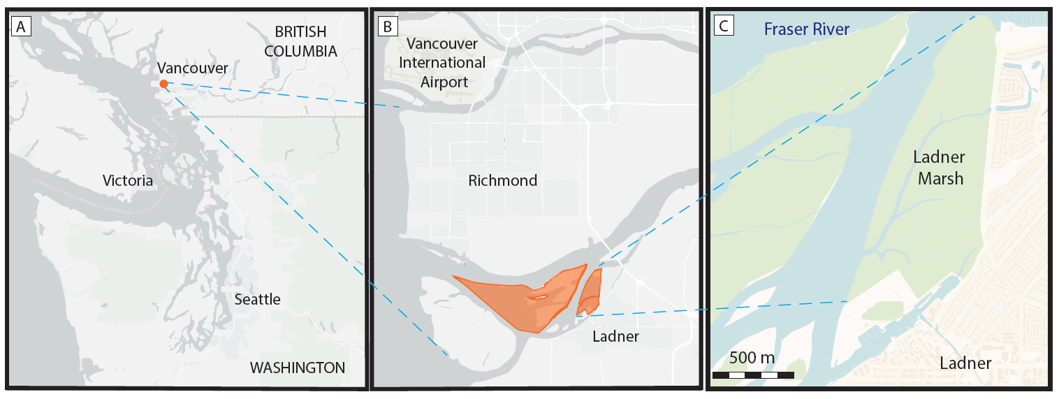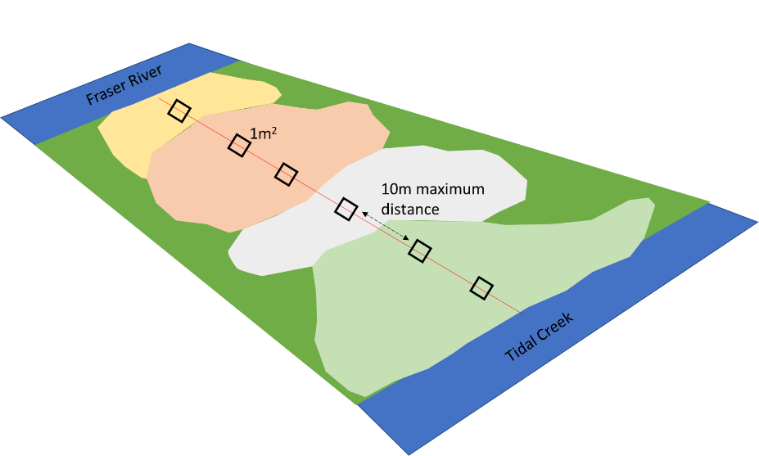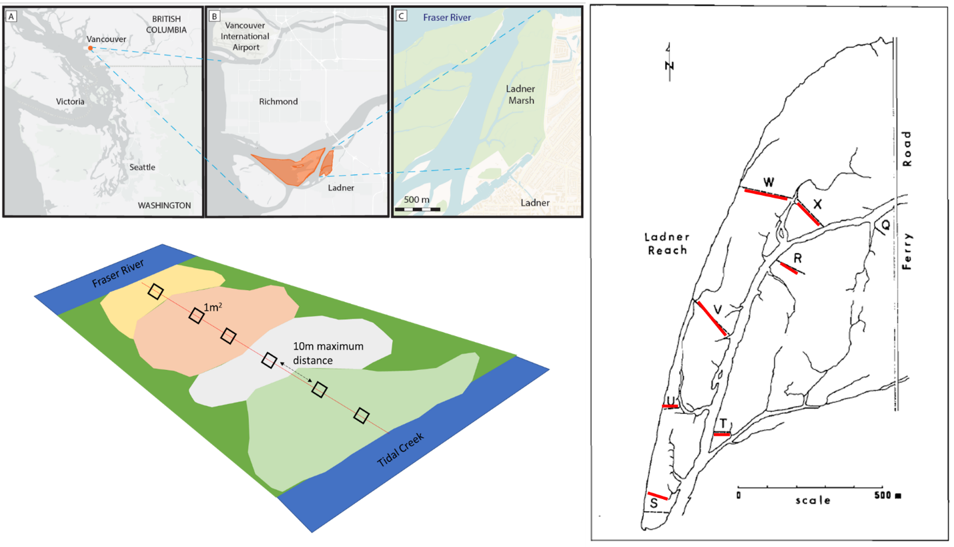

D

E

Figure . Location of the study site in Vancouver, British Columbia, Canada (A), approximately 20 km north of the South Arm Marshes Wildlife Management Area (highlighted in orange, B). Ladner Marsh abuts municipal development on the south bank of the Fraser River (C). Base maps (A, B) generated by iMap published by the B. C. Conservation Data Center (Victoria, BC, Canada, <https://maps.gov.bc.ca/ess/hm/imap4m/>) and (C) OpenStreetMap (OpenStreetMap contributors, 2015, <https://www.openstreetmap.org/>), transect locations illustrated in 1982 publication figure (line drawing), which was overlayed on Google Earth basemap to relocate transects in 2019 (red) (D), and semi-systematic plot placement within and between assemblages based on species dominance (E).

# Results

Three main assemblages within Ladner Marsh can be characterized by the same dominant species across all sampling periods. However, cluster analysis shows species cover is becoming more homogenous within assemblages, but more distinct between assemblages (Figure 2). While the indicator species with greater significance across each assemblage remain constant over time (*i.e.*, *Carex lyngbyei*, *Menyanthes trifoliata, Fescue arundinaceae*) and drive cluster groups, other species that significantly drive indicators of assemblages change over time (Table 1, Table 4). For example, in 1979 the indicator species defining the Sedge assemblage cluster were *C. lyngbyei, S. latifolia,* and *S. tabernaemontani*, however in 1999 the same assemblage included indicator species *C. lyngbyei, A. stolonifera,* and *I. capensis*. Thus, although *C. lyngbyei* remained the common indicator species of the assemblage cluster group, the associated indicator species had changed. Additionally, fewer indicator species were found in the Sedge and Fescue assemblages in 2019 than in 1979. For example, the Sedge assemblage was characterized by three species (including *C. lyngbyei*) in 1979 and 1999, but only by *C. lyngbyei* in 2019. The Fescue group was characterized by seven species in 1979, four species in 1999, and three species in 2019. While *Festuca arundinaceae* remained a common indicator species within the assemblage, all other indicator species changed in each observation year.

Across the entire Ladner Marsh plant community, two to three species were lost each year following the 1979 survey (Table 2). Within every assemblage alpha-diversity (mean number of species per plot) decreased every observation year, while beta-diversity (variation in number of species between plots) increased each year for all assemblages (Table 2). For example, the Sedge community suffered the least loss of species and alpha-diversity across sampling years, although beta-diversity increased as in other assemblages, indicating increasing variability (and thus increased rarity) in which species may be encountered within a given assemblage. The Fescue assemblage had the greatest loss of alpha-diversity (> 50%) between 1979 and 2019. Nearly 50% fewer plots clustered as Fescue in 2019 than in 1979, however bootstrapping 18 random plots from every sampling year showed the same trend, indicating that loss of species is not related to loss of plots (Table S5). The Bogbean assemblage had ~20% decrease in alpha-diversity since 1979 despite an increase of ~47% more plots by 2019.

Total magnitude of species turnover between 1999 and 2019 was ~50% in each assemblage (Table 6), largely driven by greater species disappearance (loss) between 1999 and 2019. For example, rate of species disappearance roughly doubled in each assemblage between 1979-1999 and 1999-2019. Rates of new species appearances in each assemblage were not as great. In fact, new species appearance 1999-2019 compared to 1979-1999 declined by 5% in the bogbean assemblage, increased by 2% in the Fescue assemblage, and increased by 9% in the sedge assemblage. Only the Sedge assemblage had a marked increase in species appearance (gain) from 1999-2019, while the Bogbean community had more species appearance from 1979-1999. While these ratios do not account for species disappearing and reappearing in the same assemblage between 1979 and 2019, the greater rates of disappearance from the assemblages are likely driving the overall loss of species in each sampling timepoint.

Cover abundance of species significantly driving assemblage associations show an overall trend of decreasing cover over time (Figure 3). Notably, Fescue assemblage shows ~50% decrease in cover of characteristic non-native species *Festuca arundinaceae* between 1979 and 2019, while cover of non-native *Phalaris arundinaceae* tripled since 1999. In the Sedge assemblage, cover abundance of *Agrostis stolonifera* appears to have decrease by almost half, however cover of assemblage-defining species *Carex lyngbyei* has decreased by about one-third. Bogbean assemblage maintains greatest coverage of its defining species (*Menyanthes trifoliata*), although cover abundance in 2019 was ~20% less than in 1979. Additionally, non-native *Mentha aquatica* accounts for ~50% of plot cover in the Bogbean assemblage by 2019. In summary, while the dominant species are maintained, their cover abundance within each assemblage is declining. Moreover, some invasive species have increased substantially in cover abundance in the Fescue and Bogbean assemblages since the original survey, indicating these assemblages are becoming increasingly occupied by non-native species.

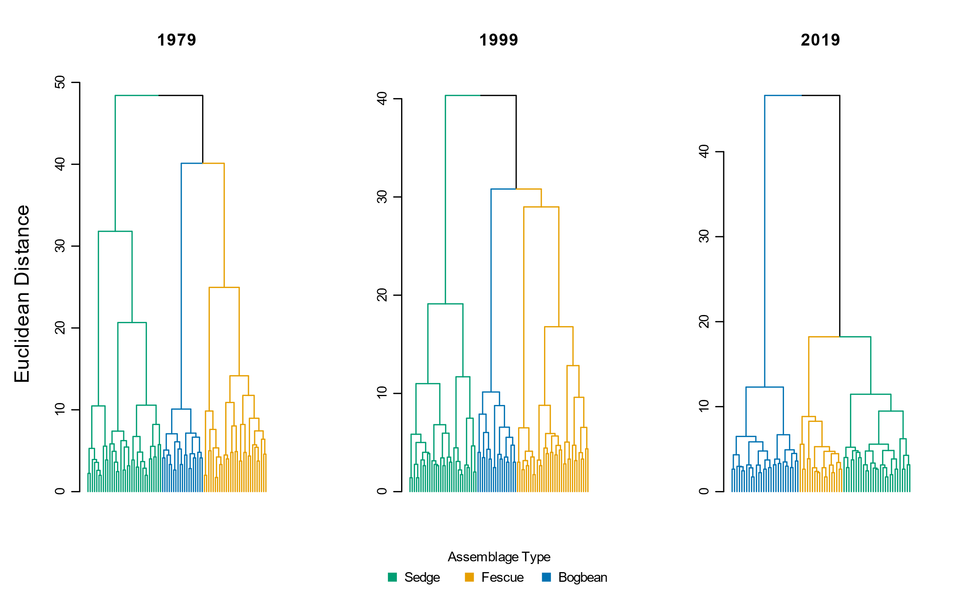

Figure . Species cover abundance becomes more dissimilar in each assemblage over time, as shown by greater Euclidean distance between assemblage types. Notably, species cover of the sedge and fescue groups become more similar in 2019.

Table . Species indicator analysis of cluster groups using Euclidean distance identifies the same dominant species in each assemblage type (Sedge, Fescue, Bogbean) as significantly driving clustering of assemblages over time. IndVal statistic reports association indices between species and plots within each cluster; p-values < 0.05 indicate the species is significantly defining the clustering association within each assemblage and observation year.

|  |  |  |  |  |  |  |  |  |
| --- | --- | --- | --- | --- | --- | --- | --- | --- |
|  | **1979** | |  | **1999** | |  | **2019** | |
| Cluster Group Name | Species | p-value |  | Species | p-value |  | Species | p-value |
|  |  |  |  |  |  |  |  |  |
| "Sedge" | *Carex lyngbyei* | 0.0001 |  | *Carex lyngbyei* | 0.0001 |  | *Carex lyngbyei* | 0.0001 |
| *Sagittaria latifolia* | 0.0001 |  | *Agrostis stolonifera* | 0.0003 |  |  |  |
| *Schoenoplectus tabernaemontani* | 0.0002 |  | *Impatiens capensis* | 0.0147 |  |  |  |
|  |  |  |  |  |  |  |  |  |
| "Fescue" | *Festuca arundinaceae* | 0.0001 |  | *Poa palustris* | 0.0001 |  | *Phalaris arundinaceae* | 0.0001 |
| *Salix lasiandra* | 0.0001 |  | *Festuca arundinaceae* | 0.0010 |  | *Festuca arundinaceae* | 0.0005 |
| *Equisetum palustre* | 0.0001 |  | *Trifolium wormskjoldii* | 0.0015 |  | *Equisetum fluviatile* | 0.0122 |
| *Lathyrus palustris* | 0.0002 |  | *Bidens cernua* | 0.0054 |  |  |  |
| *Sidalcia hendersonii* | 0.0054 |  |  |  |  |  |  |
| *Hordeum brachyantherum* | 0.0159 |  |  |  |  |  |  |
|  |  |  |  |  |  |  |  |  |
| "Bogbean" | *Menyanthes trifoliata* | 0.0001 |  | *Mentha aquatica* | 0.0001 |  | *Menyanthes trifoliata* | 0.0001 |
| *Myosotis scorpiodes* | 0.0005 |  | *Menyanthes trifoliata* | 0.0001 |  | *Mentha aquatica* | 0.0001 |
| *Bidens cernua* | 0.0007 |  | Grass (unidentified) | 0.0007 |  | *Lysimachia thyrsiflora* | 0.0001 |
| *Lythrum salicaria* | 0.0040 |  | *Lythrum salicaria* | 0.0008 |  | *Galium trifidum* | 0.0004 |
| *Equisetum fluviatile* | 0.0112 |  | *Juncus articulatus* | 0.0003 |  | *Myosotis scorpioides* | 0.0062 |
| *Lysimachia thyrsiflora* | 0.0104 |  | *Equisetum fluviatile* | 0.0010 |  | *Juncus articulatus* | 0.0128 |
|  |  |  | *Myosotis scorpioides* | 0.0033 |  |  |  |
|  |  |  | *Eleocharis palustris* | 0.0215 |  |  |  |
|  |  |  | *Equisetum variegatum* | 0.0485 |  |  |  |
|  |  |  | *Deschampsia caespitosa* | 0.0292 |  |  |  |

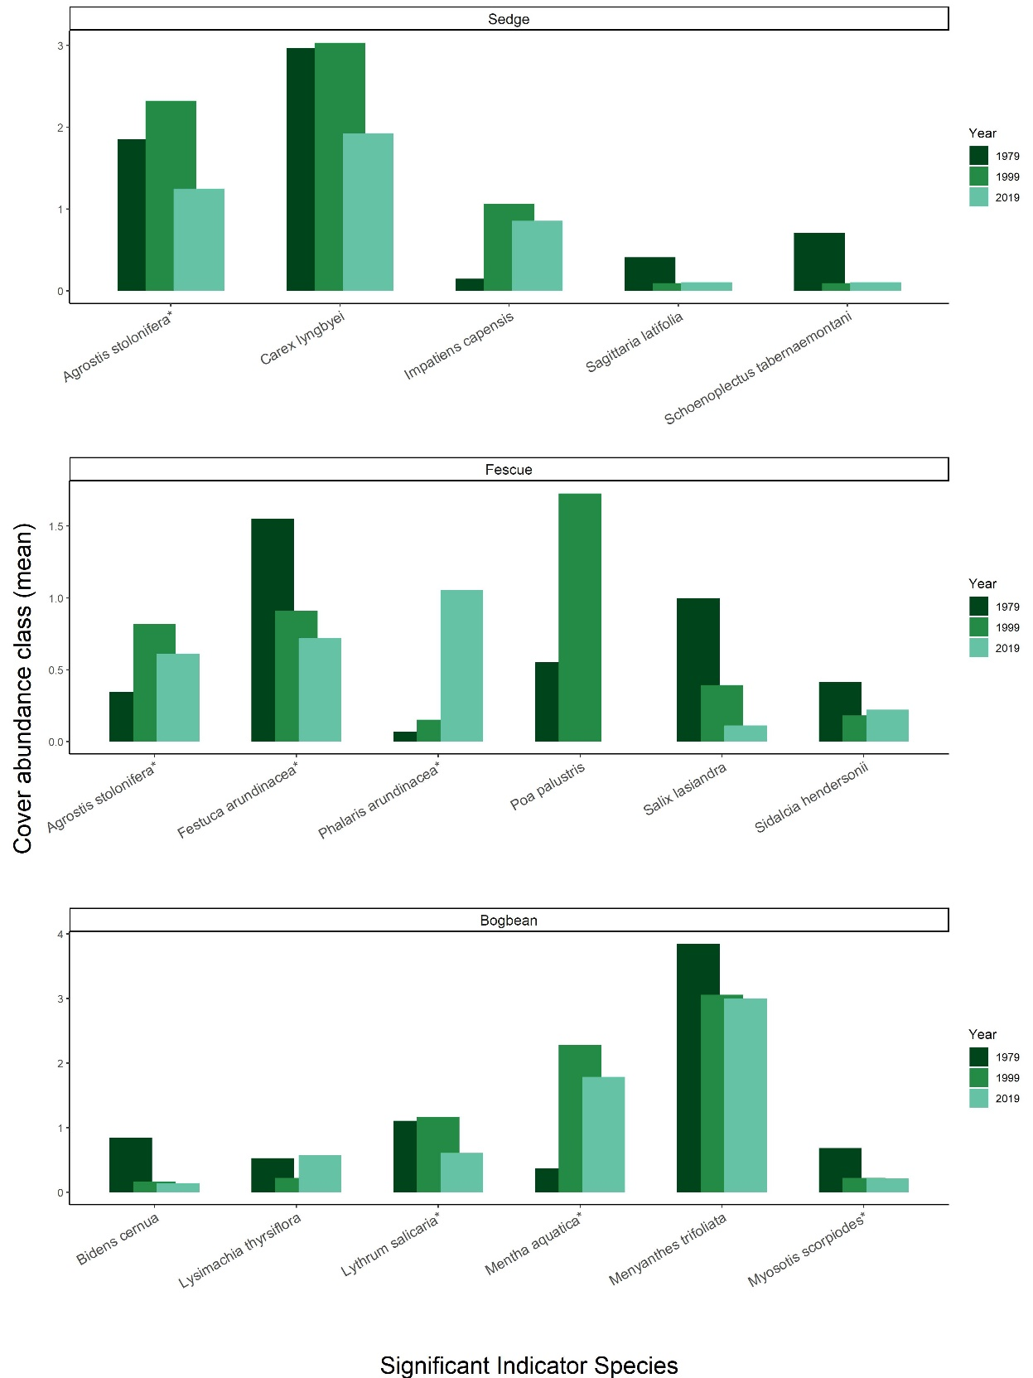

Figure . Changes in mean cover abundance of indicator species most significantly driving assemblage associations over time; blue-listed species Sidalcea hendersonii included for special status interest. Species names followed by (\*) are exotic introductions from Eurasia. Notably, each of the assemblage-defining species (C. lyngbyei, F. arundinaceae, and M. trifoliata) decrease in mean abundance in 2019. By 2019, invasive species P. arundinaceae more than triples its abundance in the Fescue assemblage.

Table . Between 1979 and 2019, 8 fewer plots and 5 fewer species were observed, resulting in slightly lower α-diversity and greater β-diversity. For each assemblage type, Bogbean is the only assemblage to proportionally gain plots between 1979 and 2019, while the Fescue and Sedge assemblages lost plots. Plot loss did not appear to have an effect on diversity components, as tested by bootstrapping a minimum of 18 plots per assemblage each year (Table 5).

|  |  |  |  |  |  |  |
| --- | --- | --- | --- | --- | --- | --- |
|  | **Plot-level components** | |  | **Diversity components** | | |
| **Assemblage** | **No. quadrats** | **No. species** |  | **α diversity** | **α diversity sd** | **β diversity** |
| **Sedge** |  |  |  |  |  |  |
| 1979 | 34 | 36 |  | 8.74 | 2.45 | 3.89 |
| 1999 | 31 | 35 |  | 8.26 | 1.98 | 4.24 |
| 2019 | 28 | 34 |  | 7.89 | 2.69 | 4.31 |
|  |  |  |  |  |  |  |
| **Fescue** |  |  |  |  |  |  |
| 1979 | 29 | 47 |  | 12.83 | 3.87 | 3.66 |
| 1999 | 33 | 41 |  | 9.69 | 3.96 | 4.23 |
| 2019 | 18 | 27 |  | 5.83 | 2.79 | 4.63 |
|  |  |  |  |  |  |  |
| **Bogbean** |  |  |  |  |  |  |
| 1979 | 19 | 32 |  | 12.84 | 3.61 | 2.49 |
| 1999 | 18 | 36 |  | 11.50 | 2.92 | 3.13 |
| 2019 | 28 | 34 |  | 10.46 | 1.90 | 3.25 |
|  |  |  |  |  |  |  |
| **Total** |  |  |  |  |  |  |
| 1979 | 82 | 48 |  | 9.96 | 3.41 | 4.82 |
| 1999 | 82 | 45 |  | 9.55 | 3.30 | 4.71 |
| 2019 | 74 | 43 |  | 8.36 | 3.03 | 5.14 |

# Discussion

We find there have been substantive changes in species composition over time, indicating that despite conservation status and broad resilience of this ecosystem, regional pressures are influencing considerable shifts in the species composition within this habitat. We found three species most significantly characterizing the three main plant assemblages, Sedge, Fescue and Bogbean, have remained the same over the past 40 years, supporting our expectation that these characteristic species should not change in the absence of significant environmental disturbance. Overall, we observed a decline of native species richness, an increased richness and abundance of exotic species, leading to homogenization of cover abundance within assemblages, and greater dissimilarity between assemblages. These shifts in compositional trends are also reflected in the overall loss of secondary indicator species for the Sedge and Fescue assemblages. Our results present another compelling case example of broader global trends of species homogenization, and are of critical concern to local conservation objectives in the Fraser River Estuary for salmon, water birds, and shoreline stability.

## Predominant themes

### Native species loss; increased exotic species richness

Overall, native species contributing to floristic diversity have been lost, both in terms of richness and cover abundance. The biodiversity loss of native species richness may indicate loss of functional redundancy (and thus resilience) within the assemblage, and the marsh community as a whole. This trend was observed as decreasing alpha diversity and increasing beta diversity, which indicated increasing rarity of secondary species within each assemblage (Table 2).

The greatest loss of native species richness occurred in the Fescue assemblage, while nominal gains in exotic richness were found in all assemblages (Table 7). The Fescue assemblage lost a total of 23 native species (net loss of 18 native species) between 1979 and 2019. Among the species lost from the assemblage, 12 were lost from all three assemblages (six forbs, six graminoids), or were never found in any other assemblage. Species gained include two woody species, and one each of forb, graminoid, and fern ally (*Equisetum arvense*). In addition to overall loss of richness, it is worth noting the woody species gained represent alternative functional traits, and provide different habitat value than forbs and graminoids. There was a net zero gain of exotics, however exotic RCG accounts for the greatest 2019 mean cover in the entire assemblage (25-50% cover). In the Bogbean assemblage, new exotic species include *Phalaris arundinaceae* (reed canary grass, RCG) and *Iris pseudacorus* (yellow flag iris). Although they are presently < 25% mean 2019 cover, these species are notorious for quickly spreading to the point of near-exclusion of other species (especially natives) (Apfelbaum & Sams, 1987; Sinks et al., 2021) Within the Sedge assemblage, there was a net loss of 3 native species, and net gain of 3 exotic species, including yellow flag and RCG. As of 2019, these species accounted for < 25% mean cover, but are of significant management concern. These results reflect broader global trends of biodiversity loss paired with exotic invasion. The unknown consequences of this invasion and native species loss may be creating broader instability within the Fraser River Estuary ecosystem through fragmented or lost propagule dispersal networks, and altered trophic cascades such as pollinator networks or primary production.

### Cover abundance homogenization within assemblages; heterogeneity between assemblages

We found that species cover has become more homogenized within assemblages, but more distinct between assemblages. That is, plots were more similar in species cover abundance within an assemblage, but increasingly dissimilar between assemblages (Figure 2), indicating sharper contrasts in species compositional abundance between assemblages. The key driver of this trend was greater dominance in cover abundance by fewer species (Table 1), while presence and cover abundance of ‘rare’ species became rarer.

It is worth noting changes in cover abundance for *Sidalcea hendersonii*, a species of special concern (blue-listed) under the Canadian Species at Risk Act, which may inform conservation best practices. Cover abundance of the species was greatest in the Fescue assemblage in 1979, butdecreased by 46% in 2019. However, it increased ~140% in the Sedge assemblage (< 25% cover in 2019). It is difficult to say whether shifting abiotic conditions or encroaching exotic species such as RCG (~1430% increase to 25-50% plot cover in 2019) were responsible for the decline in *S. hendersonii* abundance in the Fescue assemblage. However, these trends may represent an opportunity for new research to inform better conservation strategies.

Surprisingly, cover abundance of many the assemblage-dominant species have decreased over time. For example, in the Sedge assemblage both native keystone species *Carex lyngbyei* and exotic grass *Agrostis stolonifera* have decreased cover abundance from 1979-2019 (Figure 3), with each species losing ~25-35% cover abundance between 1979-2019. Meanwhile, exotic species *Lythrum salicaria* and *Festuca arundinaceae* increased ~50% and 100%, respectively, in abundance (< 25% cover) by 2019 (Table 7). Similarly, in the Bogbean assemblage, cover abundance of native keystone species *Menyanthes trifoliata* had declined ~21% (50-75% cover) by 2019, while cover of exotic *Mentha aquatica* had increased ~385% (~25-50%). Overall, the ratio of native to exotic cover within assemblages is decreasing, resulting in greater proportional cover abundance of exotic species (Figure 5b). This indicates certain exotic species are becoming more abundant within assemblages, however few species (native or exotic) represent the majority of cover within the assemblage.

### Shifts in secondary indicator species

The species indicator analysis of clustered assemblages showed that assemblage-defining species (Bogbean, Fescue, Sedge) remained consistent, however there were overall losses in indicator species, and few of those indicator species were consistently represented in the analysis over time. For example, the Sedge and Fescue assemblages had the greatest losses of assemblage indicator species. The Fescue assemblage included six indicator species in 1979, but only three in 2019, while the Sedge assemblage had three species in 1979, but only one in 2019. In both assemblages, the only species that remained the same ‘indicators’ were the assemblage-defining species *Carex lyngbyei* (sedge), and *Festuca arundinaceae*, (fescue). However, in the Fescue assemblage RCG (*Phalaris arundinaceae*) has replaced *F. arundinaceae* as the most significant indicator species.

The identity of the shifting indicator species may offer clues to changing abiotic conditions or functional traits. For example, the indicator species analysis for the Sedge assemblage in 1979 included indicators of highly saturated soils (*Sagittaria latifolia, Schoenoplectus tabernaemontani*), but in 1999 the assemblage indicators included species tolerant of drier conditions (*Agrostis stolonifera, Impatiens capensis*). Alternatively, if the shifts in assemblage indicator species do not readily point to functional traits or abiotic factors, they may be more indicative of the likelihood of high interannual variability in the assemblage or broader community despite the perennial life history of many of the species. For example, the number of indicator species for the Bogbean assemblage varied across time, with 6, 10, and 6 species in 1979, 1999, and 2019, respectively. In the Fescue assemblage, woody willow species *Salix lasiandra* was an indicator species in 1979, and therefore one might expect a succession of riparian fringe over time. By 1999 the species was no longer a significant indicator species, which either suggests a long-term shift in environmental factors making the habitat less hospitable to willow (such as encroachment of RCG), or that environmental factors shift so frequently that indicator species will shift accordingly on faster timescales.

The turnover of secondary indicator species may simply represent dynamic trends in compositional abundance. However, greater homogeneity of cover abundance within assemblages, and greater compositional abundance distinction between assemblages may result directly from overall loss of native floristic richness. These trends of high turnover and loss of richness may indicate greater susceptibility to invasion (Kuiters, *et al.*, 2009), and thus a loss of resistance over time to exotic species encroachment.

## Potential mechanisms

We propose several interacting mechanisms are likely responsible for the observed changes. These mechanisms include fragmentation of remnant tidal wetlands (loss of native propagules) and increased exotic abundance from municipal and agricultural settlement (introduction of exotic propagules), combined with altered sedimentation processes and resulting edaphic conditions.

Local colonization and extinction dependent on the local, but also regional propagule pool. At the local scale, if secondary species are becoming rarer due to local extinction, this results in loss of local propagative inputs to the habitat. However, local native species loss may be rescued by dispersal through regional aquatic networks. If similar habitats within the estuarine ecosystem are lost to the point where distance between patches exceeds propagule dispersal distance (Shi, et al., 2020), then species colonization within the ecosystem is rare or lost. Similarly, if exotic species are more prevalent throughout the regional dispersal network, then there is a greater chance of exotic species introduction over native within a local marsh community. Ladner Marsh was historically described as being high in floristic diversity (Bradfield & Porter, 1982). We found this site is losing total species diversity, and becoming homogenized in terms of species cover. This may indicate that a source of native propagules is being lost in the Fraser River Estuary dispersal network, and/or abundance of exotic propagules are more readily available, and thus more competitive in the environment. As exotic species increase in presence and abundance, they co-opt space and resources, increasing stress upon the native ecosystem. This stress feedback loop further shifts community composition and function, and over time consequential abiotic shifts may be altering the seed recruitment niches to favor exotics and limit native species recruitment (Lane, 2022). This reflects a general trend of exotic species’ competitive advantage in disturbed systems, and represents ongoing press disturbance by anthropogenic impacts with cumulative ecosystem effects.

A key abiotic driver of tidal marsh development includes sediment deposition, which allows plant communities to compensate for changing inundation rates due to sea level rise (Marijnissen, et al., 2020). Sediment delivered by river transport is trapped by vegetation, creating a feedback loop of rising tidal marsh platforms, increased vegetation growth, and increased sediment trapping capacity (Corenblit et al., 2015; Peteet et al., 2018). In their 1982 publication, Bradfield and Porter proposed assemblage occurrence was largely driven by edaphic factors, with the Bogbean assemblage occurring in poorly drained areas, Sedge assemblage occurring in regularly flooded and drained areas, and Fescue assemblage along slightly elevated channel edges. Native *Menyanthes trifoliata* (bogbean) and exotic *Mentha aquatica* are highly adapted to aquatic or poorly drained habitats, and the increased prevalence of plots clustered in the Bogbean assemblage within Ladner Marsh may be indicative of changing edaphic factors such as sediment starvation or marsh subsidence (Mendelssohn & Kuhn, 2003; Nyman, et al., 2006). Conversely, in 1979 the Sedge assemblage was characterized by indicator species tolerant of highly saturated conditions, but by 2019 the assemblage included species more tolerant of drier conditions. These contrasting changes may indicate assemblage-specific patterns of marsh platform subsidence and sediment deposition driven by vegetation structure or physical settling processes during sediment deposition.

Loss of sediment within the Lower Fraser River reaches is driven by a combination of factors, such as increased impervious cover, bank dyking or armoring, and channel dredging (Atkins, Tidd, & Ruffo, 2016). Edaphic shifts resulting in more saturated areas, such as sediment starvation or subsidence, would likely drive the increased prevalence of Bogbean assemblage, and may also be driving disappearance of species across all assemblages, as fewer species are able to tolerate increasingly saturated conditions. Similarly, areas receiving more sediment would accrete in elevation, and may also be more likely to receive exotic propagules within the distributed sediment. Thus, these processes may be altering the recruitment niche for clonal and seed propagules (Lane, 2022), which may favor species tolerant to the changing soil conditions (e.g., RCG).

## Limitations & opportunities

While these data have shown coarse trends through time, we cannot account for interannual variation in compositional abundance trends. However, this snapshot of long-term trends may be used to refine future questions such as identifying whether abiotic drivers, recruitment potential, or assemblage-scale conservation of species diversity convey greater susceptibility or resistance to invasion and loss of native species diversity. We observed that while the Bogbean assemblage showed an increasing abundance of exotic *Mentha aquatica*, it retained cover abundance and increased richness of native species. Thus, although the assemblage is being invaded, homogenization and loss of diversity may be happening more slowly than in other assemblages. These trends may yield further insights to how abiotic processes mitigate or facilitate competitive pre-emption of space and propagule recruitment to prevent loss of species diversity.

Ecosystem stressors such as sediment loss, propagule loss, and competitive strategies are likely interacting, resulting in loss of species diversity and facilitating spread of invasive species. Disentangling explicit causes would be no easy task, however experimentally testing effects of sediment loading on species-specific clonal or seed propagule recruitment would prove valuable for understanding best practices to shift the plant community towards functionally desired compositional states.

## Applications

Despite our knowledge to the contrary, practitioners often erroneously assume no direct anthropogenic disturbance suffices to conserve an ecologically appropriate reference state (e.g., Stoddard, et al., 2006, and citations therein). However, the biodiversity loss described here presents real concerns for the resilience of this important community, and highlights negative impacts in unmanaged ecosystems thought to be relatively pristine. Most importantly: active management will be needed to maintain ecologically desired species composition in the face of climate change. These active management decisions will necessitate understanding native species loss through experimental adaptive management of hydro-geomorphological drivers, dispersal networks, and recruitment strategies.

These findings yet again confirm that contemporary “reference” sites are not sufficient benchmarks for restoration success (Shackelford, et al., 2021). Despite Ladner Marsh’s status as a protected wetland and legacy of little anthropogenic disturbance, its plant community is succumbing to cumulative pressures that reduce its quality as a reference condition. Therefore, as land managers consider restoration outcomes resilient to climate change in coastal wetlands, they must necessarily look beyond contemporary remnants of historic ecosystems to design models and functional ecological targets.

## Recommendations

If we are to prioritize conservation of functional coastal wetlands that include a significant representation of native species, we must seek new ways to actively manage habitats such as Ladner Marsh through mechanical control of invasive species (e.g., stands of reed canary grass), combined with experimental management practices using sediment application and/or native species planting to enhance ecosystem processes within remnant marsh habitats.

This active management process also presents a timely and necessary opportunity to engage with First Nations to revive traditional management practices, such as select mechanical disturbance (Turner, 2014): working with traditional knowledge holders may yield deeper understanding of plant community function and habitat stability, which would enhance ecosystem resilience and potentially lead to positive effects on salmonid populations while contributing to reconciliation between Indigenous and colonial cultures.

# Acknowledgements

The lead author would like to thank Z. Davis for providing R programming advice; P. Roper for field assistance; B. Staines (Ladner Harbour Authority) for providing canoe and harbour use. Financial support was provided by Natural Sciences and Engineering Research Council of Canada Discovery Grant RGPIN-2018-03838 to J. Richardson, and research site access was granted by The Ministry of Forests, Lands, Natural Resource Operations and Rural Development.

# Literature Cited

Apfelbaum, S. I., & Sams, C. E. (1987). Ecology and Control of Reed Canary Grass (Phalaris arundinacea L.). *Natural Areas Journal*, *7*, 69–74.

Atkins, R. J., Tidd, M., & Ruffo, G. (2016). Sturgeon Bank, Fraser River Delta, BC, Canada: 150 Years of Human Influences on Salt Marsh Sedimentation. *Journal of Coastal Research*, *SI*, 790–794.

Bradfield, G. E., & Porter, G. L. (1982). Vegetation structure and diversity components of a Fraser estuary tidal marsh. *Canadian Journal of Botany*, *60*, 440–451.

Brophy, L. S., Greene, C. M., Hare, V. C., Holycross, B., Lanier, A., Heady, W. N., … Dana, R. (2019). Insights into estuary habitat loss in the western United States using a new method for mapping maximum extent of tidal wetlands. *PLOS ONE*, *14*, e0218558.

Chalifour, L., Scott, D. C., MacDuffee, M., Iacarella, J. C., Martin, T. G., & Baum, J. K. (2019). Habitat use by juvenile salmon, other migratory fish, and resident fish species underscores the importance of estuarine habitat mosaics. *Marine Ecology Progress Series*, *625*, 145–162.

Corenblit, D., Baas, A., Balke, T., Bouma, T., Fromard, F., Garófano‐Gómez, V., … Walcker, R. (2015). Engineer pioneer plants respond to and affect geomorphic constraints similarly along water–terrestrial interfaces world-wide. *Global Ecology and Biogeography*, *24*, 1363–1376.

Davis, M. J., Woo, I., Ellings, C. S., Hodgson, S., Beauchamp, D. A., Nakai, G., & De La Cruz, S. E. W. (2021). A climate-mediated shift in the estuarine habitat mosaic limits prey availability and reduces nursery quality for juvenile salmon. *Estuaries and Coasts*. https://doi.org/10.1007/s12237-021-01003-3

De Cáceres, M., & Jansen, F. (2016). *Indicspecies*. Retrieved from http://r.meteo.uni.wroc.pl/web/packages/indicspecies/indicspecies.pdf

Denoth, M., & Myers, J. H. (2007). Competition between Lythrum salicaria and a rare species: Combining evidence from experiments and long-term monitoring. *Plant Ecology*, *191*, 153–161.

Donohue, I., Hillebrand, H., Montoya, J. M., Petchey, O. L., Pimm, S. L., Fowler, M. S., … Yang, Q. (2016). Navigating the complexity of ecological stability. *Ecology Letters*, *19*, 1172–1185.

Douglas, T. J., Schuerholz, G., & Juniper, S. K. (2022). Blue Carbon Storage in a Northern Temperate Estuary Subject to Habitat Loss and Chronic Habitat Disturbance: Cowichan Estuary, British Columbia, Canada. *Frontiers in Marine Science*, *9*. Retrieved from https://www.frontiersin.org/article/10.3389/fmars.2022.857586

Dufrêne, M., & Legendre, P. (1997). Species Assemblages and Indicator Species:the Need for a Flexible Asymmetrical Approach. *Ecological Monographs*, *67*, 345–366.

Emmett, R., Llansó, R., Newton, J., Thom, R., Hornberger, M., Morgan, C., … Fishman, P. (2000). Geographic signatures of North American West Coast estuaries. *Estuaries*, *23*, 765–792.

Hallett, L. M., Jones, S. K., MacDonald, A. A. M., Jones, M. B., Flynn, D. F. B., Ripplinger, J., … Collins, S. L. (2016). codyn: An r package of community dynamics metrics. *Methods in Ecology and Evolution*, *7*, 1146–1151.

Hanski, I. (1982). Dynamics of Regional Distribution: The Core and Satellite Species Hypothesis. *Oikos*, *38*, 210–221. JSTOR.

Hitchcock, C. L., & Cronquist, A. (1973). *Flora of the Pacific Northwest, an illustrated manual*. Seattle and London: University of Washington Press.

Holling, C. S. (1973). Resilience and Stability of Ecological Systems. *Annual Review of Ecology and Systematics*, *4*, 1–23.

Kopecký, M., & Macek, M. (2015). Vegetation resurvey is robust to plot location uncertainty. *Diversity and Distributions*, *21*, 322–330.

Lane, S. L. (2022). Using marsh organs to test seed recruitment in tidal freshwater marshes. *Applications in Plant Sciences*, e11474.

Legendre, P., & Legendre, L. (2012). *Numerical Ecology* (3rd ed., Vol. 24). Elsevier.

Lepš, J. (2004). What do the biodiversity experiments tell us about consequences of plant species loss in the real world? *Basic and Applied Ecology*, *5*, 529–534.

Marijnissen, R., Kok, M., Kroeze, C., & van Loon-Steensma, J. (2020). The Sensitivity of a Dike-Marsh System to Sea-Level Rise—A Model-Based Exploration. *Journal of Marine Science and Engineering*, *8*, 42.

Mendelssohn, I. A., & Kuhn, N. L. (2003). Sediment subsidy: Effects on soil–plant responses in a rapidly submerging coastal salt marsh. *Ecological Engineering*, *21*, 115–128.

Nyman, J. A., Walters, R. J., Delaune, R. D., & Patrick, W. H. (2006). Marsh vertical accretion via vegetative growth. *Estuarine, Coastal and Shelf Science*, *69*, 370–380.

Ovaskainen, O., Rybicki, J., & Abrego, N. (2019). What can observational data reveal about metacommunity processes? *Ecography*, *42*, 1877–1886.

Pasternack, G. B. (2009). Chapter 3. Hydrogeomorphology and sedimentation in tidal freshwater wetlands. In A. Barendregt, D. F. Whigham, & A. H. Baldwin (Eds.), *Tidal Freshwater Wetlands* (pp. 31–40). Leiden, The Netherlands: Backhuys Publishers.

Peteet, D. M., Nichols, J., Kenna, T., Chang, C., Browne, J., Reza, M., … Stern-Protz, S. (2018). Sediment starvation destroys New York City marshes’ resistance to sea level rise. *Proceedings of the National Academy of Sciences*, *115*, 10281–10286.

Schaefer, V. (2004). Ecological setting of the Fraser River delta and its urban estuary. In B. J. Groulx, D. C. Mosher, J. L. Luternauer, & D. E. Bilderback (Eds.), *Fraser River Delta, British Columbia: Issues of an Urban Estuary* (pp. 147–172). Geological Survey of Canada, Bulletin 547.

Shackelford, N., Dudney, J., Stueber, M. M., Temperton, V. M., & Suding, K. L. (2021). Measuring at all scales: Sourcing data for more flexible restoration references. *Restoration Ecology*, *n/a*, e13541.

Shi, W., Shao, D., Gualtieri, C., Purnama, A., & Cui, B. (2020). Modelling long-distance floating seed dispersal in salt marsh tidal channels. *Ecohydrology*, *13*, e2157.

Sinks, I. A., Borde, A. B., Diefenderfer, H. L., & Karnezis, J. P. (2021). Assessment of Methods to Control Invasive Reed Canarygrass (Phalaris arundinacea) in Tidal Freshwater Wetlands. *Natural Areas Journal*, *41*, 172–185.

Stoddard, J. L., Larsen, D. P., Hawkins, C. P., Johnson, R. K., & Norris, R. H. (2006). Setting Expectations for the Ecological Condition of Streams: The Concept of Reference Condition. *Ecological Applications*, *16*, 1267–1276.

Turner, N. (2014). *Ancient Pathways, Ancestral Knowledge: Ethnobotany and Ecological Wisdom of Indigenous Peoples of Northwestern North America*. McGill-Queen’s Press - MQUP.

Underwood, A. J., Chapman, M. G., & Connell, S. D. (2000). Observations in ecology: You can’t make progress on processes without understanding the patterns. *Journal of Experimental Marine Biology and Ecology*, *250*, 97–115.

Whittaker, R. H. (1975). *Communities and Ecosystems* (2nd ed.). New York, NY: Macmillan.

# Supplemental

Table . A total of 25 plots sampled in 1979 and 1999 were not sampled in 2019, mostly due to issues of accessibility. Transect names and plot ID of plots omitted follow Fig. 3 in Bradfield & Porter (1982).

|  |  |  |
| --- | --- | --- |
| **Transect** | **1979/1999**  **Plot No.** | **Reason omitted in 2019** |
| Q | 1-7 | Transect in dense riparian thicket overgrown with Himalayan blackberry |
| R | 8 | Plot on lower bench (> 1 m lower than marsh platform), vegetation no longer exists |
| R | 17-19 | Plots in 1979 & 1999 sampled across a channel. Ended transect in 2019 at channel edge. |
| S | 33-36 | Transect length in 2019 was shorter than in 1979/1999. Suspect combination of erosion and offset transect relocation altered sampling distance. |
| T | 45 | Transect length in 2019 was shorter than in 1979/1999. Suspect combination of erosion and offset transect relocation altered sampling distance. |
| U | 51-52 | Transect length in 2019 was shorter than in 1979/1999. Suspect combination of erosion and offset transect relocation altered sampling distance. |
| V | 53 | Plot 53 only plot across a channel. Increased channel width and likely erosion made crossing this channel dangerous; omitted plot in 2019. |
| V | 54, 70-71 | Transect length in 2019 was shorter than in 1979/1999. Suspect combination of erosion and offset transect relocation altered sampling distance. |
| W | 89-92 | Transect length in 2019 was shorter than in 1979/1999. Suspect combination of erosion and offset transect relocation altered sampling distance. |
| X | 93 | Transect length in 2019 was shorter than in 1979/1999. Suspect combination of erosion and offset transect relocation altered sampling distance. |

*Table 4. Species indicator analysis of cluster groups using Bray-Curtis distance identifies the same dominant species in each assemblage type (Sedge, Fescue, Bogbean), however Bray-Curtis distance identifies different associated indicator species than those identified by Euclidean distance (Table 1****Error! Reference source not found.****).*

|  |  |  |  |  |  |  |  |  |  |  |  |
| --- | --- | --- | --- | --- | --- | --- | --- | --- | --- | --- | --- |
|  | **1979** | | |  | **1999** | | |  | **2019** | | |
| **Cluster Group Name** | **Species** | **IndVal stat** | **p-value** |  | **Species** | **IndVal stat** | **p-value** |  | **Species** | **IndVal stat** | **p-value** |
|  |  |  |  |  |  |  |  |  |  |  |  |
| "Sedge" | *Carex lyngbyei* | 0.678 | 0.001 |  | *Carex lyngbyei* | 0.804 | 0.001 |  | *Carex lyngbyei* | 0.714 | 0.001 |
| *Sagittaria latifolia* | 0.559 | 0.001 |  | *Agrostis stolonifera* | 0.434 | 0.003 |  | *Mentha arvensis* | 0.322 | 0.033 |
| *Schoenoplectus tabernaemontani* | 0.391 | 0.001 |  |  |  |  |  |  |  |  |
|  |  |  |  |  |  |  |  |  |  |  |
|  |  |  |  |  |  |  |  |  |  |  |  |
| "Fescue" | *Festuca arundinacea* | 0.753 | 0.001 |  | *Festuca arundinacea* | 0.765 | 0.001 |  | *Phalaris arundinaceae* | 0.584 | 0.001 |
| *Salix lucida* | 0.586 | 0.001 |  | *Phalaris arundinaceae* | 0.334 | 0.019 |  | *Festuca arundinacea* | 0.416 | 0.001 |
| *Lathyrus palustris* | 0.543 | 0.001 |  |  |  |  |  |  |  |  |
| *Equisetum palustre* | 0.475 | 0.002 |  |  |  |  |  |  |  |  |
| *Impatiens capensis* | 0.391 | 0.002 |  |  |  |  |  |  |  |  |
| *Sidalcia hendersonii* | 0.387 | 0.001 |  |  |  |  |  |  |  |  |
| *Platanthera dilatata* | 0.308 | 0.020 |  |  |  |  |  |  |  |  |
|  |  |  |  |  |  |  |  |  |  |  |  |
| "Bogbean" | *Menyanthes trifoliata* | 0.807 | 0.001 |  | *Menyanthes trifoliata* | 0.782 | 0.001 |  | *Mentha aquatica* | 0.752 | 0.001 |
| *Myosotis scorpioides* | 0.577 | 0.001 |  | *Leersia oryzoides* | 0.495 | 0.001 |  | *Menyanthes trifoliata* | 0.709 | 0.001 |
| *Juncus articulatus* | 0.523 | 0.001 |  | *Mentha aquatica* | 0.492 | 0.001 |  | *Lysimachia thyrsiflora* | 0.547 | 0.001 |
| *Lythrum salicaria* | 0.400 | 0.002 |  | *Bidens cernua* | 0.489 | 0.003 |  | *Salix lucida* | 0.465 | 0.001 |
| *Lysimachia thyrsiflora* | 0.400 | 0.002 |  | *Lysimachia thyrsiflora* | 0.478 | 0.001 |  | *Eleocharis palustris* | 0.460 | 0.001 |
| *Trifolium wormskjoldii* | 0.381 | 0.003 |  | *Juncus articulatus* | 0.438 | 0.001 |  | *Juncus articulatus* | 0.373 | 0.004 |
| *Lilaeopsis occidentalis* | 0.360 | 0.004 |  | *Juncus oxymeris* | 0.356 | 0.015 |  | *Galium trifidum* | 0.348 | 0.008 |
| *Mentha aquatica* | 0.313 | 0.010 |  | *Myosotis scorpioides* | 0.356 | 0.019 |  | *Bidens cernua* | 0.323 | 0.012 |
|  |  |  |  | Poaceae (unidentified sp.) | 0.356 | 0.013 |  |  |  |  |
|  |  |  |  | *Deschampsia caespitosa* | 0.354 | 0.014 |  |  |  |  |
|  |  |  |  | *Sagittaria latifolia* | 0.301 | 0.046 |  |  |  |  |

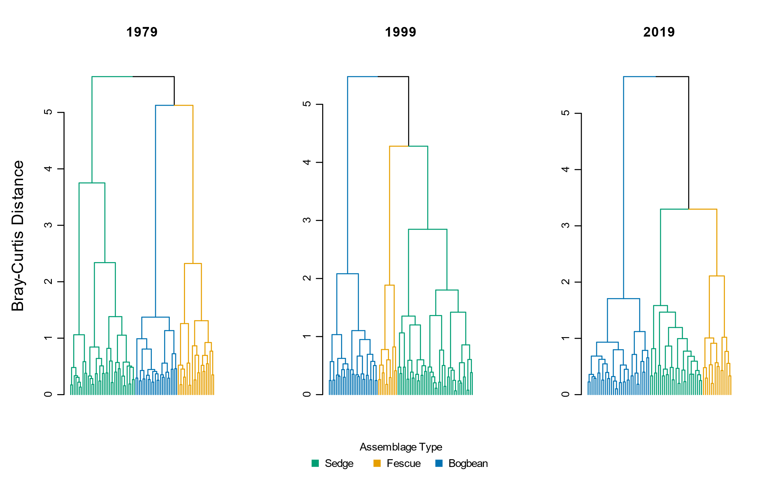

Figure . Cluster analysis using Bray-Curtis distance measure shows similar trends of increasing dissimilarity over time as when using Euclidean distance (Figure 2).

|  |  |  |  |  |  |  |
| --- | --- | --- | --- | --- | --- | --- |
|  | **Plot-level components** | |  | **Diversity components** | | |
| **Assemblage** | **No. quadrats** | **No. species** |  | **α diversity** | **α diversity sd** | **β diversity** |
| **Sedge** |  |  |  |  |  |  |
| 1979 | 18 | 32.3 |  | 10.67 | 2.34 | 3.03 |
| 1999 | 18 | 31.6 |  | 8.31 | 1.98 | 3.81 |
| 2019 | 18 | 30.8 |  | 8.18 | 2.51 | 3.77 |
|  |  |  |  |  |  |  |
| **Fescue** |  |  |  |  |  |  |
| 1979 | 18 | 43.3 |  | 12.96 | 3.91 | 3.35 |
| 1999 | 18 | 36.4 |  | 9.72 | 3.92 | 3.76 |
| 2019 | 18 | 27 |  | 5.83 | 2.79 | 4.63 |
|  |  |  |  |  |  |  |
| **Bogbean** |  |  |  |  |  |  |
| 1979 | 18 | 31.7 |  | 12.83 | 3.63 | 2.47 |
| 1999 | 18 | 36 |  | 11.50 | 2.92 | 3.13 |
| 2019 | 18 | 31.4 |  | 10.52 | 1.90 | 2.99 |
|  |  |  |  |  |  |  |
| **Total** |  |  |  |  |  |  |
| 1979 | 54 | 47.6 |  | 12.15 | 3.49 | 3.92 |
| 1999 | 54 | 42.1 |  | 10.02 | 3.35 | 4.22 |
| 2019 | 54 | 41.7 |  | 8.18 | 3.08 | 5.10 |

Table . Bootstrapping 18 randomly selected plots 10 times shows consistent overall trend in loss of species and alpha diversity over time, and overall increase in beta diversity between 1979 and 2019 in all assemblages and across the entire Ladner Marsh plant community. Therefore, loss of plots due to sampling re-location or how number of plots clustered into assemblages as reported in Table 2 is not expected to affect loss of species or plot-based diversity metrics.

Table 6. Total turnover and rates of species disappearance (loss) was always greater between 1999 and 2019 than between 1979 and 1999. However, fewer species were gained in the Bogbean assemblage 1999-2019 than 1979-1999.

|  |  |  |  |  |
| --- | --- | --- | --- | --- |
| **Assemblage** | **Year** | **Total turnover** | **Species Appearance** | **Species Disappearance** |
| Bogbean | 1979-1999 | 0.47 | 0.30 | 0.16 |
| 1999-2019 | 0.51 | 0.23 | 0.28 |
| Fescue | 1979-1999 | 0.35 | 0.13 | 0.21 |
| 1999-2019 | 0.58 | 0.15 | 0.44 |
| Sedge | 1979-1999 | 0.32 | 0.17 | 0.15 |
| 1999-2019 | 0.50 | 0.24 | 0.26 |

Table . Percent change in mean abundance (cover class) between from 1979 to 2019 for non-native and native species observed in each assemblage. New species appearances from 1979 to 2019 indicated by (+); species only appearing in 1999 indicated by ‘NA’. Native status is listed as ‘unknown’ if plant was not identified to species level.

|  |  |  |  |  |  |  |
| --- | --- | --- | --- | --- | --- | --- |
| **Assemblage** | **Status** | **Species** | **1979** | **1999** | **2019** | **Percent Change (1979-2019)** |
| Bogbean | Non-native | *Mentha arvensis* | 0.47 | 0.00 | 0.07 | -84.9 |
| *Myosotis scorpiodes* | 0.68 | 0.22 | 0.21 | -68.7 |
| *Agrostis stolonifera* | 3.21 | 1.50 | 1.29 | -60.0 |
| *Lythrum salicaria* | 1.11 | 1.17 | 0.61 | -45.1 |
| *Rumex conglomeratus* | 0.05 | 0.00 | 0.04 | -32.1 |
| *Mentha aquatica* | 0.37 | 2.28 | 1.79 | 384.7 |
| *Iris pseudocorus* | 0.00 | 0.33 | 0.21 | + |
| *Lycopus europaeus* | 0.00 | 0.00 | 0.04 | + |
| *Phalaris arundinacea* | 0.00 | 0.06 | 0.04 | + |
| *Festuca arundinacea* | 0.00 | 0.17 | 0.00 | NA |
| Native | *Alisma plantago aquatica* | 0.16 | 0.11 | 0.00 | -100.0 |
| *Alopecurus geniculatus* | 0.05 | 0.00 | 0.00 | -100.0 |
| *Deschampsia caespitosa* | 0.26 | 0.22 | 0.00 | -100.0 |
| *Equisetum fluviatile* | 1.37 | 1.17 | 0.00 | -100.0 |
| *Leersia oryzoides* | 0.26 | 0.33 | 0.00 | -100.0 |
| *Lilaeopsis occidentalis* | 0.21 | 0.00 | 0.00 | -100.0 |
| *Oenanthe sarmentosa* | 0.63 | 0.11 | 0.00 | -100.0 |
| *Poa trivialis* | 0.11 | 0.00 | 0.00 | -100.0 |
| *Sium suave* | 0.63 | 0.17 | 0.00 | -100.0 |
| *Caltha palustris* | 0.95 | 0.22 | 0.07 | -92.5 |
| *Bidens cernua* | 0.84 | 0.17 | 0.14 | -83.0 |
| *Trifolium wormskjoldii* | 0.95 | 0.11 | 0.18 | -81.2 |
| *Schoenoplectus tabernaemontani* | 0.16 | 0.00 | 0.07 | -54.8 |
| *Eleocharis palustris* | 0.63 | 0.78 | 0.39 | -37.8 |
| Symphyotrichum *subspicatum* | 0.47 | 0.33 | 0.32 | -32.1 |
| *Juncus oxymeris* | 0.05 | 0.11 | 0.04 | -32.1 |
| *Platanthera dilatata* | 0.05 | 0.06 | 0.04 | -32.1 |
| *Menyanthes trifoliata* | 3.84 | 3.06 | 3.00 | -21.9 |
| *Lysimachia thyrsiflora* | 0.53 | 0.22 | 0.57 | 8.6 |
| *Juncus articulatus* | 0.26 | 0.39 | 0.29 | 8.6 |
| *Sidalcea hendersonii* | 0.05 | 0.00 | 0.07 | 35.7 |
| *Carex lyngbyei* | 0.47 | 0.33 | 1.00 | 111.1 |
| *Rumex occidentalis* | 0.05 | 0.11 | 0.14 | 171.4 |
| *Potentilla anserina-pacifica* | 0.26 | 1.00 | 1.07 | 307.1 |
| *Equisetum arvense* | 0.00 | 0.00 | 0.64 | + |
| *Galium trifidum* | 0.00 | 0.00 | 0.39 | + |
| *Hypericum scouleri* | 0.00 | 0.00 | 0.04 | + |
| *Impatiens capensis* | 0.00 | 0.44 | 0.32 | + |
| *Juncus acuminatus* | 0.00 | 0.00 | 0.04 | + |
| *Lathyrus palustris* | 0.00 | 0.11 | 0.50 | + |
| *Lysichiton americanum* | 0.00 | 0.00 | 0.07 | + |
| *Salix lasiandra* | 0.00 | 0.61 | 0.50 | + |
| *Salix scouleriana* | 0.00 | 0.00 | 0.04 | + |
| *Typha latifolia* | 0.00 | 0.28 | 0.25 | + |
| *Equisetum palustre* | 0.00 | 0.11 | 0.00 | NA |
| *Equisetum variegatum* | 0.00 | 0.11 | 0.00 | NA |
| *Galium sp.* | 0.00 | 0.06 | 0.00 | NA |
| *Poa palustris* | 0.00 | 0.50 | 0.00 | NA |
| *Poaceae sp.* | 0.00 | 0.28 | 0.00 | NA |
| *Sagittaria latifolia* | 0.00 | 0.17 | 0.00 | NA |
|  |  |  |  |  |  |  |
| **Assemblage** | **Status** | **Species** | **1979** | **1999** | **2019** | **Percent Change (1979-2019)** |
| Fescue | Unknown | *Festuca sp.* | 0.03 | 0.00 | 0.00 | -100.0 |
| Non-native | *Mentha aquatica* | 0.31 | 0.09 | 0.00 | -100.0 |
| *Myosotis scorpiodes* | 0.31 | 0.03 | 0.00 | -100.0 |
| *Mentha arvensis* | 0.17 | 0.24 | 0.06 | -67.8 |
| *Festuca arundinacea* | 1.55 | 0.91 | 0.72 | -53.5 |
| *Lythrum salicaria* | 0.38 | 0.58 | 0.44 | 17.2 |
| *Agrostis stolonifera* | 0.34 | 0.82 | 0.61 | 77.2 |
| *Phalaris arundinacea* | 0.07 | 0.15 | 1.06 | 1430.6 |
| *Cirsium arvense* | 0.00 | 0.03 | 0.06 | + |
| *Iris pseudocorus* | 0.00 | 0.15 | 0.22 | + |
| *Lycopus europaeus* | 0.00 | 0.00 | 0.06 | + |
| Native | *Alisma plantago aquatica* | 0.10 | 0.18 | 0.00 | -100.0 |
| *Alopecurus geniculatus* | 0.03 | 0.00 | 0.00 | -100.0 |
| *Bidens cernua* | 0.21 | 0.52 | 0.00 | -100.0 |
| *Deschampsia caespitosa* | 0.62 | 0.09 | 0.00 | -100.0 |
| *Dulichium arundinaceum* | 0.07 | 0.00 | 0.00 | -100.0 |
| *Eleocharis palustris* | 0.97 | 0.33 | 0.00 | -100.0 |
| *Equisetum palustre* | 0.76 | 0.09 | 0.00 | -100.0 |
| *Galium trifidum* | 0.03 | 0.00 | 0.00 | -100.0 |
| *Hypericum formosum* | 0.10 | 0.00 | 0.00 | -100.0 |
| *Juncus articulatus* | 0.52 | 0.06 | 0.00 | -100.0 |
| *Leersia oryzoides* | 0.14 | 0.24 | 0.00 | -100.0 |
| *Lilaeopsis occidentalis* | 0.17 | 0.00 | 0.00 | -100.0 |
| *Mimulus guttatus* | 0.03 | 0.00 | 0.00 | -100.0 |
| *Oenanthe sarmentosa* | 0.17 | 0.30 | 0.00 | -100.0 |
| *Platanthera dilatata* | 0.21 | 0.03 | 0.00 | -100.0 |
| *Poa palustris* | 0.55 | 1.73 | 0.00 | -100.0 |
| *Poa trivialis* | 0.31 | 0.00 | 0.00 | -100.0 |
| *Polygonum hydropiper* | 0.03 | 0.00 | 0.00 | -100.0 |
| *Sagittaria latifolia* | 0.03 | 0.15 | 0.00 | -100.0 |
| *Salix sp.* | 0.03 | 0.00 | 0.00 | -100.0 |
| *Sium suave* | 0.14 | 0.15 | 0.00 | -100.0 |
| Symphyotrichum *subspicatum* | 0.59 | 0.24 | 0.00 | -100.0 |
| *Trifolium wormskioldii* | 0.69 | 0.55 | 0.00 | -100.0 |
| *Menyanthes trifoliata* | 1.86 | 1.33 | 0.06 | -97.0 |
| *Caltha palustris* | 0.66 | 0.39 | 0.06 | -91.5 |
| *Salix lasiandra* | 1.00 | 0.39 | 0.11 | -88.9 |
| *Carex lyngbyei* | 0.76 | 1.42 | 0.11 | -85.4 |
| *Potentilla anserina-pacifica* | 0.48 | 0.64 | 0.22 | -54.0 |
| *Sidalcea hendersonii* | 0.41 | 0.18 | 0.22 | -46.3 |
| *Lysimachia thyrsiflora* | 0.10 | 0.33 | 0.06 | -46.3 |
| *Typha latifolia* | 0.69 | 0.36 | 0.44 | -35.6 |
| *Hordeum brachyantherum* | 0.17 | 0.00 | 0.11 | -35.6 |
| *Equisetum fluviatile* | 0.62 | 0.36 | 0.44 | -28.4 |
| *Schoenoplectus tabernaemontani* | 0.07 | 0.15 | 0.06 | -19.4 |
| *Lathyrus palustris* | 0.55 | 0.18 | 0.56 | 0.7 |
| *Rumex occidentalis* | 0.07 | 0.15 | 0.11 | 61.1 |
| *Impatiens capensis* | 0.28 | 0.42 | 0.61 | 121.5 |
| *Equisetum arvense* | 0.00 | 0.00 | 0.39 | + |
| *Juncus effusus* | 0.00 | 0.00 | 0.06 | + |
| *Lysichiton americanum* | 0.00 | 0.00 | 0.11 | + |
| *Myrica gale* | 0.00 | 0.00 | 0.22 | + |
| *Salix scouleriana* | 0.00 | 0.00 | 0.17 | + |
| *Asteracea sp.* | 0.00 | 0.03 | 0.00 | NA |
| *Carex sp.* | 0.00 | 0.06 | 0.00 | NA |
| *Galium sp.* | 0.00 | 0.03 | 0.00 | NA |
| *Juncus oxymeris* | 0.00 | 0.09 | 0.00 | NA |
| *Salix sitchensis* | 0.00 | 0.03 | 0.00 | NA |
|  |  |  |  |  |  |  |
| **Assemblage** | **Status** | **Species** | **1979** | **1999** | **2019** | **Percent Change (1979-2019)** |
| Sedge | Unknown | *Galium sp.* | 0.00 | 0.03 | 0.00 | NA |
| Non-native | *Myosotis scorpiodes* | 0.03 | 0.00 | 0.00 | -100.0 |
| *Mentha arvensis* | 0.29 | 0.16 | 0.04 | -87.9 |
| *Agrostis stolonifera* | 1.85 | 2.32 | 1.25 | -32.5 |
| *Lythrum salicaria* | 0.26 | 0.26 | 0.39 | 48.4 |
| *Festuca arundinacea* | 0.09 | 0.10 | 0.18 | 102.4 |
| *Iris pseudocorus* | 0.00 | 0.13 | 0.25 | + |
| *Lycopus europaeus* | 0.00 | 0.00 | 0.11 | + |
| *Mentha aquatica* | 0.00 | 0.16 | 0.54 | + |
| *Phalaris arundinacea* | 0.00 | 0.00 | 0.07 | + |
| *Cirsium arvense* | 0.00 | 0.03 | 0.00 | NA |
| Native | *Alisma plantago aquatica* | 0.35 | 0.06 | 0.00 | -100.0 |
| *Deschampsia caespitosa* | 0.21 | 0.00 | 0.00 | -100.0 |
| *Leersia oryzoides* | 0.18 | 0.19 | 0.00 | -100.0 |
| *Lilaeopsis occidentalis* | 0.06 | 0.10 | 0.00 | -100.0 |
| *Mimulus guttatus* | 0.09 | 0.00 | 0.00 | -100.0 |
| *Oenanthe sarmentosa* | 0.71 | 0.39 | 0.00 | -100.0 |
| *Platanthera dilatata* | 0.09 | 0.03 | 0.00 | -100.0 |
| *Poa palustris* | 1.00 | 0.23 | 0.00 | -100.0 |
| *Puccinella pauciflora* | 0.03 | 0.00 | 0.00 | -100.0 |
| *Sium suave* | 0.59 | 0.19 | 0.00 | -100.0 |
| *Caltha palustris* | 1.09 | 0.48 | 0.04 | -96.7 |
| *Equisetum fluviatile* | 0.88 | 0.58 | 0.04 | -96.0 |
| *Schoenoplectus tabernaemontani* | 0.71 | 0.10 | 0.11 | -84.8 |
| *Trifolium wormskjoldii* | 0.41 | 0.13 | 0.07 | -82.7 |
| *Sagittaria latifolia* | 0.41 | 0.10 | 0.11 | -74.0 |
| *Bidens cernua* | 0.47 | 0.13 | 0.21 | -54.5 |
| *Eleocharis palustris* | 0.79 | 0.35 | 0.39 | -50.5 |
| *Menyanthes trifoliata* | 0.32 | 0.68 | 0.18 | -44.8 |
| *Carex lyngbyei* | 2.97 | 3.03 | 1.93 | -35.1 |
| *Typha latifolia* | 0.59 | 0.35 | 0.43 | -27.1 |
| Symphyotrichum *subspicatum* | 0.29 | 0.13 | 0.25 | -15.0 |
| *Rumex occidentalis* | 0.12 | 0.16 | 0.11 | -8.9 |
| *Lysimachia thyrsiflora* | 0.09 | 0.00 | 0.11 | 21.4 |
| *Sidalcea hendersonii* | 0.09 | 0.10 | 0.21 | 142.9 |
| *Potentilla anserina-pacifica* | 0.29 | 0.74 | 0.79 | 167.1 |
| *Rumex conglomeratus* | 0.03 | 0.00 | 0.11 | 264.3 |
| *Lathyrus palustris* | 0.09 | 0.26 | 0.46 | 426.2 |
| *Impatiens capensis* | 0.15 | 1.06 | 0.86 | 482.9 |
| *Salix lasiandra* | 0.03 | 0.03 | 0.29 | 871.4 |
| *Equisetum arvense* | 0.00 | 0.00 | 0.68 | + |
| *Galium palustre* | 0.00 | 0.00 | 0.04 | + |
| *Galium trifidum* | 0.00 | 0.00 | 0.07 | + |
| *Hypericum scouleri* | 0.00 | 0.00 | 0.07 | + |
| *Juncus articulatus* | 0.00 | 0.00 | 0.04 | + |
| *Juncus oxymeris* | 0.00 | 0.00 | 0.04 | + |
| *Scirpus microcarpus* | 0.00 | 0.00 | 0.07 | + |
| *Equisetum palustre* | 0.00 | 0.19 | 0.00 | NA |
| *Lysichiton americanum* | 0.00 | 0.03 | 0.00 | NA |
| *Salix sitchensis* | 0.00 | 0.06 | 0.00 | NA |

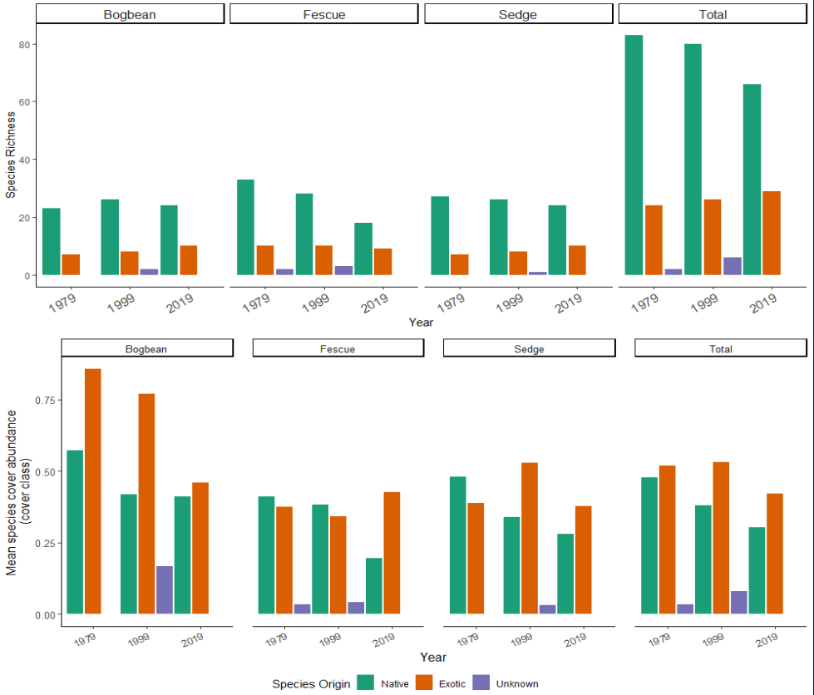

Figure . Top panel: Loss of native species richness over time across all assemblages is largely driven by loss of native species from the Fescue Assemblage. However, native species richness does not change substantially in the other two assemblages. Bottom panel: Native species cover is decreasing on average across all assemblages. Exotic species cover largely remains unchanged, although the ratio of native to exotic cover in Bogbean assemblage becomes more even by 2019. ‘Unknown’ species origin represents species identified only to genus, and assessment of native status cannot be made.

# Potential journals

## [Journal of Vegetation Science](https://onlinelibrary.wiley.com/page/journal/16541103/homepage/forauthors.html)

2020 IF 2.865 (Q1, Ecology/Plant Science)

\*\*Open access fee (J. Veg. Sci. and App. Veg. Sci.) = USD $3800

The Journal of Vegetation Science publishes articles on all aspects of plant community ecology and macroecology of vegetation, with particular emphasis on articles that develop new concepts or methods, test theory, **identify general patterns**, or that are otherwise likely to interest a broad international readership. An article may focus on any aspect of vegetation science, e.g. community structure (including community assembly and plant functional types), **biodiversity (including species richness and composition)**, spatial patterns (including plant geography and landscape ecology), **temporal changes (including demography, community dynamics** and palaeoecology) and processes (including ecophysiology), provided the focus is on increasing our understanding of plant communities. The journal does not publish articles on the ecology of a single species, except for studies framed in the community context, especially of species that play a key role in structuring plant communities (e.g. stand dominants). Articles that apply ecological concepts, theories and methods to the vegetation management, conservation and restoration, and articles on vegetation survey should be directed to our associate journal, [Applied Vegetation Science](https://onlinelibrary.wiley.com/page/journal/1654109x/homepage/forauthors.html).

## [Wetlands](https://www.springer.com/journal/13157/submission-guidelines" \l "Instructions%20for%20Authors_Article%20Types)

2020 SJR IF 2.369 (Q2, Ecology)

\*\* Open access fee = USD $3390, however there may be a discount from SpringerOpen/BMC affiliation

Original research: Articles reporting original research about wetlands, natural or constructed, including, but not limited to mechanisms underlying ecosystem processes, the values of wetlands to society, their management, **quality assessment** and restoration.

## [Marine & Freshwater Research](https://www.publish.csiro.au/mf/forauthors)

2020 SJR IF 2.034 (Q2, Aquatic Science)

Marine and Freshwater Research welcomes the submission of articles presenting original and significant research in the aquatic sciences (see [Scope](http://www.publish.csiro.au/nid/126/aid/429.htm)).

Articles that address broad conceptual questions, are interdisciplinary and of wide interest, and that consider further implications and management applications are especially encouraged, given the journal's broad scope. Specialist articles at the forefront of their field are also welcome as long as their context is clearly stated. **Descriptive articles may be considered if they are placed in an appropriate conceptual setting and have global relevance.** However, articles that are purely taxonomic, parochial, describe preliminary or incremental results, or simply present data without context will not be considered.

## [Plant Ecology](https://www.springer.com/journal/11258)

2020 SJR IF 1.914 (Q2, Ecology)

Plant Ecology publishes original scientific papers that report and interpret the findings of pure and applied research into the ecology of vascular plants in terrestrial and wetland ecosystems. Empirical, experimental, theoretical and review papers reporting on ecophysiology, population, community, ecosystem, landscape, molecular and historical ecology are within the scope of the journal.

* Note – Denoth & Myers (2007) was published in this journal; their dataset is included in this publication.

## [Canadian Journal of Botany](https://cdnsciencepub.com/journal/cjb/about)

2-year IF 1.323, no quartile ranking found

Published since 1929, this monthly journal features comprehensive research articles and notes in all segments of plant sciences, including cell and molecular biology, ecology, mycology and plant-microbe interactions, phycology, physiology and biochemistry, structure and development, genetics, genomics, systematics, and phytogeography….

* Note – Bradfield & Porter (1982) was published in this journal; their dataset is included in this publication.