Plant community changes over 40 years in a tidal freshwater marsh of the Fraser River Estuary, British Columbia

Stefanie L. Lane, John S. Richardson, Gary E. Bradfield | University of British Columbia

# Abstract

***Premise of study***: Identifying long-term habitat changes and their implications for habitat management is dependent on data availability. In the absence of long-term monitoring programs, repeated observation at historical study sites can provide insight to community compositional shifts.

***Methods:*** Three datasets collected over 40 years were used to assess shifts in community diversity in Ladner Marsh, a reference freshwater tidal marsh in the Fraser River Estuary near Vancouver, BC. Cluster analysis and non-metric multidimensional scaling illustrate changes in plant community assemblages.

***Results***: Plant composition has become homogenized within each of three community types, but with greater dissimilarity between community types. Sedge and fescue communities have greater proportion of invasive species, while invasive species cover in the bogbean-dominated community type has not changed significantly over 40 years.

***Discussion:*** Ladner Marsh has greater cover of invasive species, and greater partitioning between communities, which together may not achieve long-term conservation objectives. Identification of likely drivers of change such as sediment starvation or marsh platform subsidence in the context of sea level rise will be key to mitigating further shifts away from desired community structure.

**Keywords:** Habitat conservation; managed retreat; community resistance; juvenile salmon habitat; wildlife management area

# Introduction

Tidal marshes within estuaries experience hydrogeomorphic and plant community changes on annual, decadal, and millennial timescales (Chalifour et al., 2019; Pasternack, 2009). Their valuable functions of carbon cycling, shoreline protection, and aquatic habitat make their protection extremely important. Estuary conservation efforts are intended to protect coastal municipalities and provide sufficient habitat; however, tidal marshes must resist change to continuously provide these services. The opportunity to characterize plant community changes on decadal timescales contributes to observation of meaningful long-term patterns of community stability, and is instructive to form inferences about drivers of community stability or change over time. Management initiatives such as Canada’s Coastal Restoration Fund or British Columbia’s Salmon Restoration and Innovation Fund or Sea Level Rise Adaptation programs target successes on 50-100 year horizons, so understanding what leads to resistant or resilient communities within this timescale is of great importance to shoreline communities for immediate habitat conservation or floodwater protection initiatives.

A key abiotic driver of plant community resistance include sediment trapping (Marijnissen, et al., 2020). Sediment delivered by river transport is trapped by vegetation, creating a feedback loop of rising tidal marsh platforms, increased vegetation growth, and increased sediment trapping capacity (Corenblit et al., 2015; Peteet et al., 2018). Biotic resistance to invasion or species displacement within the plant community depends on the total richness within the site (Tilman, 1997). This is partially due to the resilience of plant life history strategies, such as community-dominant plants being comprised of perennial species that do not yield space for new species to encroach (Hopfensperger et al., 2009). If sediment transport is altered, tidal marsh platforms will not accrue elevation, and over time will experience more frequent and longer periods of inundation as the landform subsides, sea levels rise, or a combination of the two processes occur. This gradual change in elevation leads to altered habitat conditions for foundational plant communities, eventually shifting the botanic species composition that may be supporting specific fauna assemblages. Hindcasting processes such as sedimentation is difficult, however observing impacts on plant communities can offer a method to infer ecological processes and their impacts on habitats that have not been directly altered. One such opportunity is available in the Fraser River Estuary, where two historical studies (Bradfield & Porter, 1982; Denoth & Myers, 2007) were conducted to document floristic richness.

The Fraser River drains the largest catchment in British Columbia, and its estuary currently spans 2814 ha, one-third of which lies within the South Arm Marshes Wildlife Management Area (Schaefer, 2004) (Figure 1). Ladner Marsh occupies approximately 100 ha within the South Arm Marshes, bounded to the east by municipal development and by the Fraser River along its western edge (Figure 1C). While much of the marshland in the lower Fraser River Estuary was converted to log-sorting, fish cannery, agriculture, or dry docks, Ladner Marsh escaped these developments and is relatively undisturbed. Because of this, it is used by regional land managers as a benchmark reference for tidal marsh restoration. Because Ladner Marsh has not experienced direct impacts, it is an ideal ecological laboratory to monitor plant community stability over decadal timescales. Two studies conducted in Ladner Marsh documented floristic diversity over the past 40 years (Bradfield & Porter, 1982; Denoth & Myers, 2007), which provides the opportunity to repeat observations to characterize long-term plant community changes. The main objective of this study was to determine what changes in plant community composition have occurred over 40 years in Ladner Marsh (Bradfield & Porter, 1982). I specifically wanted to know whether (1) the dominant communities are still characterized by the same species, (2) the diversity increased or was reduced, and (3), if diversity has changed, are the plant communities more or less diverse than 40 years ago? If processes such as sedimentation rates and local plant recruitment are intact, then I expect assemblage total richness, relative abundance, and the species dominating characteristic communities should be highly similar across time. I also expect that measures of diversity, such as α-diversity (species density) and β-diversity will be the same, even if secondary richness has changed. Alternatively, if these processes have altered the habitat, then I expect these variables will be significantly changed. These observations can help generate or refine hypotheses about key mechanisms of community profile changes.

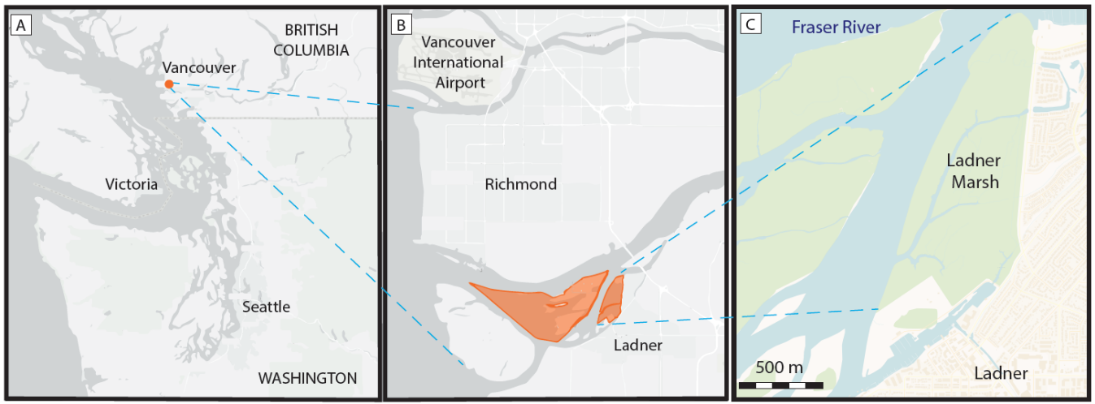

Figure 1. Vancouver, BC, Canada (A), located approximately 20 km north of the South Arm Marshes Wildlife Management Area (highlighted in orange, B). Ladner Marsh abuts municipal development on the south bank of the Fraser River (C). Basemaps generated by Conservation Lands dataset published by the [Ministry of Forests, Lands, Natural Resource Operations and Rural Development](https://catalogue.data.gov.bc.ca/organization/ministry-of-forests-lands-natural-resource-operations-and-rural-development) - [Wildlife and Habitat](https://catalogue.data.gov.bc.ca/organization/wildlife-and-habitat); source data from Tantalis and derived from GeoBC (A, B) and OpenStreetMap (C).

# Methods

## Vegetation surveys and site selection

### 1979 & 1999

Data were originally collected in 1979 as part of an observational study to characterize dominant community types (Bradfield & Porter, 1982). Cluster analysis and principal components analysis (PCA) distinguished three community associations, each dominated by a distinct species: Lyngbye’s sedge (*Carex lyngbyei* Hornem.), fescue (*Festuca arundinaceae* Schreb.), and bogbean (*Menyanthes trifoliata* L.). Eight transects were positioned along a north-to-south gradient, and 1 m2 quadrats (plots) were placed semi-systematically in the center of patches with distinct vegetation changes (Bradfield, 2019 personal comm.).

A subsequent survey conducted in 1999 recreated the transects and sought to place sampling plots at exact positions sampled in 1979 to test relationships between invasive purple loosestrife (*Lythrum salicaria*, L.) and Henderson’s checkermallow (*Sidalcea hendersonii* S. Watson), which is a Blue Listed species of special concern in British Columbia (Denoth & Myers, 2007). While Denoth & Myers did not seek to test changes in community composition, data were collected according to the same protocols as in 1979, and the data has generously been made available for comparison. This publication will reference dates the data were collected, rather than publication dates of the preceding studies.

### 2019

No permanent markers were left in Ladner Marsh, so precise transects assessed by Bradfield & Porter (1982) or Denoth & Myers (2007) were not identifiable in 2019. To approximate transect locations, the map from Figure 1 (Bradfield & Porter, 1982) was overlaid onto 2019 Google Earth Imagery (Google Earth Pro 7.3.2.5776, Imagery Dates November 9, 2002 and June 12, 2019). Dominant channel features shown in Figure 1 (Bradfield & Porter, 1982) were easily distinguished on Google Earth, and used as visual guides to place transect ends in 2019. GPS locations of transect beginnings and ends were georeferenced (NAD83) and transferred to Avenza 3.2 (72.23) for field wayfinding. Actual GPS locations of transect ends and assemblage area polygons were recorded in Avenza. Transects to be resampled were selected based on ecosystem similarity to published results. For example, Transect “Q” (n = 7 plots) was omitted in 1999 and 2019 due to inaccessibility and conversion to thick riparian forest with an understory of Himalayan blackberry (*Rubus armeniacus*) since 1979. An additional total of 18 plots were removed in 2019 due to issues accessing all plots, either due to overgrowth of riparian fringe, widening of tidal channels, or placement of transects resulting in shorter sampling distances. For example, the last 30 m of transect “W” (n = 4 plots, # 89-92 in Fig. 3, Bradfield & Porter (1982)) were truncated at its western edge due to inaccessibility into the often-submerged low marsh. In another instance, transect “U” was recorded as 60 m long in 1979 and 1999, but in 2019 the approximated transect was 44 m long, resulting in the exclusion of two historical sampling plots. Despite these decisions to exclude plots, Kopecký & Macek (2015) have demonstrated that uncertainty of plot location does not produce unreliable evidence of plant community changes on decadal timescales.

To test the hypothesis that dominant species would remain the same in local communities, I resampled vegetation in the same manner as the 1979 survey by semi-systematically placing 1 m2 quadrats in the center of patches where vegetation contained noticeably different species, or every 10 m of transect length, whichever distance was shorter. Assemblage types were considered if their boundary intersected the transect tape; assemblages tangential to the survey transect (but not intersecting it) were ignored. Assemblages were defined as being dominated >50% by one or two species. If no species was clearly dominant, the area was characterized as “undefined.” To keep survey methods consistent with the 1979 survey, 1 m2 quadrats were placed at the center of the assemblage region (Figure 2). No areas of assemblage types were so small that the 1 m2 quadrat was less than 1 m from the boundary of the next assemblage. Along transects where the same assemblage reached > 20 m, quadrats were sampled every 10 m to reproduce a modal distance of 10 m (Bradfield & Porter, 1982).

Individuals were defined as “in the plot” if >50% of their most basal stem originated within the plot boundary; overhanging stems were not considered. Aerial coverage was considered as percent of the quadrat occluded by foliage; rambling lianas (*Lathyrus palustris* L.) were visually estimated as groundcover (even if climbing vertically). Percent cover of the quadrat was estimated to the nearest 1/64th m2, and later binned into quartile categories (< 25%, 25-50%, 50-75%, and > 75%).

Elevation for the center of each plot sampled was determined by traditional methods using a surveyor’s level (LineSite AL28 Auto Level, Trinitec Distribution, Inc., Burnaby, BC, Canada), and referencing plot elevations to the nearest Survey Canada Geodetic Control Marker (GCM 737197, Tablet Marking 84H0431, CVD28 Datum). Each plot’s distance from a channel edge of at least 0.3 m width was calculated in a desktop exercise using 2019 Google Earth Imagery (Google Earth Pro 7.3.2.5776, Imagery Dates November 9, 2002 and June 12, 2019).

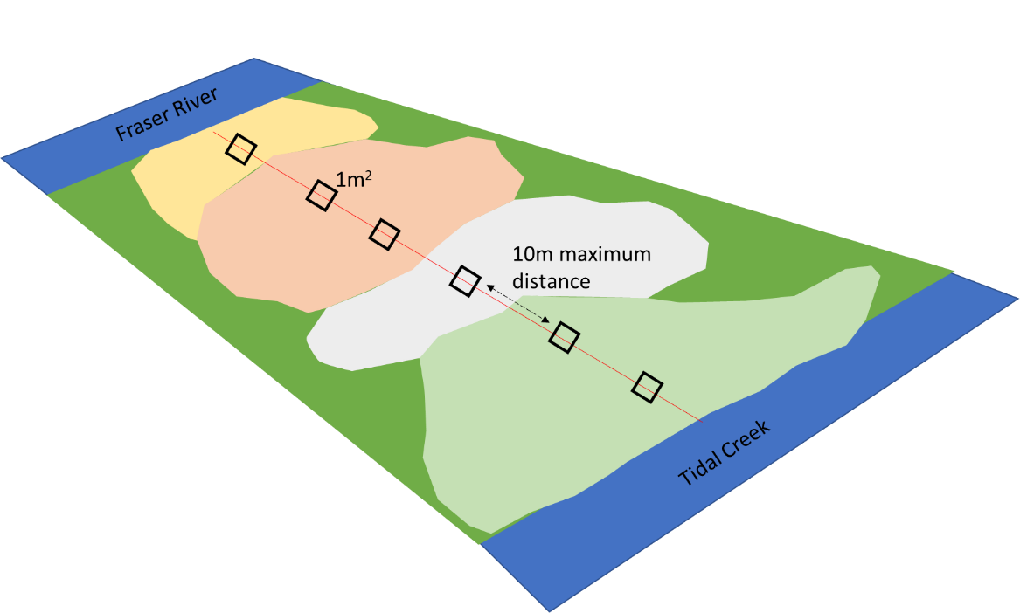

Figure 2. Sampling schematic along sample transect of unique community types, represented by irregular polygons. Sampling plots of 1 m2 were placed at the center of the unique community polygon, or every 10 m of transect length, whichever was less. Illustration not to scale.

### Taxonomy

Observation of vascular plant species was conducted in all sampling years during early summer (approx. June-July). In all datasets, most plants were identified to species according to Hitchcock & Cronquist (1973), although a few were identified at higher taxonomic levels due to insufficient identifying characteristics (n = 6 to genus, n = 2 to Family; see Appendix 1). To account for changes in nomenclature revision over time, all datasets were harmonized to use the most recently accepted species name as reported in the PLANTS Database of the United States Department of Agriculture, Natural Resources Conservation Science [USDA NRCS (Appendix 1)]. In the instance of *Agrostis* species, the judgement to assume *Agrostis alba* identified in 1979 and 1999 is the same as *Agrostis stolonifera* in 2019 was made based on the likelihood that the presence of a species would not be replaced by another with similar abundance.

## Statistical analyses

All statistical analyses were performed in R v.4.0.2. To determine dominant community types, cluster analysis was performed for each observation year using Euclidean distance as the measure of plot dissimilarity (function *hclust*, package ‘stats’). Dendrograms for each year were cut into three groups, and all plots within a cluster group were subjected to a species indicator analysis to determine the dominant species driving clusters (function *multipatt*, package ‘indicspecies’). Nonmetric multidimensional scaling (NMDS) was used to demonstrate shifts in community associations over time using the Bray-Curtis distance (function *metaMDS*, package ‘vegan’).

Diversity components were calculated for each community group for all years. Alpha diversity (species density) was calculated as average number of taxa per m2, and beta diversity was calculated as the total number of species per community type divided by species density (Whittaker & Gauch, 1978). Relative abundance of select invasive species was calculated as a proportion of average plot cover. Permutational analysis of multivariate dispersion (PERMDISP) tested whether community groups were homogeneously dispersed (function *betadisper*, package ‘vegan’). Significant differences in changes between years were assessed by permutational analysis of variance (PERMANOVA, with Bray–Curtis distances) using 999 permutations (function *adonis*, package ‘vegan’). PERMANOVA was chosen over analysis of similarity (ANOSIM) due to lower sensitivities to unbalanced sampling sizes within each community group (Anderson & Walsh, 2013).

# Results

## Diversity components, PERMDISP, and PERMANOVA

The total number of taxa recorded declined in each subsequent year of observation after 1979. Trends within each major community type vary, with bogbean-dominated communities appearing the most stable and sedge-dominated community showing greater trends of instability. The total number of bogbean plots encountered in 2019 along the same lengths of transect increased by almost 50% over previous years, while number of fescue plots decreased by ~40% (Table 1). In the fescue community type, α-diversity (species density) decreased by ~25% per observation year, resulting in nearly half the α-diversity lost between 1979 and 2019. Of note is that Lyngbye’s sedge communities had the fewest plots recorded in 2019, but a comparable number of species observed as in previous years. The total number of species observed in 2019 fescue plots was approximately 60% of what was observed in prior years, however some of this could be related to a proportionally reduced number of plot observations as well. Beta diversity was comparable 1999-2019.

Tests of dispersion assume equal variance in composition, however the rate of rejection in PERMANOVA is less than 2% when the greater amount of dispersion is in the larger group sampled (Anderson & Walsh, 2013). Because there was greatest dispersion in the larger group (1979, Table 1), analysis with PERMANOVA was conducted despite unequal variance for the Lyngbye’s sedge community group. In all groups, PERMANOVA results were significant, indicating that while fescue and bogbean groups had the same compositional variance, species composition had significantly changed. For Lyngbye’s sedge, this similarly suggests that species composition has likely changed significantly, in addition to significant compositional variance.

Permutational analysis of multivariate dispersion (PERMDISP) showed significant changes in community β-diversity in the bogbean community, but not the sedge and fescue communities (Table 1). However, permutational analysis of variance (PERMANOVA) indicate community composition changed significantly in in all community types (Table 1), which are especially visible in the 2019 community samples in the NMDS plot (Figure 4). The magnitude of compositional shifts (R2) range from 10% in the fescue community to 25% in the bogbean community (Table 1).

## Cluster analysis, indicator species, and NMDS

Community groups were identified by applying indicator species analysis to the three main clusters generated by cluster analysis. Although associated species within each cluster change over time, the species common to each cluster in each year are Lyngbye’s sedge, fescue, and bogbean (Table 2), which reflect the major groups identified in Bradfield & Porter (1982). Overall, comparison of dendrograms across time show a trend of increasing dissimilarity between major community groups, and increasing similarity within major community groups (Figure 3). Bogbean and fescue groups clustered with greater similarity in 1979 and 1999, while in 2019 fescue and Lyngbye’s sedge were more closely clustered (Figure 3). These shifts in association are likely due to which plots were kept from the 1979 and 1999 datasets, and may be more indicative of relationships to environmental gradients.

Differences in community composition between years were represented by a two-dimensional NMDS ordination (stress = 0.232). Communities in 1979 occupied the majority of the ordination space, while those in 2019 occupied the least (Figure 4), reflecting reduced variation of community types assessed by cluster analysis. Environmental data were not available for 1979 or 1999 observations, however elevation above mean sea level (MSL) and distance from nearest tidal creek channel edge were assessed as potential explanatory variables for observations made in 2019. Elevation above MSL was nearly orthogonal to distance from channel edge, indicating no strong relationship, in contrast to the conclusions made in the original analysis (Bradfield & Porter, 1982). However, the fescue community type was most strongly associated with elevation, while the bogbean communities were most strongly associated with greater distance from channel edges. (Figure 5) Invasive species comprise relatively equal proportions in the bogbean community types across all years, however invasive species cover in fescue community plots more than doubled between 1979 and 2019 observation years (Figure 6).

Table 1. Plot-level temporal changes including α-diversity, temporal differences in β-diversity (PERMDISP), and temporal differences in community composition (PERMANOVA)

|  |  |  |  |  |  |  |  |  |  |  |  |  |
| --- | --- | --- | --- | --- | --- | --- | --- | --- | --- | --- | --- | --- |
|  | Plot-level components | |  | Diversity components | |  | PERMDISP | |  | Community composition (PERMANOVA) | | |
| Community Group | **No. quadrats** | **Total no. species** |  | **α diversity** | **β diversity** |  | **F** | **Pr(<F)** |  | **R2** | **F** | **Pr(<F)** |
| Lyngbye's sedge |  |  |  |  |  |  |  |  |  |  |  |  |
| **1979** | 34 | 34 |  | 8.7 | 3.9 |  | 3.44 | 0.044 |  | 0.15 | 15.2 | < 0.001 |
| **1999** | 31 | 35 |  | 8.3 | 4.2 |  |  |
| **2019** | 25 | 34 |  | 8 | 4.2 |  |  |
|  |  |  |  |  |  |  |  |  |  |  |  |  |
| Fescue |  |  |  |  |  |  |  |  |  |  |  |  |
| **1979** | 29 | 47 |  | 12.8 | 3.7 |  | 1.29 | 0.297 |  | 0.09 | 7.42 | < 0.001 |
| **1999** | 33 | 41 |  | 9.7 | 4.2 |  |  |
| **2019** | 14 | 26 |  | 6.6 | 3.9 |  |  |
|  |  |  |  |  |  |  |  |  |  |  |  |  |
| Bogbean |  |  |  |  |  |  |  |  |  |  |  |  |
| **1979** | 19 | 32 |  | 12.8 | 2.5 |  | 2.61 | 0.094 |  | 0.25 | 20.72 | < 0.001 |
| **1999** | 18 | 36 |  | 11.5 | 3.1 |  |  |
| **2019** | 28 | 34 |  | 10.5 | 3.2 |  |  |

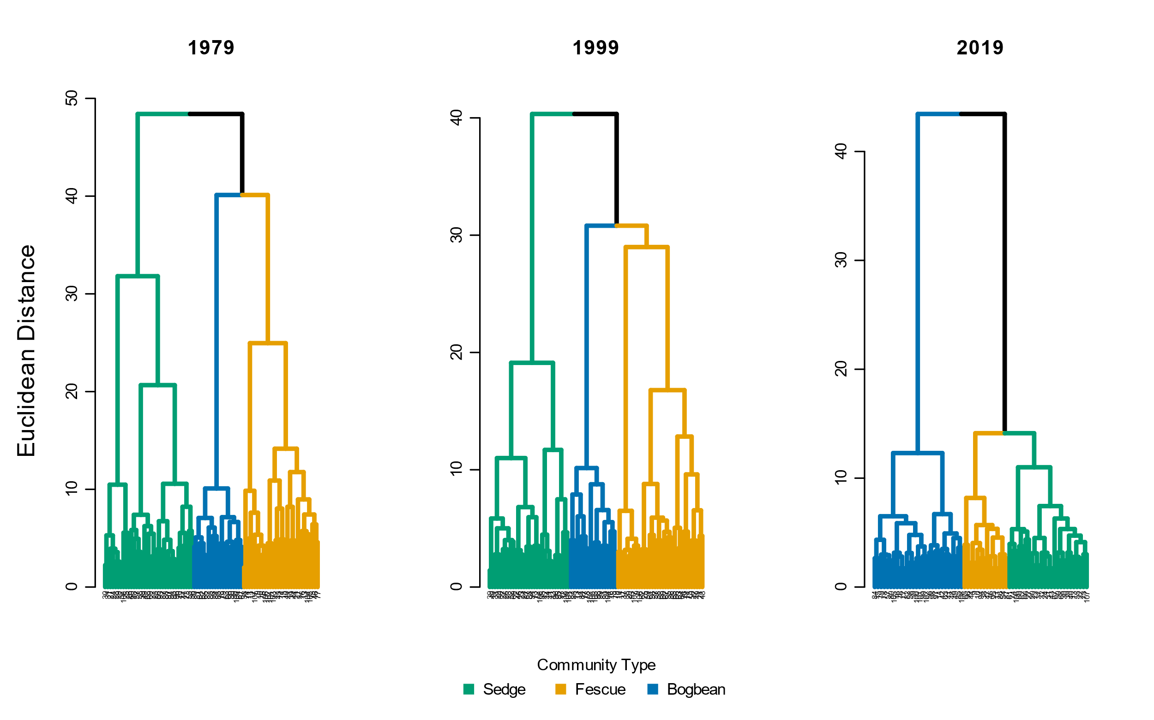

Figure 3. Cluster analysis of vegetation cover data along comparable lengths of transects (n = 7) observed in 1979, 1999, and 2019. Dendrograms cut into three groups (k = 3). Each cluster group subjected to indicator species analysis to determine driving species associations within each cluster. Common species to each cluster includes Lyngbye’s sedge (Carex lyngbyei, green), bogbean (Menyanthes trifoliata, blue), and Fescue (Festuca arundinaceae, orange). Labels of dendrogram leaves are the unique plot number sampled (n1979 = 82, n1999 = 82, n2019 = 67)

Table 2. Indicator species analysis of clusters for each year of observation data. 'Cluster Group Name' is the common name of the species found across all years with the most significant indicator value (IndVal).

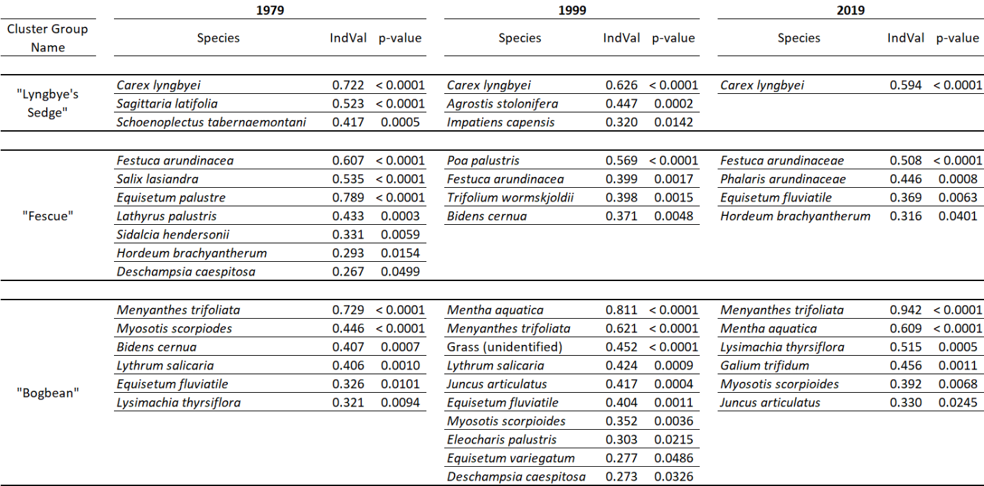

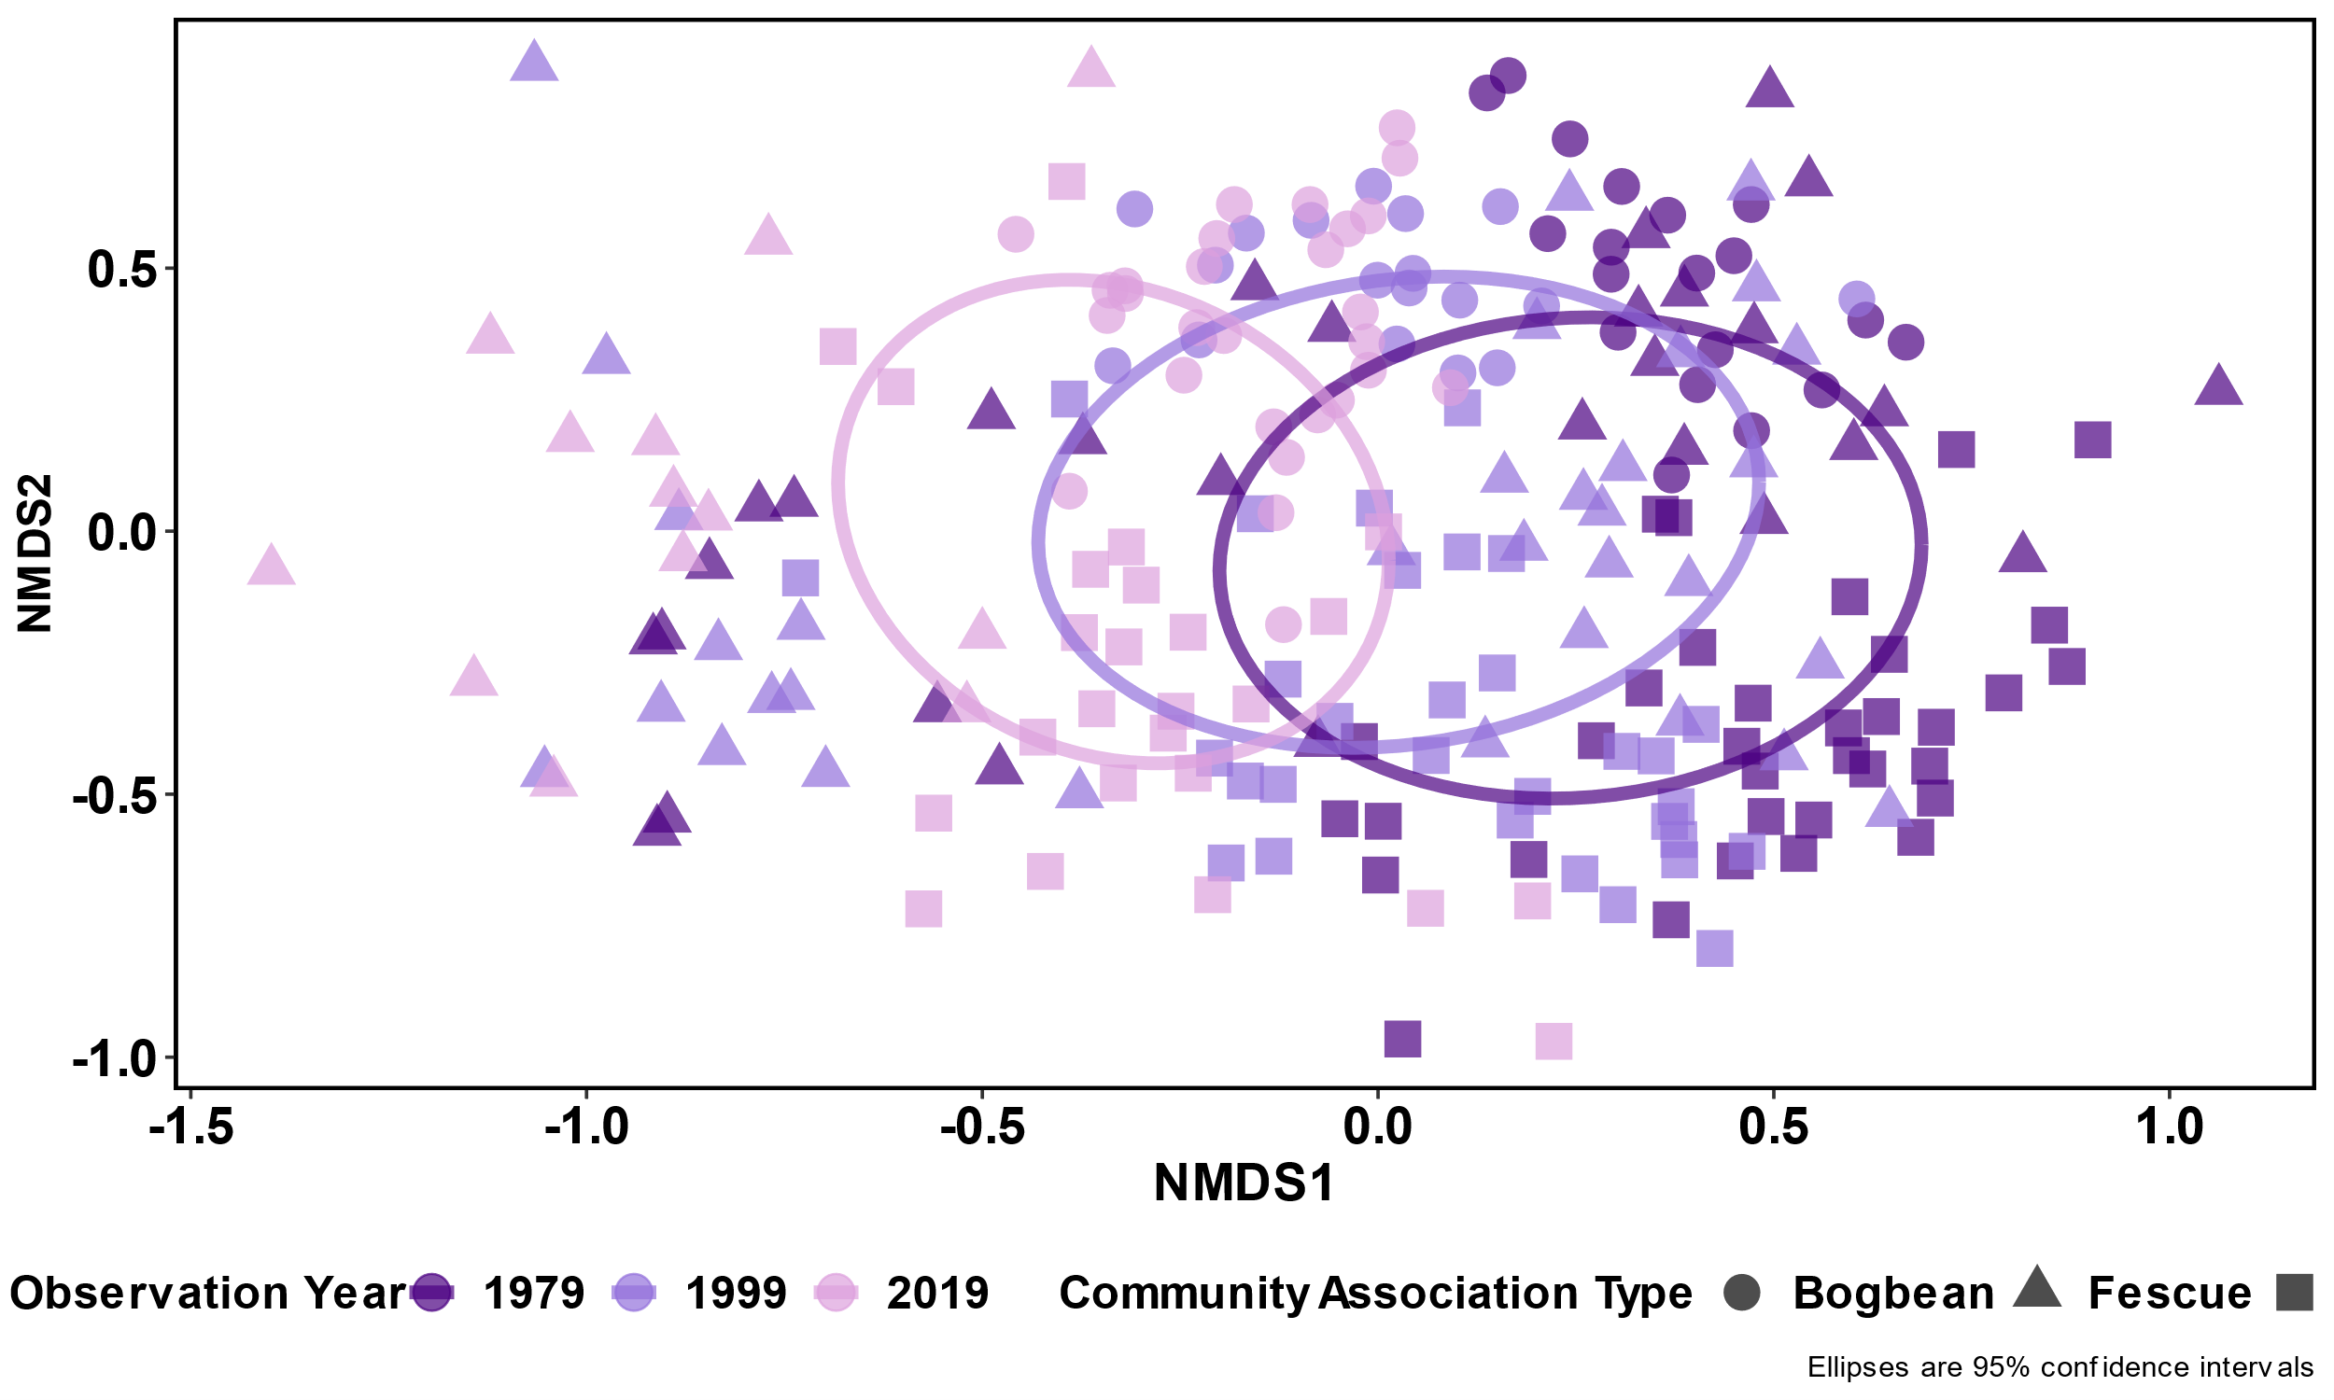

Figure 4. NMDS shows drift in composition within each of the community types, and across time overall (stress = 0.232 with two outliers from 2019 removed). Overall, 2019 communities appear more closely related along NMDS Axis 1 than 1979 and 1999 communities. Analysis of Similarity (ANOSIM) across all years shows statistically significant differences (R = 0.20, a < 1e-04); PERMANOVA similarly shows significant differences between all years (F = 22.25, r2 = 0.089, p < 0.001).

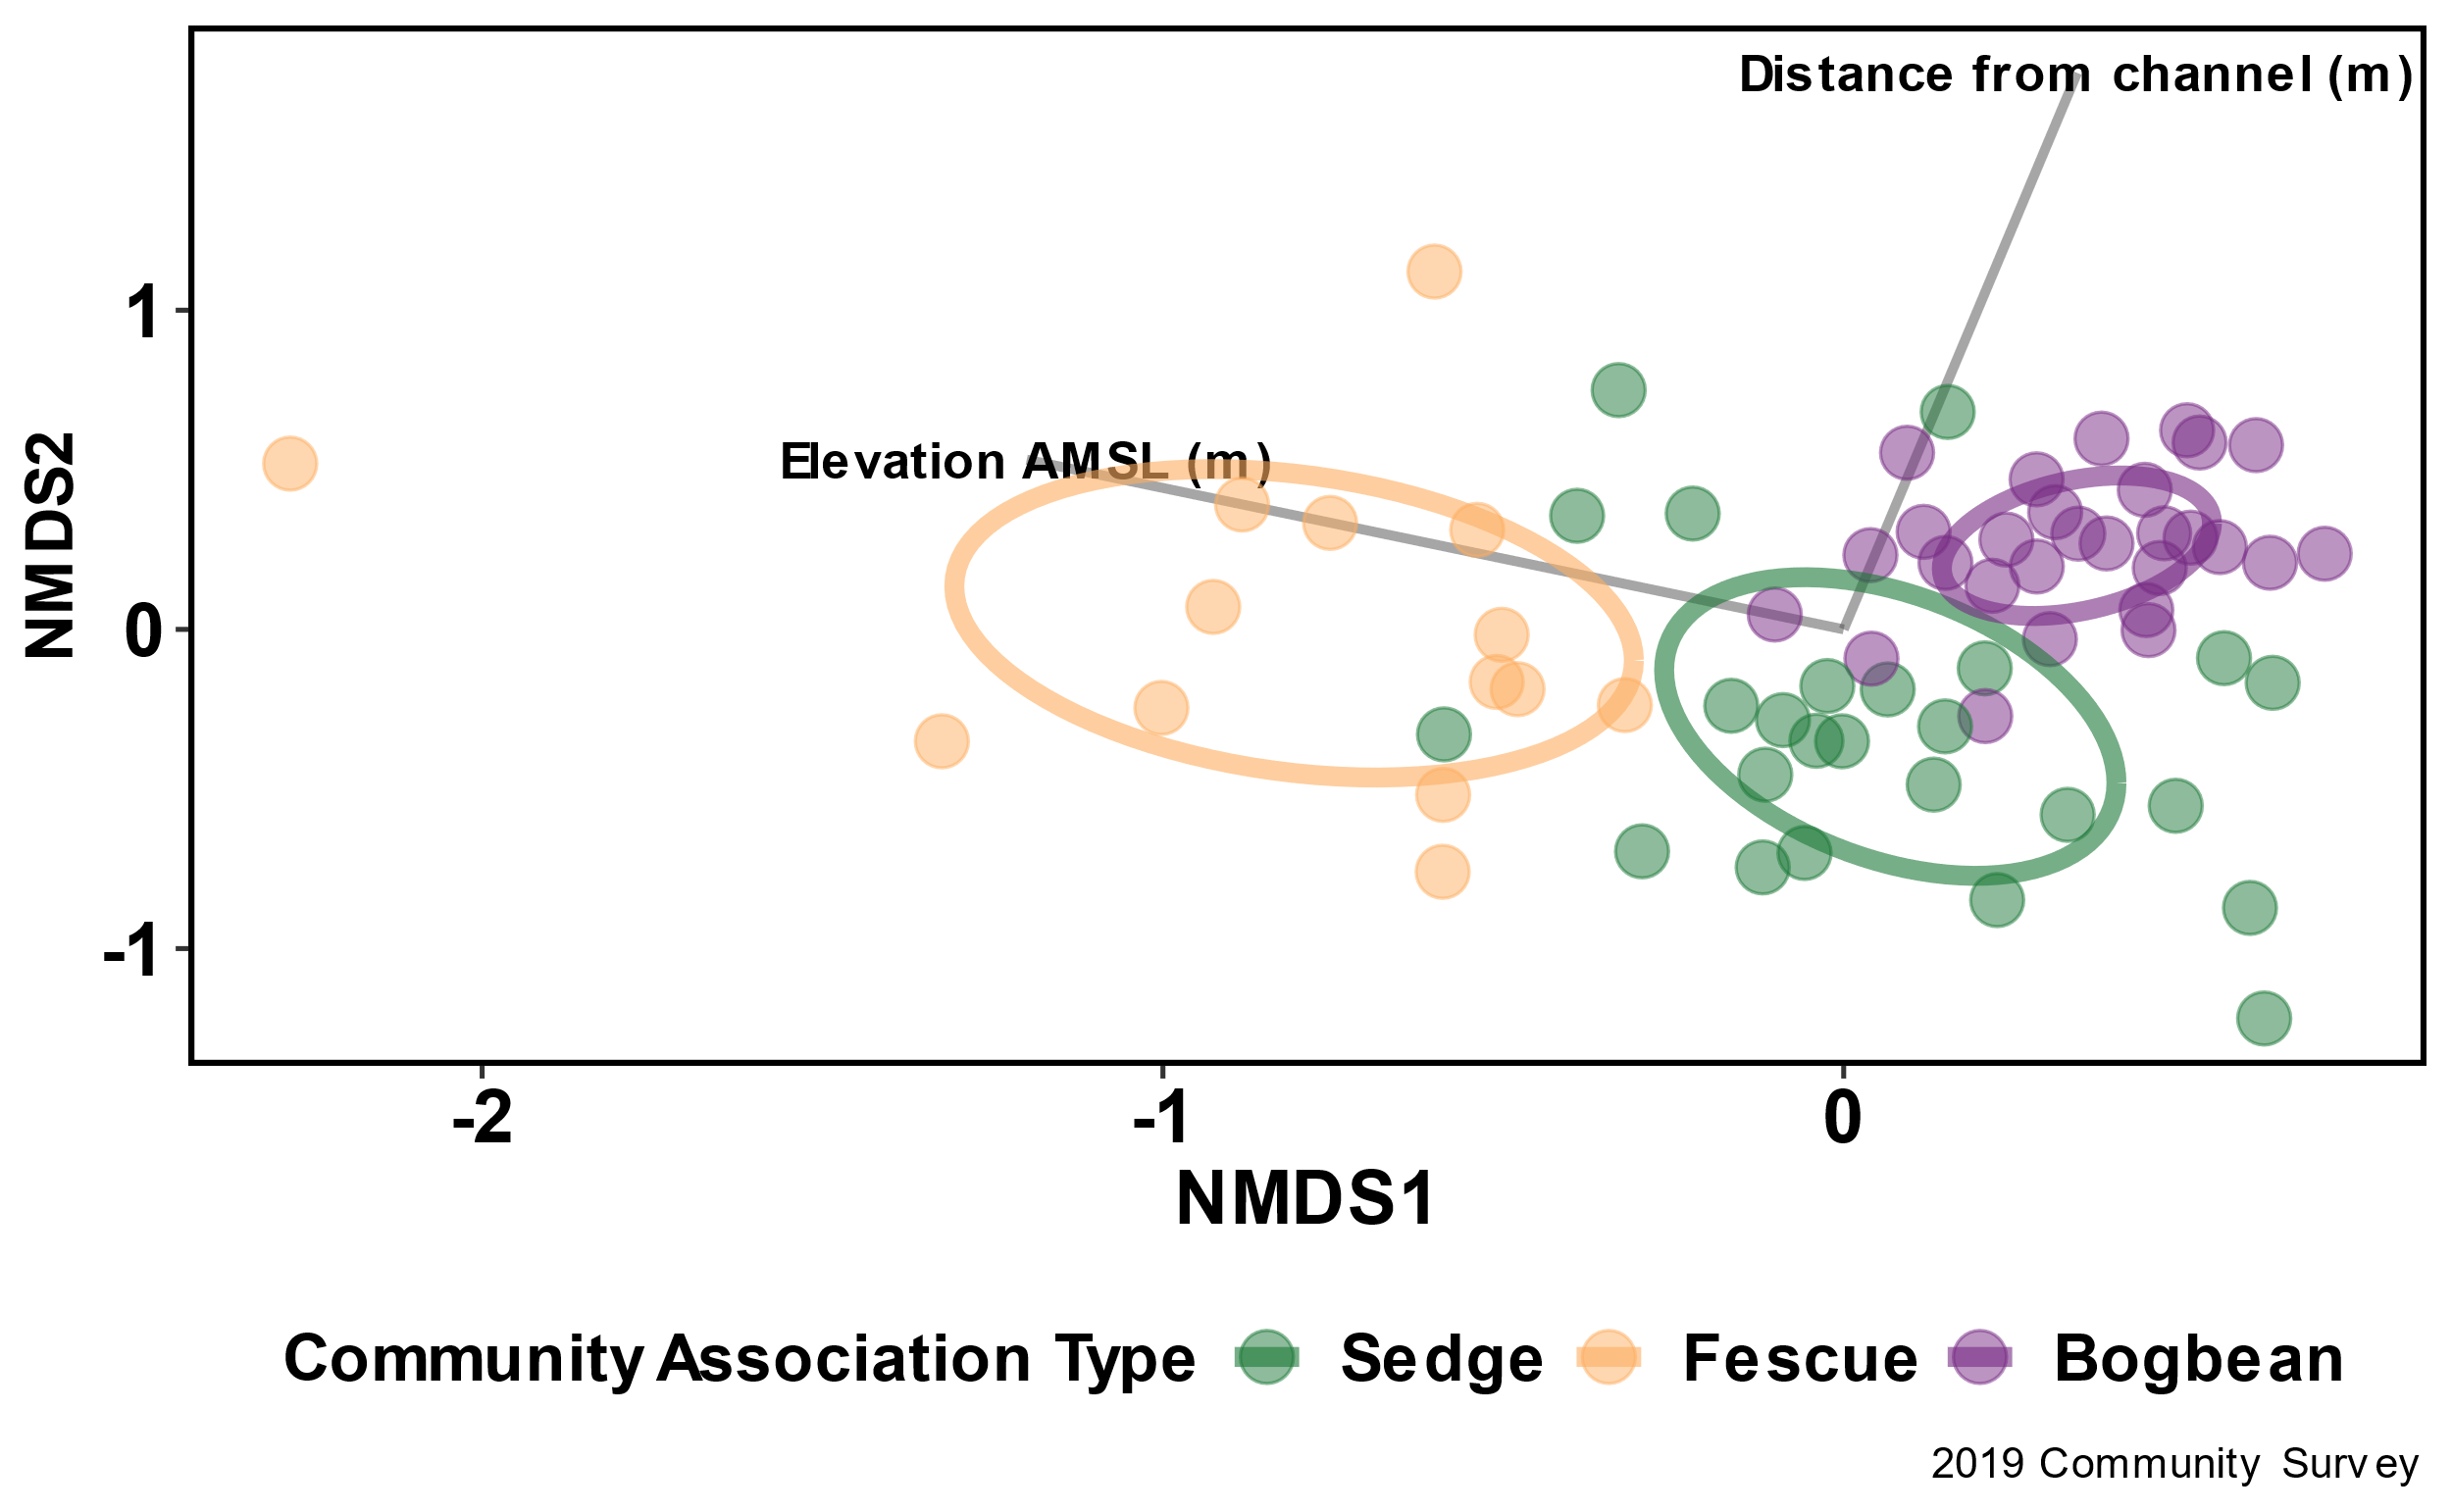

Figure . NMDS with potential environmental explanatory variables for community observation data collected in 2019.

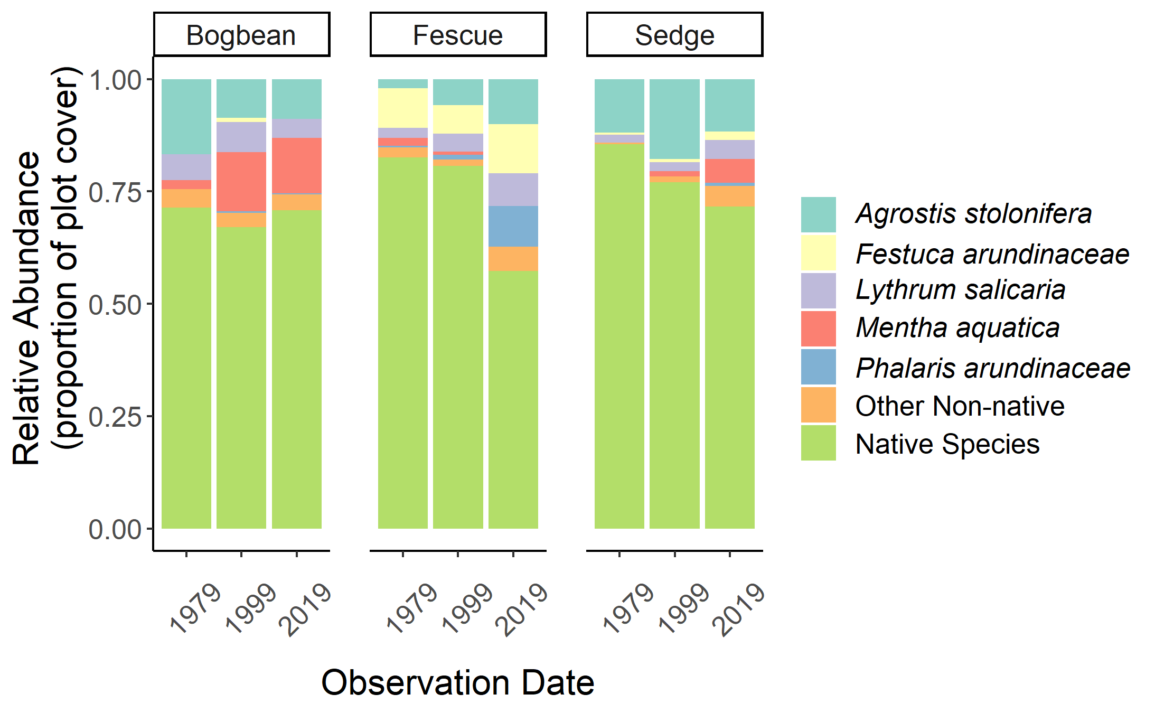

Figure . Relative abundance of select non-native species. Species selected are community dominant, or of management concern.

# Discussion

The main objective of this study was to determine whether the dominant communities characterized 40 years ago were the same, and whether species diversity has increased or decreased in that time. Hierarchical clustering and indicator species analysis shows the same species dominate three major community types, but that compositional species diversity within these communities have changed significantly. A key concern is that α-diversity is decreasing in all community types sampled, and that each community type is becoming more homogenous. An additional concern is the abundance of non-native species encroaching, especially into the Fescue community type.

The fescue community experienced the greatest reduction in α-diversity in fescue type, although this could be in part due to the reduced number of plots observed of this community type (Scheiner, 2003). Many plots discarded from earlier studies were closer to channel edges, which should have made fescue plots less common in the 1979 and 1999 datasets. Additionally, NMDS of environmental gradients showed the fescue community was not strongly associated with distance from channel edge, and also has the greatest proportion of non-native species per plot in 2019. Bradfield & Porter (1982) suggested fescue preferred the slightly higher and dryer conditions along channel edges – this may indicate the fescue community group has been a pathway for invasive species to get established within the marsh, and that the community type is no longer restricted to channel edges.

In concert with this trend is the increased number of bogbean plots, which also had the least reduction in α-diversity. Because bogbean and associated species can withstand more saturated conditions, this seems to indicate that bogbean community type is expanding and the most stable within Ladner Marsh. This could indicate the marsh platform is slowly subsiding or experiencing greater saturation due to sea level rise. The Lyngbye’s sedge community had somewhat fewer plots, but a similar number of species recorded in previous years. However, species density has decreased and there is an increasing abundance of *Mentha aquatica*, which prefers highly saturated soil conditions. These trends may indicate that individuals within the community are not tolerating saturated conditions, and/or that replacement through recruitment is not successful. This may be driven by a gradual change in saturation due to sediment starvation or rising sea level, which has risen at least 6 cm since 1993 (NOAA).

Reduced dissimilarity within community groups over time (Euclidean distances, Figure 3) indicates increasing homogeneity of species associations, despite overall species diversity. However, increased dissimilarity between community groups over time points to stronger environmental gradients excluding species associations with multiple community types. Together, these trends point to biotic homogenization within environmentally-driven community groups, which in turn may lead to loss of functional redundancy or resilience.

## Proposed mechanisms

Despite escaping direct anthropogenic manipulations, Ladner Marsh and adjacent estuary habitats are likely affected by regional urbanization. The Fraser River delivers nutrient-rich sediment from the extent of the watershed, and through annual spring floods and monthly high tide events sediment would have been washed over a landscape that is now dominated by impervious cover to support the infrastructure of the cities of Richmond, Ladner, Delta, and other municipalities further upstream. The construction of the George Massey Tunnel (formerly Deas Island Tunnel) in 1957 created an artificial barrier in the riverbed that has altered sediment flow, while the dredging of the channel for commercial transport removes sediment from the lower reaches of the channel. This long-term, systemic reduction of sediment inhibits tidal marsh platform accrual, which in turn alters the abiotic niche requirements of the plant species structuring the tidal marsh habitat. Empirical tests of these relationships would be difficult, in part due to the long-term observation required to test community stability. However, pilot studies of adding dredge spoils to test sites within subsiding marshes may be an effective way to test increases in α-diversity and species associations within a relatively short timeframe of 2-5 years.

## Applications

The combination of a rising water table, longer tidal inundation periods within the marsh, and sedimentation rates that do not allow for marsh platforms to accrue elevation sufficient to offset tidal inundation may be driving in compositional shift that is reducing graminoid-dominated habitat in favor of a forb-dominated community that tolerates waterlogged conditions. As community resistance to environmental change decreases, invasive species encroachment further shifts functional community types and alters baseline reference conditions.

Ladner Marsh and similar habitats in the South Arm Marshes WMA are protected for their ability to support juvenile salmon populations, which depend on Lyngbye’s sedge for cover and the detritus food webs (Maier & Simenstad, 2009) that support their maturation. If the trends observed in 2019 continue, it is likely that bogbean-dominated communities will continue to expand, and communities of Lyngbye’s sedge will become more sparsely populated. The different community contributions to food web and cover quality during seasonal migration should be investigated further. This will offer habitat managers guidance on whether management action should be taken to create Lyngbye’s sedge habitat, mitigate landform subsidence, or if different community types such as those dominated by bogbean would be sufficient to successfully support juvenile salmon populations.

Management initiatives such as Canada’s Coastal Restoration Fund or British Columbia’s Salmon Restoration and Innovation Fund or Sea Level Rise Adaptation programs target successes on 50-100 year horizons, so understanding what leads to stable communities within this timescale is of great importance to agency managers wanting to maintain or create shoreline communities for immediate habitat conservation or floodwater protection initiatives. Additionally, land managers operating under these programs should be aware that reference locations such as Ladner Marsh may be in the process of changing to a condition that does not optimally support program benchmarks for success. Understanding how far the threshold of ‘reference’ has shifted is of great importance for setting restoration objectives for targets to maintain consistent success over program timelines.

# Acknowledgements

The author would like to thank G. Bradfield, G. Porter, M. Denoth, and J. Myers for sharing existing datasets; Z. Davis for providing R programming advice; P. Roper for field assistance; B. Staines (Ladner Harbour Authority) for providing watercraft use. Support was provided by Natural Sciences and Engineering Research Council of Canada Discovery Grant RGPIN-2018-03838 under J. Richardson, and research access was granted by The Ministry of Forests, Lands, Natural Resource Operations and Rural Development. Comments from ____ anonymous reviewers greatly improved this manuscript.

# Literature Cited

Anderson, M. J., & Walsh, D. C. I. (2013). PERMANOVA, ANOSIM, and the Mantel test in the face of heterogeneous dispersions: What null hypothesis are you testing? *Ecological Monographs*, *83*(4), 557–574. https://doi.org/10.1890/12-2010.1

Bradfield, G. E., & Porter, G. L. (1982). Vegetation structure and diversity components of a Fraser estuary tidal marsh. *Canadian Journal of Botany*, *60*(4), 440–451. https://doi.org/10.1139/b82-060

Chalifour, L., Scott, D. C., MacDuffee, M., Iacarella, J. C., Martin, T. G., & Baum, J. K. (2019). Habitat use by juvenile salmon, other migratory fish, and resident fish species underscores the importance of estuarine habitat mosaics. *Marine Ecology Progress Series*, *625*, 145–162. https://doi.org/10.3354/meps13064

Corenblit, D., Baas, A., Balke, T., Bouma, T., Fromard, F., Garófano‐Gómez, V., González, E., Gurnell, A. M., Hortobágyi, B., Julien, F., Kim, D., Lambs, L., Stallins, J. A., Steiger, J., Tabacchi, E., & Walcker, R. (2015). Engineer pioneer plants respond to and affect geomorphic constraints similarly along water–terrestrial interfaces world-wide. *Global Ecology and Biogeography*, *24*(12), 1363–1376. https://doi.org/10.1111/geb.12373

Denoth, M., & Myers, J. H. (2007). Competition between Lythrum salicaria and a rare species: Combining evidence from experiments and long-term monitoring. *Plant Ecology*, *191*(2), 153–161. https://doi.org/10.1007/s11258-006-9232-2

HItchcock, C. L., & Cronquist, A. (1973). *Flora of the Pacific Northwest, an illustrated manual*. University of Washington Press.

Hopfensperger, K. N., Engelhardt, K. a. M., & Lookingbill, T. R. (2009). Vegetation and seed bank dynamics in a tidal freshwater marsh. *Journal of Vegetation Science*, *20*(4), 767–778. https://doi.org/10.1111/j.1654-1103.2009.01083.x

Kopecký, M., & Macek, M. (2015). Vegetation resurvey is robust to plot location uncertainty. *Diversity and Distributions*, *21*(3), 322–330. https://doi.org/10.1111/ddi.12299

Maier, G. O., & Simenstad, C. A. (2009). The Role of Marsh-Derived Macrodetritus to the Food Webs of Juvenile Chinook Salmon in a Large Altered Estuary. *Estuaries and Coasts*, *32*(5), 984–998. https://doi.org/10.1007/s12237-009-9197-1

Marijnissen, R., Kok, M., Kroeze, C., & van Loon-Steensma, J. (2020). The Sensitivity of a Dike-Marsh System to Sea-Level Rise—A Model-Based Exploration. *Journal of Marine Science and Engineering*, *8*(1), 42. https://doi.org/10.3390/jmse8010042

Pasternack, G. B. (2009). Chapter 3. Hydrogeomorphology and sedimentation in tidal freshwater wetlands. In A. Barendregt, D. F. Whigham, & A. H. Baldwin (Eds.), *Tidal Freshwater Wetlands* (pp. 31–40). Backhuys Publishers.

Peteet, D. M., Nichols, J., Kenna, T., Chang, C., Browne, J., Reza, M., Kovari, S., Liberman, L., & Stern-Protz, S. (2018). Sediment starvation destroys New York City marshes’ resistance to sea level rise. *Proceedings of the National Academy of Sciences*, *115*(41), 10281–10286. https://doi.org/10.1073/pnas.1715392115

Schaefer, V. (2004). Ecological setting of the Fraser River delta and its urban estuary. In B. J. Groulx, D. C. Mosher, J. L. Luternauer, & D. E. Bilderback (Eds.), *Fraser River Delta, British Columbia: Issues of an Urban Estuary* (pp. 147–172). Geological Survey of Canada, Bulletin 547.

Scheiner, S. M. (2003). Six Types of Species-Area Curves. *Global Ecology and Biogeography*, *12*(6), 441–447. JSTOR.

Tilman, D. (1997). Community Invasibility, Recruitment Limitation, and Grassland Biodiversity. *Ecology*, *78*(1), 81–92. https://doi.org/10.1890/0012-9658(1997)078[0081:CIRLAG]2.0.CO;2

Whittaker, R. H., & Gauch, H. G. (1978). Evaluation of Ordination Techniques. In R. H. Whittaker (Ed.), *Ordination of Plant Communities* (pp. 277–336). Springer Netherlands. https://doi.org/10.1007/978-94-009-7989-5_10

# Appendix 1

Table 3. Species described in each observational dataset.

|  |  |  |  |  |
| --- | --- | --- | --- | --- |
| **1979** | **1999** | **2019** | **NRCS Symbol** | **Reported Synonym?** |
| *Agrostis alba* | *Agrostis alba* | *Agrostis stolonifera* | AGST2 | Y |
| *Alisma plantago aquatica* | *Alisma plantago aquatica* |  | ALPL |  |
| *Alopecurus geniculatus* |  |  | ALGE2 |  |
|  | Compositae misc |  | Asteraceae_misc |  |
| *Aster eatonii* | *Aster eatonii* |  | SYEA2 |  |
| *Bidens cernua* | *Bidens cernua* | *Bidens cernua* | BICE |  |
| *Caltha palustris* | *Caltha palustris* | *Caltha palustris* | CAPAP6 |  |
|  | *Carex*_sp1 |  | Carex_sp1 |  |
|  | *Carex*_sp2 |  | Carex_sp2 |  |
| *Carex lyngbei* | *Carex lyngbei* | *Carex lyngbei* | CALY3 |  |
| *Cirsium arvense* | *Cirsium arvense* | *Cirsium arvense* | CIAR4 |  |
| *Deschampsia caespitosa* | *Deschampsia caespitosa* |  | DECE |  |
| *Dulichium arundinaceum* |  |  | DUAR3 |  |
| *Eleocharis palustris* | *Eleocharis palustris* | *Eleocharis palustris* | ELPA3 |  |
|  |  | *Equisetum arvense* | EQAR |  |
| *Equisetum fluviatile* | *Equisetum fluviatile* | *Equisetum fluviatile* | EQFL |  |
| *Equisetum palustre* | *Equisetum palustre* |  | EQPA |  |
| *Equisetum variegatum* | *Equisetum variegatum* |  | EQVA |  |
| *Festuca arundinacea* | *Festuca arundinacea* | *Festuca arundinacea* | FEAR3 |  |
| *Festuca* sp. |  |  | Festuca_sp. |  |
|  |  | *Galium palustre* | GAPA3 |  |
| *Galium cymosum* |  | *Galium trifidum* | GATR3 | Y |
|  | *Galium sp.* |  | Galium_sp. |  |
| *Hordeum brachyantherum* |  | *Hordeum brachyantherum* | HOBR2 |  |
| *Hypericum formosum* | *Hypericum formosum* |  | HYFO7 |  |
|  |  | *Hypericum scouleri* | HYSC5 |  |
| *Impatiens capensis* | *Impatiens capensis* | *Impatiens capensis* | IMCA |  |
|  | *Iris pseudocorus* | *Iris pseudocorus* | IRPS |  |
|  |  | *Juncus acuminatus* | JUAC |  |
| *Juncus articulatus* | *Juncus articulatus* | *Juncus articulatus* | JUAR |  |
| *Juncus effusus* |  | *Juncus effusus* | JUEF |  |
| *Juncus oxymeris* | *Juncus oxymeris* | *Juncus oxymeris* | JUOX |  |
| *Lathyrus palustris* | *Lathyrus palustris* | *Lathyrus palustris* | LAPA4 |  |
| *Leersia oryzoides* | *Leersia oryzoides* |  | LEOR |  |
| *Lilaea scilloides* |  |  | LISC4 |  |
| *Lilaeopsis occidentalis* | *Lilaeopsis occidentalis* |  | LIOC |  |
|  |  | *Lycopus* sp. | Lycopus_sp |  |
|  | *Lysichiton americanum* | *Lysichiton americanum* | LYAM3 |  |
| *Lysimachia thyrsiflora* | *Lysimachia thyrsiflora* | *Lysimachia thyrsiflora* | LYTH2 |  |
| *Lythrum salicaria* | *Lythrum salicaria* | *Lythrum salicaria* | LYSA2 |  |
| *Mentha citrata* | *Mentha citrata* | *Mentha aquatica* | MEAQ | Y |
| *Mentha arvensis* | *Mentha arvensis* | *Mentha arvensis* | MEAR4 |  |
| *Menyanthes trifoliata* | *Menyanthes trifoliata* | *Menyanthes trifoliata* | METR3 |  |
| *Mimulus guttatus* |  |  | MIGU |  |
|  |  | *Myrica gale* | MYGA |  |
| *Myosotis scorpiodes* | *Myosotis scorpiodes* | *Myosotis scorpiodes* | MYSC |  |
| *Oenanthe sarmentosa* | *Oenanthe sarmentosa* |  | OESA |  |
| *Phalaris arundinacea* | *Phalaris arundinacea* | *Phalaris arundinacea* | PHAR3 |  |
| *Platanthera dilatata* | *Platanthera dilatata* | *Platanthera dilatata* | PLDID |  |
| *Poa palustris* | *Poa palustris* |  | POPA2 |  |
| *Poa trivialis* |  |  | POTR2 |  |
|  | Grass (unid) |  | Poaceae_misc |  |
| *Polygonum hydropiper* |  |  | POHY |  |
| *Potentilla pacifica* | *Potentilla pacifica* | *Potentilla pacifica* | POPA23 |  |
| *Puccinella pauciflora* |  |  | PUPA3 |  |
| *Rumex conglomeratus* |  | *Rumex_conglomeratus* | RUCO2 |  |
| *Rumex occidentalis* | *Rumex occidentalis* | *Rumex occidentalis* | RUOC3 |  |
| *Sagittaria latifolia* | *Sagittaria latifolia* | *Sagittaria latifolia* | SALA2 |  |
|  |  | *Salix scouleriana* | SASC |  |
| *Salix lasiandra* | *Salix lasiandra* | *Salix lasiandra* | SALUL |  |
| *Salix sitchensis* | *Salix sitchensis* |  | SASI2 |  |
| *Salix* sp. |  |  | Salix_sp. |  |
|  |  | *Scirpus microcarpus* | SCMI2 |  |
| *Scirpus validus* | *Scirpus validus* | *Schoenoplectus tabernaemontani* | SCTA2 | Y |
| *Sidalcia hendersonii* | *Sidalcia hendersonii* | *Sidalcia hendersonii* | SIHE4 |  |
| *Sium suave* | *Sium suave* |  | SISU2 |  |
| *Sonchus arvensis* |  |  | SOAR2 |  |
|  |  | *Symphotrichum subspicatum* | SYSU4 |  |
| *Trifolium wormskjoldii* | *Trifolium wormskjoldii* | *Trifolium wormskjoldii* | TRWO |  |
| *Typha latifolia* | *Typha latifolia* | *Typha latifolia* | TYLA |  |
| *Zannichellia palustris* |  |  | ZAPA |  |

# Suggested journals

|  |  |  |  |  |  |
| --- | --- | --- | --- | --- | --- |
| **Journal title** | **IF** | **Aims & scope** | **Publication frequency** | **Publication Fees (USD)** | **Notes** |
| Ecology & Society | 4.14 (2018) | * **the management, stewardship and sustainable use of ecological systems, resources and biological diversity at all levels** * the role natural systems play in social and political systems and conversely, the effect of social, economic and political institutions on ecological systems and services, and * the means by which we can develop and sustain desired ecological, social and political states. * [Link to editorial policies](https://www.ecologyandsociety.org/about/policies.php#other_1) | Quarterly; accepted articles available immediately | $975 for first 5000 words (excluding figures/tables, captions, Lit Cited, Appendices). [(link to details)](https://www.ecologyandsociety.org/about/policies.php#other_2) | Open access. Author retains copyright; article published under a Creative Commons license. |
| Global Change Biology | 8.55 (2019), 9.83 (5-yr) | * Mechanisms of species and ecosystems resilience * Management in the face of climate change * **Land use change and system connectivity** * **Loss of biodiversity** * [Link to aims & scope](https://onlinelibrary.wiley.com/page/journal/13652486/homepage/forauthors.html) | Immediately | $4250 | Hybrid open access ([link to details](https://onlinelibrary.wiley.com/page/journal/13652486/homepage/fundedaccess.html)); check whether copyright retained |
| None | Subscription publication ([link to details](https://onlinelibrary.wiley.com/page/journal/13652486/homepage/forauthors.html#7)); charge for printing color figures. ($257 CAD for first fig, $86 each subsequent fig). |
| Wetlands | 1.78 (2019), 2.22 (5-yr) | * Original research: Articles reporting original research about wetlands, natural or constructed, including, but not limited to mechanisms underlying ecosystem processes**, the values of wetlands to society, their management, quality assessment** and restoration. | 6 times per year | None | Traditional subscription publication |
| $3280 | Open access ([link to details](https://www.springer.com/journal/13157/open-access-publishing)) |
| Canadian Journal of Botany | 1.32 (2020); 1.57 (5-yr) |  |  | $1500 | Partner institutions (incl. UBC) receive 50% discount off $3k open access pub fee [(link to details](https://cdnsciencepub.com/journal/cjb/publication-fees#fees))  Bradfield & Porter (1982) published in this journal. |