# Introduction

* The global importance of climate change impacts drives a need to understand patterns of plant community compositional change, as it pertains to understanding ecologically appropriate reference states.
  + Descriptive study of decadal changes in patch-scale plant community compositional stability are useful to indicate persistence of reference-quality habitat.
* Community stability can be characterized by low variability in species or functional diversity over time.
  + Stability is driven by functional redundancies in species composition & diversity; loss of redundancy, such as through species homogenization/invasion by non-native species, reduces the reference quality of a community.
    - This is important to land managers using extant reference sites as benchmarks for conservation/restoration targets.
  + In communities with restricted compositional/functional palettes such as estuaries, loss of species richness may be an early indicator of decreased resilience.
    - Loss of species richness reveals loss of functional redundancy, and may be an indicator of reduced resistance to change or resilient capacity to recover from disturbance (Bai, Han, Wu, Chen, & Li, 2004; Tilman, Reich, & Knops, 2006), thus use of the site as an historical reference would be flawed.
      * If needed: examples of disturbance may be gradual changes that alter abiotic drivers of stability, such as changing soil properties or hydrologic regimes.
* Estuaries are at the terrestrial-marine interface where cumulative environmental and anthropogenic stressors have shifted due to landscape-scale changes, and ecosystems will experience accelerated change under sea level rise. These habitats are of increasing concern for ecosystem service value, and understanding how to maintain or facilitate creation of estuarine habitat is a major objective of climate change resilience strategies.
  + In North America, estuaries are of greater conservation importance in the PNW (limited space due to fjord geography, contrast to expansive alluvial plains of eastern North America).
  + Tidal freshwater marshes (TFMs) are the upper reaches of estuaries where freshwater dominates, but they are particularly important as early transitional habitat along salinity gradient for salmonids).
    - Land use conversion due to anthropogenic value led to agricultural, municipal, and industrial/commercial development, which has led to altered abiotic processes: decreased sedimentation rates due to increased impervious cover, or removal of sediment from the system by channel dredging. These actions reduce available sediments which estuaries depend upon to continually build up marsh vegetation platforms.
  + These reaches are of high conservation and restoration interest, therefore understanding habitat permanence is useful to conservation objectives in anticipation of sea level rise.
  + Define biodiverse but restricted habitat types within TFM with respect to general herbaceous structure, dominated by sedges/rushes with some salinity tolerance, but with greater forb diversity unique to TFMs that don’t occur in higher salinity or non-tidal wetlands;
    - Emphasize biodiversity and habitat value, and concern for species gained/lost.
* A major challenge of understanding community stability is the lack of long-term monitoring. In absence of long-term monitoring, using historical datasets can provide a ‘snapshot’ of changes across time.
  + One such opportunity exists in Ladner Marsh, which escaped development through designation as protected habitat (Figure 1).
    - Portions of the South Arm Marshes WMA complex are used as reference sites for ongoing restoration projects in the Fraser River Estuary.
    - Understanding how reference conditions have changed prior to and since the 1991 establishment of the WMA are important for regional land managers in evaluating restoration success.
  + Two historical studies conducted in Ladner Marsh (Bradfield & Porter, 1982; Denoth & Myers, 2007) used similar methods to document floristic diversity.
    - Bradfield & Porter identified distinct community sub-types (hereafter, “assemblages”), with niche occupancy driven by edaphic factors such as drainage. Denoth & Myers repeated the sampling to determine whether a non-native species (purple loosestrife) was displacing a species of concern (Henderson’s checkermallow).
    - While these studies independently characterize different community metrics, these datasets provide the opportunity to repeat observations and characterize long-term plant community changes and stability of ‘reference quality’ habitat.
* The main objective of this work is to infer stability of plant community compositional structure in the absence of large-scale or direct disturbance in a tidal freshwater marsh. I used three observational datasets spanning four decades to answer the following questions:

1. Are assemblages are still characterized by the same dominant species?
   1. In the absence of significant environmental disturbance, I expect the same species to dominate each assemblage as identified by Bradfield & Porter (1982).
      1. **ANALYSIS**: cluster analysis (Figure 1) w/ indicator species analysis of each cluster to identify which species are driving the cluster (Table 1, or Supplement).
2. Is diversity stable within and between assemblage types over time?
   1. I expect community-wide diversity to be more stable than diversity within each assemblage type.
      1. **ANALYSIS**: community_stability (“codyn”) to measure mean richness over time, and variance ratio to determine significance of richness variance (report value in text).
3. What is the total community species turnover, and which species gained or lost are driving changes within each assemblage’s diversity?
   1. If assemblages have greater species homogenization within assemblages, I expect this to be driven by significant invasive species abundance.
      1. **ANALYSIS**: (1) total turnover of community (report value in text), (2) rank clock plots of species dominance over time within assemblages and rate of community change (Figure 2)

# Methods

* Site context & plot selection composite figure; show overlay of 2019 transects on line drawing site figure from Bradfield & Porter (1982)? (Figure 1)
* Field methods
  + Historical data collection & site relocation (with statements of uncertainty).
  + Present data collection methods, with estimation of transect accuracy statement.
    - Taxonomy
* Analyses performed

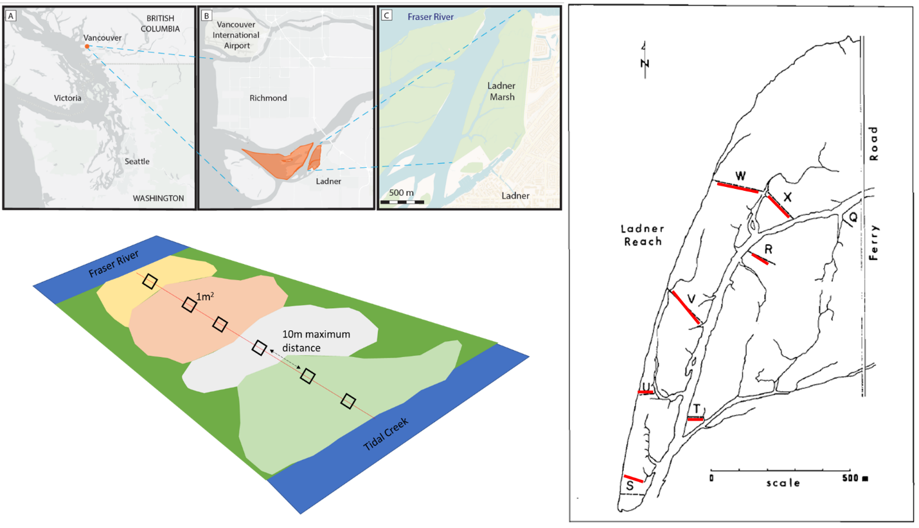

Figure . Clockwise from top left: Geographical site context, transect relocation method by overlaying 1982 publication figure onto Google Earth basemap, and field-testing accessibility, and plot sampling design.

# Results

Table 1. Species indicator analysis identifies the same dominant species in each assemblage type (sedge, fescue, bogbean) as significantly driving clustering of assemblages over time.

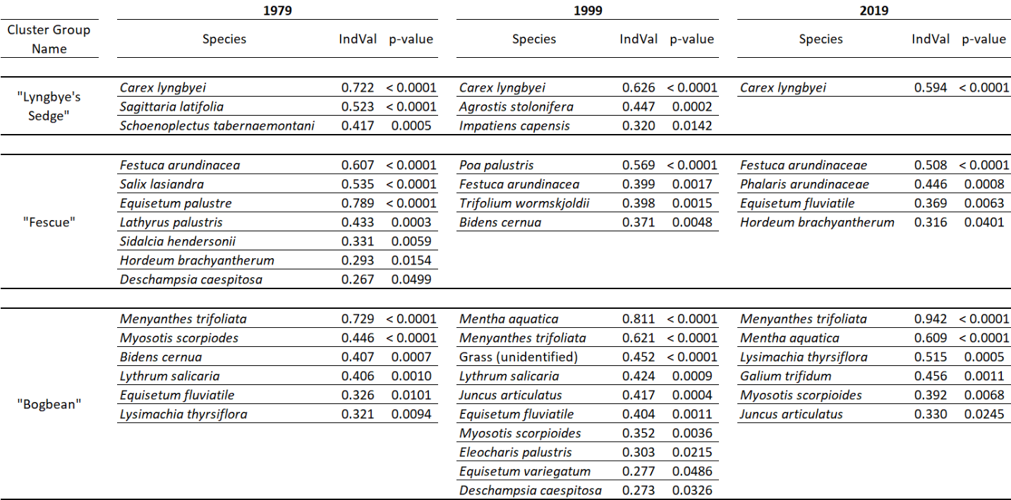



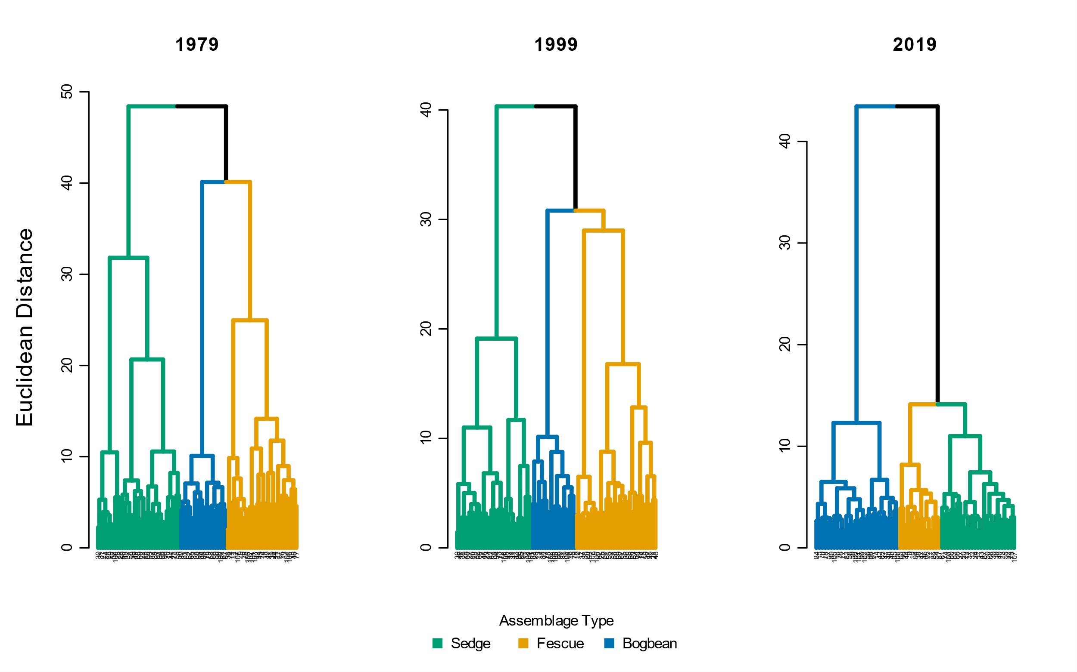

Figure . Assemblage diversity becomes more dissimilar over time, as shown by greater Euclidean distance between assemblage types. (Euclidean distance chosen b/c that's what original authors did. I still need to take out plot #s at leaves.)

# Discussion

1. Answer the questions
   1. How has stability been affected?
2. What broader pattern of change has been observed, and what does this mean for reference conditions?
   1. Can this suggest species homogenization, especially wrt invasive species?
   2. (Lomer, 2021)
3. Edaphic factors may be driving species selection by adaptation to saturation or drainage between assemblage patches, more strictly partitioning the diversity of species that can occupy an assemblage. Additionally, recruitment of new diverse individuals into the assemblage may be limited.
   1. Bring in topics of sediment trapping vs. starvation, marsh subsidence. Can suggest that future studies to measure dendritic channel edge gains/losses through erosion and sedimentation rates may provide mechanistic insight to drivers of microsite edaphic conditions.
4. Discussion of inference limitations, and strengths of comparisons.
   1. Acknowledge transect relocation and sampling method likely alters results, however still provides a ‘snapshot’ of marsh-wide conditions along a major tidal channel.

# Literature Cited

Bai, Y., Han, X., Wu, J., Chen, Z., & Li, L. (2004). Ecosystem stability and compensatory effects in the Inner Mongolia grassland. *Nature*, *431*, 181–184.

Bradfield, G. E., & Porter, G. L. (1982). Vegetation structure and diversity components of a Fraser estuary tidal marsh. *Canadian Journal of Botany*, *60*, 440–451.

Denoth, M., & Myers, J. H. (2007). Competition between Lythrum salicaria and a rare species: Combining evidence from experiments and long-term monitoring. *Plant Ecology*, *191*, 153–161.

Lomer, F. (2021). Rare Plants of the Fraser Valley. In B. Klinkenberg (Ed.), *E-Flora BC: Electronic Atlas of the Flora of British Columbia [eflora.bc.ca]*. Vancouver, Canada: Lab for Advanced Spatial Analysis, Department of Geography, University of British Columbia. [Accessed January 16, 2022]

Tilman, D., Reich, P. B., & Knops, J. M. H. (2006). Biodiversity and ecosystem stability in a decade-long grassland experiment. *Nature*, *441*, 629–632.